*Chapter 14: The Headmaster*

The four walked back to their new home and settled in for a quiet day until it was time to return to Castle Waterdeep for dinner with the Hidden Lords of the Gray Hands, but they didn’t get further than a single block. The blood rain began to pour profusely, forming puddles and streams that emptied into gutters and made their way along sewage canals under their feet.

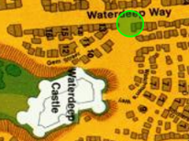

And then they spotted the monstrosity rising above the rooftops before them and taking on a demonic form. Encompassing nearly a third of the entire Trades Ward was the gigantesque form of Pale Night herself, risen anew, and sprouting from her vile womb avatars of her various spawns.

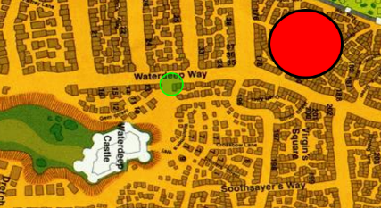

Round 1

“I KNEW it!” Brene snapped. “Too good to be true!”

“Keep her busy!” Atlas called. He said a quick prayer and touched Angren’s shoulder.

*Angren gained +4 to all primary abilities.*

The quartet activated their mindblocking armor and masks, and flew upward toward the monstrous demon, with Steelshade going towards it, while Brene moved north over the housetops. Devrion followed Steelshade, and Atlas moved southeast.

Steelshade cast *dragonskin* on herself as she closed with her enemy.

*Steelshade gained +5 to FF AC and AC.*

Devrion went to work, pointing at the demon and speaking sharply. “Meteorraj!”

|  |  |  |  |  |  |
| --- | --- | --- | --- | --- | --- |
| **Ranged Weapon** | **D+** | **TH+** | **Atk** | **Roll** | **Check** |
| Ranged Touch Attack | +4 | 1 | 17 | 9 | 26 |
| Ranged Touch Attack | +4 | 1 | 17 | 16 | 33 |
| Ranged Touch Attack | +4 | 1 | 17 | 3 | 20 |
| Ranged Touch Attack | +4 | 1 | 17 | 6 | 23 |

*Hit, hit, hit, hit. Dmg: (11 + 3 + 10 + 8) + (18 fire + 21 fire + 30 fire + 20 fire) = 32 + 90 fire = 122. Possibly some damage negated.*

Brene readied her bow as she moved with the others.

The giant mass of demonic plasm reeled from the agony of the meteors striking it and detonating with cosmic-scale impact. Pale Night’s midsection fumed, and she now turned around to face the quartet that stood intrepidly as others around them scrambled for their lives. Buildings collapsed at her feet, and she now roared and bore a half-dozen house-sized demons from an auxiliary womb.

The six or seven demonic behemoths—it was impossible to tell how many had been spat out by the street-sized cooze—fell onto the ground behind buildings and likely began to wreak havoc on the population and infrastructure.

Atlas had been studying the visage of the demon since she’d turned around to face the meteor-casting warmage, and took note of several telltale signs that this was not the same Pale Night they’d vanquished tendays ago. This was a comparatively formless and feral version of the Mother of Demons, and as the blood rain drenched her form, Atlas realized that the phenomenon was beginning to heal the wounds inflicted by Devrion.

And though this manifestation was an altogether new and different iteration of Pale Night, he spotted enough of the same weaknesses that he’d found in her when they’d cut her down from the inside out.

*Atlas recalled all Dark Knowledge (i.e., Tactics, Puissance, Foe, Dread Secret, and Foreknowledge), granting PCs +3 to Attacks, Saves, and AC; +3d6 to Damage, and the ability to stun her with a Dread Secret.*

She took a step towards the heroes and killed about a hundred people in the process, wounding a few hundred more.

Round 2

All four of them continued to close the distance with Pale Night to get within attack range, moving on the trajectories they’d started with.

Atlas murmured a prayer and touched his chest, casting *chasing perfection* *[expired in 20 minutes]*. “Aasterinian, please help us,” he finished his prayer.

*Atlas gained +4 to all primary abilities.*

Brene and Steelshade kept moving closer to the demon with the intent to flank Pale Night.

Devrion followed behind Steelshade, and he pointed at the demon again. “Meteorraj!”

|  |  |  |  |
| --- | --- | --- | --- |
| **Ranged Weapon** | **Atk** | **Roll** | **Check** |
| Bypass Spell Resistance | 20 | 17 | 37 |

*Success. SR bypassed.*

|  |  |  |  |  |  |
| --- | --- | --- | --- | --- | --- |
| **Ranged Weapon** | **D+** | **TH+** | **Atk** | **Roll** | **Check** |
| Ranged Touch Attack | +4 | 1 + 3 DK | 20 | 17 | 37 |
| Ranged Touch Attack | +4 | 1 + 3 DK | 20 | 10 | 30 |
| Ranged Touch Attack | +4 | 1 + 3 DK | 20 | 4 | 24 |
| Ranged Touch Attack | +4 | 1 + 3 DK | 20 | 11 | 31 |

*Hit, hit, hit, hit. Dmg: (8 + 6 + 11 + 6) + (23 fire + 13 fire + 22 fire + 24 fire) = 31 + 82 fire = 113. Possibly some damage negated.*

They all pushed the enormity of the disaster they’d brought on the city to the backs of their minds as they fought. There would be a reckoning later, they knew.

Atlas studied the gigantic form, and interpreted its telltale deformities as a sign that this was not yet a fully self-actualized form of Pale Night. In the dim recesses of his recollection, he was able to link this event to an æons-old conflict involving a deity’s last-ditch effort to resurrect itself from a former part of itself that had been previously severed. During their trek through Pale Night’s corpse, the heroes had noted several chambers devoid of matter that had previously been there, and Atlas now recognized features of internal organs comprising the skin and carapace of the forming demon. If she took enough lives, she might once again regain her former sentience and prowess.

They could not allow this to happen!

The demonic form spat out a few more lesser avatars resembling Juiblex, and struck at a flying hero who had approached with a melee attack in mind. The superhero ricocheted off the demon’s limb, and crashed into a building below. An *earthquake* spell rippled through the quarter, swallowing up entire families and homes before settling.

Round 3

They were now a mere 150’ from the torso, and likely within the demon’s ability to strike with its flailing limbs.

All four of them continued to close with the demon. Atlas studied it more to determine if they should try to enter its body again, or fight it from the outside, and outside was definitely the option, given that the massive form was likely still an amorphic, corrosive blob of goo on the inside.

Devrion cast *meteor swarm* at it again, burning ruthlessly through his spells in an attempt to at least slow the thing’s growth.

|  |  |  |  |
| --- | --- | --- | --- |
| **Ranged Weapon** | **Atk** | **Roll** | **Check** |
| Bypass Spell Resistance | 20 | 11 | 31 |

*Success. SR not bypassed.*

Steelshade continued to close into melee range, and Brene also closed the range and continued to flank the demon, looking for a weak spot to attack. Finding one, she activated the stored *vampiric touch* spell in Arkenlyl for her attack, maximized her flight speed, and assumed the role of a self-propelled missile aimed at one of the demon’s hearts.

|  |  |  |  |  |  |  |  |  |  |  |
| --- | --- | --- | --- | --- | --- | --- | --- | --- | --- | --- |
| **Melee Weapon** | **Dmg** | **D+** | **TH+** | **Crit** | **x** | **Type** | **Wt.** | **Atk** | **Roll** | **Check** |
| Shattermantle Bloodstone Falchion +5 | 2d4 | +9 +5  *vampiric*  *touch* | 7 + 2  charge  + 3 DK | 18 | 2 | Slashing | 8.0 | +38 | 18 | 56 |

*Threat. 1d20 = 4 + 38 = 42; not a critical hit. Dmg: 5 + 9 + 5 + 7 + 2 charge + 7 DK + 37 vampiric = 72.*

*Lauren gained 37 temporary hps [****230****/193].*

The pierce and slash of her sword cut through protoplasm and other demonic tissues.

The demon’s torso spat out a multitude of black and green tendrils in an effort to pull Steelshade into one of its digestion chambers.

|  |  |  |  |  |  |  |  |
| --- | --- | --- | --- | --- | --- | --- | --- |
| **Character** | **Attack Type** | **Damage** | **BAB** | **Str Mod+** | **Total Score** | **Roll** | **Total** |
| Pale Night | Digestive Tentacles | Grapple | 20 | 5 | 25 | 16 | 41 |
| Pale Night | Digestive Tentacles | Grapple | 20 | 5 | 25 | 10 | 35 |
| Pale Night | Digestive Tentacles | Grapple | 20 | 5 | 25 | 13 | 38 |
| Pale Night | Digestive Tentacles | Grapple | 20 | 5 | 25 | 2 | 27 |
| Pale Night | Digestive Tentacles | Grapple | 20 | 5 | 25 | 20 | 45 |
| Pale Night | Digestive Tentacles | Grapple | 20 | 5 | 25 | 7 | 32 |

|  |  |  |  |  |
| --- | --- | --- | --- | --- |
| **Melee Weapon** | **D+** | **Atk** | **Roll** | **Check** |
| Grapple | +9 +2 | +29+3 DK | 11 | 43 |
| Grapple | +9 +2 | +29+3 DK | 4 | 36 |
| Grapple | +9 +2 | +29+3 DK | 2 | 34 |
| Grapple | +9 +2 | +29+3 DK | 13 | 45 |
| Grapple | +9 +2 | +29+3 DK | 12 | 44 |
| Grapple | +9 +2 | +29+3 DK | 20 | 52 |

*Grapples 3 and 5 succeeded.*

Steelshade used her Close Quarters Fighting feat to slash at the tentacles, empowering her strikes (+4) as she wielded her blade.

|  |  |  |  |  |  |  |  |  |  |  |
| --- | --- | --- | --- | --- | --- | --- | --- | --- | --- | --- |
| **Melee Weapon** | **Dmg** | **D+** | **TH+** | **Crit** | **x** | **Type** | **Wt.** | **Atk** | **Roll** | **Check** |
| Shattermantle Bloodstone Falchion +5 | 2d4 | +9 +5 | 7 | 18 | 2 | Slashing | 8.0 | +36 | 19 | 55 |

*Threat. 1d20 = 13 + 36 = 49, critical hit. Tentacle severed.*

Steelshade was drawn into Pale Night’s acidic body, finding herself unable to breathe.

*Dmg: 28 acid. Damage negated.*

Below, civilians ran for their lives, and even horses and livestock ran loose in a stampede of confusion.

Round 4

The other three heroes were now all within 50’ of the flailing mass that was still birthing demons that cascaded onto the nearby buildings and streets.

Another team of flying heroes now flanked Pale Night, two of them hacking with a greataxe and a ranseur upon impact while the other three cast spells that further weakened the demon. Others could be seen approaching as well—on rocs, with their own wings, or by magical flight—and the battle would now mature to its more decisive stage as the City of Splendor’s defenders slowly rendered their contender into ashes and embers.

Brene closed to within 30’ of the demon and began to fire her bow at the titanic creature.

|  |  |  |  |  |  |  |  |  |  |  |
| --- | --- | --- | --- | --- | --- | --- | --- | --- | --- | --- |
| **Ranged Weapon** | **Dmg.** | **D+** | **TH+** | **Critical** | **Rng.** | **Wt.** | **Atk** | **Roll** | **Check** | **Properties** |
| Rapid Shortbow +2 | 1d4 | 2 + 3d4 DK | 2 + 3 DK | x3 | 60’ x 2 | 2.0 | +30 | *1* | 31 | Sneak Attack 10d6 |
| Shortbow, Rapid Shot | 1d4 | 2 + 3d4 DK | 2 + 3 DK | x3 | 60’ x 2 | - | +30 | *10* | 40 | Sneak Attack 10d6 |

*Miss, miss.*

Atlas spoke a few words to the demon.

|  |  |  |  |  |  |  |  |
| --- | --- | --- | --- | --- | --- | --- | --- |
| **Atlas: Dread Secret** | **Rank** | **Ability & Mod.** | **Misc. Mods.** | **Total** | **Roll** | **Check** | **Notes** |
| **Knowledge: The Planes** | 22 | **Int (+8)** | 5 | 35 | 16 | 51 | Trivial Knowledge, **best of 2 rolls** |
| **Knowledge: The Planes** | 22 | **Int (+8)** | 5 | 35 | 13 | 48 | Trivial Knowledge |

*Stun.*

The arch-demon’s reforming mass writhed with unease at the sound of Atlas’ baritone verbiage.

As the tentacles that held her within the primordial digestive chamber that now did its best to eat her froze, Steelshade struggled to get free and back out to where she could breathe.

*Dmg: 23 acid. Damage negated.*

*Grapple automatically fails.*

Steelshade quick cast *dimension hop* to free herself from the demon’s body, and then she full-attacked again, empowered her strikes (+4) and channeled *inflict serious wounds* through her blade. “Elsinor, if you can help, this would be a good time,” she said to her sword.

|  |  |  |  |  |  |  |  |  |
| --- | --- | --- | --- | --- | --- | --- | --- | --- |
| **Melee Weapon** | **Dmg** | **D+** | **TH+** | **Crit** | **Wt.** | **Atk** | **Roll** | **Check** |
| Shattermantle Bloodstone Falchion +5 | 2d4+4 AS | +9 +5 +4d4 AS | 7 | 18 | 8.0 | +40 | 4 | 44 |
| SB Falchion +5, 2nd Attack | 2d4+4 AS | +9 +5 +4d4 AS | 7 | 18 | - | +35 | 15 | 50 |
| SB Falchion +5, 3rd Attack | 2d4+4 AS | +9 +5 +4d4 AS | 7 | 18 | - | +30 | 17 | 47 |
| SB Falchion +5, 4th Attack | 2d4+4 AS | +9 +5 +4d4 AS | 7 | 18 | - | +25 | 6 | 31 |
| Greater Crystal of Arcane Steel | +1 to touch spells | 1 | +1 | - | - | - | - | - |

*Miss, hit, hit, miss.*

*Dmg: [4 + 9 + 5 + 11 AS + (11 + 15 ISW) + 1 Crystal] + (6 + 9 + 5 + 10 AS) = 30 + 30 + 26 negative energy = 86.*

Devrion pointed at the demon. “Furcsa!”

|  |  |  |  |  |
| --- | --- | --- | --- | --- |
| **Ranged Weapon** | **Dmg.** | **Atk** | **Roll** | **Check** |
| Bypass Spell Resistance | varies | 20 | 16 | 36 |

*Success. SR bypassed.*

*Pale Night was Stunned, heavily damaged, and unable to save.*

*See below.*

Pale Night flailed and snatched at two flying heroes whose prowess was less than formidable, but her tentacles fizzled out of existence as the central mass and its digestive chambers began to melt.

Seeing the massive being coming apart and liquifying, civilians, guards, and soldiers on the ground did their best to save themselves and those around them, and all the while heroes and other notable individuals put down the demonic incursion.

Round 5

Almost instantly, the blob of protomatter reverted to an acidic stew that cascaded upon the two blocks that it had previously occupied, slowly corroding everything in its path.

Brene followed the collapsing structure down, staying clear of the acid. She looked for anyone small that she could rescue from the acid.

Atlas descended and looked at the remains of Pale Night to determine the best way to continue the attack.

Steelshade descended lower, watching for anything that she could attack.

Devrion followed Steelshade, but the warmage was loath to cast another spell for fear of harming someone caught in the goo. “Atlas, what can we do,” he called.

They spotted a single demonic form walking through the ruins of a warehouse. It stood two stories tall, and spotted the descending, incoming heroes.

Round 6

Atlas studied the demon to determine who, or what, it might be, guessing with some confidence that it was a malformed deathdrinker.

|  |  |  |  |  |  |  |  |
| --- | --- | --- | --- | --- | --- | --- | --- |
| **Atlas: DK Tactics** | **Rank** | **Ability & Mod.** | **Misc. Mods.** | **Total** | **Roll** | **Check** | **Notes** |
| **Knowledge: The Planes** | 22 | **Int (+8)** | 5 | 35 | 6 | 41 | Trivial Knowledge |
| **Knowledge: The Planes** | 22 | **Int (+8)** | 5 | 35 | 11 | 46 | Trivial Knowledge, **best of 2 rolls** |

*PCs gained +3 to AB vs. deathdrinker.*

Devrion took a moment to cast *mage armor* on himself.

*Devrion gained +4 to AC and FFAC.*

Brene circled around behind the demon, keeping her distance for the moment.

Steelshade flew toward the creature and prepared to engage it.

Round 7

The deathdrinker spotted Steelshade’s beeline and Brene’s orbiting, and met the duskblade’s offensive by shedding off the layer of babau slime that coated it, revealing its hideous, longsword-wielding form. Its aura of unlife was now in full effect, and it now braced for impact with the incoming heroes.

Other heroes flew and glided downward towards other threats as the No Laughing Matter crew engaged the deathdrinker.

Atlas knew this demon had the *true sight* ability, and illusions would not thwart it. He _____.

*Any PC can close into melee on this round, and would receive a +2 charge bonus and another +2 height bonus if charging.*

Brene spotted a breach in the composition of the deathdrinker, a signature dimple in its skull that Atlas had been pointing out in other demons they’d faced in tendays past. She closed to within thirty feet of the demon and fired on the weak spot she’d identified.

|  |  |  |  |  |  |  |  |  |  |  |
| --- | --- | --- | --- | --- | --- | --- | --- | --- | --- | --- |
| **Ranged Weapon** | **Dmg.** | **D+** | **TH+** | **Critical** | **Rng.** | **Wt.** | **Atk** | **Roll** | **Check** | **Properties** |
| Rapid Shortbow +2 | 1d4 | 2 | 2 + 1 | x3 | 60’ x 2 | 2.0 | +28 | 14 | 42 | Sneak Attack 10d6 |
| Shortbow, 2nd Shot | 1d4 | 2 | 2 + 1 | x3 | 60’ x 2 | - | +23 | 16 | 39 | Sneak Attack 10d6 |
| Shortbow, 3rd Shot | 1d4 | 2 | 2 + 1 | x3 | 60’ x 2 | - | +18 | 11 | 29 | Sneak Attack 10d6 |

*Hit (threat), hit (threat), miss. 1d20 = 7 + 28 = 35; 4 + 23 = 27; one critical hit.*

*Dmg: [(3 x 3) + 2 + 1 + 29 Sneak] + (2 + 2 + 1 + 39 Sneak) = 12 + 29 + 5 + 39 = 85.*

Devrion felt a surge of power overcome him, and noted an aura consistent with an Empowering metamagic property. Suspecting he would involuntarily imbue this property into his next spell, he pointed at the demon. “Implózió!”.

|  |  |  |  |
| --- | --- | --- | --- |
| **Ranged Weapon** | **Atk** | **Roll** | **Check** |
| Bypass Spell Resistance | 20 | 12 | 32 |

*Empower property does not alter the outcome. 9th-level slot used.*

|  |  |  |  |  |
| --- | --- | --- | --- | --- |
| **Character** | **Save vs.**  *implosion* | **Ranks** | **Roll** | **Check** |
| Deathdrinker | Fortitude | 23 | 18 | 41 |

*Success. Spell effect negated.*

Steelshade was suddenly *hastened*. Noting that her allies were not, she channeled vampiric touch through her sword, empowered her strikes (+4), and, as Brene might have said, opened a bag of whoop-ass on the demon.

|  |  |  |  |  |  |  |  |  |  |  |  |
| --- | --- | --- | --- | --- | --- | --- | --- | --- | --- | --- | --- |
| **Melee Weapon** | **Dmg** | **D+** | **TH+** | **Crit** | **x** | **Type** | **Wt.** | **Atk** | **Roll** | **Check** | **Properties** |
| Shattermantle Bloodstone  Falchion +5 | 2d4 | +9 +5 + 4d4 AS | 7 + 4 | 18 | 2 | Slashing | 8.0 | +36 | 3 | 39 |  |
| SB Falchion +5,  2nd Attack | 2d4 | +9 +5 + 4d4 AS | 7 + 4 | 18 | 2 | Slashing | - | +31 | 12 | 43 |  |
| SB Falchion +5,  3rd Attack | 2d4 | +9 +5 + 4d4 AS | 7 + 4 | 18 | 2 | Slashing | - | +26 | 17 | 43 |  |
| SB Falchion +5,  4th Attack | 2d4 | +9 +5 + 4d4 AS | 7 + 4 | 18 | 2 | Slashing | - | +21 | 19 | 40 |  |
| SB Falchion +5, *haste* | 2d4 | +9 +5 + 4d4 AS | 7 + 4 | 18 | 2 | Slashing | - | +36 | 13 | 49 |  |
| Greater Crystal  of Arcane Steel | +1 to touch spells | 1 | +1 | - | - | - | - | - | - | - | +1 to spell DC |

*Hit, hit, hit, hit, hit. Dmg: (6 + 9 + 5 + 12 AS) + (5 + 9 + 5 + 7 AS) + (7 + 9 + 5 + 7 AS) + (4 + 9 + 5 + 13 AS) + (5 + 9 + 5 + 8AS) = 32 + 26 + 28 + 31 + 27 = 144 + VT*.*

|  |  |  |  |  |
| --- | --- | --- | --- | --- |
| **Steelshade** | **Dmg.** | **Atk** | **Roll** | **Check** |
| Bypass Spell Resistance | 10d6+1 vamp | +21 | 2 | 23 |

*\* Fail. Vampiric damage negated.*

The deathdrinker attacked Steelshade.

|  |  |  |  |  |  |  |  |
| --- | --- | --- | --- | --- | --- | --- | --- |
| **Character** | **Attack Type** | **Damage** | **BAB** | **Str Mod+** | **Total Score** | **Roll** | **Total** |
| Deathdrinker | Adamantine Longsword +3 | 3d6+13 | 27 | 11 | 38 | 9 | 47 |
| Deathdrinker | Longsword, 2nd Attack | 3d6+13 | 22 | 11 | 33 | 13 | 46 |
| Deathdrinker | Longsword, 3rd Attack | 3d6+13 | 17 | 11 | 28 | 5 | 33 |
| Deathdrinker | Longsword, 4th Attack | 3d6+13 | 12 | 11 | 23 | 6 | 29 |

*Hit, hit, miss, miss.*

*1d100 = 64, 23. 2nd hit was negated by Concealment.*

*Dmg: 13 + 13 = 26 [163/236].*

The deathdrinker’s Aura of Unlife taxed Steelshade of her life essence.

*Dmg: 4 negative energy [139/236].*

In the distance, other deathdrinker and assorted demons were being duly dispatched by the diligent heroes and dillydallying dilettantes now in full force.

Round 8

Atlas moved up behind Steelshade, prayed briefly, and touched her shoulder.

*Steelshade gained protection from evil bonuses.*

Brene repeated her attack against the demon.

|  |  |  |  |  |  |  |  |  |  |  |
| --- | --- | --- | --- | --- | --- | --- | --- | --- | --- | --- |
| **Ranged Weapon** | **Dmg.** | **D+** | **TH+** | **Critical** | **Rng.** | **Wt.** | **Atk** | **Roll** | **Check** | **Properties** |
| Rapid Shortbow +2 | 1d4 | 2 | 2 + 3 DK | x3 | 60’ x 2 | 2.0 | +30 | 16 | 46 | Sneak Attack 10d6 |
| Shortbow, 2nd Shot | 1d4 | 2 | 2 + 3 DK | x3 | 60’ x 2 | - | +25 | 4 | 29 | Sneak Attack 10d6 |
| Shortbow, 3rd Shot | 1d4 | 2 | 2 + 3 DK | x3 | 60’ x 2 | - | +20 | 4 | 24 | Sneak Attack 10d6 |

*Threat, threat, miss. 1d20 = 5 + 30 = 35; 8 + 25 = 33. One critical hit.*

*Dmg: [(3 x 3) + 2 + 45 Sneak] + (4 + 2 + 39 Sneak) = 11 + 45 + 6 + 39 = 101.*

Most tacticians would have recommended to any archer to run at this moment, given the futility that a demon of this scope could be brought down by arrows, but indeed, two of Brene’s missiles struck so true that they brought the deathdrinker’s constitution down to that of a pitiful, whimpering, fleeing mass of bone and protoflesh.

Devrion pointed at the fleeing demon as it made headway for a temple of Ilmater. “Halál ujja!”

|  |  |  |  |  |
| --- | --- | --- | --- | --- |
| **Character** | **Save vs.**  *Finger of death* | **Ranks** | **Roll** | **Check** |
| Deathdrinker | Fortitude | 23 | 3 | 26 |

*Success. Dmg: 16 + 20 = 36.*

And though it didn’t disintegrate, the ebon bolt emanating from Devrion’s right index finger did bore a hole through the demon’s torso such that the demon ceased to exist, and as demonic flesh usually did when it died, it now withered into the fleeting currents of the multiverse.

Steelshade was about to give chase, but instead turned to look around her for other threats as the blood rain suddenly ceased to fall.

Pale Night had been vanquished before she could return to a fully self-realized existence, and though it had been a close call, Atlas was fairly confident that this was the definitive stake in the sarcophagus.

Another demon—this one a kastighur—was spotted in the distance, and the heroes all flew over to put an end to it.

~*~

Ten minutes later, the battle for Waterdeep was over. Brene’s quiver was empty, and the magic users had depleted most of their spells as they dispatched the last of the demons. Atlas had gathered every healing wand the group possessed, and went about healing everyone he could. He, too, had exhausted most of his spells, either in combat, or while helping others. They gathered at an undamaged intersection near the devastated area and took stock of the situation.

“I think we found a place for our funds,” Brene said grimly. “Maybe they won’t run us out of town if we help pay for the damages.”

“I wouldn’t count on that,” Devrion replied in a low voice.

Angren looked around. “I wonder if our house survived.”

Atlas seemed distracted as he mulled over the incident in his mind. “I don’t know about all of this,” the archivist said after a moment. “I must seek out some wiser folk to answer some questions of mine.”

“Can we do that at our house, if it’s still standing?” Brene asked.

With that, the foursome lifted into the air again and went to see if their house was still there.

~*~

Almost two full days later, most of the city’ damaged infrastructure had been restored by magical and mundane means. The heroes’ home had only suffered minimal damage, and they’d repaired it with a handful of *make whole* spells. The blood rain had not returned, and a knock at the front door alerted them to an unexpected arrival.

It was actually an envoy of the Hidden Lords with two pikemen behind him, and he introduced himself as Schrevner of the Rushbards, and provided Brene—who had opened the door—with a writ detailing the gratitude of the Hidden Lords for partaking in the defense of Waterdeep.

They entertained a brief conversation in the doorway before Schrevner informed them that the Gray Hands would be in touch soon. The three then took their leave, and the heroes returned to their previous conversation about demons.

Atlas had learned of Iggwilv’s whereabouts in the Abyss, having consulted several tomes and his own inner oracle, and finding that Iggwilv’s motives were far more complex and far fetched than he cared to fathom. It was clear that she lusted for dominance over her realm, but like most arch-demons, she was likely also gunning for other realms in the Abyss, and would likely crush any and all in her path.

“So we are to live in the Age of Iggwilv?” Brene mused.

“Only insofar as we were living in the Age of Graz’zt,” Atlas assured his lover that this would not be any more chaotic an age than the last. “The Blood War will still rage on; the Heavens and Hells with both continue to tremble at the sound of the arch-demons that remain; and we will still have cause to unsheathe our wares in the name of... what is it we fight for?”

Steelshade passively answered, “Justice?”

“Most of the time,” Devrion.

“I mean: we like Chaos, right?” Brene squinted.

“Sure, far more than the shackles of Law,” Steelshade spoke for all.

“But like we agreed a few years ago,” Atlas reminded them. “Chaos wedded to Evil is no freedom at all, and certainly bears no virtue to pursue.”

Brene got wet hearing Atlas speaking of ethics.

Angren grinned at the halfling’s expression as she gazed on her lover. “Oh, get a room.”

“I have a room, thank you.” She rose to her feet and held out her hand to Atlas. The archivist rose to his feet and took her hand in his, whereupon she led the way up the stairs.

“What,” Devrion asked as Angren shook her head.

“Humans and halflings – ruled by their urges.”

“And you have none?” the warmage said gently.

She looked at him. “They frighten me, Devrion. I’ve never considered having a mate, from any perspective.”

“We bathe and explore together, and you enjoy that.”

Angren flushed and nodded. Their shared bath times had progressed to Angren’s education about oral sex, both giving and receiving. His enjoyment had been tempered with caution as she learned to control her teeth, but she’d caught on quickly. She still retained her innocence in actual mating, which was something much more than their games. “I wonder what Aasterinian will require of us next.”

Devrion inclined his head respectfully, accepting the change of subject. “We should seek out her counsel.” He stood. “For now, I think we should go to that nice bathhouse up the street. I think they put it back together this morning.”

“I’d like that,” Angren said with a smile.

~*~

At the bathhouse, they had a great time until they were intercepted by Elaith with grave news. “It’s Lauren.”

“What?”

“She’s missing.”

~*~

They were back at Rook’s temple, and had been as fully briefed as possible. Elaith—wearing crimson makeup indicative of being on a quest to save her sensei and honor Red Knight—now stood beside Rook, who explained the situation further, as he had the most knowledge of the places where she was likely to be.

In short, Lauren’s previous adventuring party—Destiny’s Gambit—had vanquished the depraved Kaszüm the Acquirer and his two accomplices, Karmen Santiago and Gwen Triflestrife; and as sometimes happened, the Acquirer had left a few loose ends with characters even more unsavory than him, and as such, someone or something else had found Lauren and probably taken her against her will.

“How do we know this last part?” asked Devrion.

“She was last spotted by a confirmed *arcane eye* flying at an altitude of about 50’ and struggling against an invisible aura on route to Julthoon Street where transplanar conduits kept in a single room could convey someone to about ten different planes,” Rook explained. “I realize that Atlas here could accomplish this in a few days’ time, but these are sure-shot, unlimited use portals that Lauren and our friends had shut down years ago.”

Atlas interjected, “Such conundrums are not uncommon. Where there are transplanar travelers there are also temporal ones, and I wouldn’t put it past someone to grab the portals at an opportune moment, and chronoport them to the same location at some fallow stage of the house’s history.”

“Let’s see if the portals are still there, then,” Angren suggested.

At that, the group prepared for their next outing. Brene and Devrion stored their bags of holding in Rook’s strong room, along with the group’s coins, save a hundred gold each and enough coin to replace the wands Atlas had used. The halfling and the elf also stored some of their heavier mundane gear in their respective lovers’ magical haversacks, thus lightening their loads. They provisioned their packs with food from Rook’s kitchen, and set off for Lauren’s home. On the way, they stopped off to purchase the replacement healing wands.

Having stocked up on wands, arrows, and other munitions and provisions, the party now stood at the planning table in the courtyard of Rook’s well-tended temple to his goddess. Rook turned to Elaith, instructing her, “I had to convince them to let you go along, and that your hunches would be well informed.”

“*Hunches*?!” Steelshade knew that to be a concept outside the Red Knightite creed, and thus demanded elaboration with the single word.

Rook smiled, “Elaith’s intuition is often spot-on, but as I keep pointing out, there’s always a heuristic explanation for what she calls the ‘feeling’. It’s a neuron-fast calculation and consequent execution based on the same strategic principles that Red Knight teaches.”

Devrion could follow that Rook was encapsulating Elaith’s gut feelings into his rigid paradigm of hierarchical and sequential rule paths. “So what’s the plan?” asked the warmage. “Head over to Julthoon Street, storm the château, and improvise based on what we find?”

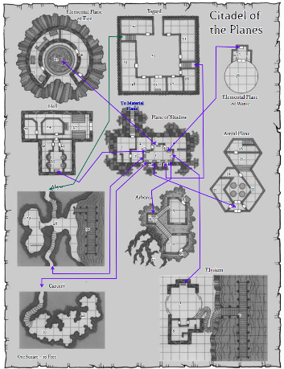

Atlas nodded as he studied the maps before him. “We should ensure that we’re prepared for all these exotic biomes. I usually snap us to Krigala and other idyllic planes. One of these is a layer of the Abyss, and another leads to Dis.”

Rook reminded them, “And this is the configuration that existed 10 years ago. Don’t assume it’s the same now.”

“What’s a neuron?” Brene asked. “Is that anything like a moron?” She whipped around to glare at Devrion as he tried to stifle a laugh. “Oh, I bet you don’t know either, elf.”

Angren snickered as Devrion raised his hands defensively.

“All right, let’s focus,” Atlas said with a longsuffering sigh. “We’re ready to go and see if the place is still the same.”

~*~

Julthoon Street

The heroes now had the property’s outer wall in their line of sight, and were deciding on whether to fly in or try the front gate.

Brene walked up to the gate, checking for traps and to see if the gate was locked. The others stayed back twenty feet and watched for anyone or anything out of place.

Some passersby recognized the high-profile saviors trying to get into the notorious property, and murmured to one another to steer clear, most of them crossing the street to the other side and disappearing to disperse and distribute gossip and speculation.

And after a shrug of her shoulders with her lockpick set in motion, she pushed the gate open.

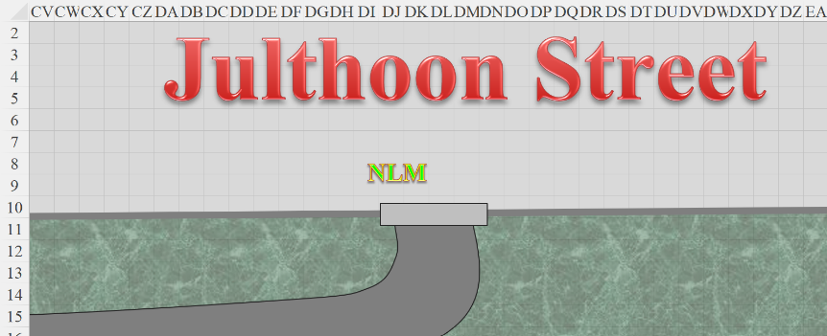

“Now what?” asked the rogue.

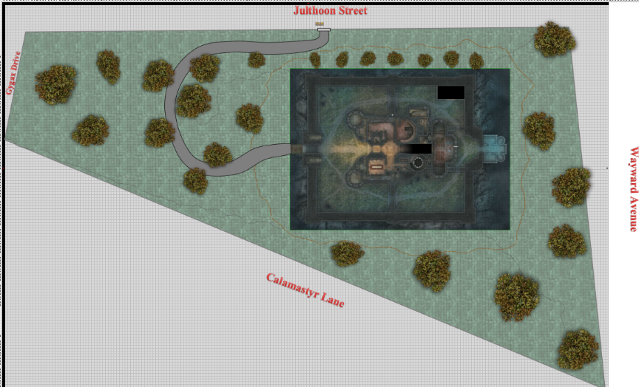

Angren stepped up next to her. “Lead on.”

Brene walked up the path, with Steelshade, Devrion, and Atlas following her.

The winding path led upward onto the slightly raised mound atop which rested the château proper.

As they approached the old-style drawbridge that had scarcely served a tactical purpose, Elaith recalled the architecture that was partly from another time, and partly just reminiscent of that bygone time by virtue of restorers’ craftsmanship. They all beheld the exquisite marble and alabaster stonework accented by woodwork from when Waterdeep was a sprawling child.

The drawbridge was lowered, and the mostly calm waters below betrayed the presence of humanoid-sized crocodilians that were confined by the steepness of the moat’s border. Brene was the first to notice that the crocodilians were a glamer effect—an illusion rendered by the shimmering water that was itself a magical figment cast to distract the attention of lesser heroes.

An automaton made itself evident at the threshold of the drawbridge, and greeted them in a bland Common, “Greetings, citizens of Waterdeep. The Headmaster hails you, and has bestowed upon you the title of *Those Who Will Have Vanquished Iggwilv*.”

They looked at one another, and everyone else’s eyes converged on Elaith, who at the moment was the resident expert on the residence’s expert on them. The mechanical and yet anthropomorphic figure was comprised of a frame of three metals—probably gold, platinum, and bronze—and waited calmly for the heroes to respond, making no hostile gestures.

Brene touched the tattered grey headband that passed just above her eyebrows, activating its *true seeing* ability. She then gazed back down to see something she could describe but not identify. She murmured to Atlas, “I’m seeing a greenish-grayish swirl of gas with what looks like animated shapes within it.”

Atlas closed his eyes and said a brief prayer, and then he stepped up next to Brene to see for himself, casting *true seeing* and confirming what she had just described. He held back laughter, though he smiled, almost admiring the cunning design and manufacture of the illusory scaffolding and the true essence within.

“You are correct,” Atlas said, his eyes shifting from Brene to the automaton still 30’ away, and back to his friends. “It is transplanar matter, and if I’m not mistaken, it is the same plasm that constituted the deathdrikers we encountered the other day.”

“Harvested?” Devrion guessed.

“Possibly, but in any case,” Atlas surmised, “it’s definitely active.”

“Can it reach out with tendrils and nab us?” asked Steelshade, getting to the logistical point.

The automaton felt at liberty to answer, “Technically, yes, they would do so to anyone identified as an intruder, and so can the hounds. You are, however, welcome within.”

Steelshade stepped forward. “On whose word does this welcome come?”

“Why… at the behest of the Headmaster!” the automaton happily replied.

Steelshade suppressed the urge to sigh. “Who is the Headmaster?”

“Do come in, and the Headmaster will describe himself in other words.”

Brene suspected foul play, though ambiguously. It was her job to worry when she had no reason to worry, so she did.

The halfling shook her head and started into the keep at the head of the group, her bow at the ready. Steelshade trailed behind her, followed by Elaith, Devrion, and Atlas.

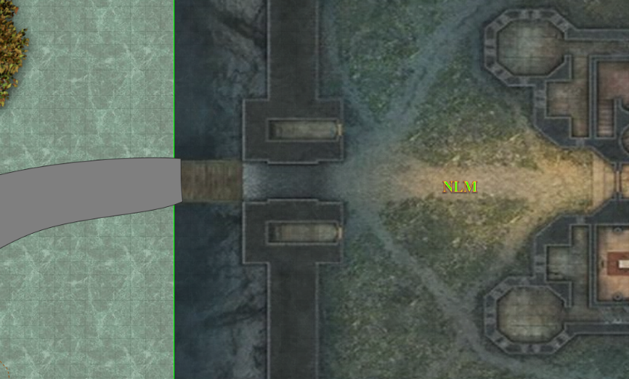

Their *true seeing* ability allowed them to perceive irregularities in the reality around them, and Atlas identified transplanar bindings that altered the physical properties of the area. They were led along the dirt path that led to the keep’s front doors. The stick-man automaton approached the double doors as they opened, and it said cheerfully, “Lunch is almost served.”

“As long as we aren’t the main course,” Devrion muttered from the middle of the group.

The automaton seemed to be going over some inventory or menu in its memory bank, then replied, “No, I don’t believe so.”

“Nah, you elves are all gristle and bone,” Brene retorted.

“Oh, I know of one of his bones that has meat on it,” Steelshade commented as she looked around.

“Oh, spare us,” Atlas called from the back.

Elaith glanced behind her at Devrion, who had colored to the tips of his ears, and giggled at the sight of him.

Brene laughed and turned her attention back to the task at hand.

They entered the château and were led further east into a four-way entryway, then told, “Please wait here for the Headmaster. He should be in shortly.”

And once had the automaton stopped speaking, the rotund body of a towering figure approached from the unlit hallway to the east. Standing just south of the quartet, the automaton then said, “Ah, Headmaster! I present to you the ones that others have called No Laughing Matter.”

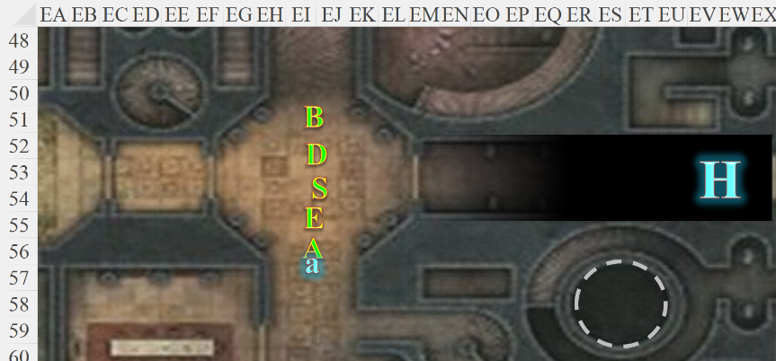

Round 1

At first, only Steelshade had a line of sight to the obese monstrosity making headway in a rather civil manner and at a moderate pace. Within seconds, Devrion and Elaith did as well, but Brene and Atlas could not see the approaching figure.

The group waited patiently, with Brene and her boyfriend not knowing exactly what to expect as the other three began to get a better impression of their host as he came into the light.

What they thought had been a head now revealed itself as a cluster of eyestalks atop what they had taken for a bloated body.

Before them was a scaly, tentacled beholder—quite handsome outside his own esteem—who introduced himself as the Headmaster, the Autocrat, and the Redeemer. “Make yourselves at home, and I will explain your predicament to you as we dine.”

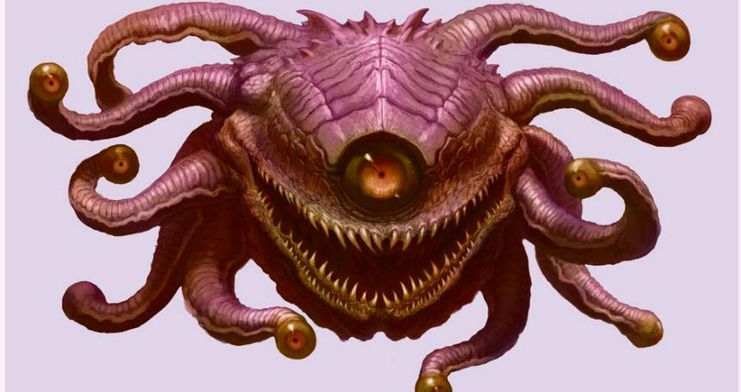

All the guests save for Elaith activated their Mindarmor items with the command words. Atlas considered the beholder to determine if its motives were benign or not. Without thinking much about it, the ranged combatants took a step back.

“What do you want?” Steelshade asked. “We are loath to trust your kind, so why are you here?”

“Ah, straight to business?” the beholder smirked, then blinked all of his eyes at once and shook his spherical body. “Nay, I’ll not drill into your heads; I am a bender of reality.” He then gave a gentle, telekinetic, caress to each of them, taking his liberties with any part of their frame that he wished within the span of a second, then urged them, “Do please come and dine; I promise I won’t poison you or to some other lowly, underhanded thing. If I wanted you dead, I would have already looked you in the eyes and done my best to do you in. You are *guests* today!”

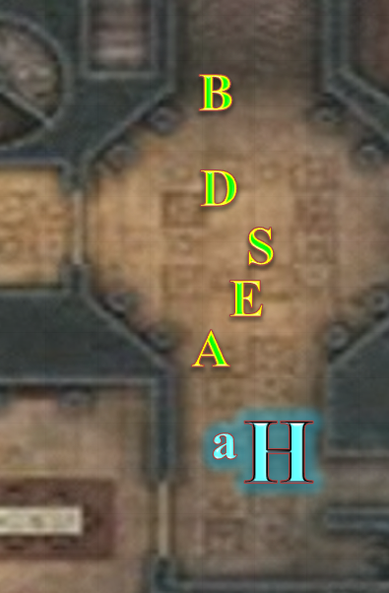

And then he floated southward with the automaton.

Brene muttered something vile under her breath. “I can’t believe this,” she continued in Common. “A beholder.”

“Well, let’s not keep it waiting,” Atlas said with a grim smile. “After you.”

Steelshade and Elaith led the way after the beholder, with Devrion, Atlas, and Brene following.

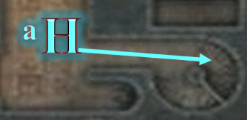

They went up a flight of stairs that Elaith recalled ascending once, then .

A handful of other animated objects were busy serving food as the beholder *seated* himself along the southern, chairless length of the table while the majordomo automaton that had led them in gestured for them to be seated in any arrangement that they liked.

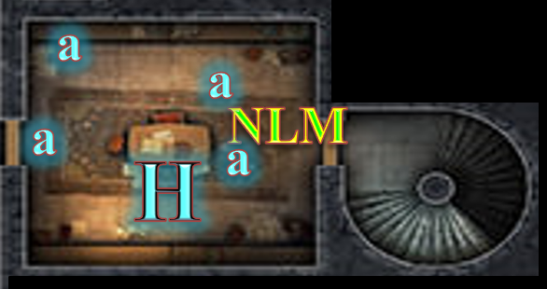

*[Assuming PCs were seated]*

The first course was a chickeny broth along with some rothé ribs. “Sorry for the portion sizes. We weren’t expecting anyone. We’ll get some finer bits in here for the main course, right Schmooze?”

“Of course, Headmaster,” the broomstick-constituted automaton confirmed, and headed east into the kitchen to check on the status of said course.

“Now then, I can tell you’re eager to get to the end of the season without all the developments and teasers, but alas, this caper must be played out to script, even if with a little improvisation. So!” he began the next sentence as if it had been said, then chomped on a rothé’s entire third, right rib in one full bite, continuing, “You want to save Lauren, but you don’t know from what exactly, and maybe it’s from me, and how can you outsmart a handsome fuck like me that’s mostly brains and the rest good looks?” He took another bite, letting one of them get a few words in before gulping the bone and flesh down and resuming his unrehearsed monologue.

“Of course,” Devrion interjected blandly.

As the Headmaster spoke, Atlas wracked his brain to dredge up any bits of trivia that might shed some light on this bizarre situation and the Headmaster’s uncharacteristic behavior.

“Right? So now you’re all thinking to yourselves, ‘maybe we should have prepared some kind of *Rary’s telepathic link* spell to go over this while the Headmaster tries in vain to read our minds’, or whatever, and maybe even reaching for your signature weapon and bringing such a nice meal to an abrupt end... yes?”

The head automaton had returned from the kitchen, announcing, “The main course is ready whenever you should desire it, Headmaster.”

“Ah, I see Devrion has finished his entrée already. Please do bring in the yummies for our humanoid guests,” the behold requested politely before devouring yet another rib and washing it down with a simmering pitcher of broth.

“As you wish, Sire.”

“How did you come to be the Headmaster here?” Steelshade asked.

The beholder smirked and almost flirtingly winked his rightmost eyes at the duskblade. He giggled, “I bought it from the gal who’d bought it from the guy who had inherited it from... I don’t recall the names now, but Elaith here was part of the original acquisition from the Acquirer, the gnome mastermind whose methods—I must say—were quite admirable... that is, until Lauren’s blade cut him down.”

Angren knew Lauren less well than Elaith and Rook did, and they all knew the story from one angle or another. Rook had been there, and had seen Lauren quickly repeated her previous attack, using most of her remaining spell power to do bring down Kaszüm. His account of events to Elaith later would spare no detail.

|  |  |  |  |  |  |  |  |  |  |  |  |
| --- | --- | --- | --- | --- | --- | --- | --- | --- | --- | --- | --- |
| **Melee Weapon** | **Dmg** | **D+** | **TH+** | **Crit** | **x** | **Type** | **Wt.** | **Atk** | **Roll** | **Check** | **Properties** |
| Shattermantle Bloodstone Falchion +3 | 2d4 | +2 +3  +4d4 | 3 + 4 | 18 | 2 | Slashing | 8.0 | +22 | 16 | 38 | Vampiric Touch |
| SB Falchion +3, 2nd Attack | 2d4 | +2 +3  +4d4 | 3 + 4 | 18 | 2 | Slashing | - | +17 | 14 | 31 |  |
| SB Falchion +3, 3rd Attack | 2d4 | +2 +3  +4d4 | 3 + 4 | 18 | 2 | Slashing | - | +12 | 8 | 20 |  |
| SB Falchion +3, 4th Attack | 2d4 | +2 +3  +4d4 | 3 + 4 | 18 | 2 | Slashing | - | +7 | 17 | 24 |  |

*Hit, hit, miss, miss. Dmg: (4 + 2 + 3 + 12 AC + 33 vampiric) + (3 + 2 + 3 + 9 AC) = 21 + 17 + 33 vampiric = 61.*

The first swipe had likely done the job, and the *vampiric touch* hadn’t swiped more than the drop of life that the gnome had left in him. She pulled back her blade, causing the giant gnome to collapse among the half-dozen dead bodies of those he’d likely just betrayed.

Kaszüm was dead.

~*~

Elaith came back to the moment as the Headmaster assumed a perfectly elven form and stood before them holding what appeared to be a writ.

It unfurled and he showed it to the others, adding, “The deed to this humble abode.” The writ then diminished in size until it was microscopic, and he then subsumed the particle into his being.

The beholder’s guests either ate or watched attentively as the apparent prestidigitator spoke some more, “In any case, I *did* pay for this fair and square, and like you all, I got my coin from that adventuring life. If I’m not mistaken, you all just went on a transplanar killing spree, stealing prized weapons and doodads from those you felled. No shame, no judgment…”

Steelshade looked straight at the Headmaster. “We are serving Aasterinian; not simply going about killing others. Taking some of what we’ve won in combat isn’t stealing, either.”

“Oh? I received a list of dragons and sphinxes who no longer live because you wrested their most prized possessions from their claws. Well, no matter,” shrugged the beholder with his new shoulders.

The Headmaster had stopped eating while in elven form, and now that the automatons cleared away the ribs and broth and brought in some tofu-looking thing and saucerfuls of sauces, he further explained, “No doubt, Kaszüm was a formidable man, and other notable sorts have passed through these halls since his demise, but now...” for the first time, the beholder betrayed on his elven face a measure of pause and perhaps fear, “... now there is something far more sinister, and I fear, far more cunning, than all of us combined, and it will take our combined efforts to address whatever being holds Lauren captive in *my lair*!” he stressed, then looked up and raised his voice, “In *my house!*” he sighed, seemingly taxed.

Elaith was about to say something, but Steelshade discouraged her with a wary look.

“You see,” the Headmaster said in a softer tone now, “whatever force torments this house isn’t after the house, or its many portals; nay: it’s after *me*, and alone, I will surely fall to its will. Oh, please begin,” he then said, sitting on a chair he manifested an instant earlier and ladling sauces over and partaking of the bland, gluten-free cubes.

“So why draw *us* in, of all strangers?” Atlas finally asked.

Others began to eat as well as time seemed to slow, or hasten.

“Because I have seen my fate if I do not address it,” answered the Headmaster. “And that fate is to be used to bring you down, and anyone who would oppose the force that seeks to rake my soul.”

They were not sure of how, but they were nearly finished with their main course by the time the beholder had finished speaking.

Devrion shook his head. It was a good enough motive for the beholder to be civil, but beholders were a notoriously paranoid and otherwise psychotic genus, and even the warmage knew to hold this in consideration when in dialogue with the Headmaster. They had gotten here during the earlier part of the day, but now they could see the darkening sky through a window of the upper story dining chamber.

“Well,” the elven-shaped beholder blinked as a plethora of eye stalks emerged from his head. His ears, too, took on the shape of stalks as his face now returned to his original beholder features, though his elven body remained as it was. “Now that we’ve had us a good afternoon together, let us be off to our respective challenges. Don’t think I’m abandoning you; with any luck, we’ll all survive, and our common enemy will wish they’d never been spawned.”

And with this, the beholder sighed hard, lost his humanoid body, assumed its normal size, and lost control of the part of the Weave that was holding the room intact. The fabric of spacetime fragmented, and icosahedrons of transplanar force formed around each of the guests—and around their host—shunting each individual into a discrete position in spacetime.