*Chapter 15: The Eidolons*

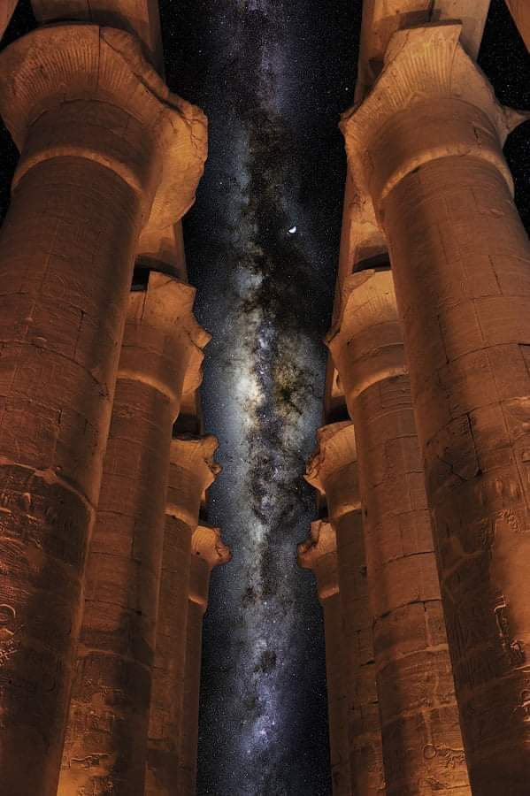

They instinctively looked all around them, seeing a band of stars above them seemingly framed by the twin rows of floating columns amidst them. Below them were looser constellations and nebulae at unfathomable distances from their feet, or perhaps just a few hundred leagues below.

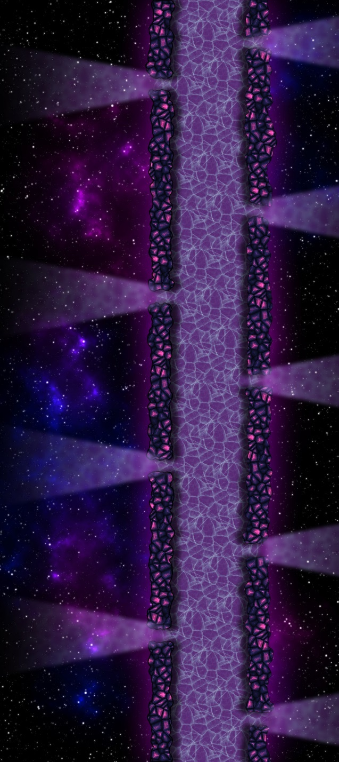

The causeway appeared endless, and Atlas could see in the crystalline, transplanar dimensions around them would negate any *planar shift* magic that he might normally conjure. They were not in an antimagic field, but rather in an encapsulated universe separate from the multiverse they knew, and magic beyond their comprehension had wedged them here at some point before lunch.

And just as they were coming to terms with their circumstance, about a half-dozen tentacled beings floated upward and regarded the quintet of newcomers with contempt. They occupied the bodies of kraken-like creatures, and the No Lives Matter crew identified them as elder eidolons. “We dispatched a few of these inside Pale Night’s corpse,” Atlas reminded his friends, recalling that these aberrations possessed no intellect of their own, and were always guided by an elder brain or an even greater power.

“State your business in Our realm!” the seven mollusk-like aberrations all spoke at once, choosing Common as the language of delivery.

“Holy shit,” Brene muttered to Elaith as they looked around.

“Hush,” Devrion interjected in a low voice.

Brene flashed him a rude halfling gesture, which the warmage ignored as he turned his attention to the creatures.

“We have come to rescue our friend who is being held captive,” Atlas answered.

“Then this shall be your final resting place,” another aberrant kraken-like being spoke, and the seven creatures then rudely started to approach the group menacingly.

Round 1

|  |  |  |  |  |  |
| --- | --- | --- | --- | --- | --- |
| **Character** | **Group** | **Initiative** | **Roll** | **Modified Roll** | **Speed** |
| Devrion | 1 | 6 | 14 | 20 | 30’ |
| Brene | 1 | 6 | 9 | 15 | 30’ |
| Steelshade | 1 | 5 | 9 | 14 | 20’ |
| Elder Eidolons | 2 | 0 | 6 | 6 | 20’ |
| Atlas | 1 | 2 | 2 | 4 | 30’ |

Gauging the average distance between himself and the approaching, floating kraken-like things to be about 35’, Devrion pointed at the nearest creature. “Implózió!” *[implosion, expires no later than Round 5]*

|  |  |  |  |  |
| --- | --- | --- | --- | --- |
| **Character** | **Save vs.**  *implosion* | **Ranks** | **Roll** | **Check** |
| Elder Eidolon Krakens | Fortitude | 6 | ?? | ?? |

*??*

The basalt construct appeared unaffected by the spell.

Atlas reminded the warmage, “They are immune to most of your magic!”

Surrounded by the seven eidolons, Brene fired her bow at the closest one.

|  |  |  |  |  |  |  |  |  |  |  |
| --- | --- | --- | --- | --- | --- | --- | --- | --- | --- | --- |
| **Ranged Weapon** | **Dmg.** | **D+** | **TH+** | **Critical** | **Rng.** | **Wt.** | **Atk** | **Roll** | **Check** | **Properties** |
| Rapid Shortbow +2 | 1d4 | 2 | 2 | x3 | 60’ x 2 | 2.0 | +27 | 16 | 43 | Sneak Attack 10d6 |
| Shortbow, 2nd Shot | 1d4 | 2 | 2 | x3 | 60’ x 2 | - | +22 | 14 | 36 | Sneak Attack 10d6 |
| Shortbow, 3rd Shot | 1d4 | 2 | 2 | x3 | 60’ x 2 | - | +17 | 15 | 32 | Sneak Attack 10d6 |
| Shortbow, Rapid Shot | 1d4 | 2 | 2 | x3 | 60’ x 2 | - | +27 | 2 | 29 | Sneak Attack 10d6 |

*Hit, hit, hit, hit. Dmg: (2 + 2 + 31 Sneak) + (3 + 2 + 36 Sneak) + (3 + 2 + 32 Sneak) + (1 + 2 + 48 Sneak) = 35 + 41 + 37 + 51 = 164.*

The arrows chiseled away at the construct that now reached Brene’s proximity.

|  |  |  |  |  |  |  |  |
| --- | --- | --- | --- | --- | --- | --- | --- |
| **Save vs.**  Insanity Aura | **Rank** | **Ability & Mod.** | **Misc. Mods.** | **Total** | **Roll** | **Check** | **Properties** |
| **Brene, Will** | **6** | **Wis (+3)** | 3 | **12** | 8 | 20 | +2 vs. Fear |

*Success. Confusion effect negated.*

`

Steelshade swift cast *dimension hop*, placing herself behind one of the creatures. She channeled her stored *vampiric touch* spell into her attack, and empowered her strikes (+4).

|  |  |  |  |  |  |  |  |  |  |  |
| --- | --- | --- | --- | --- | --- | --- | --- | --- | --- | --- |
| **Melee Weapon** | **Dmg** | **D+** | **TH+** | **Crit** | **x** | **Type** | **Wt.** | **Atk** | **Roll** | **Check** |
| Shattermantle Bloodstone Falchion +5 | 2d4+4d4 | +9 +5 | 7+4 | 18 | 2 | Slashing | 8.0 | +40 | 3 | 43 |
| SB Falchion +5, 2nd Attack | 2d4+4d4 | +9 +5 | 7+4 | 18 | 2 | Slashing | - | +35 | 16 | 51 |
| SB Falchion +5, 3rd Attack | 2d4+4d4 | +9 +5 | 7+4 | 18 | 2 | Slashing | - | +30 | 5 | 35 |
| SB Falchion +5, 4th Attack | 2d4+4d4 | +9 +5 | 7+4 | 18 | 2 | Slashing | - | +25 | 4 | 29 |

*Hit, hit, hit, hit. Dmg: (4 + 9 + 5 + 11 AS) + (3 + 9 + 5 + 10 AS) + (8 + 9 + 5 + 7 AS) + (5 + 9 + 5 + 12 AS) = 29 + 27 + 29 + 31 = 126.*

Though not completely destroyed, Steelshade’s target was nearly incapacitated. As with Devrion’s *implosion* spell, however, the *vampiric touch* spell seemed to do no additional harm to the basalt construct.

|  |  |  |  |  |  |  |
| --- | --- | --- | --- | --- | --- | --- |
| **Save vs.**  Insanity Aura | **Rank** | **Ability & Mod.** | **Misc. Mods.** | **Total** | **Roll** | **Check** |
| **Steelshade, Will** | 12 | **Wis (+4)** | 3 | 19 | 10 | 29 |

*Success. Confusion effect negated.*

The elder eidolons—built of ancient rock, basalt, porphyry, obsidian, and other igneous stone—attacked the heroes, at least those who got close enough.

|  |  |  |  |  |  |  |  |  |  |
| --- | --- | --- | --- | --- | --- | --- | --- | --- | --- |
| **Character** | **Attack Type** | **Damage** | **BAB** | **Str Mod+** | **Total Score** | **Roll** | **Total** | **Threat** | **Targeting** |
| Elder Eidolon Krakens | Tentacle 1 | 2d8+16/19-20 | 15 | 12 | 27 | 10 | 37 | ý | Atlas |
| Elder Eidolon Krakens | Tentacle 2 | 2d8+16/19-20 | 15 | 12 | 27 | 9 | 36 | ý | Brene |
| Elder Eidolon Krakens | Tentacle 1 | 2d8+16/19-20 | 15 | 12 | 27 | 19 | 46 | þ | Devrion |
| Elder Eidolon Krakens | Tentacle 2 | 2d8+16/19-20 | 15 | 12 | 27 | 4 | 31 | ý | Elaith |
| Elder Eidolon Krakens | Tentacle 1 | 2d8+16/19-20 | 15 | 12 | 27 | 19 | 46 | þ | Steelshade |

*Hit, hit, threat, hit, threat. 1d20 = 17 + 27 = 44; 6 + 27 = 33; critical hit to Devrion.*

*Concealment 1d100 = 9, 60, 53; concealment bypassed for attack against Atlas.*

*Dmg to Atlas: 13 + 16 = 29 [76/105].*

*Dmg to Devrion: 8 + 16 = 24 [98/105].*

*Dmg to Elaith: 7 + 16 = 23.*

Two eidolons would soon be in range to attack, and those that were now imposed additional confusion auras upon the heroes.

|  |  |  |  |  |  |  |
| --- | --- | --- | --- | --- | --- | --- |
| **Save vs.**  Insanity Aura | **Rank** | **Ability & Mod.** | **Misc. Mods.** | **Total** | **Roll** | **Check** |
| **Atlas, Will** | **11** | **Wis (+6)** | 13 | 30 | 6 | 36 |
| **Brene, Will** | **6** | **Wis (+3)** | 3 | 12 | 3 | 15 |
| **Devrion, Will** | **12** | **Wis (+1)** | 3 | 16 | 12 | 28 |
| **Elaith, Will** | **9** | **Wis (+0)** | 1 | 10 | 1 | 11 |
| **Steelshade, Will** | **12** | **Wis (+4)** | 3 | 19 | 12 | 31 |

*Success, fail, success, fail, success.*

*Brene and Elaith suffered from confusion.*

*1d100 = 52, 28; see below.*

Brene then turned to flee *[no move action yet]* as Elaith babbled incoherently.

Atlas stepped closer to Elaith and roared *[lion’s roar, boosts expired on Round 201]* at his opponents.

*PCs (including Elaith, not shown below) gained +1 to attacks and saves vs. Fear effects, and 1 + 20 = 21 temporary hps.*

*Atlas [****97****/105].*

*Brene [****140****/119].*

*Devrion [****102****/105].*

*Steelshade [****219****/198].*

The eidolons seemed unaffected by the archivist’s spell, just as they had been against Devrion’s and Steelshade’s magics.

Round 2

Brene’s and Elaith’s mindarmor kicked in, and they again stood against the eidolons in defensive postures.

Devrion thought to command magic that wasn’t subject to spell resistance, and pointed at the closest enemy. “Erőszféra!” *[orb of force]*

|  |  |  |  |  |  |  |  |
| --- | --- | --- | --- | --- | --- | --- | --- |
| **Ranged Weapon** | **Dmg.** | **D+** | **TH+** | **Atk** | **Roll** | **Check** | **Notes** |
| Ranged Touch Attack | 10d6 force | +4 | 1 | 17 | 4 | 21 | Weapon Focus Included |

*Hit. Dmg: 58 + 4 = 62 force.*

The *orb* didn’t quite do what his colleagues had manage to do to the others, but was enough to set the opponent aback for a moment as the hivemind contemplated how to resolve this intrusion.

Steelshade attacked the damaged construct again, empowering her strikes (+4).

|  |  |  |  |  |  |  |  |  |  |  |
| --- | --- | --- | --- | --- | --- | --- | --- | --- | --- | --- |
| **Melee Weapon** | **Dmg** | **D+** | **TH+** | **Crit** | **x** | **Type** | **Wt.** | **Atk** | **Roll** | **Check** |
| Shattermantle Bloodstone Falchion +5 | 2d4 + 4d4 | +9 +5 | 7+4 | 18 | 2 | Slashing | 8.0 | +40 | 11 | 51 |
| SB Falchion +5, 2nd Attack | 2d4 + 4d4 | +9 +5 | 7+4 | 18 | 2 | Slashing | - | +35 | 3 | 38 |
| SB Falchion +5, 3rd Attack | 2d4 + 4d4 | +9 +5 | 7+4 | 18 | 2 | Slashing | - | +30 | 6 | 36 |
| SB Falchion +5, 4th Attack | 2d4 + 4d4 | +9 +5 | 7+4 | 18 | 2 | Slashing | - | +25 | 3 | 28 |

*Hit, hit, hit, hit. Dmg: (5 + 9 + 5 + 10 AS) + (6 + 9 + 5 + 8 AS) + (3 + 9 + 5 + 10 AS) + (6 + 9 + 5 + 11 AS) = 29 + 28 + 27 + 31 = 115.*

She destroyed the already damaged automaton beyond all recognition.

*[DM assumption]* Brene thought she could finish off the one she’d just set back, so she fired upon it.

|  |  |  |  |  |  |  |  |  |  |  |
| --- | --- | --- | --- | --- | --- | --- | --- | --- | --- | --- |
| **Ranged Weapon** | **Dmg.** | **D+** | **TH+** | **Critical** | **Rng.** | **Wt.** | **Atk** | **Roll** | **Check** | **Properties** |
| Rapid Shortbow +2 | 1d4 | 2 | 2 | x3 | 60’ x 2 | 2.0 | +27 | 6 | 33 | Sneak Attack 10d6 |
| Shortbow, 2nd Shot | 1d4 | 2 | 2 | x3 | 60’ x 2 | - | +22 | 16 | 38 | Sneak Attack 10d6 |
| Shortbow, 3rd Shot | 1d4 | 2 | 2 | x3 | 60’ x 2 | - | +17 | 10 | 27 | Sneak Attack 10d6 |
| Shortbow, Rapid Shot | 1d4 | 2 | 2 | x3 | 60’ x 2 | - | +27 | 5 | 32 | Sneak Attack 10d6 |

*Hit, hit, miss, hit. Dmg: (1 + 2 + 33 SA) + (4 + 2 + 40 SA) + (3 + 2 + 23 SA) = 36 + 46 + 28 = 110.*

And indeed, she efficiently chipped away at the important bits in the automaton’s outer system, breaching the inner gel circuitry.

Elaith swift cast *dragonskin [expired on Round ]*, and attacked the nearest construct while empowering her strikes (+4).

*Elaith gained +5 to AC.*

|  |  |  |  |  |  |  |  |  |  |
| --- | --- | --- | --- | --- | --- | --- | --- | --- | --- |
| **Melee Weapon** | **Dmg** | **D+** | **TH+** | **Critical** | **Type** | **Wt.** | **Atk** | **Roll** | **Check** |
| Greatsword +4 | 2d6+4d4 | +4 +4 | 4 + 4 | 19-20/x2 | Slashing | 8.0 | +29 | **19** | 48 |
| Greatsword +4, 2nd Attack | 2d6+4d4 | +4 +4 | 4 + 4 | 19-20/x2 | Slashing | - | +24 | 13 | 37 |
| Greatsword +4, 3rd Attack | 2d6+4d4 | +4 +4 | 4 + 4 | 19-20/x2 | Slashing | - | +19 | **19** | 38 |
| Greatsword +4, 4th Attack | 2d6+4d4 | +4 +4 | 4 + 4 | 19-20/x2 | Slashing | - | +14 | 9 | 13 |

*Threat, hit, threat, miss. 1d20 = 18 + 29 = 47; 6 + 19 = 25; one critical hit.*

*Dmg: [(2 x 8) + 4 + 4 + 11 AS] + (9 + 4 + 4 + 10 AS) + (7 + 4 + 4 + 13 AS) = 35 + 27 + 28 = 91.*

The damaged—but not destroyed—eidolons began to slowly and passively repair themselves as they identified Elaith as the least of their concerns, and the mind that controlled them opted to have its pawns converge on the worshipper of Red Knight. Four eidolons surrounded and tried to grapple her as the fifth one that remained active attacked Brene. As the eidolons did this, two left themselves open for Steelshade to swipe at them, so she took a moment to slice at the one that Devrion had just blasted with an *orb of force*.

|  |  |  |  |  |  |  |  |  |  |  |
| --- | --- | --- | --- | --- | --- | --- | --- | --- | --- | --- |
| **Melee Weapon** | **Dmg** | **D+** | **TH+** | **Crit** | **x** | **Type** | **Wt.** | **Atk** | **Roll** | **Check** |
| Shattermantle Bloodstone Falchion +5 | 2d4 | +9 +5 | 7 | 18 | 2 | Slashing | 8.0 | +36 | 7 | 43 |

*Hit. Dmg: 5 + 9 + 5 = 19.*

|  |  |  |  |  |  |  |  |
| --- | --- | --- | --- | --- | --- | --- | --- |
| **Character** | **Attack Type** | **Damage** | **BAB** | **Str Mod+** | **Total Score** | **Roll** | **Total** |
| Elder Eidolon Krakens | Tentacle | 2d8+16/19-20 | 15 | 12 | 27 | 14 | 41 |
| Elder Eidolon Krakens | Tentacle | 2d8+16/19-20 | 15 | 12 | 27 | 12 | 39 |
| Elder Eidolon Krakens | Tentacle | 2d8+16/19-20 | 15 | 12 | 27 | 14 | 41 |
| Elder Eidolon Krakens | Tentacle | 2d8+16/19-20 | 15 | 12 | 27 | 3 | 30 |

*Hit, hit, hit, hit. Dmg: (14 + 16) + (4 + 16) + (11 + 16) + (9 + 16) = 30 + 20 + 27 + 25 = 102.*

Elaith did not do well against the onslaught, and the creatures now tried to grapple her limbs.

|  |  |  |  |  |  |  |  |  |  |
| --- | --- | --- | --- | --- | --- | --- | --- | --- | --- |
| **Character** | | **Attack Type** | | | **BAB** | **Str Mod+** | **Total Score** | **Roll** | **Total** |
| Elder Eidolon Kraken | | Grapple | | | 15 | 32 | 47 | 10 | 57 |
| Elder Eidolon Kraken | | Grapple | | | 15 | 32 | 47 | 8 | 55 |
| Elder Eidolon Kraken | | Grapple | | | 15 | 32 | 47 | 17 | 64 |
| Elder Eidolon Kraken | | Grapple | | | 15 | 32 | 47 | 8 | 55 |
| **Elaith** | **D+** | | **Atk** | **Roll** | **Check** |
| Opposed Grapple | +4 +2 | | +21 | 4 | 25 |
| Opposed Grapple | +4 +2 | | +21 | 18 | 39 |
| Opposed Grapple | +4 +2 | | +21 | 12 | 33 |
| Opposed Grapple | +4 +2 | | +21 | 9 | 30 |

*All four grapples succeeded. Constrict dmg: (11 + 24) + (12 + 24) + (8 + 24) + (11 + 24) = 35 + 36 + 32 + 35 = 138.*

Elaith was torn limb from limb, and her severed parts were cast asunder as the eidolon targeting Brene took particular delight in announcing that the rogue would be next.

|  |  |  |  |  |  |  |  |
| --- | --- | --- | --- | --- | --- | --- | --- |
| **Character** | **Attack Type** | **Damage** | **BAB** | **Str Mod+** | **Total Score** | **Roll** | **Total** |
| Elder Eidolon Krakens | Tentacle | 2d8+16/19-20 | 15 | 12 | 27 | 14 | 41 |

*Hit. 1d100 = 72, concealment not bypassed.*

Atlas murmured a brief prayer *[chasing perfection, expired on Round 202]* and touched Brene’s shoulder.

*Brene gained +4 to all primary abilities.*

Round 3

Devrion pointed at the most damaged eidolon. “Erőszféra!” *[orb of force]*

|  |  |  |  |  |  |  |
| --- | --- | --- | --- | --- | --- | --- |
| **Ranged Weapon** | **Dmg.** | **D+** | **TH+** | **Atk** | **Roll** | **Check** |
| Ranged Touch Attack | 10d6 | +4 | 1 | 17 | 16 | 33 |

*Hit. Dmg: 32 + 4 = 36 force.*

Brene fired on the closest eidolon.

|  |  |  |  |  |  |  |  |  |  |  |
| --- | --- | --- | --- | --- | --- | --- | --- | --- | --- | --- |
| **Ranged Weapon** | **Dmg.** | **D+** | **TH+** | **Critical** | **Rng.** | **Wt.** | **Atk** | **Roll** | **Check** | **Properties** |
| Rapid Shortbow +2 | 1d4 | 2 | 2 | x3 | 60’ x 2 | 2.0 | +29 | 14 | 43 | Sneak Attack 10d6 |
| Shortbow, 2nd Shot | 1d4 | 2 | 2 | x3 | 60’ x 2 | - | +24 | 8 | 32 | Sneak Attack 10d6 |
| Shortbow, 3rd Shot | 1d4 | 2 | 2 | x3 | 60’ x 2 | - | +19 | 10 | 29 | Sneak Attack 10d6 |
| Shortbow, Rapid Shot | 1d4 | 2 | 2 | x3 | 60’ x 2 | - | +29 | 12 | 41 | Sneak Attack 10d6 |

*Hit, hit, hit, hit. Dmg: (3 + 2 + 24 SA) + (1 + 2 + 31 SA) + (3 + 2 + 28 SA) + (3 + 2 + 33 SA) = 29 + 34 + 33 + 38 = 134.*

She destroyed the eidolon that Devrion had just zapped.

Steelshade attacked the most damaged eidolon after the other two attacks.

|  |  |  |  |  |  |  |  |  |  |  |
| --- | --- | --- | --- | --- | --- | --- | --- | --- | --- | --- |
| **Melee Weapon** | **Dmg** | **D+** | **TH+** | **Crit** | **x** | **Type** | **Wt.** | **Atk** | **Roll** | **Check** |
| Shattermantle Bloodstone Falchion +5 | 2d4 | +9 +5 | 7 | 18 | 2 | Slashing | 8.0 | +36 | 2 | 38 |
| SB Falchion +5, 2nd Attack | 2d4 | +9 +5 | 7 | 18 | 2 | Slashing | - | +31 | 17 | 48 |
| SB Falchion +5, 3rd Attack | 2d4 | +9 +5 | 7 | 18 | 2 | Slashing | - | +26 | 3 | 29 |
| SB Falchion +5, 4th Attack | 2d4 | +9 +5 | 7 | 18 | 2 | Slashing | - | +21 | 17 | 38 |

*Hit, hit, hit, hit. Dmg: (5 + 9 + 5) + (6 + 9 + 5) + (5 + 9 + 5) + (2 + 9 + 5) = 19 + 20 + 19 + 16 = 74.*

Steelshade—too—destroyed the eidolon adjacent to her.

The three remaining elder eidolons now went for Brene, allowing Steelshade another opportunistic swipe.

|  |  |  |  |  |  |  |  |  |  |  |
| --- | --- | --- | --- | --- | --- | --- | --- | --- | --- | --- |
| **Melee Weapon** | **Dmg** | **D+** | **TH+** | **Crit** | **x** | **Type** | **Wt.** | **Atk** | **Roll** | **Check** |
| Shattermantle Bloodstone Falchion +5 | 2d4 | +9 +5 | 7 | 18 | 2 | Slashing | 8.0 | +36 | 9 | 45 |

*Hit. Dmg: 6 + 9 + 5 = 20.*

|  |  |  |  |  |  |  |  |
| --- | --- | --- | --- | --- | --- | --- | --- |
| **Character** | **Attack Type** | **Damage** | **BAB** | **Str Mod+** | **Total Score** | **Roll** | **Total** |
| Elder Eidolon Kraken | Tentacle | 2d8+16/19-20 | 15 | 12 | 27 | 16 | 43 |
| Elder Eidolon Kraken | Tentacle | 2d8+16/19-20 | 15 | 12 | 27 | 16 | 43 |
| Elder Eidolon Kraken | Tentacle | 2d8+16/19-20 | 15 | 12 | 27 | 15 | 42 |
| Elder Eidolon Kraken | Tentacle | 2d8+16/19-20 | 15 | 12 | 27 | 5 | 32 |

*Hit, hit, hit, miss.*

*1d100 = 03, 50, 24. 2nd and 3rd attacks bypassed concealment.*

*Dmg: (9 + 16) + (7 + 16) = 25 + 23 = 48 [92/119].*

|  |  |  |  |  |  |  |  |  |
| --- | --- | --- | --- | --- | --- | --- | --- | --- |
| **Character** | | **Attack Type** | | **BAB** | **Str Mod+** | **Total Score** | **Roll** | **Total** |
| Elder Eidolon Kraken | | Grapple | | 15 | 32 | 47 | 13 | 60 |
| Elder Eidolon Kraken | | Grapple | | 15 | 32 | 47 | 10 | 57 |
| **Melee Weapon** | **D+** | | **Atk** | **Roll** | **Check** |
| Grapple | 2d8+24 | | +20 | 2 | 22 |
| Grapple | 2d8+24 | | +20 | 13 | 33 |

*Both grapples remained in place.*

*Constrict damage: (9 + 24) + (3 + 24) = 33 + 27 = 60 [32/119].*

Atlas murmured a brief prayer *[freedom of movement, expired on Round 603]* and touched Brene.

*Brene gained freedom of movement benefits.*

“Come with me,” he said as he flew back away from the eidolons, inviting two to swipe at him as they turned their stances to face him in midair.

|  |  |  |  |  |  |  |  |
| --- | --- | --- | --- | --- | --- | --- | --- |
| **Character** | **Attack Type** | **Damage** | **BAB** | **Str Mod+** | **Total Score** | **Roll** | **Total** |
| Elder Eidolon Kraken | Tentacle 1 | 2d8+16/19-20 | 15 | 12 | 27 | 10 | 37 |
| Elder Eidolon Kraken | Tentacle 2 | 2d8+16/19-20 | 15 | 12 | 27 | 9 | 36 |

*Hit, hit. Dmg: (13 + 16) + (6 + 16) = 29 + 22 = 51 [76/105].*

Fortunately, this time the two eidolons were not poised to also grapple and constrict the human, though they would soon be.

Round 4

Devrion cast *orb of force* again on the damaged eidolon (#5).

|  |  |  |  |  |  |  |  |  |  |
| --- | --- | --- | --- | --- | --- | --- | --- | --- | --- |
| **Ranged Weapon** | **Dmg.** | **D+** | **TH+** | **Critical** | **Rng.** | **Wt.** | **Atk** | **Roll** | **Check** |
| Ranged Touch Attack | 10d6 | +4 | 1 | 17 | 4 | 21 |

*Hit. Dmg: 39 + 4 = 43.*

Brene flew after Atlas, activating all of the charges in her healing belt as she did.

*Brene gained 28 hps.*

Steelshade full-attacked the damaged eidolon (#5), and was ready to shift her attack to another if she destroyed the first. She empowered her strikes (+5).

|  |  |  |  |  |  |  |  |  |  |  |
| --- | --- | --- | --- | --- | --- | --- | --- | --- | --- | --- |
| **Melee Weapon** | **Dmg** | **D+** | **TH+** | **Crit** | **x** | **Type** | **Wt.** | **Atk** | **Roll** | **Check** |
| Shattermantle Bloodstone Falchion +5 | 2d4 | +9 +5+5d4 | 7+4 | 18 | 2 | Slashing | 8.0 | +40 | 18 | 58 |
| SB Falchion +5, 2nd Attack | 2d4 | +9 +5+5d4 | 7+4 | 18 | 2 | Slashing | - | +35 | 14 | 49 |
| SB Falchion +5, 3rd Attack | 2d4 | +9 +5+5d4 | 7+4 | 18 | 2 | Slashing | - | +30 | 14 | 44 |
| SB Falchion +5, 4th Attack | 2d4 | +9 +5+5d4 | 7+4 | 18 | 2 | Slashing | - | +25 | 16 | 41 |

*Threat, hit, hit, hit. 1d20 = 13 + 40 = 53; critical hit. Dmg: ([2 x 6] + 9 + 5 + 11 AS) + (5 + 9 + 5 + 9 AS) + (6 + 9 + 5 + 9 AS) + (3 + 9 + 5 + 14 AS) = 37 + 28 + 29 + 31 = 125.*

That last swipe put the final filet on the stone drone, and they were now facing only two still-floating eidolons, who reeled and tried to finish Atlas and Brene.

|  |  |  |  |  |  |  |  |
| --- | --- | --- | --- | --- | --- | --- | --- |
| **Targeting Atlas** | **Attack Type** | **Damage** | **BAB** | **Str Mod+** | **Total Score** | **Roll** | **Total** |
| Elder Eidolon Kraken | Tentacle 1 | 2d8+16/19-20 | 15 | 12 | 27 | 4 | 31 |
| Elder Eidolon Kraken | Tentacle 2 | 2d8+16/19-20 | 15 | 12 | 27 | 18 | 45 |
| Elder Eidolon Kraken | Arm 1 | 1d6+8 | 10 | 12 | 22 | 8 | 30 |
| Elder Eidolon Kraken | Arm 2 | 1d6+8 | 10 | 12 | 22 | 13 | 35 |
| Elder Eidolon Kraken | Arm 3 | 1d6+8 | 10 | 12 | 22 | 16 | 38 |
| Elder Eidolon Kraken | Arm 4 | 1d6+8 | 10 | 12 | 22 | 7 | 29 |
| Elder Eidolon Kraken | Arm 5 | 1d6+8 | 10 | 12 | 22 | 7 | 29 |
| Elder Eidolon Kraken | Arm 6 | 1d6+8 | 10 | 12 | 22 | 1 | 23 |
| Elder Eidolon Kraken | Bite | 4d6+8 | 10 | 12 | 22 | 13 | 35 |

*Miss, hit, miss, miss, miss, miss, miss, miss.*

*1d100 = 27, concealment bypassed.*

*Dmg: 6 + 16 = 22 [54/105].*

|  |  |  |  |  |  |  |  |
| --- | --- | --- | --- | --- | --- | --- | --- |
| **Elder Eidolon Kraken** | | | **BAB** | **Str Mod+** | **Total Score** | **Roll** | **Total** |
| Grapple | | | 15 | 32 | 47 | 11 | 58 |
| **Atlas** | **Atk** | **Roll** | **Check** |
| Grapple | +15 | 13 | 28 |

*Grapple successful. Dmg: 9 + 24 = 33 [21/105].*

|  |  |  |  |  |  |  |  |
| --- | --- | --- | --- | --- | --- | --- | --- |
| **Targeting Brene** | **Attack Type** | **Damage** | **BAB** | **Str Mod+** | **Total Score** | **Roll** | **Total** |
| Elder Eidolon Kraken | Tentacle 1 | 2d8+16/19-20 | 15 | 12 | 27 | 3 | 30 |
| Elder Eidolon Kraken | Tentacle 2 | 2d8+16/19-20 | 15 | 12 | 27 | 11 | 38 |
| Elder Eidolon Kraken | Arm 1 | 1d6+8 | 10 | 12 | 22 | ***20*** | 42 |
| Elder Eidolon Kraken | Arm 2 | 1d6+8 | 10 | 12 | 22 | 16 | 38 |
| Elder Eidolon Kraken | Arm 3 | 1d6+8 | 10 | 12 | 22 | 4 | 26 |
| Elder Eidolon Kraken | Arm 4 | 1d6+8 | 10 | 12 | 22 | 15 | 37 |
| Elder Eidolon Kraken | Arm 5 | 1d6+8 | 10 | 12 | 22 | 2 | 24 |
| Elder Eidolon Kraken | Arm 6 | 1d6+8 | 10 | 12 | 22 | 5 | 27 |
| Elder Eidolon Kraken | Bite | 4d6+8 | 10 | 12 | 22 | 6 | 28 |

*Hit, threat, hit, miss, hit, miss, miss, miss.*

*1d100 = 60, 85, 06. Concealment bypassed on first two hits.*

*Dmg: (11 + 16) + (4 + 8) = 27 + 12 = 39 [21/119].*

*Freedom of movement renders all grapples unsuccessful.*

Atlas focused his effort on the remaining eloidons to give the others an advantage.

*DK: Foe.*

|  |  |  |  |  |  |  |  |
| --- | --- | --- | --- | --- | --- | --- | --- |
| **Skill** | **Rank** | **Ability & Mod.** | **Misc. Mods.** | **Total** | **Roll** | **Check** | **Notes** |
| **Knowledge: Arcana** | 18 | **Int (+8)** | 2 | 28 | 18 | 46 | Trivial Knowledge, **best of 2 rolls** |
| **Knowledge: Arcana** | 18 | **Int (+8)** | 2 | 28 | 15 | 43 | Trivial Knowledge |

*PCs gained +3d6 weapon damage vs. eidolons.*

Round 5

Devrion cast *orb of force* again on the eliodon holding Atlas.

|  |  |  |  |  |  |  |
| --- | --- | --- | --- | --- | --- | --- |
| **Ranged Weapon** | **Dmg.** | **D+** | **TH+** | **Atk** | **Roll** | **Check** |
| Ranged Touch Attack | 10d6 force | +4 | 1 | 17 | 9 | 26 |

*Hit. Dmg: 33 + 4 = 37 force.*

Brene fired first on the eliodon holding Atlas. He was more able to figure out how to bring her back than she could in bringing him back.

|  |  |  |  |  |  |  |  |  |  |  |
| --- | --- | --- | --- | --- | --- | --- | --- | --- | --- | --- |
| **Ranged Weapon** | **Dmg.** | **D+** | **TH+** | **Critical** | **Rng.** | **Wt.** | **Atk** | **Roll** | **Check** | **Properties** |
| Rapid Shortbow +2 | 1d4 | 2 | 2 | x3 | 60’ x 2 | 2.0 | +29 | 4 | 33 | Sneak Attack 10d6 |
| Shortbow, 2nd Shot | 1d4 | 2 | 2 | x3 | 60’ x 2 | - | +24 | 16 | 40 | Sneak Attack 10d6 |
| Shortbow, 3rd Shot | 1d4 | 2 | 2 | x3 | 60’ x 2 | - | +19 | 19 | 38 | Sneak Attack 10d6 |
| Shortbow, Rapid Shot | 1d4 | 2 | 2 | x3 | 60’ x 2 | - | +29 | 13 | 42 | Sneak Attack 10d6 |

*Hit, hit, hit, hit. Dmg: (3 + 2 + 43 SA + 14 DK) + (4 + 2 + 41 SA + 15 DK) + (4 + 2 + 32 SA + 10 DK) + (3 + 2 + 35 SA + 12 DK) = 62 + 62 + 46 + 52 = 232.*

Getting the hang of this, Brene destroyed an eidolon with four arrows.

Steelshade full-attacked the only remaining eliodon, empowering her strikes (+5).

|  |  |  |  |  |  |  |  |  |  |  |
| --- | --- | --- | --- | --- | --- | --- | --- | --- | --- | --- |
| **Melee Weapon** | **Dmg** | **D+** | **TH+** | **Crit** | **x** | **Type** | **Wt.** | **Atk** | **Roll** | **Check** |
| Shattermantle Bloodstone Falchion +5 | 2d4 | +9 +5+5d4 | 7+5 | 18 | 2 | Slashing | 8.0 | +41 | 19 | 60 |
| SB Falchion +5, 2nd Attack | 2d4 | +9 +5+5d4 | 7+5 | 18 | 2 | Slashing | - | +36 | 20 | 56 |
| SB Falchion +5, 3rd Attack | 2d4 | +9 +5+5d4 | 7+5 | 18 | 2 | Slashing | - | +31 | 6 | 37 |
| SB Falchion +5, 4th Attack | 2d4 | +9 +5+5d4 | 7+5 | 18 | 2 | Slashing | - | +26 | 8 | 34 |

*Hit, hit, hit, hit. Dmg: (6 + 9 + 5 + 12 AS + 8 DK) + (4 + 9 + 5 + 17 AS + 14 DK) + (5 + 9 + 5 + 14 AS + 8 DK) + (5 + 9 + 5 + 10 AS + 7 DK) = 40 + 49 + 41 + 36 = 166.*

The remaining eidolon burst into a thousand fragments against its will, sacrificed by its master to make a point.

*Dmg to Atlas: 11 [10/105].*

*Dmg to Brene: 13 [8/119].*

*Dmg to Devrion: 8 [94/105].*

*Dmg to Steelshade: 17 [****202****/198].*

Then all was silent around them.

Round 6

Brene rushed to Atlas and hugged him fiercely. No one felt an urge to laugh at their differences in stature as they embraced warmly.

Uncharacteristically, Devrion put his arm around Angren. “Are you okay?”

Angren nodded and scrubbed at her cheek with the back of her right glove. “Elaith. What can we do about her?”

“She’s... gone,” Devrion could find no part of her anywhere.

Round 7

“I don’t know, Melamin. Atlas can probably tell us. For the moment, they need some attention. I will see if I can find all of... her.” Devrion set about finding Elaith’s sundered parts and bringing them back to her torso.

Rounds 8 – 11

Atlas and Brene separated after a moment and began healing themselves and one another with their wands of curing while Steelshade stood watch. The archivist was unsure about how to answer Angren’s question. For the moment, he said nothing, and tried to take in all the context of the situation.

*Round 8*

*Atlas applied his wand of cure moderate wounds to himself, gaining 12 + 4 = 16 hps [26/105].*

*Brene applied her wand of cure serious wounds to herself, gaining 16 + 6 = 22 hps [30/119].*

*Devrion applied his wand of cure moderate wounds to himself, gaining 4 + 4 = 8 hps [102/105].*

*Round 9*

*Atlas applied his wand of cure moderate wounds to himself, gaining 7 + 4 = 11 hps [37/105].*

*Brene applied her wand of cure serious wounds to herself, gaining 13 + 6 = 19 hps [49/119].*

*Devrion applied his wand of cure moderate wounds to himself, gaining 10 + 4 = 14 hps [105/105].*

*Round 10*

*Atlas applied his wand of cure moderate wounds to himself, gaining 15 + 4 = 19 hps [56/105].*

*Brene applied her wand of cure serious wounds to herself, gaining 13 + 6 = 19 hps [68/119].*

*Devrion applied his wand of cure moderate wounds to Atlas, bestowing 9 + 4 = 13 hps [69/105].*

*Round 11*

*Atlas applied his wand of cure moderate wounds to himself, gaining 8 + 4 = 12 hps [81/105].*

*Brene applied her wand of cure serious wounds to herself, gaining 17 + 6 = 23 hps [91/119].*

*Devrion applied his wand of cure moderate wounds to Atlas, bestowing 12 + 4 = 16 hps [97/105].*

Round 12

Nearly fully healed now, Atlas looked out in one direction, and saw a battalion of archers casting a hailstorm of arrows upward into a sky that he could not see. The arrows arced as expected, raining down upon another standard-bearing army that the archivist could somehow also survey. He thanked Devrion for the extra healing, and tapped himself one more time to get fully right.

*Atlas applied his wand of cure moderate wounds to himself, gaining 11 + 4 = 15 hps [105/105].*

Brene looked in the same direction, instead seeing the outskirts of a Turmish town she barely recalled, whose name she’d probably never committed to memory as she’d passed through, making love to some farm boy before showing him her back forever. She tapped herself absentmindedly, hoping this would have to be the last charge expended for the moment.

*Brene applied her wand of cure serious wounds to herself, gaining 14 + 6 = 20 hps [111/119].*

Seeing nothing of interest in that direction, Devrion finished the job and turned around to see what Lauren was looking at.

*Devrion applied his wand of cure moderate wounds to Brene, bestowing 5 + 4 = 9 hps [119/119].*

Brene had only been there three days, but remembered how the dry grass and flamenco became her pillows and her slumber songs. She saw within these fields of spice and lilies several paisley-patterned ponies reminiscent of mythology’s genesis, and there, remembered giving her heart to a boy who was either now a man or a memory. She spied a couple making love, feeling her own loss of innocence as fig leaves fell all around the lovers on the field.

Devrion and Steelshade, on the other hand, were looking in the opposite direction, and both could see a single form in the far-off distance. “What is it?” asked Devrion.

Round 13

“I don’t recognize it,” Steelshade answered. “It may be good to buff in case this is a whale eidolon or something worse. Atlas?”

“What?” the archivist’s mind was captivated by the conflict he was witnessing, but he pulled away, and turned around to see the same thing approaching. “Beholder maybe?”

Round 14

It was still about 1000’ away, and was headed straight for them.

Steelshade cast *dragonskin [expired on Round 1,914]* on herself, wishing she could bestow this boon on another.

|  |  |  |  |
| --- | --- | --- | --- |
| **Spell** | **Range** | **Reference** | **Page** |
| Dragonskin | Personal | Spell Compendium | 73 |

*Steelshade gained +5 to FFAC and AC.*

|  |  |  |  |  |
| --- | --- | --- | --- | --- |
| **Character** | **Concealment** | **TAC** | **FFAC** | **AC** |
| **Steelshade** | **40%** | **16** | **36** | **41** |

Atlas prayed and cast *chasing perfection* on himself, Angren, and Devrion.

*Atlas gained +4 to all primary abilities.*

Brene extracted and read her scroll of *stoneskin*.

*NOTE: I see 0 scrolls of stoneskin. Did she get any recently? I’ll assume yes.*

*Brene gained DR 10/adamantine for up to 150 points of damage.*

Devrion placed his palm on his chest. “Mágus Páncél!” *[mage armor, expired 12,014]*

*Devrion gained +4 to FFAC and AC.*

|  |  |  |  |  |
| --- | --- | --- | --- | --- |
| **Character** | **Concealment** | **TAC** | **FFAC** | **AC** |
| **Devrion** | **0%** | **16** | **34** | **39** |

Round 15

The form got closer, and its shape began to display definition. “That’s no beholder,” Atlas could now say as the form eliminated about 200’ of distance between them in the span of six seconds.

“What then?” Steelshade wanted to know. “What does your Dark Knowledge say about such a thing? It looks like a hellfire engine.” she asked, now noting the similarity between the monstrosity approaching and a diabolical automaton they’d vanquished years ago.

Atlas cast *chasing perfection [expired on Round 215]* on Angren.

*Angren gained +4 to all primary abilities.*

Round 16

Another 200’ of distance were crossed, and now the apparent construct—a behemoth compared to the eidolon sentries—could be heard chugging through an astral medium straight towards them. At a distance of about 600’, it seemed to be perfectly suited to flight, and appeared to have no locomotive limbs or wheels, bearing tentacled claws from its underside instead.

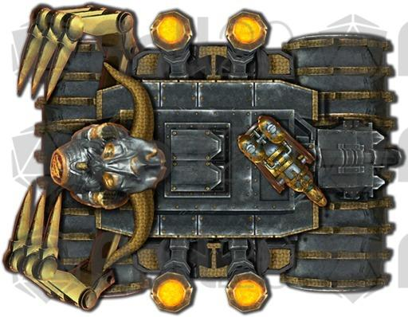

“That it does, but I’m not seeing anything Infernal about it,” Atlas continued, now casting *chasing perfection* on Devrion.

*Devrion gained +4 to all primary abilities.*

“What about that horned skull on the hood?”

“I’ll let you know my analysis once we’ve dealt with this,” Atlas braced for impact with the chugging, ramping engine that would soon release the orange fire now stoking in its central chamber. “But this is not hellfire coming at us... it’s something else.”

“Oh, good,” Devrion said as he lifted straight up 50’ and moved 30’ to his left to await the construct.

Brene also flew up to a mirroring position across from Devrion.

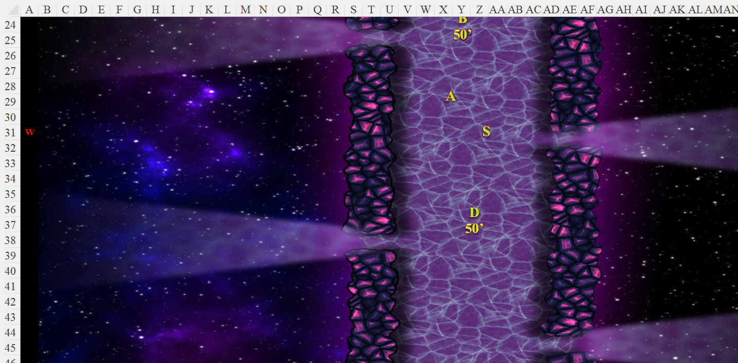

Round 17

The engine was about 400’ away now, and still unveering.

Atlas cast *freedom of movement* on Angren as they both lifted straight up.

*Angren gained freedom of movement properties.*

The warmage pointed at the machine. “Meteorraj!” *[meteor swarm]*

|  |  |  |  |  |  |  |
| --- | --- | --- | --- | --- | --- | --- |
| **Ranged Weapon** | **Dmg.** | **D+** | **TH+** | **Atk** | **Roll** | **Check** |
| Ranged Touch Attack | 2d6 | +4 | 1 | 17 | 5 | 22 |
| Ranged Touch Attack | Bludgeon | +4 | 1 | 17 | 12 | 29 |
| Ranged Touch Attack | +6d6 | +4 | 1 | 17 | 3 | 20 |
| Ranged Touch Attack | Fire | +4 | 1 | 17 | 15 | 32 |

*Hit, hit, hit, hit. Charge forfeits Reflex saves for ½ damage.*

*Dmg: (4 + 18 Fire) + (9 +18 Fire) + (8 + 16 Fire) + (6 + 22 Fire) = 27 + 64 Fire = 91.*

Atlas then identified the construct as an Abyssalflame engine, the chaotic and much faster equivalent of the Hellfire engine, and began to passively *[Swift action, involuntary, with -10 penalty]* recall Dark Knowledge previously exploited on the Hellfire engine they’d once encountered.

|  |  |  |  |  |  |  |  |
| --- | --- | --- | --- | --- | --- | --- | --- |
| **Atlas: DK Foe** | **Rank** | **Ability & Mod.** | **Misc. Mods.** | **Total** | **Roll** | **Check** | **Notes** |
| **Knowledge: Arcana** | 18 | **Int (+8)** | 2 – 10 | 18 | 13 | 31 | Trivial Knowledge |
| **Knowledge: Arcana** | 18 | **Int (+8)** | 2 – 10 | 18 | 18 | 36 | Trivial Knowledge, **best of 2 rolls** |

*Party gained +3d4 weapon damage to the Abyssalflame engine.*

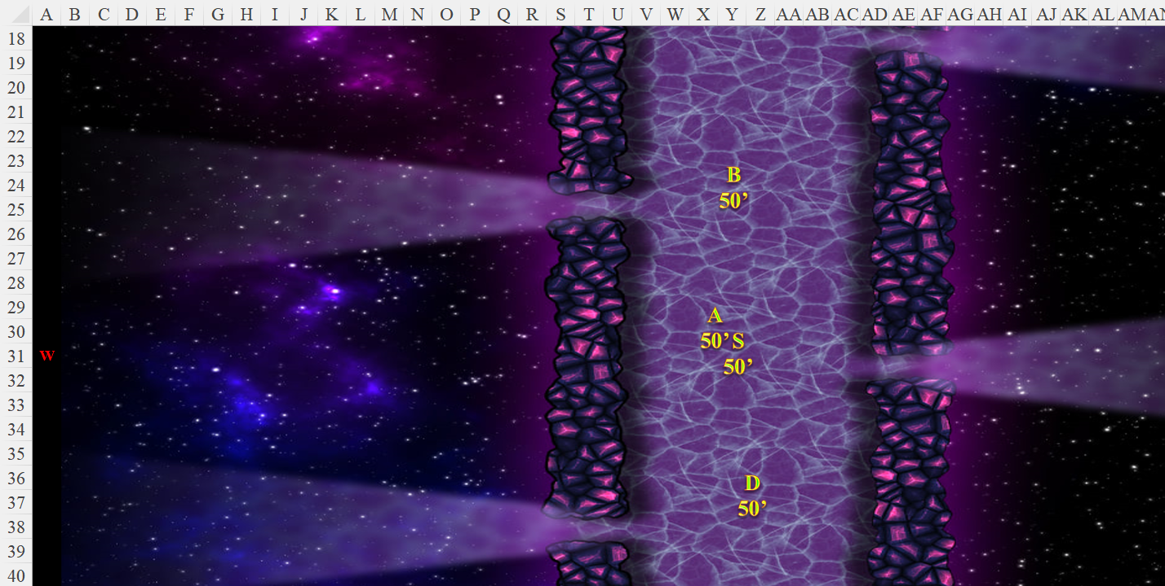

Round 18

Having adjusted its trajectory slightly upward, the engine got within 40’ of the floating targets, and released its conic breath weapon upon them, headed straight for Steelshade.

|  |  |  |  |
| --- | --- | --- | --- |
| **Character** | **Attack Type** | **Damage** | **BAB** |
| Abyssalflame Engine | Breath | 20d10 Reflex DC 32 ½ | 60’ cone |

*Base damage to all within cone: 102 (51 Fire + 51 Chaotic).*

|  |  |  |  |  |  |  |
| --- | --- | --- | --- | --- | --- | --- |
| **Save vs.**  Breath Weapon | **Rank** | **Ability & Mod.** | **Misc. Mods.** | **Total** | **Roll** | **Check** |
| **Atlas, Reflex** | **6** | **Dex (+7)** | 13 | 26 | 18 | 44 |
| **Angren, Reflex** | **6** | **Dex (+5)** | 3 | 14 | 19 | 33 |

*Success, success. Both save for ½ damage. Chaotic damage negated.*

*Dmg to Atlas: ½ x 51 Fire = 25 Fire. Damage negated.*

*Dmg to Steelshade: ½ x 51 Fire = 25 Fire. Damage negated.*

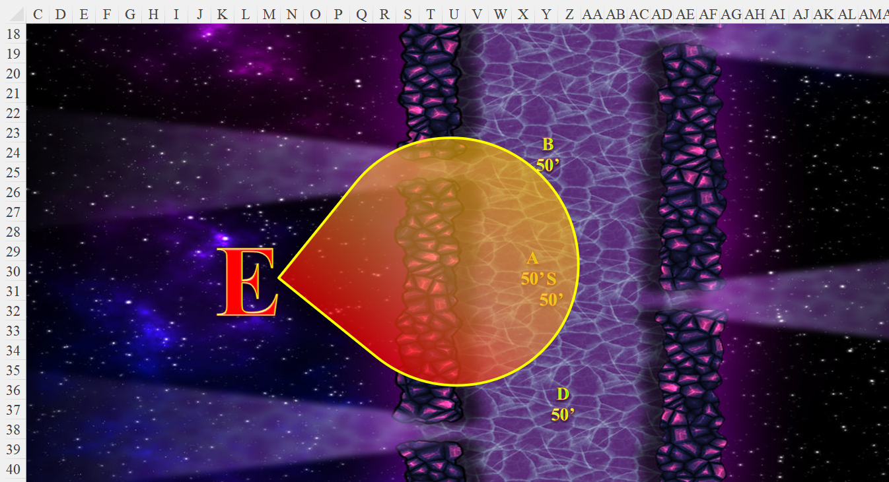

The locomotive then crashed into Steelshade and Atlas.

|  |  |  |  |  |  |  |  |  |  |
| --- | --- | --- | --- | --- | --- | --- | --- | --- | --- |
| **Character** | **Attack Type** | **Damage** | **BAB** | **Str Mod+** | **Other+** | **Total Score** | **Roll** | **Total** | **Targeting** |
| Abyssalflame Engine | Slam 2 (Atlas) | 2d6+21+6d6 Abyssalburn | 33 | -3 | +4 charge | 34 | 15 | 49 | Power Attacking +11 |
| Abyssalflame Engine | Slam (Steelshade) | 2d6+21+6d6 Abyssalburn | 33 | -3 | +4 charge | 34 | 18 | 52 | Power Attacking +11 |

*Hit, hit. 1d100 = 96, 100. Concealment bypassed both times.*

*Dmg to Atlas: 7 + 21 + 17 Abyssalburn = 28 + 8 Fire + 9 Chaos = 45 [77/105]. Fire and Chaotic damage negated.*

*Dmg to Steelshade: 9 + 21 + 16 Abyssalburn = 30 + 8 Fire + 8 Chaos = 46 [172/198]. Fire and Chaotic damage negated.*

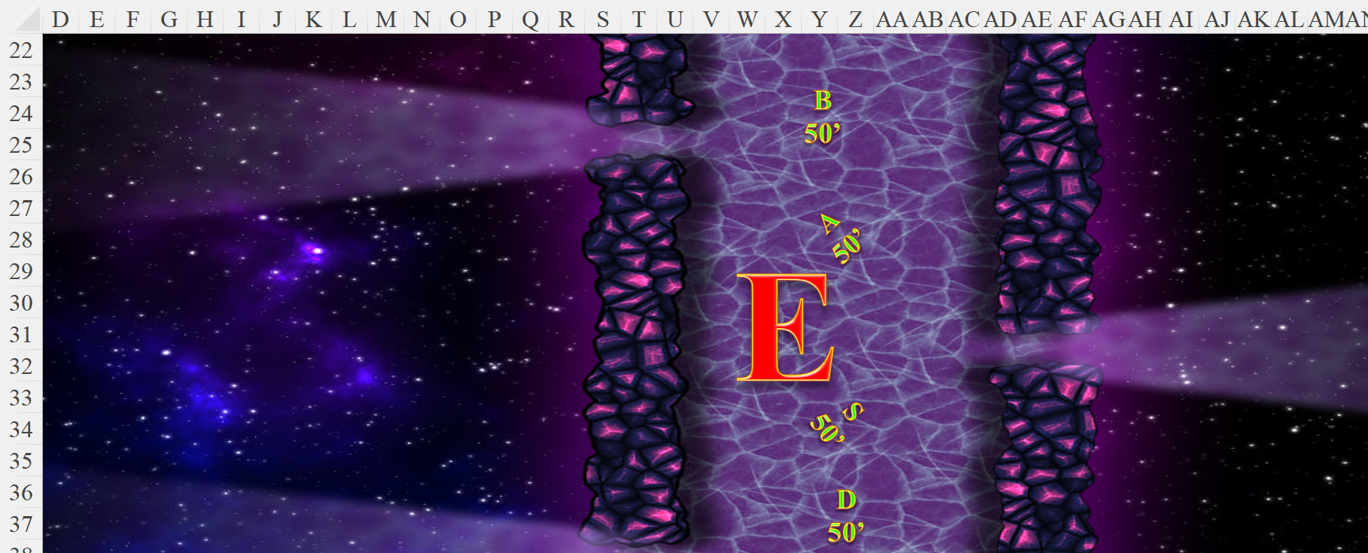

Brene flew to a point above and behind the automation, where she could avoid its claws and take potshots at vulnerable areas. She fired on the machine as she moved.

|  |  |  |  |  |  |  |  |  |  |  |
| --- | --- | --- | --- | --- | --- | --- | --- | --- | --- | --- |
| **Ranged Weapon** | **Dmg.** | **D+** | **TH+** | **Critical** | **Rng.** | **Wt.** | **Atk** | **Roll** | **Check** | **Properties** |
| Rapid Shortbow +2 | 1d4 | 2 | 2 | x3 | 60’ x 2 | 2.0 | +29 | 18 | 47 | Sneak Attack 10d6 |

*Hit. Dmg: 4 + 36 = 40. Partial damage negated.*

Devrion lifted up higher and pointed at the machine. “Erőszféra!” He didn’t risk an area effect spell so as to avoid hitting his friends.

|  |  |  |  |  |  |  |  |
| --- | --- | --- | --- | --- | --- | --- | --- |
| **Ranged Weapon** | **Dmg.** | **D+** | **TH+** | **Atk** | **Roll** | **Check** | **Notes** |
| Ranged Touch Attack | 10d6 | +4 | 1 | 17 | 4 | 21 | Weapon Focus Included |

*Hit. Dmg: 34 +3 WE = 37 force.*

Atlas murmured a prayer and then pointed at the machine *[greater dispel magic]*.

*No apparent effect.*

Steelshade lifted up to reach the machine’s flank, channeled *disintegrate [+1 DC]* through her blade, and empowered her strikes (+4).

|  |  |  |  |  |  |  |  |  |  |  |  |
| --- | --- | --- | --- | --- | --- | --- | --- | --- | --- | --- | --- |
| **Melee Weapon** | **Dmg** | **D+** | **TH+** | **Crit** | **x** | **Type** | **Wt.** | **Atk** | **Roll** | **Check** | **Properties** |
| Shattermantle Bloodstone Falchion +5 | 2d4 | +9 +5+ 4d4 | 7 + 4 | 18 | 2 | Slashing | 8.0 | +40 | 3 | 43 |  |
| SB Falchion +5, 2nd Attack | 2d4 | +9 +5+ 4d4 | 7 + 4 | 18 | 2 | Slashing | - | +35 | 7 | 42 |  |
| SB Falchion +5, 3rd Attack | 2d4 | +9 +5+ 4d4 | 7 + 4 | 18 | 2 | Slashing | - | +30 | 2 | 32 |  |
| SB Falchion +5, 4th Attack | 2d4 | +9 +5+ 4d4 | 7 + 4 | 18 | 2 | Slashing | - | +25 | 13 | 38 |  |
| Greater Crystal of Arcane Steel | +1 to touch spells | 1 | +1 | - | - | - | - | - | - | - | +1 to spell DC |

*Hit, hit, hit, hit. Dmg: (6 + 9 + 5 + 10 AC) + (7 + 9 + 5 + 9 AC) + (6 + 9 + 5 + 9 AC) + (3 + 9 + 5 + 8 AC) = 30 + 30 + 29 + 25 = 114 + disintegrate. Partial damage negated.*

|  |  |  |  |  |
| --- | --- | --- | --- | --- |
| **Character** | **Save vs.**  *Disintegrate* | **Ranks** | **Roll** | **Check** |
| Abyssalflame Engine | Fortitude | 14 | 1 | 15 |

*Fail. Dmg: 115.*

And just like that, the hellfire engine partly disintegrated, partly exploded, and partly dissolved and evaporated into an ether that migrated towards Steelshade’s already adjacent body, and coated her in chaosflame. Though it was not harmful, her *dragonskin* spell seemed to shift to *stoneskin*, but was actually now taking on the atomic properties of an adamantine-based alloy.

Round 19

“If this had been a hellfire engine,” Atlas speculated, “I would have just pegged you as a recipient of the *investiture of the hellfire engine* spell. Given that this is a chaosflame variant, I’ll guess you’re about to gain some fire-based powers for the next few minutes.”

“Great. Anything else to destroy?” Steelshade looked around, but saw nothing and no one other than the causeway below them.