*Chapter 16: The Other Eidolons*

Then, as if they’d wished for it, a single bolt of lightning struck across the violet sky, and ripped open a planar membrane that manifested solid ground all around them, as well as the ruins of a what Atlas and Devrion identified as Untherian stonework. Steelshade had a hunch, but Devrion now remarked on the millennia-old basic and caryatid stonework, and confirmed her suspicions.

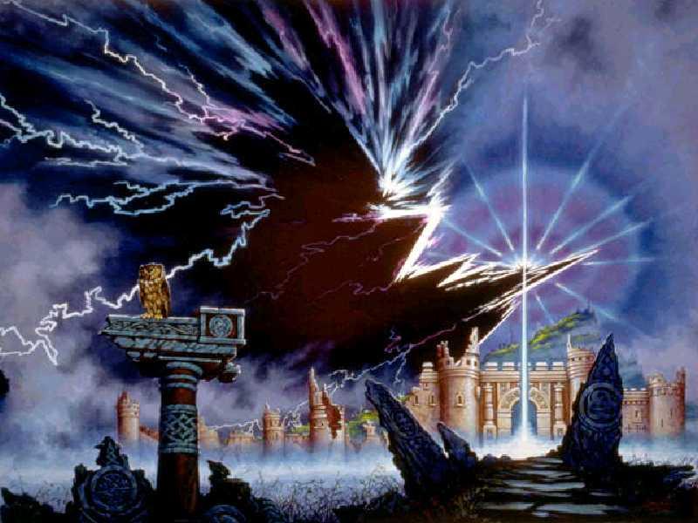

Round 20

“Did we travel back in time?” asked the duskblade.

“No, the erosion of centuries is evident,” Atlas assured her. “I fear we’re being whisked from one plane to the next, but consistently within the same timestream.”

An owl was spotted perching atop a dilapidated column, and within moments, they noted the chilly bite in the air. It looked like night was about to fall on this flat plain. Still able to fly, Brene hovered so that her head was level with the others as they took in their surroundings.

Round 21

“Anything coming our way?” asked Brene, seeing nothing.

Devrion pressed one foot to the ground, feeling no rumbles of bluespawn burrowers approaching from below, “Nope.”

|  |  |  |  |  |  |  |  |
| --- | --- | --- | --- | --- | --- | --- | --- |
| **Character** | **Melee** | **Ranged** | **Total Damage** | **Temp** | **Healing** | **HPs** | **Current HPs** |
| **AtlasPfE** | 133 | 11 | 144 | 21 | 95 | 105 | 77 |
| **Brene** | 147 | 13 | 160 | 21 | 139 | 119 | 119 |
| **Devrion** | 24 | 8 | 32 | 21 | 11 | 105 | 105 |
| **Steelshade** | 30 | 17 | 47 | 21 |  | 198 | 172 |
| **Elaith** | 263 |  | 263 | 21 |  | 162 | **-80** |

The group took a moment to heal the damage to Atlas and Angren, spreading the uses among their wands.

*Round 22*

*Atlas tapped himself with his wand of cure moderate wounds.*

*Atlas gained 12 + 4 = 16 hps [93/105].*

*Brene tapped Steelshade with her wand of cure serious wounds.*

*Steelshade gained 12 + 6 = 18 hps [190/198].*

*Devrion tapped Atlas with his wand of cure moderate wounds.*

*Atlas gained 11 + 4 = 15 hps [105/105].*

*Round 23*

*Atlas tapped Steelshade with his wand of cure moderate wounds.*

*Steelshade gained 6 + 4 = 10 hps [198/198].*

“Elaith is gone for good, I guess,” Brene said as she looked around for the redhead’s remains. “We shouldn’t have let her come.”

“She made her own choice,” Angren replied quietly, thinking she heard something behind her, and turning. “She knew that it would be dangerous.”

“We should go,” Atlas said diplomatically, pointing toward the ruined structure. “Whatever it is we are to find, it’s probably there.”

The foursome moved toward the structure, with Brene leading, Angren behind her, and the men behind her in turn.

Steelshade kept an eye out behind her, and Brene backed her up. “Sensing something?” the wee one asked.

“Keep your eyes peeled,” Steelshade said, her saber already drawn.

~*~

They approached the keep, and Devrion noted the owl they’d spotted earlier now flying overhead. Night appeared to be looming on the eastern horizon, while a gradient from amber through pink to violet characterized the rest of the sky. A few clouds dotted and puffed said sky, but for the most part, it had been a sunny day here, though not a warm one.

And so, they made it to the closed gates of the ruined keep whose outer wall had been breached at so many points, that it would likely be easier to just meander around the rubble through one of the breaches.

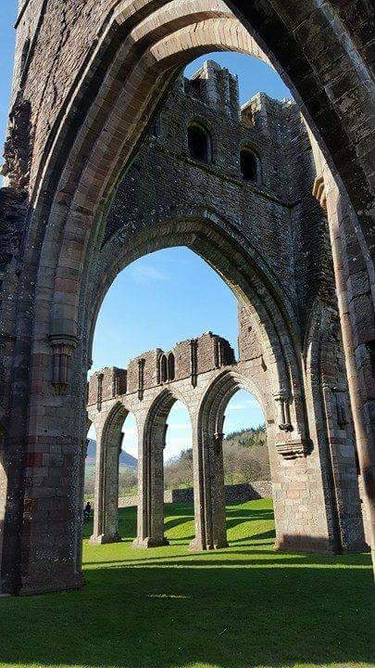

Though the grass was dead now in the harshness of winter, Devrion’s imagination allowed him to envision the landscape in the spring when this entire area would be transformed into a verdant scape. But today was the emissary of Deepwinter.

Nothing stirred within the courtyard, which boasted a spring of water that emerged from the pores of the earth and swelled into a pond with a small dock where a rowboat floated. The pond fed a series of streams that formed a natural moat within the central structure within the walls.

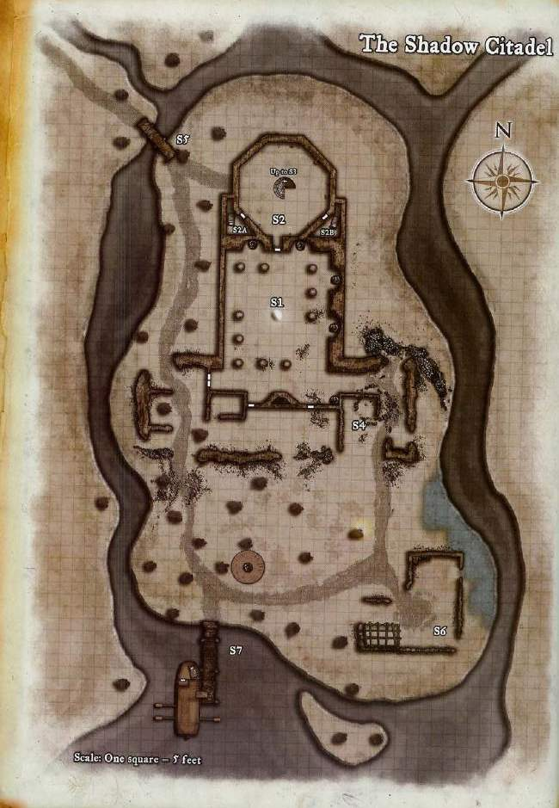

Brene eyed the keep with scant favor, and then she turned to the others. “I’ve been taught that the best way to enter a building is from the roof.” She pointed at the top of the keep’s tower. “We should go up there and work our way down.”

Angen looked at the men, who nodded in agreement. “Let’s go.”

The foursome flew up to the tower’s top, and looked for a place to set down, but found that all of the towers—all of the keep, in fact—lacked any kind of solid roof.

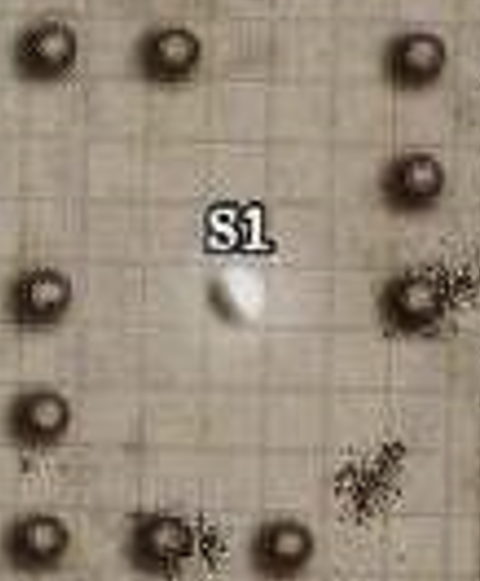

“Oh, well,” Brene sighed, “this should be simple enough.” Then she and the others noted a slightly iridescent chrome sphere floating in the middle of what had probably been the main reception hall.

“Just a moment,” Atlas said as he looked over the sphere, thinking about anything similar he may have seen. From this distance, his eyes could not give him enough information to trigger his knowledge, but if he had to guess, based on their circumstances, it was either a sphere of annihilation or a portal. He’d seen both that looked like this from afar.

When he voiced his opinion, Angren glanced at him and snickered. “What? Oh, it will either destroy us, or take us somewhere else, but I can’t tell, which,” she said with a laugh. “That’s helpful.”

Devrion sighed and shook his head.

“You two leave him be,” Brene snapped. She looked at Atlas, who smirked at Angren when his lover came to his defense. “Give me your rope.” Atlas complied, and Brene held one end and tossed the coil into the sphere. When it landed, she began reeling it in.

“Yeah, it’s a portal, alright,” Atlas now confidently concluded as the coil returned to this plane intact.

Brene and Atlas rolled up the rope again as they considered their next steps.

“This is the same keep, but on a different plane,” Angren asked as she looked around from her vantage point above the structure.

“Well, not exactly,” Atlas had to clarify. “The portal is that 5’ x 5’ ball that I thought might’ve been a *sphere of annihilation*. The rest of the ruin...” he squinted. “It looks like it’s made of shadowstuff, but we’re definitely *not* in the Shadow Plane.”

Angren frowned, “Queer. The ground looks shadowy too.”

Devrion smiled, theorizing, “I wouldn’t be surprised if someone brought in the entire architecture—maybe block by block—in from the Shadow Plane.”

Atlas said nothing, but could not debunk the posed scenario outright, and noted the rough and irregular outline of the shadowy ground and the more mundane-looking packed earth along the periphery of the keep and outside it.

As they talked, they all spotted movement at different places within the circular confines of these ruins. It took a few moments, but the figures appeared to be constituted of some kind of ghostly matter that rose out of the ground like spirits emerging from their slain corpses.

“Here we go!” Devrion was excited to kick some ass in such a picturesque and exotic location. “I hope that beholder’s watching.”

Round 50

“Wait,” Atlas stayed the warmage’s hand, “they don’t appear outwardly hostile.”

By now, a dozen or so of the humanoid figures were standing at seemingly random places below them, and another dozen were still rising from the ground, all staring up at the newcomers.

Angren pulled out their carpet and deployed it next to her. Everyone climbed aboard, and she brought it down to within 6’ of the ground 20’ from the floating orb.

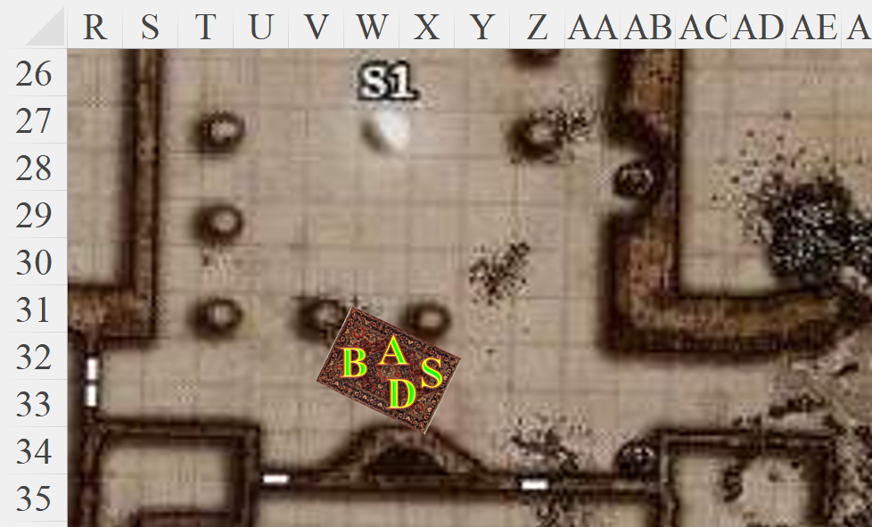

Several of the apparitions drew their weapons in defensive manners, but one of the forms raised a robed limb and stayed their mobilization.

“We are not here to fight,” Atlas announced. “We are looking for a drow named Lauren Fifthdaughter.”

|  |  |  |  |  |  |  |
| --- | --- | --- | --- | --- | --- | --- |
| **Skill** | **Rank** | **Ability & Mod.** | **Misc. Mods.** | **Total** | **Roll** | **Check** |
| **Steelshade, Diplomacy** | 7 | **Cha (+4)** | 2 | 13 | 5ish | ?? |

*See below.*

The apparitions were now all standing erect over the spots where they’d likely died in battle against adversaries who had not risen, or perhaps had never fallen. Their faces were less fuzzy now, and Atlas identified these as eidolons, or ghosts of the living that had not gravitated towards the destinal plane. He squinted at the peculiar coincidence that they had just battled a completely different form of creature also called an eidolon, and thought about how to best phrase this to his friends to not confuse them. “Best to use the term ‘ghost’ for the moment,” he thought.

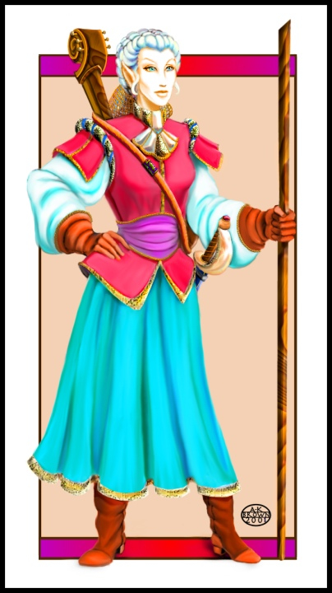

One of the eidolons approached, bearing the guise of the woman’s body that had housed her in life. She wore the clothing of a traveler, and hoisted on her back a lute-like instrument that none of the living could name. They could faintly see the traces of color on her otherwise white, semi-transparent form, and as she got closer, she spoke. “We greet you with no malice, but know nothing of your drow friend.”

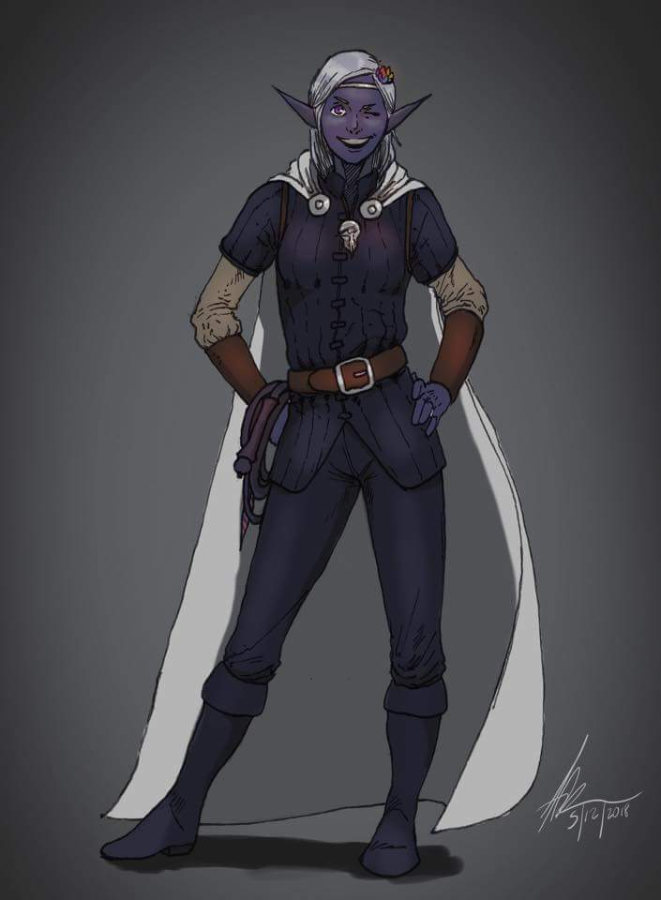

By then, another soul separated from its corporeal housing long expired had been approaching from the periphery of the unliving audience. Another woman displayed her body’s form in life as that of a young drow, and asked, “Fifthdaugher of whom?”

Most of the heroes knew not, but Steelshade had that trivial tidbit committed to memory. “Her father was human; her mother, drow. I believe his name was Seamus, but consistent with the drow’s matrilineal traditions, she bore her mother’s family name—Grîxot—until taking her bride’s name: Maltholas.”

There was some murmuring as ghosts made sense of the moment, having risen with no seemingly set purpose but to guard the transplanar soil on which they perished.

The elven woman with the string instrument slung over her back floated over, her feet only inches from the ground, and introduced herself as the rest of the eidolons came closer but stayed back enough to not crowd the newcomers. Some seemed curious; others, a bit wary; and yet others appeared haggard and longing to return to their peaceful rest.

Brene looked around with a bit of apprehension, scanning the ghostly assembly for any familiar faces. Devrion and Steelshade let Atlas do the talking.

Atlas continued. “Where does this portal lead?” He pointed to the sphere.

“There is another world, like this one, but it is a drop in the Shadow Plane,” the unliving bard answered, adding, “Our souls cannot travel there, but your bodies can.”

“A drop?” asked Atlas.

“A pocket plane,” explained another ghost whose vocabulary was a bit more technical. “It is coated in shadowstuff, but its core is of this plane, while the ground where you stand now was originally in that plane.”

“How did this happen?” asked Brene.

“We know not.”

“All that is known is that successive incursions of beholders, aboleths, and other beings of unfathomable age and power brought their conflicts here, and our living bodies fell in defense of what was our stronghold. We were less than pawns in their game.”

“We were ants on the hill they’d chosen to flatten,” another ghost said.

“We were crushed, and lie here forevermore to contemplate our twisted fates.”

“We had less than a moment to even mobilize against them.”

“Those moments are behind us now.”

“Let us return to the shadows of this fortress.”

One by one, the eidolons began to slowly succumb to a drawing downward as their lethargy returned. A few would remain, but most crouched and reclined into the shadowy soil that felt no different than regular soil.

“May we explore this fortress?” Brene asked.

“Treat it like your own temple,” said one of the voices as the ghosts took their respective leaves. Some stayed floating about, while the majority returned to their slumber.

Brene guided the carpet around the ruins while the others looked for anything interesting.

“Don’t touch anything,” Atlas warned.

“I wouldn’t dream of it,” Brene replied with a sniff.

The other three looked at each other with a chorus of snorts.

“What?” The halfling tried and failed to look indignant, drawing a round of soft laughter. “Screw you guys.”

There was nothing to scavenge on the long-ago scoured ruin. Perhaps an excavator might find something of archaeological value under the soil, but if it emitted a magical aura, it was likely already confiscated, such as whatever treasure lay in what looked like a 5’ wide crater of shadowstuff, but was actually a dug-out hole that had partly eroded with seasons of rainfall.

They first heard it, then turned towards the sound of the beholder falling like a meteor from the sky, having just been hurled by another being about 1000’ above them. They braced for an attack, but the beholder that had been their host now crashed and made an actual crater about 20’ wide as it kicked up the better part of a ton of debris into the air.

Brene moved the carpet away from the impact point, while Steelshade covered herself and Brene with her shield. “Come here!”

Atlas and Devrion huddled close to them, too.

The duskblade swift cast *Bigby’s clenched fist [expired in 2 minutes]*, and had the manifestation open its hand and cover the four of them like a shield. The debris did indeed bounce right off the hand of force, and once the blast had resolved and there was only dust to deal with from above, the hand reverted to its default fist.

“I thought beholders could fly,” Brene noted as she looked upward.

“From the way it hit the ground, I think that little feller hurled him beyond terminal velocity,” Atlas was pretty sure. “I wouldn’t be surprised if what we saw coming at us was an already dead beholder.”

Atlas peered up at the distant figure, while Brene and Steelshade drew their weapons.

“Should we check dental records to identify the deceased?” Devrion wasn’t serious.

The breeze swept away the dust from the crater and revealed a pancake-shaped form with a handful of eyestalks trying to crawl away from their crushed host.

It was impossible to tell if the figure 1000’ above them was casting a spell, quaffing a potion, or doing something else, but the situation called for caution. They _____ *[another round of PC actions]*.

The being seemed to be studying them, then released a package of sorts, which fell slowly with a *feather fall* spell towards the island where the portal was.

The bundle was maybe 950’ above the ground as the party flew at 20’ altitude atop the carpet, and _____ *[another round of PC actions]*.

“At least this one’s coming down gently,” Brene mused.

“What do you think *this* is?” Steelshade asked their attorney and advisor.

Atlas held back a giggle, “A devastating warhead?”

And as the package *feather fell* towards the heroes, the halfling-sized figure that had splattered the beholder against the surface of this ground manifested a bronze-hued portal, and disappeared.

“Did you see that?” Devrion asked, almost excitedly.

“Looked like Aasterinian’s signature glimmer,” Atlas agreed, “but remain wary of what’s coming at us.”

“Should we bail maybe?” Brene asked. “I can guide the carpet.”

“Take us away from here,” Steelshade said to Brene.

“I agree.” Brene piloted the carpet as far as she could away from the package’s estimated impact point.

They headed towards the setting sun for about a minute, and when they knew that the falling object had had enough time to drop, slowed down a bit, turned around, and saw no mushroom cloud or other catastrophe coming at them.

Brene turned the carpet around and headed back while everyone else kept watch.

Within 20 seconds, they could hear a child crying, and after a few more seconds, they could see a humanoid baby wrapped up in a bundle near the portal.

Steelshade touched her Scout’s Headband, activating the true seeing function. “I’ll see about the baby, the rest of you keep searching.” She flew off the carpet and approached the bundle, her sword and shield at the ready.

Meanwhile, Brene piloted the carpet in a wide circle around the bundle’s resting place.

“It’s a kiddo!” Brene felt a tinge of compassion for the being wrapped inside the bronze-leaf bundle as Steelshade discerned no illusions about.

The half-drow walked up to the child and examined it and its bronze-leafed bunting without touching anything. The child was not wearing the hood that hung from the back of the sleeveless onesie surely sewn by aasimar hands, and the rounded ears and other facial proportions bespoke of a human lineage, though Steelshade could also discern a slight draconic ancestry, noting miniscule bronze scales under the fine hairs of her eyebrows.

Steelshade dropped to one knee and leaned down to look at the child. “Hello, little one. Who might you be?” She studied the child’s features to determine if she looked somehow familiar.

Due to the cross-race effect, she pretty much defined it as a human who looked like most fair-haired humans: a relatively petite mouth; rounded, hazel eyes; undulating hair about an inch long at the crown of the head; and a layer of lanugo along her shoulders. Oh! And more scales along her neck, Steelshade now noticed.

The half-dragon duskblade pondered on their circumstances, wondering who that figure might have been who presumably slew the beholder and bestowed upon them this infant half-dragon, if that is what it was.

Steelshade put up her sword, leaned down, and scooped up the child in her arms. “I don’t know who you are, but you probably won’t last long without care.”

Meanwhile, the other three were watching for anyone who might be approaching them. No one was; the coast was clear, but a single eidolon stared with interest before receding back into the shadowstuff at its feet.

The child cooed and seemed to smile at Steelshade.

Brene piloted the carpet back to Steelshade. “Congratulations, when is the wedding?”

Steelshade grinned. “At least I didn’t ruin my figure with the baby.”

The halfling peered at the child. “She looks much better not having that elf for a father.”

Atlas chuckled, while Devrion just rolled his eyes.

The duskblade stepped onto the carpet. “Atlas, what do you think of her?”

Atlas examined her closely from the carpet... musing, “Most military historians and theologians would agree that she’s cute, but...” he scratched his head, figuratively, trying to surmise the validity of a benign dropping of a child off for them to ponder after slaying a beholder. “I don’t know what... what do make of it.”

Steelshade got back on the carpet with the child in her arms.

“We can’t go into another fight while we have the baby with us,” Brene pointed out. “And, she will need food and a clean nappy soon, too.”

Atlas and Devrion looked at Brene. “Don’t look at us,” Devrion said. “I’ve had nothing to do with babies—ever.”

“Me, either,” Atlas added hastily.

“Oh, gods,” Angren sighed. “Men.” She looked to Brene. “Let’s see if there’s another way out besides that portal.”

Brene lifted the carpet up to 200’ and circled the keep.

Steelshade turned to Atlas. “The portal?”

Atlas nodded. “The portal.”

“On my way,” Brene said. She set the carpet down near the portal, whereupon Steelshade rolled it and put it away. Atlas took the baby, and Steelshade drew her falchion. “Okay, we go together.”

Brene and Devrion touched Steelshade’s shoulders, and Atlas put one hand on her back. Together, they stepped through the portal.

~*~

They found themselves under a tree, and within seconds realized that said tree was a sprout growing from the truncated trunk of an ancient, giant variant of a sequoia.

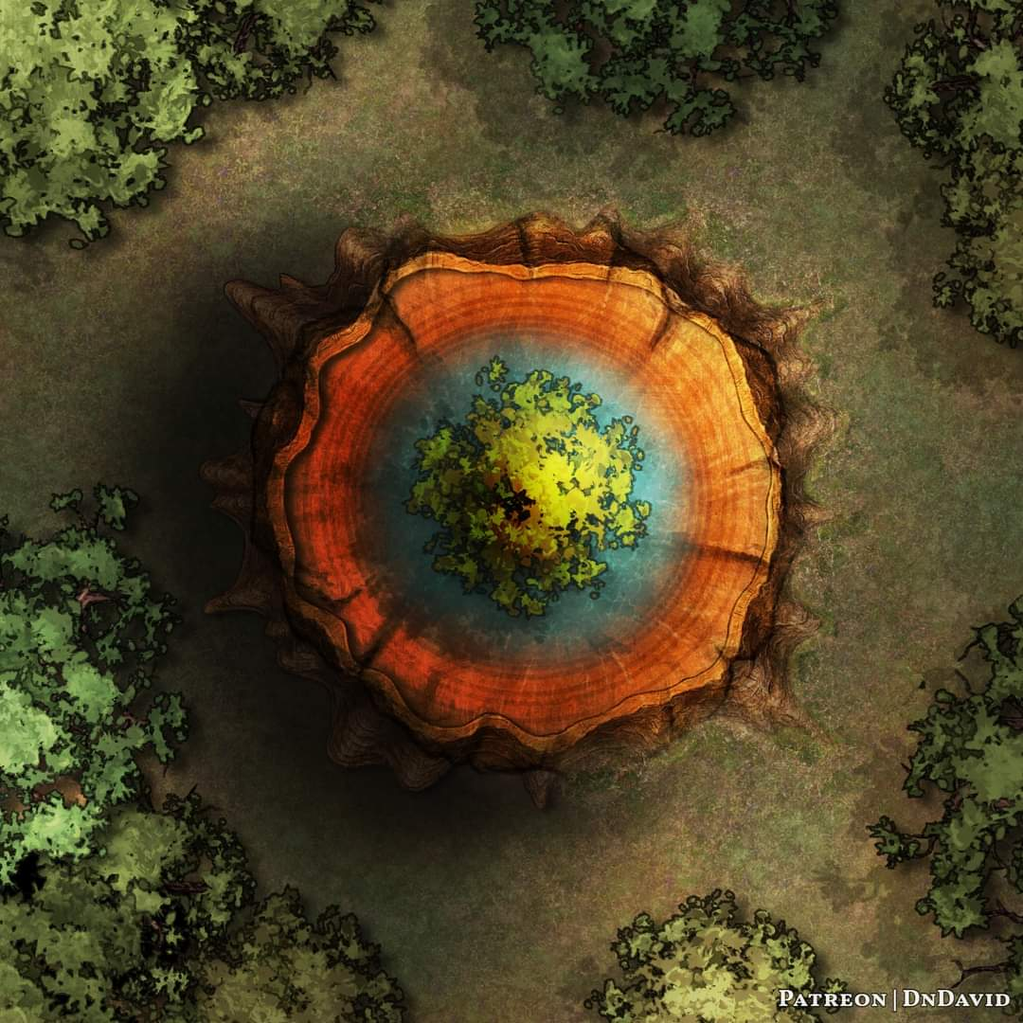

A portal was affixed to the flat-topped trunk, just feet away from the center, where the rings gave rise to the second attempt at life that now covered them from the warm sun above them.

There was no shadowstuff in sight.

All around them were trees of varying heights and widths, and the birds among them that chirped, cooed, and cawed.

That sense of senselessness that characterized the ruined citadel was absent here. All here seemed to be quite in harmony, except the chopped-down tree that for the last few years had done its best to rage against the dying of the light.

Devrion—a jungle elf with an eye for a thing like this—noted the recurring pattern on the leaves of the determined tree above and below them. Though they were minutely variated, like snowflakes, each leaf had an embroidery-patterned edge. Devrion noted the same trend across the few dead leaves on the ground as well, and mentioned it.

The child cooed as sunlight reflected off of her amber irises.

The foursome looked around them.

“Any idea where we are?” Steelshade asked Atlas.

The archivist studied the landscape to determine where they might be. “Arrr... borea?” he guessed, but needed more information to confirm or refute this.

Steelshade handed the child to Devrion, who took it with a wide-eyed expression. She took out the carpet and spread it so they could all climb aboard. “Brene, let’s get above the trees and look around.

The halfling nodded and took control of the carpet, shooting a grin at Devrion as she did.

They went up and cleared the tree line, seeing above the conifers and other phyla of plant a cloudless, boundless sky.

“We are definitely in Arborea, and...” he produced the folio that Rook had given him before they’d walked over to the beholder’s house, and thumbed through the leaves. “... if I’m not mistaken, that tree stump is the same individual that had housed what Rook’s people had termed the Oakleaf Suite.” He showed the illustration to the others.

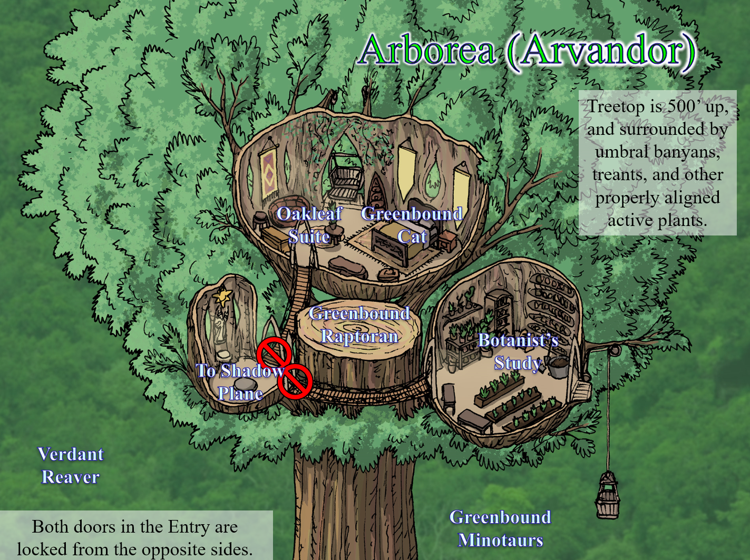

Devrion looked down at the stump to imagine that treetop as it would have been, and it would surely have towered over the surrounding vegetation.

The topography seemed flat towards the horizon in every direction, making it nearly impossible to distinguish one part of the expansive forest from the other.

“What a shameful act: to cut down such a beautiful living thing!” Devrion held back a tear.

~*~