*Chapter 17: The Ssvaklor’s Lair*

Elsewhere in the universe...

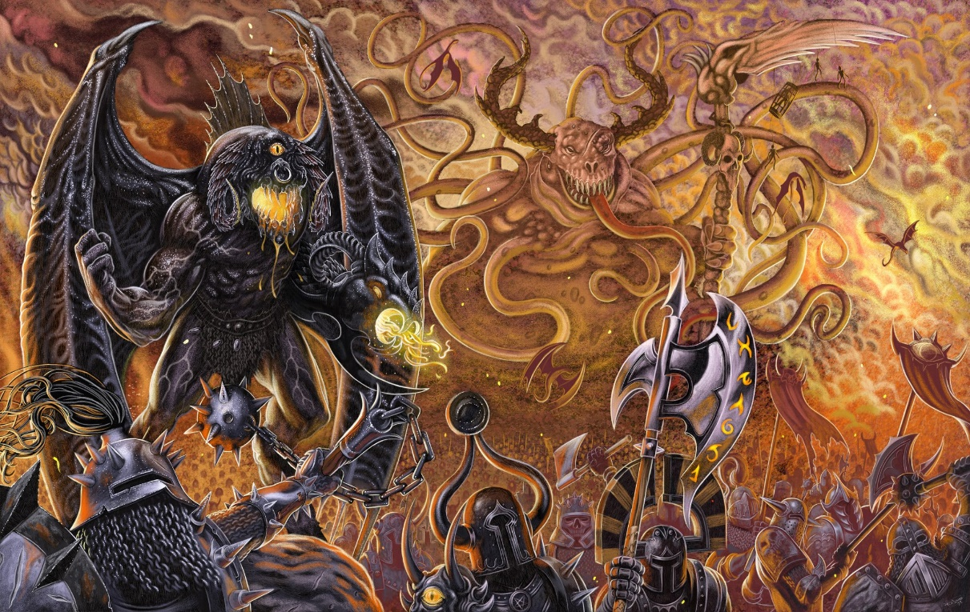

Hordes from the Abyss took advantage of a breach in the fabric between planes, and through a conduit that linked their plane through the Astral and into the Material Plane, they entered a battlefield where two battalions were already in the midst of strife.

<< Cut them downnnn! >> one indescribable demon seemed to command, though there was no coherent command structure among the fiends as they decimated the already weary humanoid troops.

~*~

Steelshade dispassionately considered the area. “How did they get here?”

“Who?” asked one of her comrades.

The archivist looked up. “Lauren, her wife Allisa, along with some others, visited here some years ago. These are notes Rook made about their visit. I’m reading back to see where the portal they used is located.” The archivist Atlas flipped to the front of the folio, and showed the others. “Years ago, the configuration looked like this, but we have no reason to assume continuity with this schematic. The portal to Arborea is—after all—nowhere near the Shadow Suite, but in the middle of a ruined citadel.

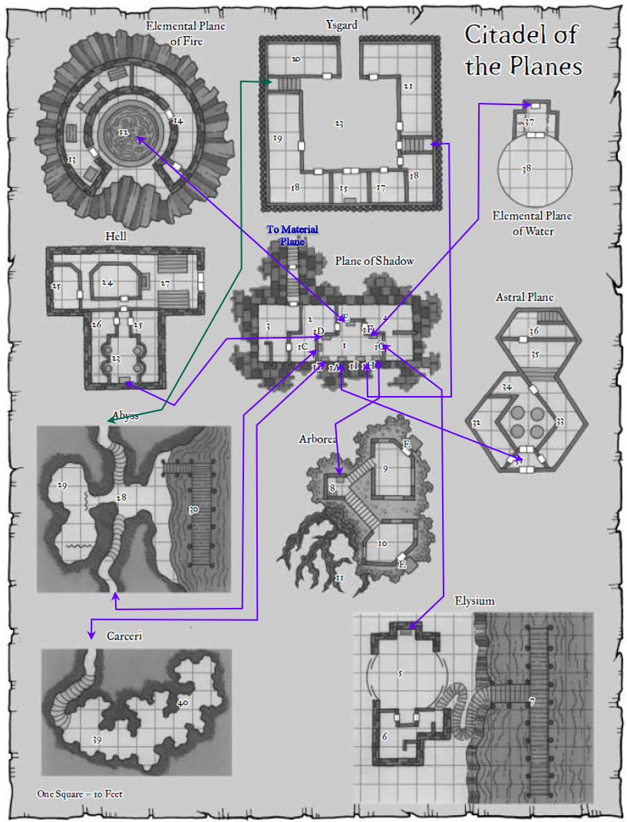

Brene frowned as she leaned over the child and peered at the map. “Okay, so we have to go back, right? There isn’t another portal here, according to the map.”

“I don’t know,” Atlas replied. He studied the map and the other papers, looking for any clues about what they should do next. “And as I said, we shouldn’t rely on this schematic. It’s likely to be completely misleading. It should give us a sense of what was available to a resident of this Citadel of the Planes, but with a beholder in charge, things are likely to change... as we can see with that tree that once towered over all else around it.”

“Can you tell where the original portal to this place came out?” Steelshade asked.

“There’s no reason to assume that there’s a second portal here, but if there is, I don’t really have a method for finding it,” Atlas sighed.

“Didn’t one of you have a *locate portal* spell at one point?”

“Find portal?” someone else knew it by a different name.

“It’s been years since I’ve prepared it,” Atlas couldn’t recall the time he’d last needed it, and now was blanking on which name was correct.

“There’s one called *discern location*. Would that be helpful?”

“Maybe we should try to get back to the Material Plane, find us a proper diviner, and come back with better prospects for intel.”

“How do we get back? We apparently can’t cast *teleport* spells with more beef than a *dimension hop*.”

“I should try *dimension door* just to see if that works,” Steelshade mused.

“Don’t waste your mojo at a time like this.”

“I should have done this sooner,” Atlas said with a sigh. It will take me a few minutes to cast the spell, though.” With that, he sat down on the carpet and began to pray quietly, calling on Aasterinian as he slipped into a meditative state while he thought of Lauren and where she might we found.

*Prepare discern location to find Lauren.*

Atlas thought for a moment. “I have a spell that I think will find Lauren for us, but I will have to take the evening to prepare.”

“Do their notes mention a place to stay?” Brene asked.

“I think so. Let me see,” the archivist mused as he looked over their notes. “Well, in the original layout, every suite is a really comfortable spot in and of itself, even if it’s surrounded by the Hells, the Abyss, the Plane of Fire, or what have you.”

“I should have done this sooner,” Atlas said with a sigh. It will take me a few minutes on the morrow to cast the spell, and I will have to pray for the spell tonight.”

“Do their notes mention a place to stay?” Brene asked.

“I think so. Let me see,” the archivist mused as he looked over their notes. “Well, in the original layout, every suite is a really comfortable spot in and of itself, even if it’s surrounded by the Hells, the Abyss, the Plane of Fire, or what have you.”

“So, where did they originally enter this plane?” Devrion asked. Then, he spoke again as an idea occurred to him. “Can we go back to Waterdeep tonight instead? The child will need food, and we have none for her.”

Atlas tried to determine if he could cast his greater plane shift spell, but as he had ascertained before, the planar properties here were too haphazard. At best, the spell might work like a normal plane shift spell; at worst, it would place them in an inhospitable corner of existence. Most likely, the effect would be rendered inert by the forces around them.

The archivist worked to find where Lauren had originally entered this plane. “I’ll start preparing the spell.”

“Spell prep’ll take hours,” Brene sighed, being the only one who didn’t cast spells.

“We’ll all be that much more prepared for what comes next,” the warmage got into a cross-legged asana, and began to gather the mental faculties needed for mana replenishment.

Steelshade nodded, and assumed a similar posture, drawing the energy around her into her being far enough from Devrion that she didn’t ruffle his own mojo.

Brene set about taking care of the baby, giving her some water and bits of bread soaked in water.

~*~

The first few minutes of spell preparation were uneventful, but just as the spellcasters were starting to get into the prep vibe, Brene and the baby turned to see a green dragon swooping down. “Dragon!” Brene cried out.

It was green only in color, bearing little resemblance to a proper green dragon, and the rogue assumed it was something native to Arborea as she roused the others with a verbal alarm, causing the baby to cry. As the others blinked back into full awareness of their surroundings, the dragon screeched, and Atlas identified the sound as that of a yuan-ti cry.

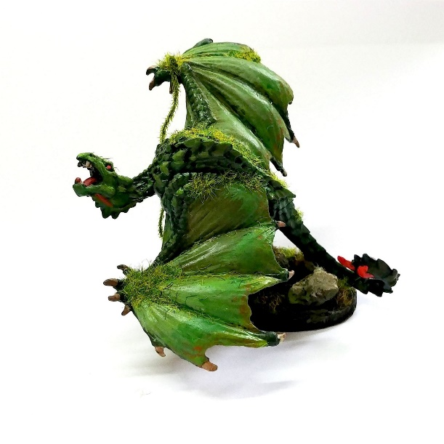

“This is a ssvaklor. Do not underestimate it due to its small size,” Atlas warned as the horse-sized dragon descended with precision upon the party. At an altitude of 500’, it now licked its teeth inside its closed maw with a forked tongue, anticipating a healthy meal.

With only the spells left for the day at their disposal, the foreigners to this plane got onto their feet and braced for a conflict with the formidable dragon.

Round 1

Brene and Atlas moved to stand together, prepared to physically shield the child with their bodies. Atlas observed the creature in an attempt to gain some protection from it.

*Dark Knowledge: Puissance.*

|  |  |  |  |  |  |  |  |
| --- | --- | --- | --- | --- | --- | --- | --- |
| **Dark Knowledge: Puissance** | **Rank** | **Ability & Mod.** | **Misc. Mods.** | **Total** | **Roll** | **Check** | **Notes** |
| **Atlas, Knowledge: Arcana** | 18 | **Int (+8)** | 2 | 28 | 16 | 44 | **Best of 2 rolls** |
| **Atlas, Knowledge: Arcana** | 18 | **Int (+8)** | 2 | 28 | 7 | 35 | Trivial Knowledge |

*Success by 20+ points. PCs gained +3 to Saves vs. effects caused by the ssvaklor.*

Devrion and Steelshade flew up to engage the creature, staying 40’ apart as they flew. The warmage cast *mage armor* *[expired in 20 hours]* on himself, while Steelshade cast *dragonskin [expired in 190 minutes]* to protect herself. “Go away from us, and live,” Steelshade shouted to the creature in Draconic.

*Devrion gained +4 to FFAC and AC.*

*Steelshade gained +5 to FFAC and AC.*

*[DM assumption]* The rogue held the child in her arms as Atlas pronounced the words needed to give his allies the proper buff against this monster’s capabilities.

The dragon descended, reaching an altitude of just over 200’ now.

Round 2

Steelshade continued upward, closing the distance to the creature. She cast *Bigby’s clenched fist [expired on Round 21]*, materializing it as close to the creature as she could, and set it to whack the draconic creature as soon as it could without going out of range.

The *fist* materialized right in the flight path of the incoming dragon, and knocked it the fuck back upward and northward.

|  |  |  |  |  |  |
| --- | --- | --- | --- | --- | --- |
| **Melee Weapon** | **Dmg** | **Atk** | **Roll** | **Check** | **Properties** |
| Bigby’s Clenched Fist | 1d8+11+stun | 19 | 16 | 35 | Fortitude DC 21 |

*Hit. Dmg: 1 + 11 = 12 + stun.*

|  |  |  |  |  |
| --- | --- | --- | --- | --- |
| **Character** | **Save vs.**  *Bigby’s clenched fist* | **Ranks** | **Roll** | **Check** |
| Greater Ssvaklor | Fortitude | 26 | 14 | 40 |

*Success. Stun negated.*

The knock reset the dragon’s trajectory, but did not faze its faculties.

Devrion stayed with Steelshade, climbing toward the creature. He pointed at it and spoke sharply. “Meteorraj!” He set the projectiles to appear directly in the creature’s face, too close for it to dodge the swarm *[meteor swarm]*.

|  |  |  |  |  |  |  |
| --- | --- | --- | --- | --- | --- | --- |
| **Ranged Weapon** | **Dmg.** | **D+** | **TH+** | **Atk** | **Roll** | **Check** |
| Ranged Touch Attack | 2d6 bludgeon  + 6d6 fire | +4 | 1 | 17 | 13 | 30 |
| Ranged Touch Attack | 2d6 bludgeon  + 6d6 fire | +4 | 1 | 17 | 6 | 23 |
| Ranged Touch Attack | 2d6 bludgeon  + 6d6 fire | +4 | 1 | 17 | 14 | 31 |
| Ranged Touch Attack | 2d6 bludgeon  + 6d6 fire | +4 | 1 | 17 | 7 | 24 |

*Hit, hit, hit, hit. Dmg: (7 + 25 fire) + (10 + 14 fire) + (8 + 24 fire) + (3 + 19 fire) = 28 + 82 fire = 100.*

And though the damage would have killed an army of mortal humans, it barely made an impact on the formidable beast that closed in on Steelshade and would be upon her soon.

Brene extracted a scroll of *enervation* and readied it so she could read it at need. She crouched next to a tree, using it for additional cover.

Atlas further considered the creature.

|  |  |  |  |  |  |  |  |
| --- | --- | --- | --- | --- | --- | --- | --- |
| **Dark Knowledge: Foe** | **Rank** | **Ability & Mod.** | **Misc. Mods.** | **Total** | **Roll** | **Check** | **Notes** |
| **Atlas, Knowledge: Arcana** | 18 | **Int (+8)** | 2 | 28 | 12 | 40 |  |
| **Atlas, Knowledge: Arcana** | 18 | **Int (+8)** | 2 | 28 | 19 | 47 | Trivial Knowledge, **best of 2 rolls** |

*Success by 20+. PCs gained +3d6 weapon damage against ssvakors.*

The dragon readied its breath weapon as it went for Steelshade, deeming her the worthiest opponent thus far.

Round 3

Atlas kept at his studies.

|  |  |  |  |  |  |  |  |
| --- | --- | --- | --- | --- | --- | --- | --- |
| **Dark Knowledge: Tactics** | **Rank** | **Ability & Mod.** | **Misc. Mods.** | **Total** | **Roll** | **Check** | **Notes** |
| **Atlas, Knowledge: Arcana** | 18 | **Int (+8)** | 2 | 28 | 5 | 33 | Trivial Knowledge |
| **Atlas, Knowledge: Arcana** | 18 | **Int (+8)** | 2 | 28 | 14 | 42 | Trivial Knowledge, **best of 2 rolls** |

*Success by 20+. PCs gained +3 to AB against ssvakors.*

Brene knelt next to the tree, ready to protect the child and her scroll from the creature’s breath weapon.

Devrion halted his advance and pointed at the creature. “Borzalmas hervadás!”

|  |  |  |  |
| --- | --- | --- | --- |
| **Ranged Weapon** | **Atk** | **Roll** | **Check** |
| Bypass Spell Resistance | 20 | **20** | 40 |

*Success.*

|  |  |  |  |  |
| --- | --- | --- | --- | --- |
| **Character** | **Save vs.**  *horrid wilting* | **Ranks** | **Roll** | **Check** |
| Greater Ssvaklor | Fortitude | 26 | 2 | 28 |

*Success; saved for ½ damage. Dmg: ½ x 56 = 28 negative energy.*

One of the dragon’s limbs withered a bit, but the thing stayed true to its reputation. Despite its minute form, the horse-sized dragon would prove a formidable opponent.

Steelshade carefully timed her next move – she flew ahead until the dragon was 40’ away, and then she swift cast *dimension hop*, placing herself just above the dragon’s back. She channeled *keen edge [expired on Round 1903 (190 minutes)]* through Arkenlyl and empowered her strike (+4).

*Falchion’s critical range = 15.*

|  |  |  |  |  |  |  |  |  |  |  |
| --- | --- | --- | --- | --- | --- | --- | --- | --- | --- | --- |
| **Melee Weapon** | **Dmg** | **D+** | **TH+** | **Crit** | **x** | **Type** | **Wt.** | **Atk** | **Roll** | **Check** |
| Shattermantle Bloodstone Falchion +5 | 2d4 | +9 +5+4d4 AS +3d4 DK | 7 + 4 AS +3 DK | 15 | 2 | Slashing | 8.0 | +43 | 16 | 59 |

*Threat. 1d20 = 19 + 43 = 62, critical hit. Dmg: (2 x 5) + 9 + 5 + 11 AS + = 43 + (–2) penalty to SR for 1 round.*

Though she pierced the beast, Steelshade knew they would have a tough time bringing it down. She then checked her mojo to get a better sense of what condition her condition was in.

The dragon got within range, and released its poisonous breath weapon upon Steelshade.

|  |  |  |  |
| --- | --- | --- | --- |
| **Character** | **Attack Type** | **Damage** | **BAB** |
| Greater Ssvaklor | Breath | 1d4 Con; Fort. DC 32 ½ | 60’ cone |

|  |  |  |  |  |  |  |  |
| --- | --- | --- | --- | --- | --- | --- | --- |
| **Save vs.**  Breath Weapon | **Rank** | **Ability & Mod.** | **Misc. Mods.** | **Total** | **Roll** | **Check** | **Properties** |
| **Steelshade, Fortitude** | 12 | **Con (+5)** | 3 + 3 | 20 | 9 | 29 | *+3 DK* |

*Success. Con damage negated.*

Round 4

Steelshade full-attacked the creature, empowering her strikes (+3).

|  |  |  |  |  |  |  |  |  |  |  |  |
| --- | --- | --- | --- | --- | --- | --- | --- | --- | --- | --- | --- |
| **Melee Weapon** | **Dmg** | **D+** | **TH+** | **Crit** | **x** | **Type** | **Wt.** | **Atk** | **Roll** | **Check** | **Properties** |
| Shattermantle Bloodstone  Falchion +5 | 2d4 | +9+5+  3d4+3d6 | 7+3+3 | 15 | 2 | Slashing | 8.0 | +42 | 17 | 59 |  |
| SB Falchion +5, 2nd Attack | 2d4 | +9+5+  3d4+3d6 | 7+3+3 | 15 | 2 | Slashing | - | +37 | 12 | 49 |  |
| SB Falchion +5, 3rd Attack | 2d4 | +9+5+  3d4+3d6 | 7+3+3 | 15 | 2 | Slashing | - | +32 | 16 | 48 |  |
| SB Falchion +5, 4th Attack | 2d4 | +9+5+  3d4+3d6 | 7+3+3 | 15 | 2 | Slashing | - | +27 | 17 | 44 |  |
| Greater Crystal of Arcane Steel | +1 to touch spells | 1 | +1 | - | - | - | - | - | - | - | +1 to spell DC |

*Threat, hit, threat, threat. 1d20 = 15 + 42 = 57; 1 + 32 = 33; 13 + 27 = 40; 2 critical hits.*

*Dmg: ([4 x 2] + 9 + 5 + 9 AS + 14 DK) + (5 + 9 + 5 + 7 AS + 13 DK) + ([2 x 1] + 9 + 5 + 9 AS + 11 DK) + (6 + 9 + 5 + 8 AS + 14 DK) = 22 + 19 + 18 + 20 + 33 AS + 52 DK = 165+ (–2) penalty to SR for 1 round.*

Devrion closed to 10’ from the creature’s flank and pointed at it. “Halál ujja!”

|  |  |  |  |
| --- | --- | --- | --- |
| **Ranged Weapon** | **Atk** | **Roll** | **Check** |
| Bypass Spell Resistance | 20 | 18 | 38 |

*Success.*

|  |  |  |  |  |
| --- | --- | --- | --- | --- |
| **Character** | **Save vs.**  *finger of death* | **Ranks** | **Roll** | **Check** |
| Greater Ssvaklor | Fortitude | 26 | 11 | 37 |

*Success. Dmg: 13 + 20 = 33.*

Brene watched the battle as the dragon flinched and began to show signs of wear.

The baby also watched intently, focusing on the draconic form that was novel to her. She looked at Brene, and pointed.

Brene noticeably became more aware of the dragon’s details, noting its roar’s distinctiveness.

Atlas spoke loudly to the creature.

|  |  |  |  |  |  |  |  |
| --- | --- | --- | --- | --- | --- | --- | --- |
| **Dark Knowledge: Dread Secret** | **Rank** | **Ability & Mod.** | **Misc. Mods.** | **Total** | **Roll** | **Check** | **Notes** |
| **Atlas, Knowledge: Arcana** | 18 | **Int (+8)** | 2 | 28 | 16 | 44 | Trivial Knowledge, best of 2 rolls |
| **Atlas, Knowledge: Arcana** | 18 | **Int (+8)** | 2 | 28 | 5 | 33 | Trivial Knowledge, best of 2 rolls |

*Success by 20+. Ssvaklor stunned for 1 round.*

The dragon did its best to fly, but could not, so it fell downward, and was now about 40’ above the ground.

Round 5

Atlas took a breath and roared *[lion’s roar; bonuses expire on Round 205]* at the falling dragon.

|  |  |  |  |  |
| --- | --- | --- | --- | --- |
| **Ranged Weapon** | **Dmg.** | **Atk** | **Roll** | **Check** |
| Bypass Spell Resistance | 10d6 sonic | +20 | 11 | 31 |

*Spell Resistance bypassed.*

|  |  |  |  |  |
| --- | --- | --- | --- | --- |
| **Character** | **Save vs.**  *lion’s roar* | **Ranks** | **Roll** | **Check** |
| Greater Ssvaklor | Fortitude | 26 | 8 | 34 |

*Success. Ssvaklor saved for ½ damage, and negated stun effect.*

*Dmg: ½x x 58 = 29 sonic.*

*PCs gained boosts already active from last casting of lion’s roar.*

The dragon was weakened, but not in its resolve.

Brene made sure to put the bulk of the tree between herself and the ssvaklor.

Devrion moved downward and to the side to maintain a little distance. Two could play the game of sapping their opponent’s strength, he decided. “A kimerültség hullámai!”

|  |  |  |  |  |
| --- | --- | --- | --- | --- |
| **Ranged Weapon** | **Dmg.** | **Atk** | **Roll** | **Check** |
| Bypass Spell Resistance | Exhaustion | 20 | 3 | 23 |

*Fail. Effect negated.*

Steelshade went after the ssvaklor and attacked it again, channeling inflict serious wounds and empowering her strikes (+3).

|  |  |  |  |  |  |  |  |  |  |  |
| --- | --- | --- | --- | --- | --- | --- | --- | --- | --- | --- |
| **Melee Weapon** | **Dmg** | **D+** | **TH+** | **Crit** | **x** | **Type** | **Wt.** | **Atk** | **Roll** | **Check** |
| Shattermantle Bloodstone Falchion +5 | 2d4 | +9 +5 +  3d4 + 3d6 | 7 + 3 + 3 | 15 | 2 | Slashing | 8.0 | +42 | 19 | 61 |
| SB Falchion +5, 2nd Attack | 2d4 | +9 +5 +  3d4 + 3d6 | 7 + 3 + 3 | 15 | 2 | Slashing | - | +37 | 13 | 50 |
| SB Falchion +5, 3rd Attack | 2d4 | +9 +5 +  3d4 + 3d6 | 7 + 3 + 3 | 15 | 2 | Slashing | - | +32 | 14 | 46 |
| SB Falchion +5, 4th Attack | 2d4 | +9 +5 +  3d4 + 3d6 | 7 + 3 + 3 | 15 | 2 | Slashing | - | +27 | 5 | 32 |

*Threat, hit, hit, hit. 1d20 = 2 + 42 = 44, critical hit.*

*Dmg: ([2 x 4] + 9 + 5 + 8 DK + 7 AC) +* *(7 + 9 + 5 + 6 DK +13 AC) + (6 + 9 + 5 + 7 DK + 11 AC) + (4 + 9 + 5 + 9 DK + 6 AC) = 37 + 40 + 38 + 32 = 147.*

The first swipe at the dragon cut its tail off, while the second beheaded it. The third two were mostly to see if she could lob off both wings before it started to fall, and she did.

Brene was duly impressed by how her three friends wrapped up the fight with a neat little bow. The dragon fell to the ground with its torso hitting first, then its head and tail, and lastly its wings, one by one.

All was quiet, save for a gentle breeze.

Devrion went to check the dragon’s remains for anything of value while the others set up camp next to a nearby tree.

“I wish there was something around that we could milk,” Brene commented. “The baby needs food.”

Atlas sat down and extracted a small book from his pack. “Let me see what I can come up with for baby food.” He looked up for a moment. “Angren, come help me figure out something.”

Consulting his Tome of Worldly Memory, he looked up a few keystone elements of logic and reasoning pertinent to this topic.

*Atlas gained +5 to his next Knowledge check.*

|  |  |  |  |  |  |  |  |
| --- | --- | --- | --- | --- | --- | --- | --- |
| **Skill** | **Rank** | **Ability & Mod.** | **Misc. Mods.** | **Total** | **Roll** | **Check** | **Notes** |
| **Knowledge: Nature** | 12 | **Int (+8)** | 0 | 20+5 ToWM | 8 | 33 | Trivial Knowledge, **best of 2 rolls** |
| **Knowledge: Nature** | 12 | **Int (+8)** | 0 | 20 | 6 | 26 | Trivial Knowledge |

*See below.*

The duskblade lent her survival skill to the search for a suitable baby food. “There are two of us women here. Maybe we can do something to make us lactate.”

“I don’t want anything sucking on my boobs,” Brene started. She flushed as Atlas’ laugh rumbled out. “Atlas, you stop that!”

Devrion and Angren both chuckled at the now-furiously-blushing halfling as they went about their work.