*Chapter 18: The Toddler*

A minute or so passed, and Atlas put down the book to share, “It is not lactation that we should be researching.”

“How’s that?” Devrion tilted his head, surprised to hear the archivist come to that conclusion.

“I believe the child to be a brassbrow,” he began. “You remember the silverbrow humans we encountered years back?”

“Oh, right,” Steelshade nodded. “Descended from that silver dragon.”

“Yes, and this child is undoubtedly descended of a brass,” Atlas pointed out the minute scales along her eyebrows and other features.

“Interesting…”

“To say the least,” Atlas examined the child and wondered who the mysterious figure that had dropped her had been.

“So what do we feed her? Whatever brass dragons eat?”

“Her metabolism is likely to be lower than ours, but not as low as a reptiles: something like a platypus or a basilisk,” Atlas assumed the others had a baseline notion of normal mammalian and reptilian metabolisms, then followed up with, “we ought not to overfeed her, but it will be prudent to fetch a variety of foods to see what she’s most likely to accept.

And at that moment, a dragonfly flew past them, and the child snatched it in midflight with the forked tip of her 2’ tongue.

“Well, that partly answers our question,” Brene sighed.

“Curious...” Steelshade frowned, not having expected seeing the child so effortlessly hunting its own prey already.

“An insectivore...” Atlas mused. “Curious, *indeed*.”

“More like an omnivore,” Angren smiled at the child as she spoke. “Let me hold her for a minute.” Brene handed her over, and Angren shifted the child to where they could see each other. “Dormi, filia. Mane mox erit,” she sang softly.

“What’s she saying?” Brene whispered to Atlas.

“It’s a lullaby,” Atlas replied as he listened to the Draconic words.

“In Drow?”

“No, something slightly softer: Draconic” the amateur linguist assessed, understanding the morphemes quite well.

Meanwhile, Devrion worked to set up camp, helping himself to Angren’s pack to select the items she carried for the party.

Camp had been set, and no other surprises came their way. The conversation had turned to options regarding the child.

“We can’t just leave her alone,” Brene said as she mopped up the last of her stew with a morsel of bread.

Devrion looked up from the child’s face, as he was taking a turn at holding her. “No, I don’t think that would be good. I wonder whose child she is.”

“Maybe she has markings of some sort to help with that,” Atlas suggested.

“Let’s see,” Angren said. She and Brene took the baby a short distance away and checked her to first see if she needed a diaper change or a bath, and also to see if there were any marks on her body, or anything hidden in her clothing.

~*~

Beyond what they’d gleaned of her origins, there were no other telltale signs of the girl’s exact pedigree. She was a precious-looking child, even for child standards, and not only had Angren and Brene been sweating more than usual for the last few hours, and Devrion now noticed that they were both lactating.

The ladies, who’d both removed their armor so they could wash up, looked down at their chests in response to Devrion’s comment.

Brene muttered something vile under her breath. “I’ll bet I’m fertile, too. Angren, you’d best be careful about elf boy unless you want to bear his child.” She glanced at Atlas. “Same goes for you and me. No offense.”

“I don’t think humans and halflings can make children,” Atlas replied. “Those two certainly could, though.”

“Well, let’s see if she will eat,” Angren suggested.

“Oh, please, you go first,” Brene invited.

Angren shrugged and lifted her light tunic over her head, leaving her topless. “Come here, little one. See if this is to your liking.” She lifted the baby and cradled her to her breast, guiding her mouth to her nipple.

The child took a few seconds to acquiesce to eons of evolutionary penchant, and suckled Steelshade for about twenty seconds before the burgeoning gland was tapped dry. “Whoo!” last time I felt an internal pressure like that was when I stood next to the demon that Devrion had *imploded*.

“Ohhh!” Devrion put his palm to his face. “That was such a close call!”

“You’re much more prudent now,” Atlas admitted.

“You think?” Brene grinned as Angren stuck out her tongue. “Here, let me try.” The halfling untied her tunic and exposed her left breast, and took the child to present it to her.

Angren slipped her tunic back on. “I suppose that we can keep her fed between the two of us.”

“And whatever bugs she sees,” Devrion added as he prepared the evening meal.

Angren went about setting up bedrolls and a shelter in case it rained during the night.

~*~

Night passed, and when Devrion woke up, Brene and the child were missing. Their bedroll had been folded, and he could tell she’d sat up in it before leaving. His rustling around as he followed her footprints a few feet roused the archivist and duskblade, and the three now talked about where the other two could be.

They packed up their stuff, and by the time they were hefting it all, Brene returned to the cut-down tree, holding the child of the toddler that the infant had become overnight.

“Any explanation for that?” asked Devrion.

Brene shrugged.

They all looked at Atlas, who shrugged and shook his head as well.

She bore a few clusters of scales across her shoulder plates, hips, and a few other accented features. Brene had dressed her in a loincloth after they’d both sat in the river for a few minutes contributing to its ecology. “She’s potty trained now,” Brene boasted. “… mostly.”

Atlas then noticed that the tree’s second growth under which they’d slept had grown vertically by about two feet, and diametrically by about the same width, and its leaves had grown in a bit more, greening the branches that stretched out in all directions but straight down.

“Well, now, *that’s* interesting.” The archivist considered anything he might have known about time passing at different rates in this part of the Planes.

Devrion sighed. “Do you know how much I hate it when you say that?”

“Shush,” Angren said with a chuckle. “Give him a moment.”

“The growth of the plant can be explained by the properties of Arborea; the child...” the archivist squinted at the girl. “Could she be partly descended of plants?”

There was silence for a moment as they all looked at her. She had been delivered to them by a presumably powerful being, and there were several telltale signs of Aasterinian’s lineage coursing through her.

“She’s a *dragon*!” Brene advocated, as if taking a position settled the matter.

The empiricist among them sighed and pursed his lips to the left to indicate a lack of confidence in the statement, “She’s partly draconic for sure, but something tells me she’s more.”

Steelshade asked, “Would she start exhibiting signs of all lineages by now? I looked like a regular drow for the first few years of my development.”

“I have no precedent specimen from which to draw forecasts. Until we can determine her exact pedigree, it is best to not assume too much.” Atlas scratched his chin, the stubble coming in and wanting to become a bronze-capped beard like the goatee of the androsphinx they’d laid out a few tendays prior.

Devrion’s normally upwardly pointing moustache dangled from the hours of sleep and sweat that had coated them. “We need a proper cleric,” he moaned somewhat arbitrarily as he wished for a *create food and water* spell right about now.

“The river’s that way if you want to sully it,” Brene pointed behind her, and the girl mimicked the rogue, emulating a few syllables that sounded like the end of what Brene had said, and pointing behind them.

“Wanu sillit!” she repeated, giggling.

“You’re a cutie,” Angren smiled at the little girl. She straightened and turned to Devrion. “I’ll help you sully the river for a few minutes.” She dug into her pack and extracted soap and a small cloth.

“Just make sure you two don’t scrub too long and too hard,” Brene smirked. The halfling giggled delightedly as Angren and Devrion both blushed to the tips of their ears. “Ho! We can use them as a source of light!

Atlas shook his head in long-suffering patience. “Brene, now leave them be.” He sighed as Brene, still chuckling, turned her attention to the child, while the other two made off for the river. He returned to his thoughts about how to leave this place and possibly go home.

~*~

Washed up, and having broken fast with some goji berries and Brazil nuts they’d foraged, the crew was as ready for the day as ever. “Where to?” asked one of them.

Angren had also prepared some bread and dried fruit for everyone, including a sample for the child to see if she would eat it.

Brene then caught a glimpse of a Diminutive fey lurking about 100’ away behind a 5’ wide trunk and eavesdropping on their conversation.

“Hello,” Brene pitched her voice to carry. “My name is Brene; what’s yours?”

It realized it had been spotted, and fluttered back amidst the woods.

“Nice first impression,” Devrion joked with Brene as the sound of fluttering faded into the distance.

“She spotted that goofy mustache. I’d have run, too,” Brene snarked. She turned to Atlas. “How do we get out of here, o, wise one?”

Devrion shook his head and helped Angren pack up the camp.

“I don’t know,” Atlas replied. “I’m working on it, though.”

“People like this mustache,” Devrion muttered as the doused embers with water, and saw to the sky.

“*What* people?” asked Brene. “The girls you tip?”

“Everybody tips!” the warmage protested.

Angren had brought out the carpet, and they were now ready to fly or walk in whichever direction they chose. With Brene in command, they rose above the treetops and looked around, seeing nothing different from the day before: just an expansive ocean of green below them, riddled with a few groves, ponds, and clearings.

Brene turned the carpet to the north and started off with it, climbing to 100’ over the trees.

~*~

Only a minute of flight passed before Devrion spotted a minor puff of smoke to the east. With a southwardly breeze blowing, the plume tilted leftward and disappeared into the sky.

The child pointed to it with wide eyed amusement.

“There,” Devrion pointed.

“Let’s see,” Brene replied as she turned the carpet in that direction.

~*~

It was a jovial fest honoring Mielikki, based on what they could tell. Centaurs, satyrs, and other sylvan creatures cavorted alongside humanoids and lesser fey, and the below them, the forest seemed to echo with laughter.

They were hailed and waved at from the ground, and several sprites and other winged creatures approached. << Who are you? >> Atlas understood one of them asking them in Sylvan.

“We are Atlas,” he placed his hand on his own chest, and then pointed to his friends while naming them in turn, and then he pointed to the child, “and we don’t know her name. We are servants of Aasterinian, and we seek a duskblade named Lauren.”

They laughed at him as he by now had come to expect from lesser fey, “Aaster*inian*!” they kept repeating, focusing on one of their favorite words: innie.

“Hee hee!” they laughed intermittently with the repetitions, fluttering back to tell their groundling friends.

Atlas shook his head. “Flighty isn’t just a description of their means of locomotion.”

Brene laughed and piloted the carpet closer to the center of the celebration while she looked for a place to land.

“Maybe they will give us some useful information,” Angren said.

“Oh, I’m sure they know something about Lauren, since she visited here,” Devrion put in.

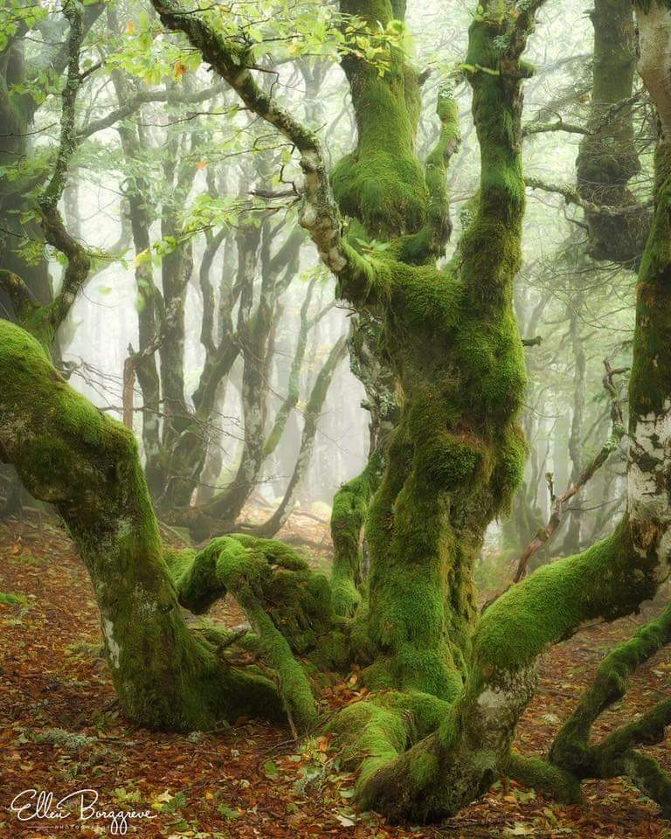

It didn’t take long for them to be welcome, and for Devrion’s jungly elven upbringing to come out in one of his idioms, which gave the centaurs and satyr cause to hoist him up as they would have a stage-diving bard.

It was all in fun and games until they threw him down onto a netted trampoline held fast by a dozen dryads who now took an interest in bouncing him like a baby boy.

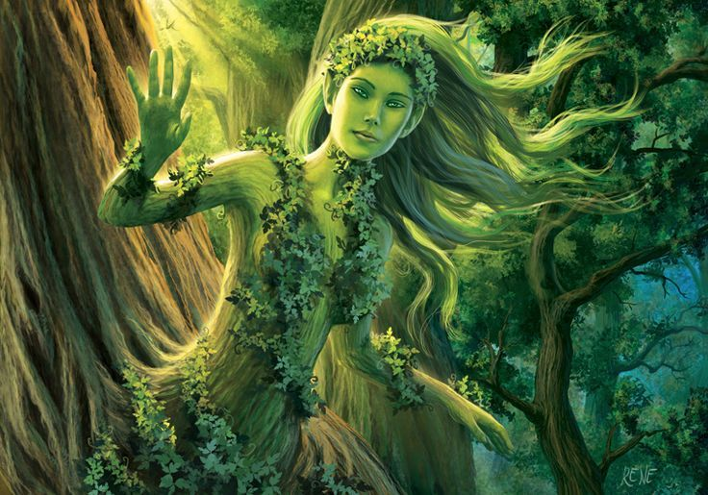

Cheers from fairies, sprites, pixies, and other fey urged the dryads on, and the taut springboard became a snare as the dryads enveloped the elf in green-sleeved branches and innocuous kisses.



Steelshade’s smile faded fast, and Atlas and Brene immediately noticed, reflexively turning to her and gulping. Angren took a breath. “He can handle himself, or at least he’d better.”

Devrion sputtered as the dryads mobbed him. “My mate is here,” he told them, “And she won’t take kindly to your games. Please, put me down.”

“Mate?” Brene, who was holding the little girl, turned to look at Angren, an act which Atlas mirrored. “Did you two do something?”

Angren flushed. “No, but we’re talking about it.”

“Talk fast,” Brene said with a nod toward the dryads, “before they claim him for themselves.”

The duskblade nodded and lifted herself up to approach Devrion. “Please let him down,” she said in accented Elven. She took care to not sound or appear threatening, but she was serious about her request.

|  |  |  |  |  |  |  |
| --- | --- | --- | --- | --- | --- | --- |
| **Skill** | **Rank** | **Ability & Mod.** | **Misc. Mods.** | **Total** | **Roll** | **Check** |
| **Steelshade, Diplomacy** | 7 | **Cha (+4)** | 2 | 13 | 16 – 20 | ?? |

*See below.*

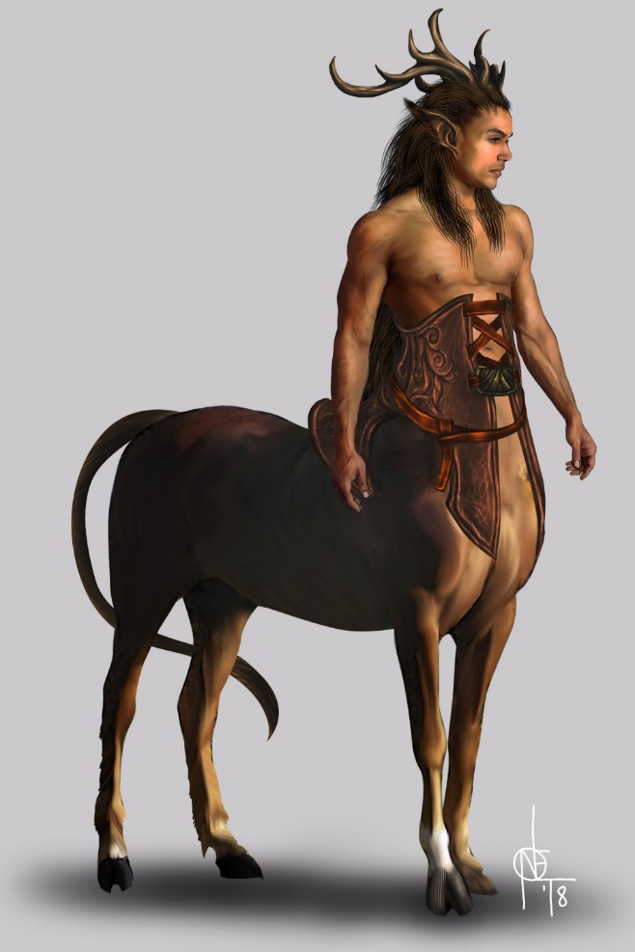

The majority of the fey paid no mind, but one centaur with antlers motioned for the girls to stop, and Devrion soon pried himself free of the net and returned to Angren’s side.

The young-looking buck approached Angren, and asked, “Is it true? He is your property?” The centaur had heard of slaves, but on such a chaotic plane, the only things that followed war were cannibalism or armistice; bondage was a poorly misunderstood alternative at best here.

“He’s not,” Angren started.

“I am her mate,” Devrion cut in as he took her hand in his. “As such, while we are not slaves to each other, we are bound by our oaths.”

“Since wh– oof!” Brene glared at Atlas, who’d elbowed her when she started talking.

“Hush,” the archivist said quietly.

Angren took a breath while she calmed her spiking emotions, none of which she could parse at the moment. “That’s right,” she heard herself say. “We are mates.”

Festivities continued, and as minutes passed and they spoke with a variety of sylvan creatures, they heard a multitude of reasons for the celebration: some trivial, and some commendable. Drinks were passed around, and cups were emptied and then filled, and the heroes could now watch a quintet of performers singing and dancing or partake in conversation with the jovial strangers.

Brene kept the girl with her as she and Atlas circulated among the group, asking about Lauren, and describing her to everyone.

Angren and Devrion did the same, holding hands and walking around.

The foursome made very sure to drink only a little of what they were offered, but the nectar of the gods was truly good, and as minutes turned to hours, the heroes found themselves acquiescing to greater laxity. Brene and Atlas lounged on a grassy mound as the child played with a satyr’s tail.

Angren shook herself mentally. “I have found out nothing about Lauren. We need to move on.”

“Where do we go?” Devrion asked.

“I don’t know, but we can’t stay here.” She led the warmage to where Atlas and Brene sat. “We need to go.”

Atlas paused for a moment. “Yes, you’re right.” He stood while Brene rose and collected the girl.

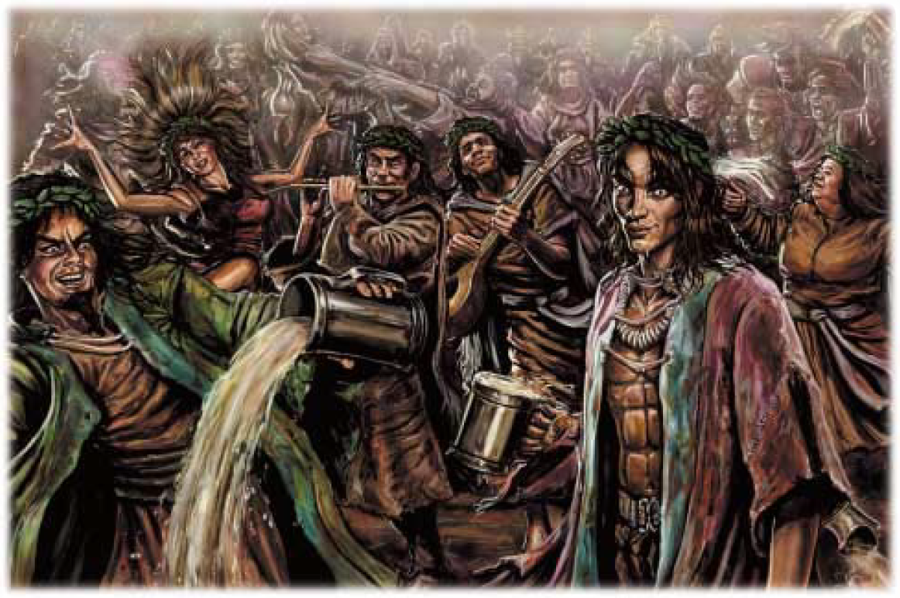

Angren was about to produce the carpet from her sack when they realized that they were not in the midst of any normal revelry; this was a bacchanal, and much to their dismay, a chaos that normally would have been welcome now possessed every tree and other being around them, manifesting in the single force that Atlas could now identify as a greater fiendish bacchanal. The bacchae sprouted wings, fangs, claws, and all manner of demonic trait that caused them all to cringe.

Brene grabbed hold of the child before any fiend could rend her.

*As long as the child is in the midst of the bacchanal, Brene must spend a full-round action every round to prevent her from being harmed, and this will lower her AC by 4.*

“We *must* fight!” he knew, for no matter where they flew or teleported, this collective fey-fiend would follow. “We will *exhaust* ourselves escaping this.”

The archivist knew not how mighty and stalwart this fearsome being might be, but they had only moments to react before the being got the best of them. A few minor swipes from the still transforming individual fey, humanoids, and trees came their way, but they were able to stave these off with little effort as they considered their options.

Holding the child under one arm (and struggling with her size), Brene drew dagger and her fended off the incoming drunkards.

Round 1

|  |  |  |  |  |  |
| --- | --- | --- | --- | --- | --- |
| **Character** | **Group** | **Initiative** | **Roll** | **Modified Roll** | **Speed** |
| Gr. Fiendish Bacchanal | 2 | 6 | 19 | 25 | 50’ f/sw |
| Steelshade | 1 | 5 | 18 | 23 | 20’ |
| Brene | 1 | 6 | 16 | 22 | 30’ |
| Devrion | 1 | 6 | 5 | 11 | 30’ |
| Atlas | 1 | 2 | 3 | 5 | 30’ |

The greater fiendish bacchanal swiped at Steelshade and Devrion in ways that mattered

|  |  |  |  |  |  |  |  |  |  |  |
| --- | --- | --- | --- | --- | --- | --- | --- | --- | --- | --- |
| **Character** | **Attack Type** | **Damage** | **BAB** | **Str Mod+** | **Dex Mod+** | **Total Score** | **Roll** | **Total** | **Crit** | **Targeting** |
| Gr. Fiendish Bacchanal | Bite | 5d8+3 | 22 | 6 | 4 | 28 | 13 | 41 | 19 | Devrion |
| Gr. Fiendish Bacchanal | Claw 1 | 6d6+4 | 22 | 8 | 4 | 30 | 16 | 46 | 19 | Steelshade |
| Gr. Fiendish Bacchanal | Claw 2 | 6d6+4 | 22 | 8 | 4 | 30 | 2 | 32 | 19 | Steelshade |

*Hit (Devrion), hit (Steelshade), miss.*

*1d100 = 72, 49. Both hits bypass concealment.*

*Dmg to Devrion: 39 + 6 = 45 [60/105].*

*Dmg to Steelshade: 40 + 8 = 48 [150/198].*

Steelshade quick-cast *dragonskin [expired on Round 1901]*, and then *fire shield [assuming Chill Shield option; expired on Round 20]*, positioning it ahead of her and pushing it into the crowd.

*Steelshade gained +5 to FFAC and AC from dragonskin; and DR Fire ½ (or total, if Save allowed and succeeded) from Chill Shield option.*

She then channeled *chain lightning* through her blade, and empowered her strikes (+3).

|  |  |  |  |  |  |  |  |  |  |
| --- | --- | --- | --- | --- | --- | --- | --- | --- | --- |
| **Melee Weapon** | **Dmg** | **D+** | **TH+** | **Crit** | **x** | **Type** | **Atk** | **Roll** | **Check** |
| Shattermantle Bloodstone Falchion +5 | 2d4 | +9 +5 | 7 + 3 | 18 | 2 | Slashing | +39 | 18 | 57 |
| SB Falchion +5, 2nd Attack | 2d4 | +9 +5 | 7 + 3 | 18 | 2 | Slashing | +34 | 16 | 50 |
| SB Falchion +5, 3rd Attack | 2d4 | +9 +5 | 7 + 3 | 18 | 2 | Slashing | +29 | 14 | 43 |
| SB Falchion +5, 4th Attack | 2d4 | +9 +5 | 7 + 3 | 18 | 2 | Slashing | +24 | 7 | 31 |

*Hit, hit, hit, hit. Dmg: (6 + 9 + 5 + 9 AS) + 62 electric+ (4 + 9 + 5 + 6 AS) + (5 + 9 + 5 + 6 AS) + (4 + 9 + 5 + 11 AS) =*

*29 + 24 + 25 + 29 + 62 electric = 107 + 62 electric =. See below.*

|  |  |  |  |  |  |
| --- | --- | --- | --- | --- | --- |
| **Ranged Weapon** | **Dmg.** | **TH+** | **Atk** | **Roll** | **Check** |
| Bypass Spell Resistance | Spell Power | 4 | +23 | 2 | 25 |

*Spell Resistance bypassed. See below.*

|  |  |  |  |  |
| --- | --- | --- | --- | --- |
| **Character** | **Save vs.**  *chain lightning* | **Ranks** | **Roll** | **Check** |
| Gr. Fiendish Bacchanal | Reflex | 24 | 3 | 27 |

*Saved for ½ electric damage = 31 electric.*

“Here go 800 clams,” Brene seemed to say only to the child as she stepped back behind Steelshade, took one hand off the infant, produced one of her scrolls of *enervation*, andread its activating phrase, pointing at the nearest extension of the enemy as she activated it.

|  |  |  |  |  |
| --- | --- | --- | --- | --- |
| **Ranged Weapon** | **Dmg.** | **Atk** | **Roll** | **Check** |
| Ranged Touch Attack | 1d4 negative levels | +27 | 4 | 31 |

*Hit. See below.*

|  |  |  |  |
| --- | --- | --- | --- |
| **Ranged Weapon** | **Atk** | **Roll** | **Check** |
| Bypass Spell Resistance | +20 | 10 | 30 |

*Spell Resistance bypassed. Dmg: 1 negative level, bestowing –1 on attacks, saves, checks, and effective level (for determining the power, duration, DC, and other details of spells or special abilities), and highest spell slot spell, if applicable.*

The second-nearest extension of the enemy snatched at the child.

|  |  |  |  |  |  |  |  |
| --- | --- | --- | --- | --- | --- | --- | --- |
| **Character** | **Attack Type** | **BAB** | **Str Mod+** | **Dex Mod+** | **Total Score** | **Roll** | **Total** |
| Gr. Fiendish Bacchanal | Grab | 22 | 6 | 4 | 28 | 1 | 29 |

*Miss.*

Brene was able to fend off the wrenching opponent as her spell reduced its fierceness a bit.

Devrion picked a spot from his companions, 30’ away. “Tüzes felhő!” *[incendiary cloud, expired on Round 21]*

|  |  |  |  |  |
| --- | --- | --- | --- | --- |
| **Ranged Weapon** | **Dmg.** | **Atk** | **Roll** | **Check** |
| Bypass Spell Resistance | 4d6 fire | 20 | 17 | 37 |

*Spell Resistance bypassed. See below.*

|  |  |  |  |  |
| --- | --- | --- | --- | --- |
| **Character** | **Save vs.**  *incendiary cloud* | **Ranks** | **Roll** | **Check** |
| Gr. Fiendish Bacchanal | Reflex | 24 | 3 | 27 |

*Success. Saved for ½ damage.*

*Dmg: ½ x 15 = 7 fire.*

The convenience of such a spell is that it always blew away from its caster irrespective of the prevailing winds, and this it did as it seared the inebriated multitude. The demonic swarm, however, was likely wily enough to know this, and divert its mass in the next few moments to avoid the linear drift of the thermal mass now boring through its agile constituents.

Atlas roared *[benefits expired on Round 201]* at the opponents on his side, now either baking in flames or reveling still in their madness.

|  |  |  |  |  |  |
| --- | --- | --- | --- | --- | --- |
| **Ranged Weapon** | **Dmg.** | **D+** | **Atk** | **Roll** | **Check** |
| Bypass Spell Resistance | 1d8 Sonic | 20 | +20 | 6 | 26 |

*Spell Resistance bypassed.*

|  |  |  |  |  |
| --- | --- | --- | --- | --- |
| **Character** | **Save vs.**  *lion’s roar* | **Ranks** | **Roll** | **Check** |
| Gr. Fiendish Bacchanal | Fortitude | 19 | 8 | 27 |

*Success. Saves for ½ Sonic damage and no stun.*

*Dmg to bacchanal: ½ x 43 = 21 Sonic. Damage negated.*

*PCs gained +1 to attacks and saves vs. Fear, and the following temporary hps:*

*Atlas: 8 + 20 = 28 [****133****\105].*

*Brene: 4 + 20 = 24 [****143****\119].*

*Devrion: 1 + 20 = 21 [****126****\105].*

*Steelshade: 8 + 20 = 28 [****226****\198].*

Atlas noted that the frenzied cacophony of a demon was immune—or at least resistant—to Sonic damage, and had a hunch that it had no other significant energy resistances.

Round 2

The greater fiendish bacchanal became fiercer, though the magic and might of its intended victims had worn its offenses and defenses down enough to make a dent. As it looked for an opportunity to tear at Brene’s child, it meanwhile swiped at the adults with several clawed limbs and jawed snouts. In an effort to strike while it still could, it expended its effort to maximize its surface attackers.

Some snatched at Atlas.

|  |  |  |  |  |  |  |  |  |  |
| --- | --- | --- | --- | --- | --- | --- | --- | --- | --- |
| **Character** | **Attack Type** | **Damage** | **BAB** | **Str Mod+** | **Dex Mod+** | **Other+** | **Total Score** | **Roll** | **Total** |
| Gr. Fiendish Bacchanal | Bite | 5d8+3 | 22 | 6 | 4 | -1 | 27 | 1 | 28 |
| Gr. Fiendish Bacchanal | Claw 1 | 6d6+4 | 22 | 8 | 4 | -1 | 29 | 10 | 39 |
| Gr. Fiendish Bacchanal | Claw 2 | 6d6+4 | 22 | 8 | 4 | -1 | 29 | 14 | 43 |
| Gr. Fiendish Bacchanal | Rend | 8d4+6 | Automatic | hit |  |  |  |  |  |

*Miss, hit, hit, automatic hit.*

*1d100 = 33, 48. Both hits bypass concealment.*

*Dmg: (16 + 4) + (18 + 4) + (13 + 6) = 20 + 22 + 21 = 63 [70/105].*

Others went for Brene, hoping to dispossess her of her perceived progeny.

|  |  |  |  |  |  |  |  |  |  |
| --- | --- | --- | --- | --- | --- | --- | --- | --- | --- |
| **Character** | **Attack Type** | **Damage** | **BAB** | **Str Mod+** | **Dex Mod+** | **Other+** | **Total Score** | **Roll** | **Total** |
| Gr. Fiendish Bacchanal | Bite | 5d8+3 | 22 | 6 | 4 | -1 | 27 | 18 | 45 |
| Gr. Fiendish Bacchanal | Claw 1 | 6d6+4 | 22 | 8 | 4 | -1 | 29 | 14 | 43 |
| Gr. Fiendish Bacchanal | Claw 2 | 6d6+4 | 22 | 8 | 4 | -1 | 29 | 14 | 43 |
| Gr. Fiendish Bacchanal | Rend | 8d4+6 | Automatic | hit |  |  |  |  |  |

*Hit, hit, hit, automatic hit.*

*1d100 = 91, 97, 12. First two hits bypass concealment.*

*Dmg: (20 + 3) + (28 + 4) + = 23 + 32 = 55 [88/119].*

Another few meddled with Devrion.

|  |  |  |  |  |  |  |  |  |
| --- | --- | --- | --- | --- | --- | --- | --- | --- |
| **Character** | **Attack Type** | **Damage** | **BAB** | **Str Mod+** | **Dex Mod+** | **Other+** | **Total Score** | **Roll** |
| Gr. Fiendish Bacchanal | Bite | 5d8+3 | 22 | 6 | 4 | -1 | 27 | 18 |
| Gr. Fiendish Bacchanal | Claw 1 | 6d6+4 | 22 | 8 | 4 | -1 | 29 | 17 |
| Gr. Fiendish Bacchanal | Claw 2 | 6d6+4 | 22 | 8 | 4 | -1 | 29 | 12 |
| Gr. Fiendish Bacchanal | Rend | 8d4+6 | Automatic | hit |  |  |  |  |

*Hit, hit, hit, automatic hit.*

*1d100 = 09, 28, 35. Last two hits bypass concealment.*

*Dmg: (28 + 4) + (23 + 4) + (17 + 6) = 32 + 27 + 23 = 82 [44/105].*

And the most futile swipes went Steelshade’s way.

|  |  |  |  |  |  |  |  |  |  |
| --- | --- | --- | --- | --- | --- | --- | --- | --- | --- |
| **Character** | **Attack Type** | **Damage** | **BAB** | **Str Mod+** | **Dex Mod+** | **Other+** | **Total Score** | **Roll** | **Total** |
| Gr. Fiendish Bacchanal | Bite | 5d8+3 | 22 | 6 | 4 | -1 | 27 | 7 | 34 |
| Gr. Fiendish Bacchanal | Claw 1 | 6d6+4 | 22 | 8 | 4 | -1 | 29 | 14 | 43 |
| Gr. Fiendish Bacchanal | Claw 2 | 6d6+4 | 22 | 8 | 4 | -1 | 29 | 5 | 34 |

*Miss, hit, miss.*

*1d100 = 26. Bypass concealment.*

*Dmg: 21 + 4 = 25 [****201****/198].*

The limbs then receded as Devrion’s *cloud* continued to cook the masses.

|  |  |  |  |  |
| --- | --- | --- | --- | --- |
| **Character** | **Save vs.**  *incendiary cloud* | **Ranks** | **Roll** | **Check** |
| Gr. Fiendish Bacchanal | Reflex | 24 | 14 | 38 |

*Success. Saved for ½ damage.*

*Dmg: ½ x 11 = 5 fire.*

Atlas noted a few behaviors that resonated with his Dark Knowledge of aberrations such as this. He effortlessly recalled a bit of information that he shared with the others as they fought.

|  |  |  |  |  |  |  |  |
| --- | --- | --- | --- | --- | --- | --- | --- |
| **Skill** | **Rank** | **Ability & Mod.** | **Misc. Mods.** | **Total** | **Roll** | **Check** | **Notes** |
| **Atlas, Knowledge: The Planes** | 22 | **Int (+8)** | 5 | 35 | 7 | 42 | Trivial Knowledge |
| **Atlas, Knowledge: The Planes** | 22 | **Int (+8)** | 5 | 35 | 17 | 52 | Trivial Knowledge, **best of 2 rolls** |

*Success by 20+: PCs gained +3d6 to weapon damage against bacchanal.*

Steelshade hacked her way through the bacchanal, ignoring the creatures’ attempts to seriously damage her. The duskblade channeled *inflict serious wounds* through her blade and empowered her strikes (+3).

|  |  |  |  |  |  |  |  |  |  |  |
| --- | --- | --- | --- | --- | --- | --- | --- | --- | --- | --- |
| **Melee Weapon** | **Dmg** | **D+** | **TH+** | **Crit** | **x** | **Type** | **Wt.** | **Atk** | **Roll** | **Check** |
| Shattermantle Bloodstone Falchion +5 | 2d4 + 3d4 | +9 + 5 | 7 + 3 | 18 | 2 | Slashing | 8.0 | +39 | 8 | 47 |
| SB Falchion +5, 2nd Attack | 2d4 + 3d4 | +9 + 5 | 7 + 3 | 18 | 2 | Slashing | - | +34 | 8 | 42 |
| SB Falchion +5, 3rd Attack | 2d4 + 3d4 | +9 + 5 | 7 + 3 | 18 | 2 | Slashing | - | +29 | 5 | 34 |
| SB Falchion +5, 4th Attack | 2d4 + 3d4 | +9 + 5 | 7 + 3 | 18 | 2 | Slashing | - | +24 | 18 | 42 |

*Hit, hit, hit, hit. Dmg: (5 + 9 + 5 + 9) + (7 + 9 + 5 + 7) + (4 + 9 + 5 + 11) + (5 + 9 + 5 + 8) = 28 + 28 + 29 + 27 = 112 + (17 + 15 negative energy) = 144.*

|  |  |  |  |  |  |
| --- | --- | --- | --- | --- | --- |
| **Ranged Weapon** | **Dmg.** | **TH+** | **Atk** | **Roll** | **Check** |
| Bypass Spell Resistance | Spell Penetration | 2 | +21 | 8 | 29 |

*Success. Spell Resistance bypassed..*

Devrion staggered as two vicious swipes slammed into him. The warmage lifted straight up as far as he could, and pointed at the creature. “Implózió!”

|  |  |  |  |  |
| --- | --- | --- | --- | --- |
| **Character** | **Save vs.**  *Implosion* | **Ranks** | **Roll** | **Check** |
| Gr. Fiendish Bacchanal | Fortitude | 19 | 16 | 35 |

*Success. Effect negated.*

“Hmm,” thought the warmage. “Must try something else.”

Brene flew up as far as she could while still having time to extract her want of *cure serious wounds* and use it on herself, incurring an Attack of Opportunity as she passed by the adversary.

|  |  |  |  |  |  |  |  |  |  |  |  |
| --- | --- | --- | --- | --- | --- | --- | --- | --- | --- | --- | --- |
| **Character** | **Attack Type** | **Damage** | **BAB** | **Str Mod+** | **Dex Mod+** | **Other+** | **Total Score** | **Roll** | **Total** | **Crit** | **Notes** |
| Gr. Fiendish Bacchanal | Claw 1 | 6d6+8 | 22 | 8 | 4 | -1 | 29 | 9 | 38 | 19 | AoO |

*Hit. Dmg: 20 + 8 = 28 [60/119].*

*Brene gained 14 + 6 = 20 XPs [80/119].*

Atlas murmured a prayer *[flame strike]* and jabbed his finger at the ground.

|  |  |  |  |  |
| --- | --- | --- | --- | --- |
| **Character** | **Save vs.** | **Ranks** | **Roll** | **Check** |
| Gr. Fiendish Bacchanal | Reflex | 24 | 20 | 44 |

*Success. Saved for ½ damage. Dmg: ½ x 41 = 10 fire + 10 divine = 20.*

And that successfully culled the greater fiendish bacchanal.

The individual bacchae seemed to be rending one another apart as their collective conscience devolved into a fierce, feral frenzy. The few that came at them now were discombobulated, disoriented, or even deformed, and they could easily block their lunges and kick them asunder.

Atlas lifted off to join Brene and Devrion. “Are you two okay?”

“I’ll manage,” Devrion huffed. “How is the child?”

Brene kept a tight grip on the child and looked her over as best she could. “I don’t see any injuries, but we need to take her somewhere and check.”

“N’j’ries!” she mimicked Brene with more enthusiasm than accuracy.

Steelshade waited a moment longer, swatting at one or two of the remaining hostiles, and then she lifted off and joined the others. “Let’s get away from here.” Vigilant as she was, she missed part of an animated limb that was now catapulted towards the child by the dying bacchanal.

The child instinctively opened her mouth and spat a brass-hued flame towards the clawed arm, searing it before it fell back down.

“Well, now that’s interesting,” Atlas opined as he watched the seared arm fall away.

The others withheld comment as they focused on landing, unrolling the carpet, and getting airborne again. This time, Devrion took command of the carpet while Brene checked the child for injuries and healed everyone who needed it with her wand. The warmage took the carpet up the about five hundred feet and turned north, while Angren and Atlas kept watch.

The bacchanal reeled as its members melted into the soil, leaving a layer of fur and filth for the rain to wash away. They selected a likely looking area to land – away from the collection of partiers that had so suddenly turned lethal. Now about 1,000’ from where they’d vanquished the swarm of opiated and inebriated fey-fuckers, they touched down once again, and continued to discuss the child.

The halfling reached into one of her belt pouches and fished out her ring of feather falling. “Here, baby: wear this. It will keep you safe if you fall.” She slipped the ring onto the child’s left middle finger and watched as it resized itself to fit.

*The child would gain the feather fall ability (activation needed) in 24 hours.*

They hadn’t noticed under an already partly overcast sky, but a cloud had formed directly overhead, allowing the sun that hung perpetually at a setting angle to continue to cast its light on them as the first drizzle foretold of what Atlas already knew would be blood rain.

They felt and saw it fall upon them. The archivist said, “It will be a torrent upon us.”

A red bolt of lightning coursed downward and struck the air still thousands of feet above them, causing a peal of thunder to resound throughout the land, and further causing the young girl to flinch and burp a blast of fire upon Brene’s face before recoiling her tongue and brandishing a formidable set of draconic claws on each hand.

*Damage negated.*

She hissed as she pushed herself off Brene with alarming alacrity and hastily and heuristically took a measure of the four adults before her before turning upward at the cloud that had just flashed red and blasted them with such a cacophony.

“Oh!” Brene exclaimed and backed up a step as the child pushed herself away.

Angren took a step and knelt in front of the child. << It’s okay, >> she said in Draconic. << It’s just a storm. We will seek cover from it, but it won’t hurt you. >>

Devrion immediately steered the carpet downward, looking for a place to shelter under the trees.

They found a tree that suited them, and were now under its 30’ span of leaves. The carpet was still on the ground, and the child had hissed herself back to a somewhat calm state.

Maniacal laughter could now be discerned coming from the cloud above them, and even under the tree, they had to endure the percolating drops of blood rain coating their armor and gear.

Drops coated the child’s face and as she tasted the blood rain, she seemed to revel in delight of its flavor.

Devrion and Brene busied themselves with rolling up the carpet and storing it, while Angren used her shield to keep the rain off the girl. Atlas studied the phenomenon to determine what may be causing it.

<< Wonhoot you! >> the child repeated Angren’s Draconic words as best as she could.

The maniacal laughter returned, and with it, a swirl of red, pink, white, and gray flashed across the cloud as a lone figure descended at terminal velocity. It was a humanoid figure, probably twice the size of a human, and had its limbs stretched out as if enjoying the fall against the rising wind.

The warmage noted that it was a fine specimen of a female... whatever it was. Devrion looked to Atlas, then Angren and Brene did as well, and finally the kid turned to the archivist, who sighed with some dismay, “... Iggwilv...”

Steelshade instantly drew her sword once again at the sound of the arch-demon’s name.

“We *must* protect the child!” Brene declared, and knew she would likely have to devote all her energies to such a mission.

“Iggwoof!” the little girl looked up and licked the air above her with her forked tongue.

Round 1

“Terrific,” Steelshade sighed. She cast *dragonskin* *[current effect extended until Round 1901]* on herself.

*Steelshade retained her +5 to FFAC and AC.*

Atlas prayed briefly and touched Steelshade’s shoulder. *[chasing perfection, expired on Round 191]*

*Steelshade gained +4 to all core ability scores.*

Devrion cast *mage armor [expired in 20 hours]* on himself.

*Devrion gained +4 to FFAC and AC.*

Brene readied her shortbow.

All four of them activated their mindarmor enhancements for their armor and equipment.

*PCs gained +5 to Will saves vs. mind-affecting spells and abilities [expired in 1 round].*

The demon princess continued to descend, and would soon land painlessly on one fist and one knee.

Round 2

Atlas prayed again and touched Devrion. *[chasing perfection]*

*Devrion gained +4 to all core ability scores.*

He then moved up to stand at Brene’s left to help shield the little girl.

Steelshade lifted off the ground and moved toward the arch demon. Devrion followed Steelshade, moving to her left as he flew, but as they’d noticed seconds earlier, the demon was already about to land.

“Stay behind me, little one,” Brene told the child as she stepped in front of her.

“Behiney!” the child cheered as she turned her attention to the falling demon.

Atlas fused heuristic hunch with years of research on demonology.

|  |  |  |  |  |  |  |  |
| --- | --- | --- | --- | --- | --- | --- | --- |
| **Skill** | **Rank** | **Ability & Mod.** | **Misc. Mods.** | **Total** | **Roll** | **Check** | **Notes** |
| **Atlas, Knowledge: The Planes** | 22 | **Int (+8)** | 5 | 35 | 10 | 45 | Trivial Knowledge, **best of 2 rolls** |
| **Atlas, Knowledge: The Planes** | 22 | **Int (+8)** | 5 | 35 | 8 | 43 |  |

*Success by 20+: PCs gained +3d6 to weapon damage against Iggwilv.*

Though he’d never encountered her, there was an unclassified type of humanoid arch-demon whose skin betrayed a tendency to bleed profusely if slashed.

*Atlas suspected that Iggwilv was vulnerable (~2x damage) to slashing attacks.*

The child puffed up her stance like a lizard anticipating the pounce of a bird of prey. She bared her teeth, and Brene noted slight fumes coming out of her nostrils as she suddenly felt a rush of coolness evaporating the light coating of sweat on their skin and clothing.

*The PCs and kid gained Resistance +5 to fire, stackable with current Resistance.*

Iggwilv landed on a knee, a foot, and a fist, then eyed the four heroes and their cuddly toddler who had grown considerably since they’d found her.

Round 3

Angren and Devrion were about 60’ above the ground, where Iggwilv stood calmly and parted her lips, causing the ground to rumble with an underlying baritone resonance that harmonized her otherwise feminine voice.

“You are the thralls of Aasterinian,” the demon princess did not ask as they gauged their horizontal distance from her to be about 120’. “I come to parley with fully murderous intention if you would prefer to keep your weapons brandished.”

Round 4

Steelshade sheathed Arkenlyl, while Brene lowered her bow and put up her arrow. The two flyers held in place, and those on the ground remained still.

“What do you want with us?” Atlas called out.

The brassbrow child asked something similar, probably.

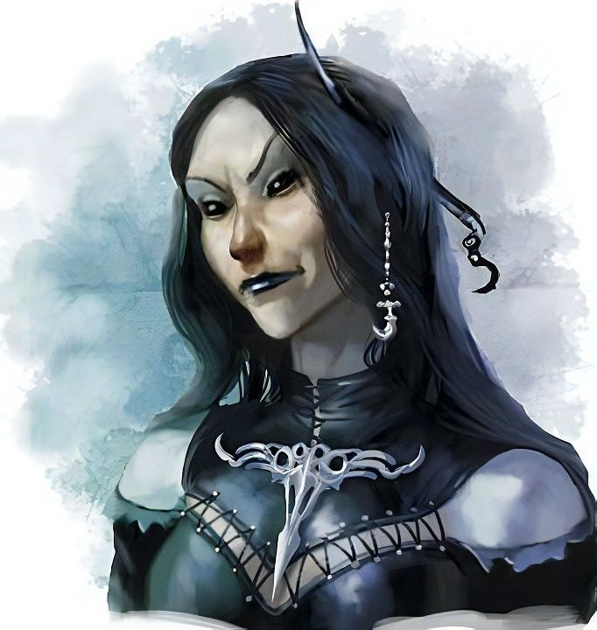

The demon woman stared at Atlas, then at the others aloft and on the ground, then smirked, “I’m not sure yet, but probably nothing much. I *am* curious as to why *you*,” and she faced Atlas now as she took only three steps forward, “such a learned mortal, would knowingly throw the Abyssal pecking order into a scramble.”

Round 5

Steelshade and Devrion looked at one another. Their motives had not been that grand in scope; they simply needed to end Graz’zt, or he would end them. Brene comforted the child as Atlas also took three steps forward, placing himself between the demon and his two allies now behind him.

“Your question suggests that you believe we’ve disregarded some cosmic structure—some order—and yet you are the embodiment of chaos,” Atlas responded. “Why would our motive to foster chaos trouble you?”

Round 6

“On the contrary, archivist,” the black-eyed demoness now smiled fully. “If it troubled me, we would already have exchanged spells and lunges. Depending on your angle, I may have a mutually fruitful proposition for you all.”

“Do go on,” Atlas knew that he spoke for the group at the moment, and could sense his teammates’ curiosity.

Round 7

“As these green grape leaves,” she pointed to a patch of wild-growing vines. “Will soon yellow and wither, the legacy of Graz’zt is even now browning, yellowing, fading into sepia memories and embellished tales of grandeur.”

“And?” Atlas wasn’t quite following the elusive point.

Round 8

She nodded, and tilted her head to the side as if to acknowledge and address her ambiguity. “... *and*... I hereby proclaim this moment to be the dawn of the post-Graz’zt age, when finally my minions piss and dance over his grave.”

“They piss, and *then* they dance on it?” Devrion turned to Steelshade and murmured. She shushed him with her eyes only, then turned back down to the parleying demon, if such a thing could exist.

Rounds 9 – 10

“Fascinating, Iggwilv,” Atlas called her by her name, trying to recall a Dread Secret or two about the arch-fiend.

“Yes,” she agreed. “Indeed, and verily, it appears that if—as word has it—you do mean to rid the planes of other demons, I can furnish you with a manifest of names, last known locations, and basic strengths and weaknesses of about a dozen unsavory individuals... all demons.”

Rounds 11 – 17

“Like who?” asked Atlas.

She listed off just about every arch-demon at the peak of the hierarchy, if such it was.

Round 18

“Impressive...” the human took in the information. “So your thoughts are to give us the information, unleash us upon your competitors at our own pace and discretion, and usurp each fallen prince’s thralls into your own orbit? Do you take us for fools?”

Rounds 19 – 20

“Not at all. I don’t intend to cajole you into my service, but unfortunately, you are living legends in your own time, and it is practically common knowledge that what I’ve proposed is in direct alignment with your brass goddess’ commandment unto you,” she interpreted what she’d gathered.

At Iggwilv’s feet, there rose from the ground lesser demons about the size of the child, and as they took form, they clung to the demon’s shins, which were twice as long as Atlas’ own shins. The slender and sultry Lady of the Abyss blinked her eyelids over jet black orbs that saw beyond color and pallor as Atlas considered what the arch-demon was telling him.

“We are here on a personal matter, and not specifically for an errand from Aasterinian,” Atlas told the towering demoness. “Now, what she might have us do in the future, I cannot say. As such, we certainly don’t have an argument with you, especially not so far from either of our homes.”

“Do you know a drow named Lauren?” Angren cut in.

<< Mins chakchak; pless ba’ruff! >> one of the fiends at Iggwilv’s feet protested.

<< Ko-phlogh! >> the arch-demon—widow-lover of the Great Incubus himself—pronounced the word, and the Abyssal form disintegrated into particles absorbed by Iggwilv. “Lauren, the legendary duskblade... no doubt you take after her... your whole style and form. Yes, I’m aware that you seek her out. I neither know nor care about the object of your idolatry, though if I did, I would surely leverage the information to bring about a mutually satisfying outcome.”

“Such as...?” wondered Angren.

The arch-demon shrugged. “Not sure it’s worth the effort to think about it if I don’t actually have the information with which to bargain.”

“So, what *is* your bargaining chip?” Atlas asked.

Iggwilv pointed with her pupils and eyebrows, confirming with a nod to the child, and a simple, “Her.”

And with little warning, the child hissed revealing her forked tongue, which was now violet. She pushed off of and away from Brene, walking with more assuredness in her stride than before as her limbs, torso, and facial features developed further into what might have been a four-year-old human child. With snake-eyed pupils, the girl spat a line of fire at Iggwilv, which Iggwilf promptly shielded with a personal *wall of force* manifested by the simple somatic gesture that she held in place for the moment.

The child drained herself—for the moment—of the fires in the furnace of her torso, and hissed menacingly as Iggwilv raised her voice to be heard a bit better. “You are tugging a dragon that will be beyond your capacity to control before long. I can contain her before she becomes a threat to all around her.”

“Like you?” Brene taunted, holding back a smirk.

“I stand before you in full civility; this beast will never afford you that courtesy. She will drain you of your energies, and strike you when you’re too weak to defend yourselves.”

“Why should we believe you?” Devrion asked, not quite buying the prophecy.

“Because,” the arch-demoness paused, and looked the child up and down as the child heaved and took a few steps forward. “She is the third such incarnation. This is a Tiamat Spore, the purpose of which is to grow in power until Tiamat herself can possess her body, thereby gaining an additional avatar across the planes.”

They turned to Atlas, who nodded to his friends. This did ring consistent with things he’d studied, though he wondered why the child was adorned with brass—and not chromatic—scales. Nevertheless, the archivist found it advantageous to feign full credulity as the demon spoke. “What do you intend? That we hand over a child to a known ruler of an Abyssal layer?”

“It’s hardly a whole layer... more of a lair... a big one, but I have to share the realm with some really unsavory types.

Brene stepped up close to the child. “It’s not a good idea to piss off someone like her,” she told the child. “Come back with me.” She didn’t dare touch her, though.

Atlas cocked his head slightly as the demoness didn’t answer his question. “Point taken, but my question still stands.”

Angren took a moment to look around to be sure nothing was sneaking up on them, and all looked, sounded, and smelled normal.

The child stepped around and behind Brene, twisting her neck in a wide, serpentine arc unavailable to most mammals, and mustering some more fire juice in case things got sour.

“If you question my motives or methods, join us for a meal as I show you the containment chamber in which she will be safe, and we from her,” the prime succubus shrugged. “Sneakthief,” she then urgently warned Brene, “your bundle of joy is about to spray your spinal column with magma-hot plasma.”

Brene half-turned to look at the child. “Are you planning to attack me? You know that it won’t hurt me that much, and that I won’t hurt you, right?”

From her torso, which was now par with Brene’s, there sprouted a pair of fin-shaped scales that instantly unfurled as they further developed from a vestigial display to fully articulated, scaled, membraned wings the color of their deity. He hissed past Brene, pointing at the demon, and uttered a single Draconic word. << Evil! >> she pronounced the word that only Atlas and Angren could understand.

Brene noted the color of the girl’s pupils had changed to the color of her former friend’s irises when that sorcerer used to cast *detect evil*.

Angren sensed great potential for treachery, as did her teammates. She said nothing, but Iggwilv was a great judge of character and reader of all things somatic, and could tell by the posture of the girl—and of each of her keepers—that she would not have her prize today by simply asking. “Very well, lizard worshippers,” she sighed. “I see now that you bleeding hearts have resolve, but have you the mettle to uphold it?” And with this, it became evident that a struggle was about to ensue. The arch-demon raised her arms and opened a veneer behind her through which scores of incubi, succubae, and other fiends emerged. They—too—had fully formed reptilian wings, and now flapped them in a swarm that would surely come down upon them soon.

Round 11

|  |  |  |  |  |  |
| --- | --- | --- | --- | --- | --- |
| **Character** | **Group** | **Initiative** | **Roll** | **Modified Roll** | **Speed** |
| Steelshade | 1 | 5 | 17 | 22 | 20’ |
| Atlas | 1 | 2 | 15 | 17 | 30’ |
| Iggwilv & Demons | 2 | 10 | 2 | 12 | 50’ |
| Devrion | 1 | 6 | 3 | 9 | 30’ |
| Brene | 1 | 6 | 1 | 7 | 30’ |

“You people just never learn, do you?” Steelshade, who retained her protections cast a minute ago, drew Arkenlyl and waited for the spellslingers to cast before she advanced. She also activated all her mindarmor protections *[expired on next round]*, just in case.

*Steelshade gained +5 to Will saves vs. mind-affecting spells and abilities.*

Atlas murmured a *[chasing perfection, expired on Round 211]* prayer and touched Brene.

*Brene gained +4 to all primary abilities.*

The archivist then activated his mindarmor protections again.

*Atlas gained +5 to Will saves vs. mind-affecting spells and abilities.*

Iggwilv seethed and studied the five adversaries as the child prepared to express her breath weapon once again. She imbued herself with some buff that they could not identify.

*Iggwilv gained greater contingency: resurrection.*

The frontline of demonic forces pounced down on the heroes, but these were the least of the demons, and their initial strikes were all in vain.

*Automatic failure on the part of all frontline demons.*

The child opened her mouth, stuck out her forked tongue, and took out three demons with perfect bosoms with a fierce flame.

*Automatic death.*

Devrion selected five demons who were closing in on the child. “Mágikus rakéta!” *[magic missile]*

*Dmg to each demon: 3 + 5 = 8 magic [force].*

This wasn’t quite enough to deter the three incubi and two succubae he hit.

Brene shot two of the closest demons with her bow.

|  |  |  |  |  |  |  |  |  |  |  |
| --- | --- | --- | --- | --- | --- | --- | --- | --- | --- | --- |
| **Ranged Weapon** | **Dmg.** | **D+** | **TH+** | **Critical** | **Rng.** | **Wt.** | **Atk** | **Roll** | **Check** | **Properties** |
| Rapid Shortbow +2 | 1d4 | 2 | 2 | x3 | 60’ x 2 | 2.0 | +29 | 16 | 45 | Sneak Attack 10d6 |
| Shortbow, 2nd Shot | 1d4 | 2 | 2 | x3 | 60’ x 2 | - | +24 | 14 | 38 | Sneak Attack 10d6 |
| Shortbow, 3rd Shot | 1d4 | 2 | 2 | x3 | 60’ x 2 | - | +19 | 19 | 38 | Sneak Attack 10d6 |
| Shortbow, Rapid Shot | 1d4 | 2 | 2 | x3 | 60’ x 2 | - | +29 | **20** | 49 | Sneak Attack 10d6 |

*Hit, hit first target. Hit, threat second target. 1d20 = 15 + 29 = 44. Critical hit. Dmg: see below.*

Brene pierced the heart and neck of two incubi, destroying their bodies with the second arrow that hit each one.

Round 12

Steelshade moved 5’ back closer to Brene and the child, swatting the most threatening demons along the way. She took out three succubae, and mortally wounded a fourth.

Atlas prayed again and touched his own chest *[chasing perfection, expired on Round 212]*. He then moved forward to protect the child.

*Atlas gained +4 to all primary abilities.*

The demons in their midst took up positions, and some of the elites began casting divine and arcane spells while others drew weapons. The fodder rushed at them, and would soon taste sudden annihilation.

A *necrotic skull bomb* flew towards Devrion.

|  |  |  |  |  |  |  |
| --- | --- | --- | --- | --- | --- | --- |
| **Save vs.**  *Necrotic Skull Bomb* | **Rank** | **Ability & Mod.** | **Misc. Mods.** | **Total** | **Roll** | **Check** |
| **Devrion, Fortitude** | **6** | **Con (+3)** | 3 | 12 | 13 | 25 |

*Success. Effect negated.*

A *vitriolic sphere* manifested around Steelshade and Brene, not quite encompassing the child behind them, and drenched them as it fell onto anything below it.

|  |  |  |  |  |  |  |
| --- | --- | --- | --- | --- | --- | --- |
| **Save vs.**  *vitriolic sphere* | **Rank** | **Ability & Mod.** | **Misc. Mods.** | **Total** | **Roll** | **Check** |
| **Brene, Reflex** | **12** | **Dex (+10)** | 5 | **27** | 10 | 37 |
| **Steelshade, Reflex** | **6** | **Dex (+5)** | 3 | **14** | 6 | 20 |

*Success, fail. Initial damage to Steelshade: 35 acid. Partial damage negated.*

|  |  |  |  |  |  |  |
| --- | --- | --- | --- | --- | --- | --- |
| **Save vs.**  *vitriolic sphere* | **Rank** | **Ability & Mod.** | **Misc. Mods.** | **Total** | **Roll** | **Check** |
| **Brene, Reflex** | **12** | **Dex (+10)** | 5 | **27** | 9 | 36 |
| **Steelshade, Reflex** | **6** | **Dex (+5)** | 3 | **14** | 12 | 25 |

*Success, success. No delayed damage.*

Five *scorching rays* shot out from a succubus with a spellbook, each targeting one humanoid much as Devrion had just done with his *magic missile.*

|  |  |  |  |  |  |  |  |
| --- | --- | --- | --- | --- | --- | --- | --- |
| **Character** | **Attack Type** | **Damage** | **BAB** | **Dex Mod+** | **Total Score** | **Roll** | **Total** |
| Demon | Ranged Touch, Atlas | 4d6 fire | 13 | 4 | 17 | 18 | 35 |
| Demon | Ranged Touch, Brene | 4d6 fire | 13 | 4 | 17 | 18 | 35 |
| Demon | Ranged Touch, Devrion | 4d6 fire | 13 | 4 | 17 | 1 | 18 |
| Demon | Ranged Touch, Steelshade | 4d6 fire | 13 | 4 | 17 | 2 | 19 |
| Demon | Ranged Touch, child | 4d6 fire | 13 | 4 | 17 | 7 | 24 |

*Hit, hit, miss, hit, hit.*

*Dmg to Atlas: 17 fire. Damage negated.*

*Dmg to Brene: 7 fire. Damage negated.*

*Dmg to Steelshade: 18 fire. Damage negated.*

*Dmg to child: 14 fire. Damage negated.*

Atlas studied the battlefield, identifying several abjurations and other buffs being cast by the opposition. The succubus that had cast *scorching ray* was now producing a ceremonial dagger ideal for casting *cloud of knives*, which she would likely do in the next few seconds.

Iggwilv moved forward in such a way that they all had to resist being seduced by her hips and breasts. << Behold! >> she pontificated in Abyssal, << I am the messenger that Death brings to your door. >> She activated her bracelet’s ability, and gained a sickly, green aura around her.

The child seemed to understand, and replied in Draconic, << I *am* Teeth of Fire! >> Without much more ado, she began to muster up another batch of fiery liquid in her belly as her brass claws and membrane-like wings grew large enough to be useful.

Devrion’s intuition and sense of sight told him that about half of these demons were illusions—really good illusions—but figments nonetheless. He pointed this out to Atlas and the others as he Devrion carefully selected a spot 50’ in front of Steelshade, and cast *circle of death*. “A halál köre!”

|  |  |  |  |  |
| --- | --- | --- | --- | --- |
| **Character** | **Save vs.**  *circle of death* | **Ranks** | **Roll** | **Check** |
| Avg. Demon | Fortitude | 11 | 4 | 15 |

*Fail.*

A score of demons turned to putrid vapors within seconds as Brene fired her bow as quickly as she could, targeting the four closest demons.

|  |  |  |  |  |  |  |  |  |  |  |
| --- | --- | --- | --- | --- | --- | --- | --- | --- | --- | --- |
| **Ranged Weapon** | **Dmg.** | **D+** | **TH+** | **Critical** | **Rng.** | **Wt.** | **Atk** | **Roll** | **Check** | **Properties** |
| Rapid Shortbow +2 | 1d4 | 2 | 2 | x3 | 60’ x 2 | 2.0 | +29 | 15 | 44 | Sneak Attack 10d6 |
| Shortbow, 2nd Shot | 1d4 | 2 | 2 | x3 | 60’ x 2 | - | +24 | **20** | 44 | Sneak Attack 10d6 |
| Shortbow, 3rd Shot | 1d4 | 2 | 2 | x3 | 60’ x 2 | - | +19 | 16 | 35 | Sneak Attack 10d6 |
| Shortbow, Rapid Shot | 1d4 | 2 | 2 | x3 | 60’ x 2 | - | +29 | 15 | 44 | Sneak Attack 10d6 |

*Hit, threat, hit, hit. 1d20 = 2 + 24 = 26, critical hit.*

*Dmg to target 1: 3 + 29 Sneak = 32.*

*Dmg to target 2: 3 + 34 Sneak = 37.*

*Dmg to target 3: 2 + 47 Sneak = 49.*

*Dmg to target 4: 2 + 38 Sneak = 40.*

One of the demons remained standing; the other three perished and vaporized, the arrows that slew them dropping to the ground.

Round 13

Steelshade quick-cast *dimension hop*, placing herself right behind the arch demon. She channeled *inflict serious wounds* through Arkenlyl and empowered her strikes (+4).

|  |  |  |  |  |  |  |  |  |  |  |
| --- | --- | --- | --- | --- | --- | --- | --- | --- | --- | --- |
| **Melee Weapon** | **Dmg** | **D+** | **TH+** | **Crit** | **x** | **Type** | **Wt.** | **Atk** | **Roll** | **Check** |
| Shattermantle Bloodstone Falchion +5 | 2d4 | +9 +5 + 4d4 | 7 + 4 | 18 | 2 | Slashing | 8.0 | +40 | 19 | 59 |
| SB Falchion +5, 2nd Attack | 2d4 | +9 +5 + 4d4 | 7 + 4 | 18 | 2 | Slashing | - | +35 | 20 | 55 |
| SB Falchion +5, 3rd Attack | 2d4 | +9 +5 + 4d4 | 7 + 4 | 18 | 2 | Slashing | - | +30 | 5 | 35 |
| SB Falchion +5, 4th Attack | 2d4 | +9 +5 + 4d4 | 7 + 4 | 18 | 2 | Slashing | - | +25 | 8 | 33 |

*Threat, threat, hit, hit. 1d20 = 1, 19 + 35 = 54, one critical hit.*

*Dmg: (5 + 9 + 5 + 10 AS) + (7 + 9 + 5 + 14 AS) + (7 + 9 + 5 + 13 AS) + (4 + 9 + 5 + 14 AS) + (13 + 15 negative energy) = 29 + 35 + 34 + 32 + 28 negative energy = 158.*

Iggwilv was almost dead, and began to manifest her exit strategy as Steelshade took a measure of her remaining mojo.

|  |  |  |  |  |  |  |
| --- | --- | --- | --- | --- | --- | --- |
| **Ring of Wizardry** | **Daily Duskblade Spells** | | | | | |
| Worn | **0th** | **1st** | **2nd** | **3rd** | **4th** | **5th** |
| **Duskblade Spells** | 6 | 10 | 10 | 9 | 7 | 5 |
| **Intelligence Bonus** | 0 | 1 | 1 | 1 | 0 | 0 |
| **Total Daily Spells** | **6** | **22** | **11** | **10** | **7** | **5** |
| **DC** | 16 | 17 | 18 | 19 | 20 | 21 |
| **Cast?** | **0** | **1** | **1** | **3** | **2** | **1** |

Atlas roared, hammering his enemies with a sonic blast [*lion’s roar*].

*PCs’ existing buffs from previous casting still in effect.*

*Dmg to Iggwilv and all demons in the 120’ radial vicinity of Atlas: 52 sonic. Partial damage negated by Iggwilv.*

Every demon within the *lion’s roar*’s radius perished, leaving only a handful of random stragglers who had flown upward before their dive into battle.

With most of the rabble put down, the child turned to Iggwilv as she continued to accumulate fiery bile in her special draconic organ.

Iggwilv tried to cast her way out of this place, but something caused her powers to fail, thus giving Devrion and Brene the opportunity to fundamentally alter the Abyssal hierarchy... again.

Devrion sighed. “You know, talk, talk, is always better than fight, fight.” He pointed at Iggwilv. “Erőszféra!”

|  |  |  |  |  |  |  |  |
| --- | --- | --- | --- | --- | --- | --- | --- |
| **Ranged Weapon** | **Dmg.** | **D+** | **TH+** | **Atk** | **Roll** | **Check** | **Notes** |
| Ranged Touch Attack | 10d6 force | +6 | 1 | 19 | 18 | 37 | Weapon Focus Included |

*Hit. Dmg: 41 force.*

Brene was about to shoot the demoness again, but Iggwilv took on a horrid aspect just before being finally destroyed by Devrion’s magical bullet to the head.

The Arborean sky slowly cleared, and the few demons that had hung on scattered away on wing.

“Pest control?” Devrion proposed a hunting expedition on their magical carpet.

Atlas counted three succubae and two incubi fleeting in five different directions as he considered the prospect. “I doubt we’ll get them all,” he regretted.

Brene unbent her bow and replaced the unfired arrow in her quiver. “They never learn, but then again we kill them, so they can’t tell anyone.”

Angren searched the corpses for anything useful. “The survivors will tell someone, but that’s probably not good for us.”

From his vantage point at treetop height, Devrion looked around for anything threatening or interesting.

Atlas turned to the girl. “Are you injured?”

<< I *am* Teeth of Fire, >> she said once again in Draconic, such that only Atlas and Angren understood her. She walked with the legs of a six-year-old human now, and carried herself in an almost feline manner as she studied the heroes before her. The fire in her belly was starting to settle when a demon burst out of the forest like a bullet hurling towards it.

She opened her mouth and sprayed the incubus with enough fire to make its charred skeleton explode into oblivion, never to both a living soul again.

The destroyed remnants of demonic flesh stuck to the little jewelry that Angren found on the ground, and all in all, she estimated that there were a dozen bracelets, about fifty piercings for various body parts, and maybe ten necklaces. Anyone with the ability to see magical auras could likely glean more information. There were also several daggers and spearheads (the wooden hefts had been destroyed) about for her to take.

Angren collected the items into a smaller sack, which she then put in her haverpack.

Atlas nodded as the girl responded. “Do you wish to stay with us, Teeth of Fire?”

She did not understand Common, it seemed.

Brene looked at Devrion. “How do we get out of here?”

“It’s just trees as far as the eye can see,” Devrion reminded her. “All we can do is keep looking for a way out,” the warmage responded. “What was the problem with the portal that we took to get here? That we don’t want to go backwards?”

The pair of them readied the carpet so they could continue their search.

“It’s just trees as far as the eye can see,” Devrion reminded her. “All we can do is keep looking for a way out,” the warmage responded. “What was the problem with the portal that we took to get here? That we don’t want to go backwards?”

“The portal’s still there?” Brene asked. “Then we should go back through it.”

“I didn’t want to suggest that,” Angren said as she put up the sack. “It seemed like a dead end.”

Atlas repeated his question to Teeth of Fire in Draconic. << Do you want to stay with us? >>

She squinted. << Ride on your back? >>

<< No, you can walk or fly on your own. We can’t carry you. >>

She snarled, and thought of ways to make it more appealing to the others to give her a piggyback ride.

~*~

Back on the carpet, everyone looked at the tree on which they’d slept, and wondered where Lauren could be. A warm breeze was blowing from what they were calling west for now, and with it came the scent of river life.

The foursome set the child’s dilemma aside while they looked for a portal near where they entered this realm. After about an hour and a half, they came upon a grove with some peeps there.

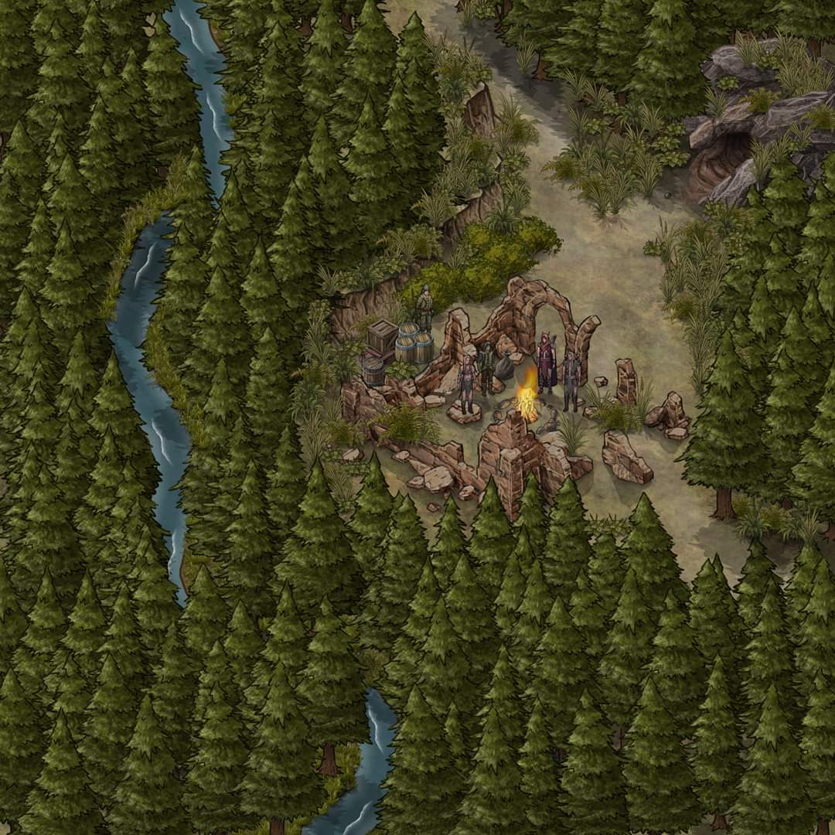

It looked like a makeshift camp in what was once a proper house that now lay in ruins. They’d been led by the smell of the smoke once they’d gotten downwind of it, and were now 200’ above the blokes warming their hands by the campfire. Some reached for their hilts slowly in case there was going to be trouble, but one of the figures stepped forward, put her hand over her brow to shield the tipping sunlight from her eyes, and waved once with a gesture of optimistic caution.

A lean, shorthaired dog barked and made his way to the waving woman, looking up as well.

“Let me go down and talk to them first,” Angren said as they drew closer. Brene held the carpet at 200’ over the trees and 300’ from the clearing. When she stopped, Angren stepped off and flew down to land near the woman. She kept her weapon sheathed, but she did have her shield on her arm.

The woman on the ground cast *detect evil* as Steelshade descended. What she beheld as she approached was a handful of outdoorsy folks dressed as if they’d not known a city in years. Touching down, she was welcome by a woman who called herself Meerat before turning to her friends and referring to them as family, though they were of different humanoid lineages. They had just finished off the last of a meal consisting of venison and roasted pears, and it was clear that Meerat had already determined that Steelshade was not evil, and if and when the others approached, they—too—would register as nonevil.

Angren nodded politely to Meerat. “Well met; I am Steelshade. My companions and I are seeking a woman named Lauren Fifthdaughter. Do any of you know her?”

They looked at one another before Meerat shrugged, “Not by that name. Who is she? What does she look like? We don’t meet a lot of folks here, but over the ages, there’s been a string of strangers we’ve come across.”

“Well, we’re looking for someone who went missing somewhat recently,” explained Steelshade, describing Lauren’s looks.

They all pretty much shook their heads, “Afraid not, though she sounds as formidable as you look,” said Meerat, offering some meat and pears to the half-drow.

“May I call my companions to join us?” Steelshade asked. “We can add to your feast as we speak.”

~*~

A minute later, everyone was munching on some elk, and the conversation had turned to adventuring. “What brought your friend to Arborea?” they asked.

“I don’t know the details,” Steelshade replied, “but she and her companions were on a quest from our home of Waterdeep.”

“Why she might have come back, we don’t know, either,” Atlas supplied.

Brene took another two slices of venison onto her trencher and offered one to the child, who munched willingly, snarling with a delightful purr.

Devrion sat quietly, observing everyone as they ate.

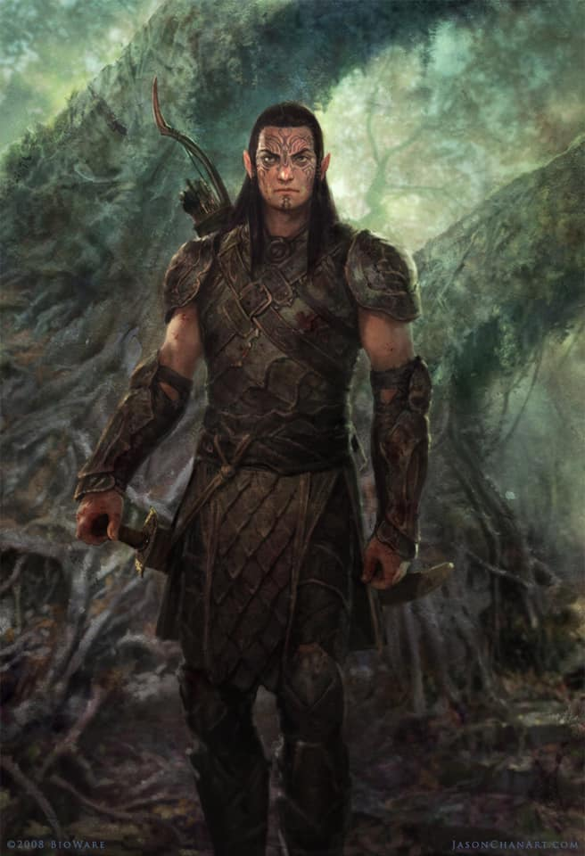

“The child looks like she hasn’t been around people much,” noted one of the quieter adventurers in the back, a half-elf armed like a Black Flame zealot, though he dressed nothing like the fanatics of that hideous cult. Perhaps the sheathed blades at his sides were not kukris. “She fights alongside you?”

“She just dropped in on us,” Brene replied. She went on to explain how the child had been cast down in front of them by a personage unknown, and how they’d cared for her while her true nature was revealed in combat. “I do know she will fight evil aligned folk,” the halfling concluded.

“Does she seem familiar to any of you?” Atlas asked the group at large.

“We don’t get a lot of kids out here,” the half-elf shook his head. “The few I remember don’t look like her kin.”

“Do you know of any portals here?” Angren asked.

They looked at one another, nodding, and mumbling before the words started to be discernible again, “… yeah, the Oak Suite!” one of them recalled.

“Oakleaf!” another provided the correct moniker.

“Oh, right, the Oakleaf Suite. It was cut down,” Meerat recalled the very portal they’d taken there. “So maybe the portal’s gone by now.”

Devrion said, “That’s how we got here, right?”

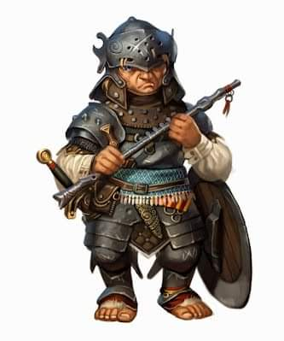

“Oh? Then it’s still active,” said a halfling hero sitting on a rock by where the dog now chilled.

“If we didn’t love it here so much, I’d say let’s make the trek and take a vacation in... where was it that it led? Somewhere on the Material Plane, if I recall,” Meerat frowned, familiar with the lore of this land.

“Maybe we can,” the half-elf proposed. “But not today. I want to sleep here today.”

“There’s that other portal to the Abyss, I think,” the halfling chimed in. “It’s about five times farther than the Oakleaf Suite, right around that direction,” he pointed. “But I don’t think you’re going to want to go there. You’ll get lost in the shifting layers of tunnels in no time.”

“... and it’s a one-way portal,” added Meerat.

“No, I don’t think that was the same portal Lauren mentioned,” Angren said. “She came in from where we started, in Waterdeep.”

“Then, that portal might still be there,” Devrion asked.

“The Oakleaf Suite has been destroyed,” Atlas put in. “That may mean that the portal was also destroyed. Or moved.”

“Who cut down the Suite?” Brene asked.

“Huhhhhh...” Meerat sighed heavily. “The likes of a beholder, and his ilk. The witch who lives in yonder swamp is the only known surviving witness from that event.”

“She was picking elderberries nearby when the beholder apparently took possession of the Citadel of the Planes and all of its portals and encompassing Suites,” the group’s loremaster proclaimed, smoking from his wooden pipe. “These days, she doesn’t seem to want to talk much. I think the whole experience traumatized her.”

“That beholder is dead,” Angren said. “Someone smashed it on the ground right in front of us. They also gave us this child, although she appeared to be human when we first saw her.”

Atlas thought for a moment. “Would you be willing to introduce us to the witch?”

“We don’t want more fights if we can help it,” Brene put in.

They discussed it a little bit, and after a few shrugs and nods, they decided, “We can take you there, but not on that carpet. We can walk.”

Angren and Devrion rolled the carpet and stowed it in Angren’s haversack. “Ready,” the duskblade announced.

Brene leaned close to the child-dragon. “Now, you need to behave yourself. If we attack, then you can. Understand?”

~*~

It felt rather quaint to meander on foot along a barely blazed trail under a canopy of baobabs and other tropical trees and undergrowth. The topography had tapered downward for the last half-mile, and they were about to enter a swampy area where the witch was said to dwell.

“How far is it from here?” asked Brene, holding the child’s hand.

“Another league, maybe,” said the half-elf.

“Noooo!” protested Meerat. “Not even half that.”

“Whatever,” sighed the faux Black Flame guy with the pointy ears. “It *feels* like a league in these boots once we’re in the muck.”

“On that note,” the pipe-smoking halfling asked, “Does anyone have a spell to get us all across this swamp?”

It was clear that the carpet would not sustain them all, and as they went through their respective power repertoires, Atlas proposed, “We don’t have to burden you further. If you point us in the right direction, we five can take the carpet, and no one need get in the muck.”

Meerat shrugged, and looked back to her friends before saying, “If you wish, then yes, this is where we part. We can hunt tapirs and other local game here tonight.”

“A good call,” said one of them.

“Very well then,” the half-elf said. “It’s a fairly straight shot that way, but this area is also home to bullywugs, lizardfolk, troglodytes, and I think we even encountered a kuo-toa raiding party in the estuary.”

“Estuary?” asked Devrion as Steelshade unrolled the carpet and activated its idling hover.

“The swamp soon yields to a delta comprising an expansive estuary. It’s at about that point, where you’d be neck deep in water without your carpet.”

“We appreciate the help in finding this place,” said Steelshade as she and her friends stepped onto the carpet.

<< I *am* Teeth of Fire! >> proclaimed the child in Draconic as she was the last to hop onto the vessel.

The two groups of heroes waved to one another, and went their separate ways.