*Chapter 2: The Unicorns’ Grove*

What exactly this area was had not yet been ascertained; Atlas had not had enough time to determine this based on the physical and metaphysical properties of the Plane, but they were certainly not on the Material Plane.

“Thanks to Aasterinian, we’re out of there,” Steelshade breathed as Devrion piloted the carpet out of the fallen demon’s carcass.

“It was probably Aasterinian who got us into this,” Pussyfoot pointed out. “Where are we, by the way?”

Atlas looked around. “I don’t know. Let me think about it for a moment.” The archivist looked for anything that might give a clue as to where they might be.

The sun shone in what felt like the afternoon sky, based on the warmth that had already ensued over the valley that lay between two verdant mountain ranges. “It will take some time for me to gather the information necessary to orient myself, but perhaps some of the local fauna or other inhabitants may provide some clues.”

As far as the eye could see, there stretched a wooded plain between the two mountain ranges, so it could’ve been Arborea, but it could just as easily have been another life-giving plane.

“Alright,” Steelshade said. “We don’t know where we are, but we still need to rest. We’ve used a good deal of magic, and I—for one—need a bath and a meal.”

There were nods of agreement all around, and so Devrion off up (“up” being west or north according to the sun and how the mountain ridges run) the valley in search of a campsite with water nearby. Everyone kept watch for any denizens who might object to their presence.

Within a few minutes, they happened upon a cataract. It must have been a 200’ drop from the precipice to the stream that reprised its southward course at the bottom. The cliff was a rocky wall that sloped perhaps only one or two degrees at the most, and trees grew tall around both sides of the stream.

“Let’s keep going upstream,” Steelshade said. “There’s too much noise to camp here.”

Devrion flew on, following the stream towards its source to find a quieter place to camp.

Within two minutes, the 6’ wide oxbow waterway had meandered uphill and tapered down to about half its width. The barely babbling brook brought boughs of banyans and baobabs to prominence among the other subtropical species of trees, shrubs and shade-loving plants that covered the forest floor.

Devrion slowed the carpet to a walk and descended toward the treetops. The quartet looked for a suitable place to camp.

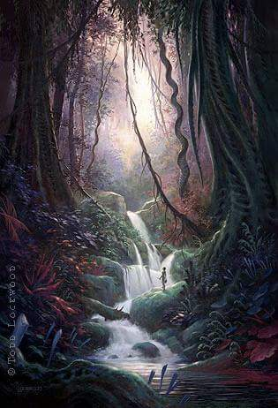

Having selected what appeared to be an ideally defensible location far enough [specify desired distance] from the stream, the party set up camp.

While Steelshade attended to brushing and storing the carpet in her haverpack, Devrion selected three sleeping spots at a campsite about ten yards from the stream. The jungle-bred half-elf ensured that there were no ants or other bugs in evidence, and then he set about clearing the spaces for their bedrolls. The largest one was for Pussyfoot and Atlas, since they slept together. Using his skills as a weaver, he selected some grass from near the stream and assembled pads for the bedrolls.

Steelshade took care of laying a small fire and arranging their cooking supplies, since she had some skill at such things. She extracted their camping kit, which contained trenchers, utensils, and cooking implements. She was careful to use only dry, fallen wood for the fire, which not only was more respectful of the land, but it kept the smoke down.

Atlas arranged his shared bedroll, and then he sat down on a rock with his Tome of Worldly Memory to see if he could determine where they were.

Pussyfoot helped arrange her bedroll, and then she stripped down to her smallclothes, gathered a towel and some soap, and approached her lover. “You can do that later. We need to bathe.”

“I’ll stand watch,” Devrion said as he sat down the last completed mat.

Steelshade pulled out some flour and sourdough starter, and set about making sourdough flatbread for dinner. They had several dried and jerked meats, along with spices and cheese. She spotted several edible plants nearby, and she went to gather them to supplement the meal while the bread dough rested. The duskblade watched as the couple made their way to the water, and she suppressed a pang of yearning for a relationship like theirs.

Atlas bent to lift Brene’s shift over her head, and then he removed his own undergarment and set them both aside on a handy rock. The halfling had found a small pool that came to her waist, but only to his knees. She took a small cloth, wet and soaped it, and started washing her towering lover. It was intimate and loving, and Atlas knelt to return the favor. While neither of them was body-conscious, they didn’t flaunt their physical relationship in front of their friends. So, while they enjoyed each other’s touch, they didn’t indulge in sex play. Also, they needed to remain alert, and so bath time was only that.

From his spot atop a rock overlooking the stream, Devrion was aware of the others, even as he took in his surroundings with due diligence. He sighed mentally as Brene and Atlas bathed, and his gaze fell gently on Angren. He’d met the draconic drow a half-year before, and his fascination with her had only grown as he traveled with her. He’d never asked about her love life, but then she was a very reserved person, no doubt due to her perceptions about her appearance. The duskblade was one of the most fearsome warriors Devrion had ever met. And, she was beginning study on a new form that would make her truly terrifying to any mortal enemy. He chastised himself for allowing his attention to wander, and he continued to scan the area for anything threatening.

Steelshade did catch Devrion’s attention on her, but she pretended to not notice him. He was always polite and kind to her, but there was something else in his manner – he was interested in her. Oh, it wasn’t like the men who’d lusted for her body; she’d had her fill of those, not that she’d ever succumbed to temptation with them. The warmage was... different. She sighed to herself and went back to her cooking.

~*~

Around the time that the flatbreads were done, and were cooling down, Atlas returned with an expression that was neither concerned nor relieved. His body language was calm, but it was apparent to those who knew him best that he was still mulling something over before speaking. Sitting down near the modest campfire that had been stoked with the intention of avoiding a puff of smoke for all the world to see, he collected his foremost conclusions before positing, “I was nearly sure that we were in Arvandor... the topmost layer of Arborea.”

“And we’re not?” Devrion asked. “Could’ve fooled me,” the jungle elf said with nary the knowledge that Atlas possessed in these matters.

“No, I really don’t think so; this is most likely Krigala, the topmost layer of the Beastlands, where the noblest of animals come to exist after their first life has come to pass.”

Steelshade and Devrion recalled some of their pets during their younger years, and that they had been told that this was where their spirits had likely transmigrated after death. They were in the realm of the pooch afterlife, where the River Oceanus coursed before dropping into Arborea and other adjacent Outer Planes, and this little stream in their midst was likely to lead into that massive waterway.

“What gives you the impression that we’re not in Arborea?” Steelshade felt compelled to learn.

Atlas nodded, as he was already going to provide the empirical basis for his claims. The archivist said, “I found some recent—perhaps day-old—hoofprints further down the stream. They and a few droppings are the telltale sign of unicorns, not other ungulates, and unicorns are among the only magical beasts that live here among the beatified reincarnations of what were once lycanthropes and mundane animals.”

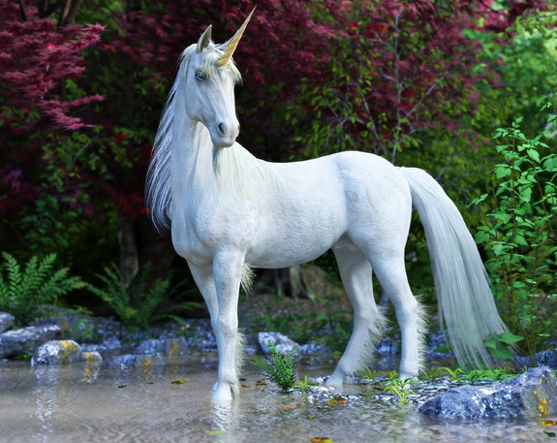

And no sooner had Atlas said this than the party became aware of the fact that they were now being watched. Turning around in every direction, the quartet now saw and heard a dozen or so unicorns of various colors approaching. Their hooves were more ovalesque than those of horses and other equines, which served to confirm Atlas’ posited suspicions, and though Steelshade’s kneejerk reaction was to reach for the mercy of her falchion, she stayed her hand before drawing the weapon.

“Remain seated, friends,” Atlas whispered calmly, intuiting the strangers’ intentions.

One of the unicorns was clearly wounded, though not badly, and his cream-and-white hair and mane were partly coated in dried blood, but their body language was nonconfrontational, and their steps were akin to a humanoid walking cautiously.

“Oh, he’s hurt!” Pussyfoot exclaimed.

“Just sit still,” Atlas told her. “Let them come to us.” He looked at the closest unicorn. “We can help your injured one, if you will allow it.”

The message appeared to be well taken, and within less than a minute, the dozen unicorns had traversed the remaining hundred feet or so between themselves and the party, and were in their midst, with some sitting down to lick the wounds that were now evident on nearly all of the magical creatures.

The initial conversation—which took place in the Common tongue—told of a warband of rabid centaurs who had ambushed them in their sacred grove, slain a handful of them along with the werebear druid who had lived with them for years, and injured nearly the rest of the entire herd.

*[If there are any actions, such as casting cure spells on the unicorns, this is a good place for them.]*

“Centaurs, you say?” Devrion was surprised.

“Yes, but there was something off about these centaurs. They radiate evil,” answered the group’s Celstial charger, a cleric of Mielikki named Dremu. “And their weapons, gear, and tattoos bore the symbolism of demonic spirits.”

This raised concern in the heroes’ minds, as they’d just been through the bowels of the greatest demonic presence they’d ever encountered... and here, in the heart of the Beastlands, no less. With no *detect evil* spells at his disposal, Atlas could still tell that these creatures were neither malicious nor deceitful, and after some subtle confirmation of his allies’ concurring with his assessment, he felt comfortable enough to share, “We spent the greater part of today vanquishing a macrodemon. Her remains are only a few leagues from here.”

Intrigued by the chilling news, the unicorns asked to know more, particularly with attention to what manner of threat this demon might have posed to this region. Atlas indulged them, beginning with the tale of how they came to know of the macrodemon’s whereabouts, and their plight to reach it. “We had tracked the Outsider to the edges of Gehenna, where some other fierce creature had minced portions of the demon’s anatomy and strewn them about to fester.

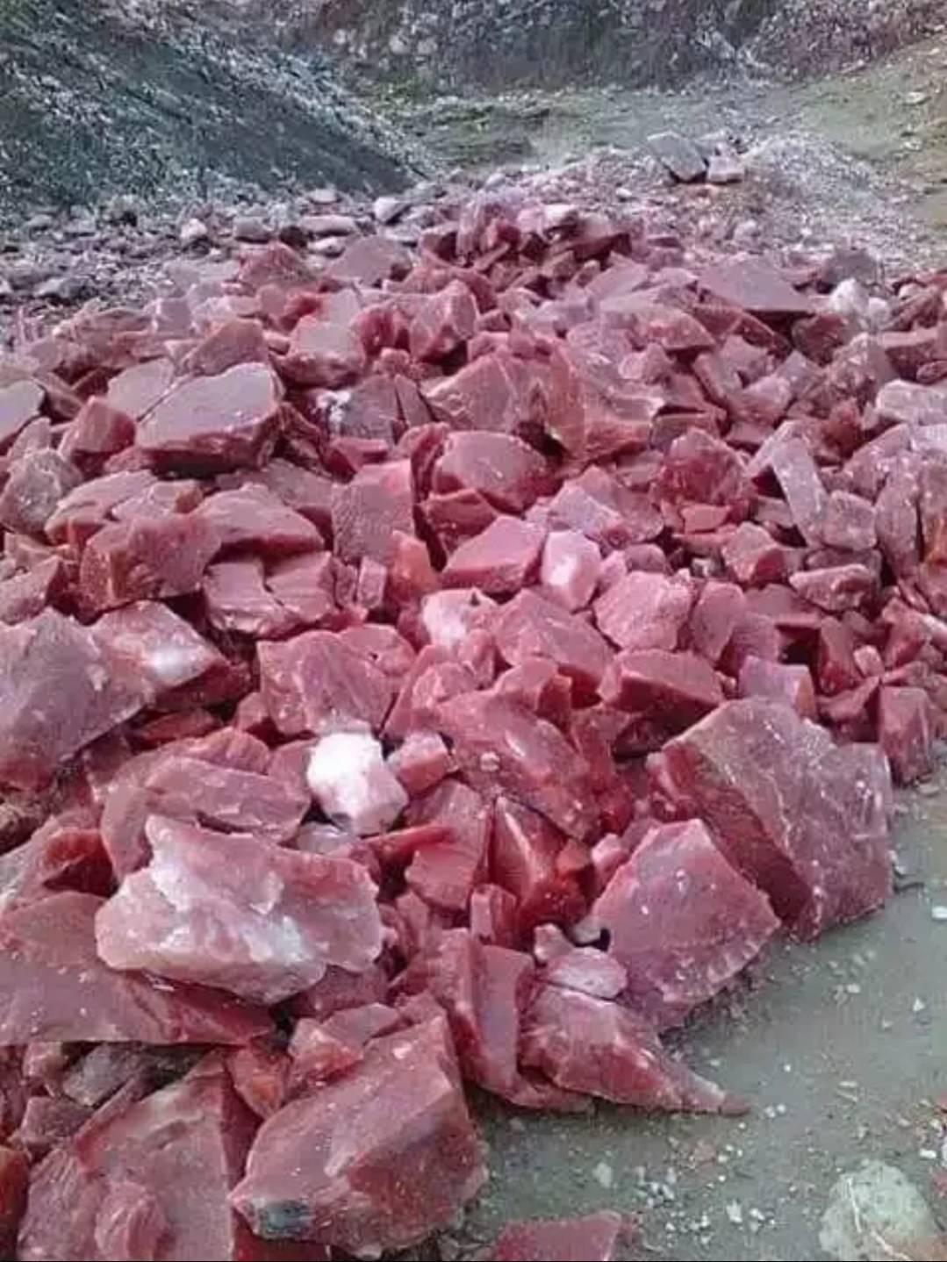

This vile flesh had petrified by the time we’d gotten there, but the stench of pestilence still hung heavy in the air. Some of the chunks assumed the form of dretches, but we—that is, Steelshade here—managed to cut them down with little effort, and in their wake, we found the organ from which the diced chunks had been severed.

We were misfortunate enough to have gotten sucked into a quicksand-covered aperture, and had to slash and burn our way through a length of organs and vessels before exiting the vile creature, only to find ourselves in the colon of a far more massive demon.”

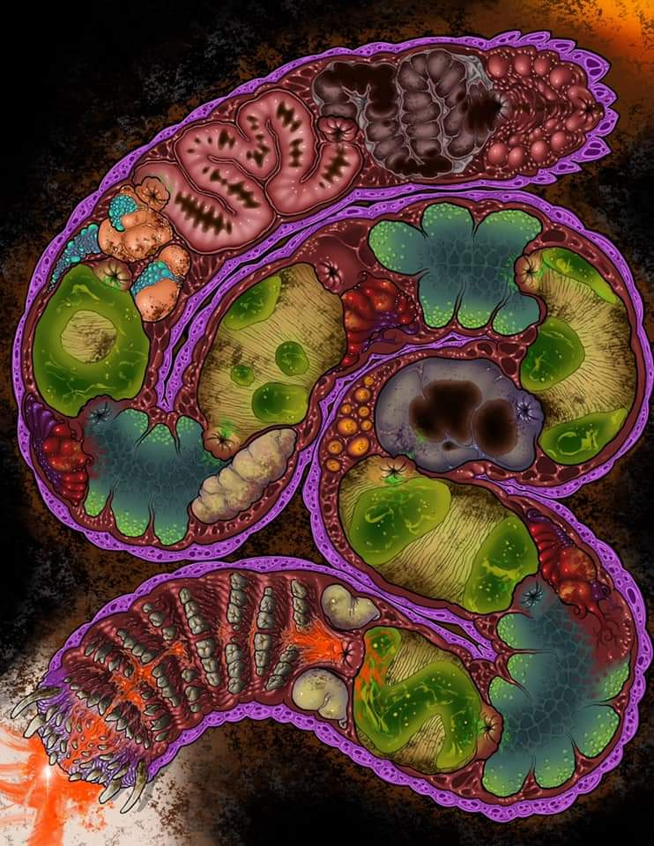

“A demon within a demon?” one of the younger centaurs was in awe.

“Alas, the worst of fates, if you can imagine it,” Pussyfoot interjected.

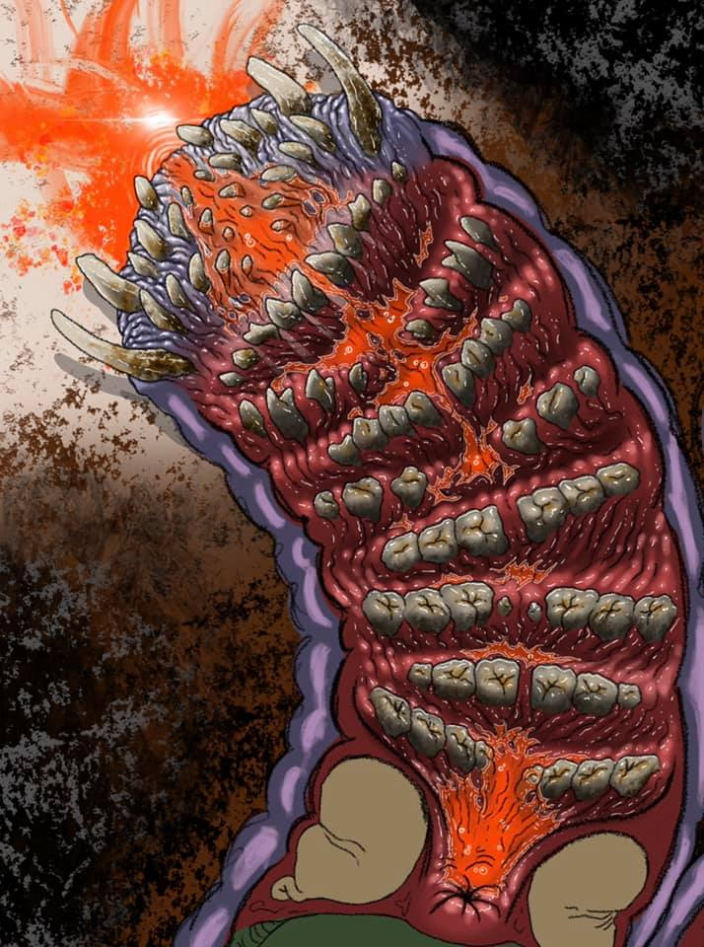

Her lover continued, having documented and archived the account in his leatherbound annals. “Aye, and though it was unclear as to whether we traversed through one beast after that or several, we ended up in a stony chamber only to find ourselves having to face off against a charnel worm.”

The unicorns didn’t know what that was, but the description caused their blood to chill and their skin to quake. By now, the unicorns were all seated, some in pairs or triads, near the fire under canopy of trees that shielded them from the perpetual afternoon sky.

Atlas moved from one unicorn to the next, praying for each of them in turn, then took note of his remaining daily spells.

|  |  |  |  |  |
| --- | --- | --- | --- | --- |
| *Daily Prayers* | | | | |
| **Prayer** | **Level** | **Electric** | **DC** | **Cast?** |
| Read Magic | 0 | 0 | 15 | q |
| Detect Magic | 0 | 0 | 15 | q |
| Message | 0 | 0 | 15 | q |
| Cure Minor Wounds | 0 | 0 | 15 | þ |
| Sanctuary | 1 | 0 | 16 | q |
| Endure Elements | 1 | 0 | 16 | q |
| Cure Light Wounds | 1 | 0 | 16 | þ |
| Entangle | 1 | 0 | 16 | þ |
| Bless | 1 | 0 | 16 | q |
| Spell Flower | 1 | 0 | 16 | q |
| Summon Monster I | 1 | 0 | 16 | q |
| Cure Moderate Wounds | 2 | 0 | 17 | þ |
| Identify | 2 | 0 | 17 | q |
| Silence | 2 | 0 | 17 | q |
| Spiritual Weapon | 2 | 0 | 17 | q |
| Flaming Sphere | 2 | 0 | 17 | q |
| Restoration, Lesser | 2 | 0 | 17 | q |
| Cure Moderate Wounds | 2 | 0 | 17 | þ |
| Dispel Magic | 3 | 1 | 19 | q |
| Call Lightning | 3 | 0 | 18 | þ |
| Stone Shape | 3 | 0 | 18 | q |
| Summon Nature’s Ally III | 3 | 0 | 18 | q |
| Footsteps of the Divine | 3 | 0 | 18 | q |
| Heart’s Ease | 3 | 0 | 18 | q |
| Footsteps of the Divine | 3 | 0 | 18 | q |
| Restoration | 4 | 0 | 19 | þ |
| Restoration | 4 | 0 | 19 | q |
| Freedom of Movement | 4 | 0 | 19 | q |
| Freedom of Movement | 4 | 0 | 19 | q |
| Divine Storm | 4 | 0 | 19 | q |
| Divination | 4 | 0 | 19 | q |
| Flame Strike | 5 | 0 | 20 | þ |
| Flame Strike | 5 | 0 | 20 | q |
| Flame Strike | 5 | 0 | 20 | q |
| True Seeing | 5 | 0 | 20 | q |
| True Seeing | 5 | 0 | 20 | q |
| Chaav’s Laugh | 5 | 0 | 20 | þ |
| Chasing Perfection | 6 | 0 | 21 | q |
| Chasing Perfection | 6 | 0 | 21 | q |
| Chasing Perfection | 6 | 0 | 21 | q |
| Chasing Perfection | 6 | 0 | 21 | q |
| Dispel Magic, Greater | 6 | 0 | 21 | q |
| Restoration, Greater | 7 | 0 | 22 | q |
| Plane Shift, Greater | 7 | 0 | 22 | q |
| Plane Shift, Greater | 7 | 0 | 22 | q |
| Withering Palm | 7 | 0 | 22 | q |
| Lion’s Roar | 8 | 0 | 23 | þ |
| Brilliant Aura | 8 | 0 | 23 | q |
| Discern Location | 8 | 0 | 23 | q |
| End to Strife | 9 | 0 | 24 | q |
| Gate | 9 | 0 | 24 | q |

Steelshade used her Healing Belt, as needed, until the creatures were as healed as they could make them. The quartet didn’t use any of their non-renewable healing devices, though.

Finally, Atlas sat back down, tired from his ministrations. “We may be able to help you with the centaurs. Are there others here who would be able to help us fight them?”

“This is a desolate place, rife only with the noble animal folk that creep over the land and burrow under it,” said a wu-jen unicorn named Tsuamu.

Dremu added, “Let’s not forget those who take wing over the land, and dwell among treetops.”

Tsuamu and others nodded.

Dremu then reconsidered, and continued, “There are... perhaps... some who may be inclined to ally with us, but if they’ve not yet encountered these nefarious centaurs, it may be a challenge to convince them of the threat at hoof.”

Atlas and the other three humanoids translated the turn of phrase, and the archivist replied, “Of whom do you speak, Dremu?”

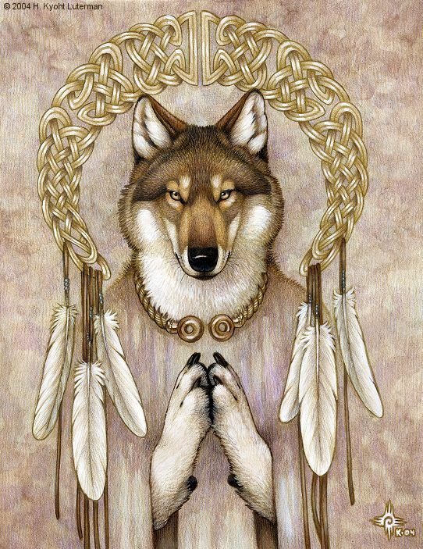

“There is a pack of werejackals—and unlike most creatures of that lineage—they abhor evil, and live as harmoniously as werebears and wereboars,” Dremu told the heroes. “They are led by a shaman named Antioch, and though they prefer to remain isolated in yonder slopes,” he pointed with his horn towards the east, where there were presumably some hills beyond the immediate forest, “they are not hostile to us. We generally respect their isolationist proclivities, and have never had cause to war with them, but it has been ages since we’ve come across any of them, and I cannot say whether they would accept an offer of armistice against those who have threatened us. Antioch has a younger sibling—a bard named Serendip—who has earned great renown for his ability to inspire passionate resolve in the midst of conflict. His lyrics and melodies are known throughout the valley, and even Zynphymu here...” he motioned with his horn towards the herd’s resident bard, “... has adapted some of Serendip’s ditties into his own repertoire of inspiring cants.”

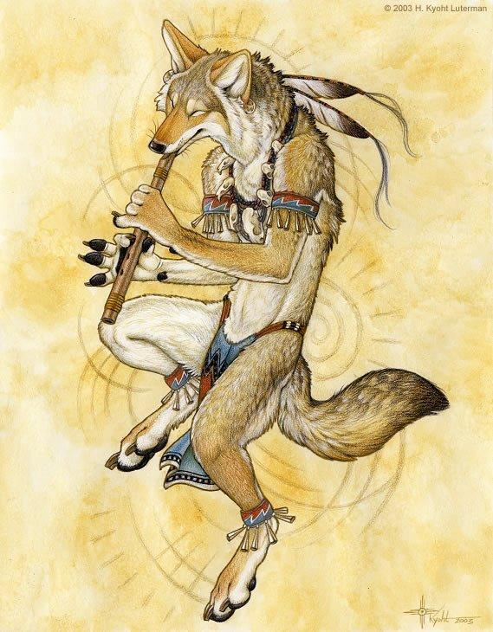

The four looked at each other as the unicorns finished their tale. Steelshade nodded at Atlas, as did Devrion and Pussyfoot, in turn.

The archivist turned back to Dremu. “We will help you as we may, although we need to rest for a time to regain some of our spells.”

The unicorns were glad to have taken the chance on the non-evil aliens to this world. The cleric of Mielikki—Dremu—said a prayer in their name as they began to set up their sleeping gear under the constant light of the afternoon sun, a pale orb whose cosmic beams pierced through the canopy of trees above, and suggested that it was not bedtime, despite the heroes’ circadian biorhythms telling them otherwise.

The unicorns were grateful for the healing bestowed upon them, and Dremu also expended the last of his divine repertoire on the remaining wounds before settling down against a thick tree trunk on the outskirts of the campsite.

Steelshade had earlier set a flat iron griddle on the fire when she’d laid it. Now it was hot and ready to use. She opened her haversack and took out a large, covered wooden bowl. It held enough fermented dough for the four of them, plus a healthy portion of starter for the next recipe. Using some oil, salt, seasonings, and fresh herbs she’s found, she fashioned the dough into flat slabs and laid them on the grill. Next came some jerked beef and sausage, which she sliced into thin pieces, along with some slices of hard cheese. She heated the meat on the griddle, and then arranged the pieces on the flatbread as it cooked. While it cooked, she added more flour and water to the sourdough starter, resealed the bowl, and put it away for the next meal.

From their mundane rations, Steelshade’s Everfull Mug, her gathered items, and Pussyfoot’s Everlasting Rations, Steelshade incorporated a variety of dried vegetables, fruit, honey, nuts, wine, and mushrooms into their meal, which she served on simple wooden chargers and matching wooden cups. For the unicorns, the drow set out the choicest of the vegetables she’d found, laying them out on a convenient, fallen log for them to sample.

After the food was eaten, and the utensils cleaned and stored, Steelshade banked the fire down to a small pile of coals that would last until they broke fast in the “morning”. Atlas and Pussyfoot retired to their shared bed, where they had rigged a light cloak between their packs that would act as a shade over their heads as they rested. The pair settled into their bed, and they were soon asleep.

Steelshade had arranged her pallet next to a tree, where she could sit and lean back in a comfortable position. Like most elves, she didn’t sleep much, but instead she would enter a light trance that afforded her mind and body the rest they needed. Devrion likewise settled in a few feet away on his preferred bed, where he lay supine in the trance state and position he preferred. Neither of them was bothered by the ever-present light as they rested. Both of them kept their armor on for their rest period.

~*~

Hours passed, and with the dozen unicorns around them, none of them felt the need to stand watch. In the end, the only thieves that passed through their camp were a pair of squirrels who made short work of their flatbread, leaving only crumbs where the uneaten bread had sat. They would’ve likely gone for the less grainy foods had one of the unicorns not snorted and startled them as he came momentarily out of slumber, then rolled onto his other side and dozed off again.

The scent of sleeping unicorns was somewhat relaxing to Pussyfoot and her friends: musky but with a hint of camphor. When their bodies told the halfling that it was time to rise, she took a look around her, noting that the jungle elf and draconic drow were still sitting in their meditative postures, concluding long sessions of open-eye meditation.

The next few minutes included hygienic rituals at the riverbank, and as the unicorns went to their respective peripheries of the campsite to relieve themselves, birds chirped melodically overhead. As Steelshade and her friends struck camp and placed most of their belongings in haversacks and packs, Dremu and Tsuamu conversed on how best to approach the werejackals and broach the subject of an armistice against the centaurs. For all they knew, the centaurs had besieged them as well, but it was impossible to tell.

The heroes, now freshly groomed and briskly awake under the perpetual afternoon light filtered by leaves and branches, was now ready to follow the unicorns eastward to the hills. “We would offer to let you ride atop the heftiest of us,” Tsuamu proposed, pointing with his horn to his four brethren who bore no saddles, but could likely carry any single humanoid atop their back with perhaps a blanket as a makeshift weight distributor, and not much else ado. The largest of them—as muscular as a draft horse—looked at Atlas with an invitation, while the others waited to see if the slighter heroes wanted to ride with them.

“Brene and I aren’t good riders, but we will go,” Atlas said. The four provided their own blankets to sit on, and Atlas lifted Pussyfoot onto the smallest of the unicorns. He climbed aboard the largest, while Devrion and Steelshade, both more skilled riders, selected among the other two. Steelshade briefly considered using the carpet, but she discarded that idea, since it could be spotted well before the riders could see anyone on the ground in the forest.

~*~

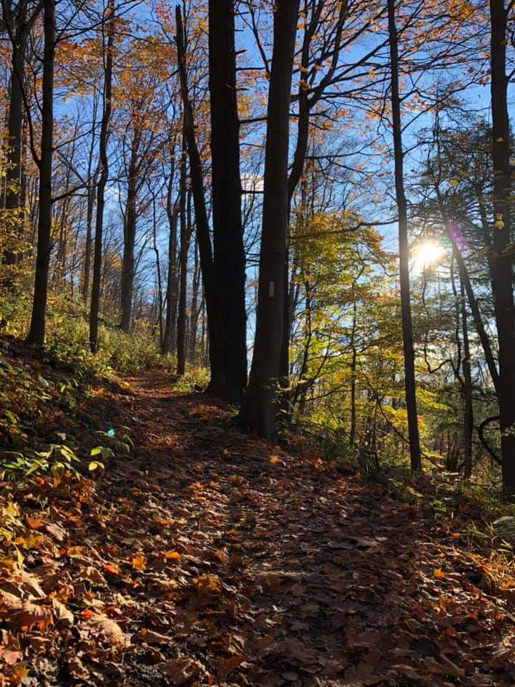

With the sun in the western sky, they began to scale the first row of wooded hills, along a path that wound predominantly northwards for a while, then continued east and into a grassy valley.

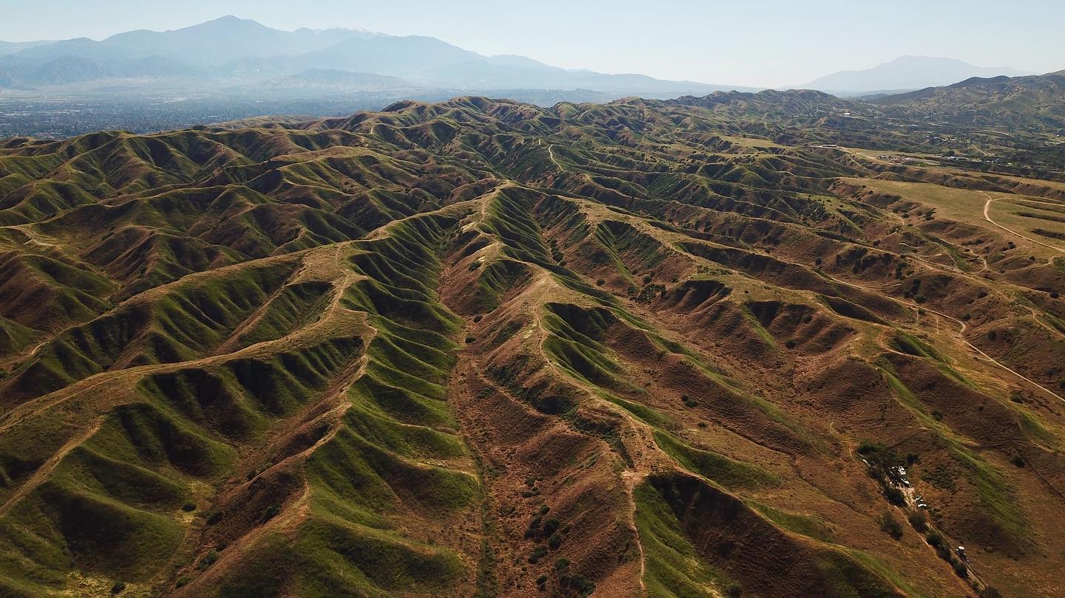

The path meandered along a well-beaten trail that had, again, wound northward, and at one point, following bipedal lupine tracks, the unicorns veered eastward once again and unto a complex of hills that did well to hide anyone who would call this topography their home.

They did not find the werejackals so much as the werejackals found them, and in a less than welcoming manner, the lycanthropes held bows and arrows trained on the twelve unicorns and their four riders for a minute or so while the initial parlaying took place. Tsuamu and Dremu did the talking, and one by one, wary archers lowered their weapons.

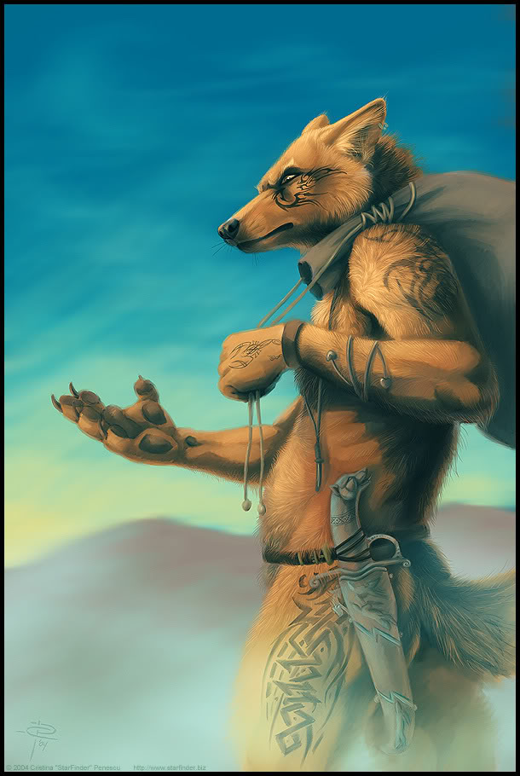

Both armed with khopeshes and no ranged weapons, Antioch and Serendip lived up to their renown by casting the necessary spells to dispel any notions that the intruders and/or their items were evil, and once they’d marched to a safer cranny within these hills, Serendip invoked a *zone of truth* spell to stave off any notions of ulterior motives on anyone’s part.

Once the initial tale of the centaurs was told to the werejackals, Antioch asked the humanoids, “How came you to exist here on Krigala?”

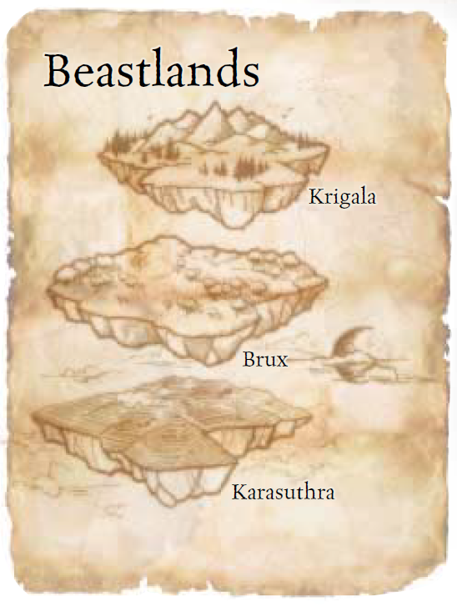

“Krigala?” Atlas considered for a moment, and then he nodded. The archivist related the events that led up to their meeting with the unicorns, including the battles within the megademon. “We agreed to help these folk,” he indicated the unicorns with a wave of his hand, “and so, here we are.”

The werejackal elders nodded, and Antioch proposed, “We would do well to strategize some contingencies. Have we any indication that they are coming to us? This would turn any disadvantage into an advantage, I would think.”

Dremu said, “I have prepared a good amount of martially oriented spells for the day, but even with these, we alone would not stand a chance against the scores of centaurs that we faced and barely escaped.”

The werejackals had also done so, as was their standard practice to do even on the most placid days. Moreover, their time to prepare spells again was coming up momentarily, so they could further martialize their repertoires in anticipation of an ambush. The druid among them—Karpath—set aloft his aquiline companion to scout the surrounding area in case anyone was approaching.

“We thank you, outlanders, for your altruism, and while we cannot reward you in gold and material riches,” Serendip sighed, “we will be glad to call you our brethren from this day forth.”

Atlas mentally reviewed his list of prayers, and decided that the selection he had will suffice for the day.

Steelshade spoke up. “Do any of you know where these centaurs may have come from, and why they might have attacked you?”

“They seemed aimless in their murderous attack,” Tsuamu shook his head. “I’ll wager they defiled the bodies of our fallen brothers and sisters. We have little of material value to plunder.”

Karfmu added, “The telltale signs of demonic worship make it very clear to me: they meant only to offend the nature of this world, to sully our peaceful plane with their masters’ evil.”

Pussyfoot noted that her health was back to normal now. Having slept off the effects of the *cloudkill* spell inflicted on her by the fiendish efreeti, she could now breathe a little easier.

Steelshade exchanged her Amulet of Tears for her Farspeaking Amulet, and gave one crystal to each of her companions.

“Evil for the sake of it,” Atlas shook his head. “That’s not much of a way to live.”

“I suppose they think it’s easier,” Devrion mused. “Selfishness always has a price.”

“In this case, the price is us, if we can find them,” Steelshade put in.

Pussyfoot stood next to Atlas, her hand in his. “But we would be so bored, if it were otherwise.” Atlas snorted at her, and she looked up at him. “What?”

~*~

The eagle brought back to its druid companion news of a smoke puff near the unicorns’ prior habitat, and reported also having spotted a single centaur scout patrolling the hinterland between the smoke puff and where the heroes were now. Karfmu relayed this to the group, and estimated, “Our former settlement is about fifteen miles out.”

They would have to traverse the same hillsides that they’d taken to get here, but Dremu know of a more direct path that would circumvent the humanoids’ campsite where they’d slept until a few hours ago.

“Then, let us be on our way,” Steelshade said.

~*~

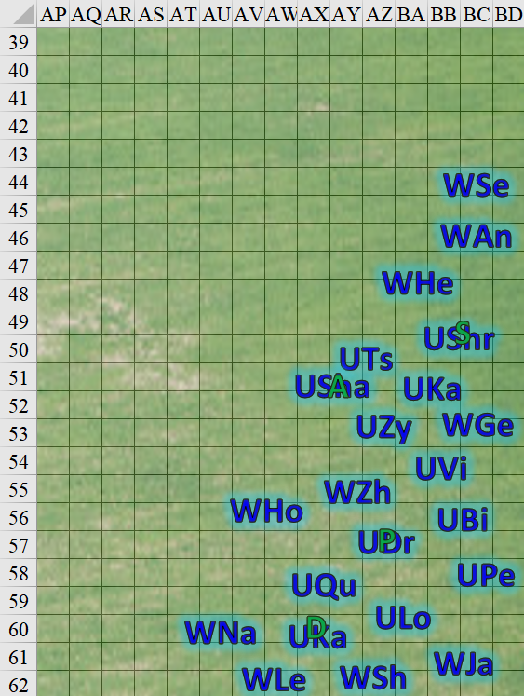

Their trek towards the centaurs’ presumed whereabouts was uneventful; all they spotted was a single scout in the far reaches of a field, who in turn spotted them and fled into the woods. Within minutes, the unicorns, werejackals, and humanoids had made it down to the plain, while centaurs had gathered along the edge of the forest. They were twelve unicorns, ten werejackals, and four humanoids, and there must have been as many representatives on the opposing side. Numbers-wise, it looked to be a fair fight, but Atlas and Steelshade suspected that reinforcements might have been standing by beyond the first rows of trees and bushes.

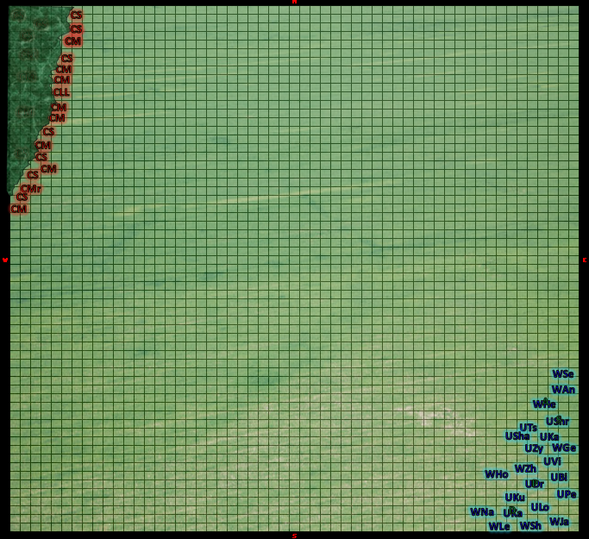

A horn was blown by one of the centaur archers, and though the two factions were almost 400’ away from one another, Dremu said, “Now is the time.”

Atlas and Devrion knew that their longest-range spells would reach the enemies by now, and prepared to cast some.

Centaur archers drew and nocked arrows, training their bows on the heroes and their friends, and with this, the legendary leader of the centaurs yelled, “Carnaaaage!”

The centaurs armed with axes and other melee weapons began to charge forward while the skirmishers took a few steps southeast, though no shots were fired yet.

From the forest’s edge, there emerged another handful of centaurs to back up those who’d already reached the frontline.

Round 1

|  |  |  |  |  |  |
| --- | --- | --- | --- | --- | --- |
| **Character** | **Group** | **Initiative** | **Roll** | **Modified**  **Roll** | **Move** |
| Devrion | 1 | 2 | 20 | 22 | 30’ |
| Steelshade | 1 | 6 | 14 | 20 | 30’ |
| Unicorns | 2 | 3 | 14 | 17 | 60’ |
| Atlas | 1 | 2 | 10 | 12 | 30’ |
| Werejackals | 2 | 3 | 8 | 11 | 30’ |
| Pussyfoot | 1 | 5 | 2 | 7 | 20’ |
| Centaurs | 3 | 2 | 5 | 7 | 50’ |

Devrion sat up straight and grinned wolfishly. This was what a warmage trained for, and, though he no longer desired that life, he relished the impending battle. He pointed toward the center of the enemy formation, and spoke sharply. “Földrengés!”

|  |  |  |  |  |
| --- | --- | --- | --- | --- |
| **Character** | **Save vs.**  *earthquake* | **Ranks** | **Roll** | **Check** |
| Centaur, elite (Leg. Ldr) | Reflex | 9 | 18 | 27 |
| Centaur, elite (Marshal) | Reflex | 9 | 14 | 23 |
| Centaur, marauders 1 – 5 | Reflex | 7 | 2 | 9 |
| Centaur, marauder 6 – 10 | Reflex | 7 | 12 | 19 |
| Centaur, marauder 11 – 15 | Reflex | 7 | 11 | 18 |
| Centaur, skirmisher 1 – 5 | Reflex | 6 | 13 | 19 |
| Centaur, skirmisher 6 – 10 | Reflex | 6 | 17 | 23 |
| Centaur, skirmisher 11 – 15 | Reflex | 6 | 7 | 13 |

*Success, success, fail, success, success, success, success, fail.*

*Centaur marauders 1 – 5 and skirmishers 11 – 15 fell into fissures.*

Steelshade drew her sword and palmed her Cube of Force. If the arrows came her way, she would shield herself and those nearby with it.

Having cast *detect* evil earlier on their descent from the hills in order to determine if a noise they’d heard was anything to worry about, Dremu now advanced a bit, ensuring that Pussyfoot was snugly seated atop him.

Having cast *detect magic* when they’d first spotted the first centaur sentry, Karfmu continued to concentrate in order to figure out if there had been any magic cast on the part of the battlefield where they now were, but noted nothing within 60’ of her. Reporting this, she then cast *barkskin [expired long after this battle]* upon herself.

*Karfmu gained +3 to AC.*

Tsuamu had also cast *detect magic*, but earlier, and the spell had now expired. He cast *protection from arrows [expired long after this battle]* and moved with the frontline unicorns.

*Tsuamu gained dr 10/magic against ranged weapon attacks.*

Zynphymu’s *detect magic* spell had also been spent when they’d encountered the werejackals, and the male unicorn now cast *message [expired long after this battle]* so he could instantly talk with a few of his unicorn friends as they advanced cautiously.

With Steelshade atop her back, Shrikteh cast *eyes of the avoral [expired long after this battle]*, gaining the keen sight of a member of that Celestial race. She then walked forward to keep up with her place in the formation.

*Skrikteh gained +21 to Spot.*

Having cast *mending* in order to fix her magical gorget, Viriteh now cast *entropic shield [expired on Round 61]* upon herself, and walked northwestward.

*Virieth gained deflection against incoming arrows, rays, and other ranged attacks. Each ranged attacker must make an attack roll (including arrows, magic arrows, Melf’s acid arrow, ray of enfeeblement, and so forth) has a 20% miss chance (similar to the effects of concealment).*

Shamu did not yet go into a rage, but advanced to the far north nonetheless with Atlas riding him.

Having already spent his *detect aberration* and *know direction* spells today, Birimu now cast *call lightning [expired on Round 51]*.

*Birimu gained 10 lightning bolts.*

Pertenteh was still benefitting from a *longstrider* spell, and moved into position near Shamu.

Qusamteh cast *detect snares and pits [expired long after this battle]*, and moved forward.

The Lookout took a leading position among her allies.

With Devrion on her back, Kadabteh had recently cast *mage armor [expired long after this battle]*, and now cast *nightshield [expired on Round 51]*.

*Kadabteh gained immunity to magic missiles and +1 to all Saves.*

Atlas held his magic, since he’d not prepared anything particularly effective at that distance.

Antioch had also cast a few divinations on their way down from the hills, and now led his kin forward as he prepared to cast some of his more offensive weapons once they got into range.

Moving in tandem with his brother, Serendip riled his allies with his Hardy Soldiers aura.

*Allies within 60’ gained dr 2/-.*

January, Geninieve, and Zhou took up positions along the south of the formation.

Hefty was not too far north of them, and prepared to enter a raging fit once they got closer.

Hodge cast *haste [expired on Round 8]* upon herself and six of her friends, then moved forward a bit.

*Hodge, Viriteh, Qusamteh, Genevieve, Shags, Levon, and Navyblu gained +1 to AC, BAB, Reflex Saves, and extra attack or 30’ movement.*

Shags had already cast *know direction* and *detect aberration*, and now cast *call lightning [expired on Round 51]* as he moved forward.

*Shags gained 10 lightning bolts.*

Levon cast *detect snares and pits [expired long after this battle]*, and moved forward.

Navyblu moved to the frontline.

Pussyfoot rode her unicorn and watched their enemies approach.

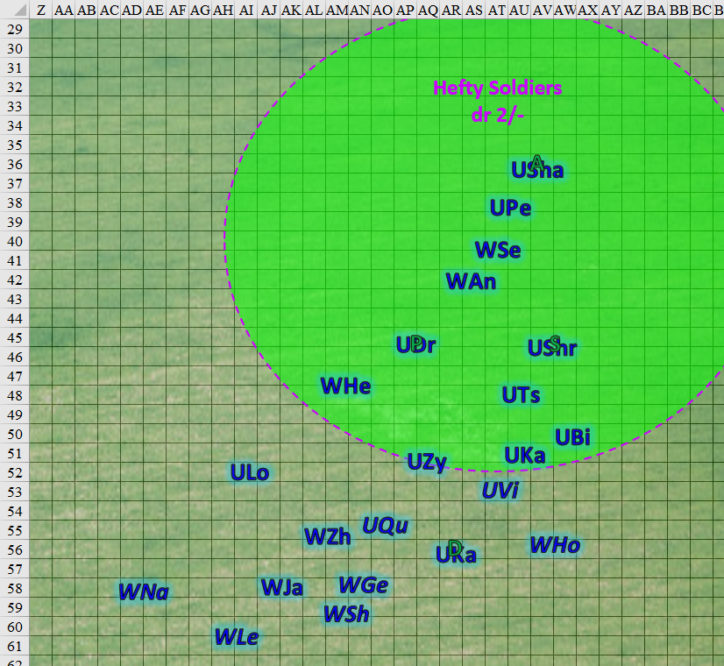

The fissures caused by Devrion’s spell closed up, swallowing almost a dozen of the enemies, some of which were still in the forest.

*Centaur marauders 1 – 5 and skirmishers 11 – 15 died.*

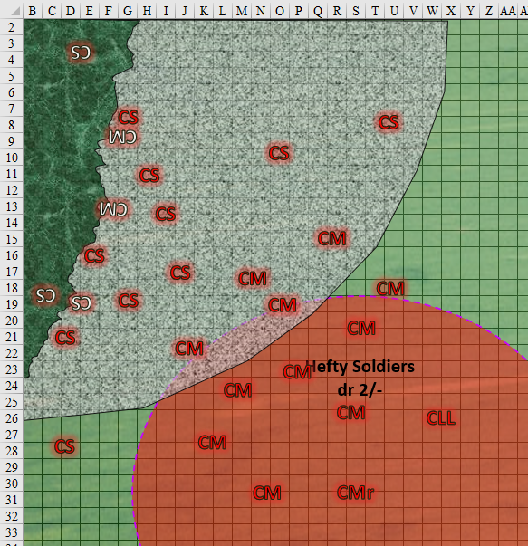

The centaurs did their best to overcome the earthquake, and charged forth with contempt.

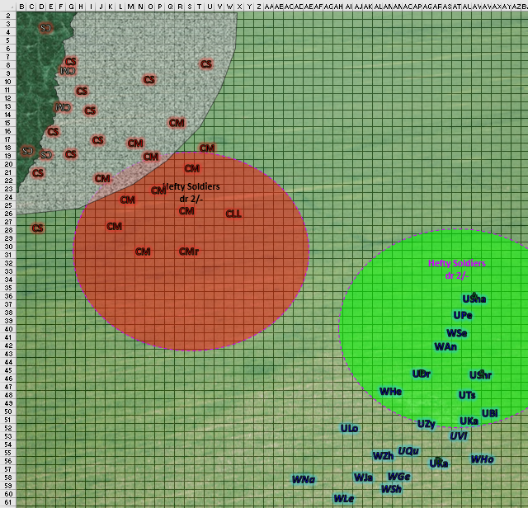

Round 2

Devrion again targeted the center of the enemy formation. “Földrengés!”

|  |  |  |  |  |
| --- | --- | --- | --- | --- |
| **Character** | **Save vs.**  *earthquake* | **Ranks** | **Roll** | **Check** |
| Centaur, elite (Leg. Ldr) | Reflex | 9 | 11 | 20 |
| Centaur, elite (Marshal) | Reflex | 9 | 19 | 28 |
| Centaur, marauder 6 – 10 | Reflex | 7 | 9 | 16 |
| Centaur, marauder 11 – 15 | Reflex | 7 | 14 | 21 |
| Centaur, skirmisher 1 – 5 | Reflex | 6 | 16 | 22 |
| Centaur, skirmisher 6 – 10 | Reflex | 6 | 14 | 20 |

*Success, success, fail, success, success, success.*

*Centaur marauders 6 – 10 fell into fissures.*

This earthquake was far more significant, and shook the centaurs so bad that it made them dizzy for the next 12 seconds. They all stopped in their tracks or fell into another series of fissures.

Steelshade cast *barkskin* *[expired on Round 1021]* on herself and continued to ride forward.

*Steelshade gained +5 to FFAC and AC.*

Dremu witnessed the massive earthquake that plummeted another handful of centaurs to their dooms, made his way northwest, and cast *hammer of righteousness* upon the centaurs’ legendary leader, a buxom woman whose appearance was magically enhanced to appear innocuous.

|  |  |  |  |  |
| --- | --- | --- | --- | --- |
| **Character** | **Save vs.**  *hammer of righteousness* | **Ranks** | **Roll** | **Check** |
| Centaur, elite | Fortitude | 10 | 18 | 28 |

*Success. Saves for ½ damage.*

*Dmg: 43 positive.*

*Dmg to Dremu: 2 Strength.*

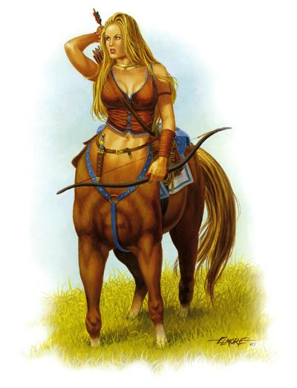

Karfmu moved 50’ northwest, cast *call lightning [expired on Round 82]* and hurled a lightning bolt at the centaur marshal.

|  |  |  |  |  |  |  |  |
| --- | --- | --- | --- | --- | --- | --- | --- |
| **Character** | **Attack Type** | **Damage** | **BAB** | **Dex Mod+** | **Total Score** | **Roll** | **Total** |
| Karfmu | Call Lightning | 4d6 electric | 4 | 4 | 8 | 1 | 9 |

*Miss.*

Tsuamu cast *fireball* upon the centaurs’ legendary leader.

|  |  |  |  |  |
| --- | --- | --- | --- | --- |
| **Character** | **Save vs.**  *fireball* | **Ranks** | **Roll** | **Check** |
| Centaur, elite | Reflex | 9 | 0 | 9 |

*Automatic failure. Dmg: 27 fire.*

Zynphymu moved closer to some of her allies, then cast *haste [expired on Round 9]* upon himself, Hefty, Zhou, the Lookout, Viriteh, Genevieve, Kadabeh, and Devrion.

*Zynphymu, Hefty, Zhou, the Lookout, Viriteh, Genevieve, Kadabteh, and Devrion gained +1 to AC, BAB, Reflex Saves, and extra attack or 30’ movement.*

With Steelshade on her back, Shrikteh moved about 50’ northwest and cast *searing light* upon the centaur marshal.

|  |  |  |  |  |  |  |  |
| --- | --- | --- | --- | --- | --- | --- | --- |
| **Character** | **Attack Type** | **Damage** | **BAB** | **Dex**  **Mod+** | **Total**  **Score** | **Roll** | **Total** |
| Shrikteh | Ranged Touch | Searing Light 3d8 | 4 | 4 | 8 | 10 | 18 |

*Hit. Dmg: 13 fire.*

Viriteh *[hastened]* cast *shield of faith [expired on Round 62]* upon herself, then moved towards the frontlines.

*Viriteh gained +3 to TAC and AC.*

Shamu entered a state of rage, and charged towards the centaur marshal, making sure to not get caught in the magical earthquake.

*Shamu gained +4 to Strength, Constitution, and Will saves, and incurred –2 to AC.*

Birimu could only reach the legendary leader with her *lightning*, so she targeted that woman and let loose the bolt.

|  |  |  |  |  |  |  |  |
| --- | --- | --- | --- | --- | --- | --- | --- |
| **Character** | **Attack Type** | **Damage** | **BAB** | **Dex Mod+** | **Total Score** | **Roll** | **Total** |
| Birimu | Call Lightning | 4d6 electric | 4 | 4 | 8 | 14 | 22 |

*Hit. Dmg: 16 electric.*

Pertenteh and Qusamteh *[hastened]* charged forth, also avoiding the area subject to Devrion’s earthquake.

The Lookout *[hastened]* moved northwest and prepared to do battle with the centaurs.

Kadabteh *[hastened]* moved 50’ northwest and cast *Melf’s acid arrow* upon the marshal.

|  |  |  |  |  |  |  |  |
| --- | --- | --- | --- | --- | --- | --- | --- |
| **Character** | **Attack Type** | **Damage** | **BAB** | **Dex Mod+** | **Total Score** | **Roll** | **Total** |
| Kadabteh | Ranged Touch | Melf’s Acid Arrow | 4 | 4 | 8 | 11 | 19 |

*Hit. Dmg: 4 acid + 4 acid on next round.*

Antioch cast *hammer of righteousness* upon the centaur marshal.

|  |  |  |  |  |
| --- | --- | --- | --- | --- |
| **Character** | **Save vs.**  *hammer of righteousness* | **Ranks** | **Roll** | **Check** |
| Centaur, elite | Fortitude | 10 | 16 | 26 |

*Success. Saves for ½ damage.*

*Dmg: ½ x 48 = 24 positive.*

*Dmg to Antioch: 1 Strength.*

The spell struck true, and drained the caster of a bit of his strength.

Serendip, January, Genivieve *[hastened]*, Zhou *[hastened]*, and Hefty *[hastened]* charged forth, but did not yet enter the area threatened by Devrion’s earthquake.

Hodge *[hastened]* cast *inspirational boost* and began to sing a song that encouraged the unicorns, werejackals, and humanoids in their plight against the centaurs.

*Friendlies within 60’ of Hodge gained +2 to BAB and weapon damage.*

Shags *[hastened]* moved 70’ northwest and targeted the marshal with a *lightning bolt*.

|  |  |  |  |  |  |  |  |
| --- | --- | --- | --- | --- | --- | --- | --- |
| **Character** | **Attack Type** | **Damage** | **BAB** | **Dex Mod+** | **Total Score** | **Roll** | **Total** |
| Shags | Call Lightning | 4d6 electric | 5 | 3 | 8 | 8 | 16 |

*Hit. Dmg: 14 electric.*

Levon *[hastened]* and Navyblu *[hastened]* charged northwest in order to prepare to cut down the centaurs as soon as the earthquake subsided.

Atlas and Pussyfoot continued to ride forward.

The centaur skirmishers could do nothing but fire the arrows they’d already prepared. The axe-wielding marauders did their best to stay standing.

|  |  |  |  |  |  |  |  |  |
| --- | --- | --- | --- | --- | --- | --- | --- | --- |
| **Character** | **Attack Type** | **Damage** | **BAB** | **Dex Mod+** | **W+** | **Total Score** | **Roll** | **Total** |
| Centaur Skirmishers | Longbow +1 | 1d8+1 | 5 | 3 | 1 | 9 | 5 | 14 |
| Centaur Skirmishers | Longbow +1 | 1d8+1 | 5 | 3 | 1 | 9 | 5 | 14 |
| Centaur Skirmishers | Longbow +1 | 1d8+1 | 5 | 3 | 1 | 9 | 6 | 15 |
| Centaur Skirmishers | Longbow +1 | 1d8+1 | 5 | 3 | 1 | 9 | 12 | 21 |
| Centaur Skirmishers | Longbow +1 | 1d8+1 | 5 | 3 | 1 | 9 | 1 | 10 |
| Centaur Skirmishers | Longbow +1 | 1d8+1 | 5 | 3 | 1 | 9 | 19 | 28 |

*Miss, miss, miss, hit, miss, hit.*

*Dmg to Pertenteh: 6 + 1 = 7.*

*Dmg to Qusamteh: 4 + 1 = 5.*

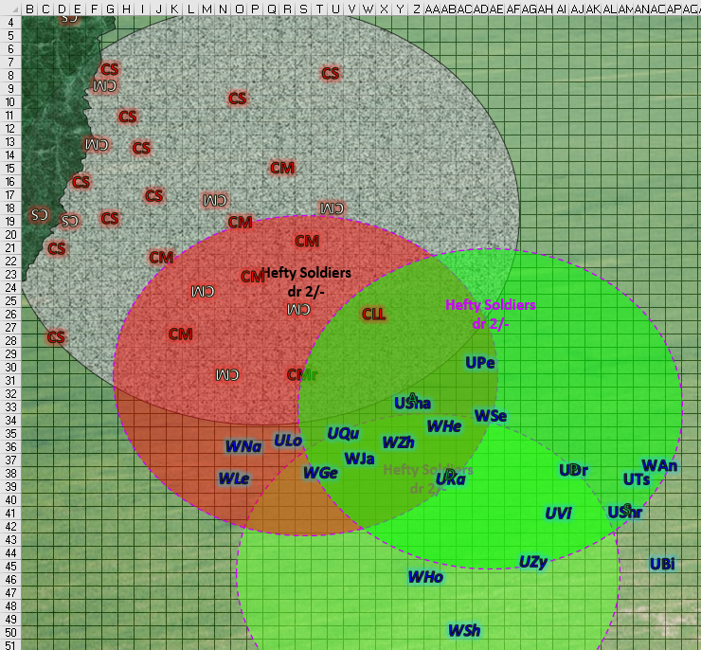

Round 3

Devrion *[hastened]* repeated his last attack again, speaking “Földrengés!” once again. He placed the spell far enough back to not catch his own allies in its effect.

|  |  |  |  |  |
| --- | --- | --- | --- | --- |
| **Character** | **Save vs.**  *earthquake* | **Ranks** | **Roll** | **Check** |
| Centaur, elite (Leg. Ldr) | Reflex | 9 | 6 | 15 |
| Centaur, elite (Marshal) | Reflex | 9 | 18 | 27 |
| Centaur, marauder 11 – 15 | Reflex | 7 | 12 | 19 |
| Centaur, skirmisher 1 – 5 | Reflex | 6 | 19 | 25 |
| Centaur, skirmisher 6 – 9 | Reflex | 6 | 16 | 22 |

*Fail, success, success, success, success.*

*Centaur legendary leader fell into fissure.*

The centaurs’ legendary leader fell into a fissure, and was surely dead, or would be in seconds. One skirmisher was outside the area of effect, and was able to fire upon a nearby werejackal.

Steelshade stayed her blade for the moment, comfortable to be riding atop a unicorn.

Dremu said something to Devrion about hogging all the XPs, then commanded his herd to stay back. Those that were about to finish their charges stopped in mid-trot and were barely able to avoid falling into the fissures themselves. The unicorns’ leader sighed, and decided to cast another prepared *hammer of righteousness* spell, sacrificing more of his Strength.

|  |  |  |  |  |
| --- | --- | --- | --- | --- |
| **Character** | **Save vs.**  *hammer of righteousness* | **Ranks** | **Roll** | **Check** |
| Centaur, elite | Fortitude | 10 | 1 | 12 |

*Fail. Dmg: 39 positive.*

*Dmg to Dremu: 1 Strength.*

Karfmu had been about to augment his horn with a *meteoric strike* spell, but unable to reach a foe without risking his own life, so he cast *bear’s endurance [expired on Round 83]* on himself.

Tsuamu targeted an area about equidistant from four marauders, and caught them all in a *fireball*.

|  |  |  |  |  |
| --- | --- | --- | --- | --- |
| **Character** | **Save vs.**  *fireball* | **Ranks** | **Roll** | **Check** |
| Centaur, marauder | Reflex | 7 | 4 | 11 |
| Centaur, marauder | Reflex | 7 | 5 | 12 |
| Centaur, marauder | Reflex | 7 | 20 | 27 |
| Centaur, marauder | Reflex | 7 | 7 | 14 |

*Fail, fail, success, fail. Maauder 13 saved for ½ damage.*

*Dmg to centaur marauder 11: 31 fire.*

*Dmg to centaur marauder 12: 30 fire.*

*Dmg to centaur marauder 13: ½ x 34 = 17 fire.*

*Dmg to centaur marauder 14: 22 fire.*

Zynphymu *[hastened]* diverted his course westward and positioned himself near the only skirmisher that was free of the *earthquake*.

Shrikteh ushered Steelshade to the frontlines in an orderly canter.

Viriteh *[hastened]* cast *sanctuary [expired on Round 9]* upon herself, and positioned herself along the northern extreme of the formation.

*Viriteh gained sanctuary protection.*

With Atlas on his back, Shamu didn’t know what to do with himself, so he trotted towards the skirmisher to the southwest, ready to charge-attack the fool on the next round.

Birimu shot a bolt of lightning at the centaur marshal.

|  |  |  |  |  |  |  |  |
| --- | --- | --- | --- | --- | --- | --- | --- |
| **Character** | **Attack Type** | **Damage** | **BAB** | **Dex Mod+** | **Total Score** | **Roll** | **Total** |
| Birimu | Call Lightning | 4d6 electric | 8 | 4 | 12 | 13 | 25 |

*Hit. Dmg: 15 electric.*

Pertenteh surpassed Viriteh as the northernmost unicorn.

Qusamteh *[hastened]* and the Lookout *[hastened]* joined Shamu towards the west.

With Devrion on his back, Kadabteh *[hastened]* positioned herself to the north.

Atlas blanched when he realized his mount was carrying him in the charge’s van. He whispered a few words, and then he opened his mouth wide and emitted a thunderous ROAR!

|  |  |  |  |  |
| --- | --- | --- | --- | --- |
| **Character** | **Save vs.**  *lion’s roar* | **Ranks** | **Roll** | **Check** |
| Centaur, elite | Fortitude | 10 | 6 | 16 |
| Centaur, marauders 11 – 13 | Fortitude | 7 | 8 | 15 |
| Centaur, skirmishers 1 – 4 | Fortitude | 3 | 3 | 6 |
| Centaur, skirmishers 7 – 10 | Fortitude | 3 | 5 | 8 |

*Fail, fail, fail, fail.*

*Dmg to marshal: 38 sonic.*

*Dmg to marauders 11 – 13: 33 sonic.*

*Dmg to skirmishers 1 – 4: 43 sonic.*

*Dmg to skirmishers 7 – 10: 45 sonic.*

Every affected centaur died almost on the spot, including Phyros, the marshal, whose leadership was practically ensured with the death of the legendary leader only seconds earlier.

~*~

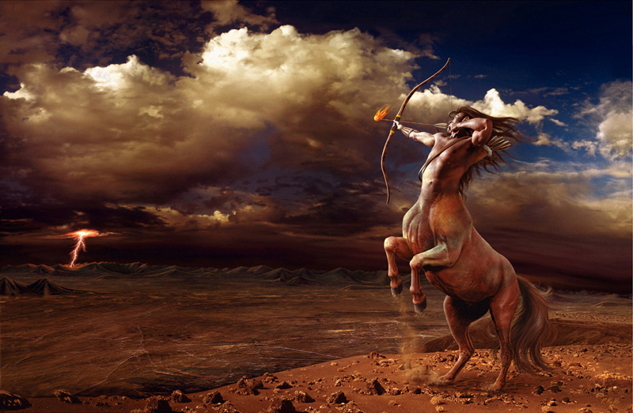

The barren land had been a fertile valley when Phyros was a younger colt, but now the archer overlooked the countryside, gazing down upon the ruins of a now abandoned settlement that lay in ruins. Beyond it, was a storm cloud that released a nearly constant barrage of lightning bolts onto the hills that skirted the valley, and it brought Phyros much sadness to see the desolation that had ensued over the land he once called home. In what now seemed to him a proper ceremonial fashion, the adult buck shot a fire-tipped arrow down into the rocky hillside, and recited a prayer to the old gods who had forsaken this land with their silence for nearly a generation now.

He turned back to the others—a score of weary, hunger-stricken centaurs whose eyes now betrayed sullen desperation—and sighed as he returned to them, looking downward in a sense of collective shame over the fate of their once lush fields and hillsides. They were the last of their kind here, and had gathered what few resources and wits they still had at their disposal before setting off for greener pastures, if such were anywhere to be found. Though they had once roamed far and wide, what remained of a centaur citizenry with a diversity of residents that included satyrs, fauns, sprites, gnomes, and other woodsy folk was now a mere herd of hoofed men and women who could hardly be called heroes.

They had faced legions of demons, hundreds—perhaps thousands—of them before the city slowly sank into disrepair and dilapidation, and in time, their structural defenses had been reduced to rubble, and their relatives had become fodder and food for their invaders. Long gone were the demons by now, who had seen little reason to remain after the bulk of the resources had been stripped from this place, and as Phyros and his kin took one last look at their homeland, they hefted their packs, shouldered their bows, and set off in the direction most likely to yield a promising path for them.

~*~

Antioch was going to cast his second preparation of *hammer of righteousness*, but with the wave of deaths on the enemy side, he simply moved to the north portion of the advance.

Serendip moved to the edge of Devrion’s spell effect, and waited for it to end before he could get closer to the remaining skirmishers.

January, Geninieve *[hastened]*, Zhou *[hastened]*, Hefty *[hastened]*, Levon *[hastened]*, Navyblu *[hastened]*, and Hodge *[hastened]* moved west a bit.

Shags *[hastened]* shot a bolt of lightning at

|  |  |  |  |  |  |  |  |
| --- | --- | --- | --- | --- | --- | --- | --- |
| **Character** | **Attack Type** | **Damage** | **BAB** | **Dex Mod+** | **Total Score** | **Roll** | **Total** |
| Shags | Call Lightning | 4d6 electric | 5 | 3 | 8 | 1 | 9 |

*Miss.*

Pussyfoot hung onto her mount for dear life, while Steelshade rode on, looking for a likely target to engage in melee.

The few remaining centaurs suffered the lingering effects of the earthquake that had shaken the ground beneath their hooves. The sole skirmisher outside the *earthquake’s* trembling radius fired a pair of shots.

|  |  |  |  |  |  |  |  |  |
| --- | --- | --- | --- | --- | --- | --- | --- | --- |
| **Character** | **Attack Type** | **Damage** | **BAB** | **Dex Mod+** | **W+** | **Total Score** | **Roll** | **Total** |
| Centaur Skirmishers | Longbow +1 | 1d8+1 | 5 | 3 | 1 | 9 | 14 | 23 |
| Centaur Skirmishers | Longbow, Rapid Shot | 1d8+1 | 0 | 3 | 0 | 2 | 1 | 3 |

*Hit, miss. Dmg to Navyblu: 8 + 1 = 9.*

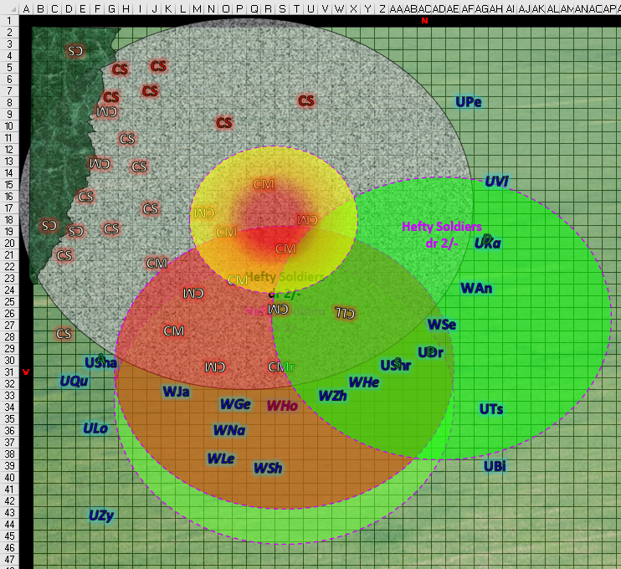

Round 4

Devrion *[hastened]* thought about casting *mage armor*, but as he saw his foes dying on the battlefield, he stayed his casting hand.

Steelshade activated her Farspeaking Amulet. “We need them alive. Demand their surrender. Tell everyone.”

The quartet called out to the allies near them. “Tell them to surrender. Give them one chance.”

Dremu, Karfmu, Tsuamu, Antioch, and Serendip heard the humanoids making a plea for mercy, and nodded to one another across the battlefield. Dremu spoke for them.

|  |  |  |  |  |
| --- | --- | --- | --- | --- |
| **Character** | **Save vs.** | **Ranks** | **Roll** | **Check** |
| Dremu | Diplomacy | 10 | 7 | 17 |

*Outcome ambiguous.*

With only two marauders healthy enough to stand and respond, the unharmed one raised his waraxe momentarily, leaving the heroes guessing whether that constituted a white flag or a red one in their cultures, then were relieved to see that the marauder deliberately dropped the axe, causing the wounded marauder to shake his head with disappointment, but dropping his axe as well.

The skirmishers followed suit, with each one dropping his or her bow, and some fleeing northwestward, thinking they were done for.

Zynphymu *[hastened]*, Viriteh *[hastened]*, Qusamteh *[hastened]*, The Lookout *[hastened]*, Kadabteh *[hastened]*, Geninieve *[hastened]*, Zhou *[hastened]*, Hefty *[hastened]*, Hodge *[hastened]*, Shags *[hastened]*, Levon *[hastened]*, Navyblu *[hastened]*, Shrikteh, Shamu, Birimu, Pertenteh, and January kept their weapons at the ready as the last of the earthquake subsided and three fleeting centaur archers disappeared into the woods.

Round 5

Steelshade tried to ride forward, approaching the surrendered centaurs. The other three remained behind her, ready to assist.

|  |  |  |  |  |  |  |
| --- | --- | --- | --- | --- | --- | --- |
| **Skill** | **Rank** | **Ability & Mod.** | **Misc. Mods.** | **Total** | **Roll** | **Check** |
| **Steelshade, Diplomacy** | 5 | **Cha (+2)** | 2 | 9 | 2 | 11 |

*See below.*

The unicorn cleric of Lurue refused the duskblade’s plea to ride northward, stating, “I don’t think that’s a sound idea.”

“Why?” Steelshade asked.

As the unicorns and werejackals rounded up the centaurs and their dropped weapons, the wise priestess replied, “Those we’ve captured will surely find motive to reveal any kind of hideout they might have, and if they have none, it is unlikely that the escaped centaurs will have much opportunity to fortify.”

Within a minute or so, they’d done a headcount of the surviving enemies, and were unable to extract the crushed bodies of the slain ones now inside the earth beneath them.

|  |  |  |  |
| --- | --- | --- | --- |
| **Character** | **Total Damage** | **HPs** | **Current HPs** |
| **Centaur Marauder 14** | 22 | 38 | 16 |
| **Centaur Marauder 15** | 0 | 38 | 38 |
| **Centaur Skirmisher 1** | 0 | 26 | 26 |
| **Centaur Skirmisher 2** | 0 | 26 | 26 |
| **Centaur Skirmisher 3** | 0 | 26 | 26 |
| **Centaur Skirmisher 4** | 0 | 26 | 26 |
| **Centaur Skirmisher 5** | 0 | 26 | 26 |
| **Centaur Skirmisher 6** | 0 | 26 | 26 |

Dremu and Tsuamu took turns speaking on behalf of the heroic faction.

“Since the dawn of time...”

“... centaurs and unicorns have lived under the banners of justice and freedom…”

“… why, now, do you turn to the ways of malfeasance?”

“… severance from your ancestors’ ways forces their tears from them…”

“… yours are the souls of the everlasting…”

“… and yet you turn from the grace of your afterlives to serve what? Demons?”

The centaurs remained quiet, then Tsuamu approached the burlier marauder, and bade him, “Speak, stranger, for you look as though you’ve words to impart.”

He did, but had been biting his tongue until now. He began to recant the woeful tale of their hard bitten exile from a now barren patch of land on the outskirts of Krigala that the werejackals and unicorns had scarcely heard of, and that was entirely foreign to the humanoids.

Once the bitter news of their self-imposed exodus had been told, the heroes now knew of their plight. They’d wandered aimlessly since they’d left their besieged homeland, and had managed to coalesce into a nomadic band of raiders who eventually found themselves cajoled into serving the selfsame demoness who had originally stripped their land of its fertility and vitality. In time, they’d nearly forgotten who they’d once been, and had sunken into the sins of drink, debauchery, and plunder, knowing nothing but the temporary thrills that came with their misdeeds at the expense of those from whose livelihoods they stole.

“... if you now seek redemption...”

“… we would offer it…”

“… but you must prove your worth, not in battle, but in purity of heart…”

Steelshade stepped down when the unicorn halted. “Thank you.”

She turned and saw Devrion approaching, with Atlas and Pussyfoot behind him. “Remind me to not make you angry,” she said lightly as he approached.

Devrion shrugged and glanced away. “I don’t enjoy this, Angren.”

“I’m sorry, Dev. But these people have suffered at the centaurs’ hands. They offered battle first.”

The tall elf, and he favored his father’s side, stepped up close to the duskblade. “Knowing that doesn’t help. I did what I had to do, right?”

Steelshade clapped him lightly on the shoulder. “Yes, Ohtistar Bolchanar, you did what you had to do.”

Devrion smiled slightly as she used his title and surname. “Thanks.” They turned to watch and listen as the unicorns spoke, not noticing that Atlas and Pussyfoot had stayed a few feet away, giving them their space.

The conversation continued for a few more minutes, and Dremu then turned to Angren, who had emerged as the humanoids’ makeshift leader, asking, “Do you trust them?”

“No, not for a while,” Steelshade replied. “We should find the rest of them, and find their camp. Was this their whole group, or part of an army?”

“This was their number when they ambushed us,” the unicorn guessed, give or take a handful. “Let us question them.”

~*~

Having questioned the remaining archers and the two marauders, they confirmed that this was their whole lot, and within the hour, werejackal scouts had been led by one of the more cooperative archers to their encampment, where they found those that had fled. They’d rounded them up, and were now tethering them to a thick trunk so they could better control the situation as the unicorns conferred regarding their next steps.

“We will camp here today,” said Tsuamu to Atlas, whose expertise had been sought on a half-dozen matters. “You are welcome to stay with us as long as you like.”

“We will stay here for the night, at least,” Steelshade replied. The others nodded in agreement. They would see what tomorrow brought to them.

After they set up camp, Steelshade moved off a short distance to meditate and pray. She sought Aasterinian’s guidance as to what they should do next.

Devrion sat down at a discreet distance to watch over the duskblade as she prayed. His blood still tingled from the rush of battle, and he sighed quietly as he attempted to center himself once more. This is why he’d stepped away from the formal assignment as a warmage. Using defensive magic was one thing, but deliberately using it to slay tens, or dozens, had they been in a dense formation, was more and more galling to him. He was in the right, of course, but it made him feel little better about it.

Atlas and Pussyfoot settled down to make dinner together. “Do you think they even like each other,” the halfling asked as she looked in their direction.

“I think so,” Atlas mused. “Love and romance just moves at a slower pace for them.”

Steelshade sighed. The only guidance she got from her intuition was to seek out a cleric of Aasterinian or someone else who could cast *omen of peril*, *divination, augury,* or some other type of Divination spell that might impart upon them some sense of direction. In any case, perhaps the best direction for the moment was the compass of freedom itself, and Krigala was as good a place as any to find such freedom. She and her friends took reprieve in the unicorns’ and werejackals’ philosophy of placid contentment with their current condition and whereabouts. In time, perhaps they might settle in a peaceful cranny of this plane, or something akin to it.

~*~

They spent the sunlight night on the very field where the battle had taken place with the majority of the unicorns and werejackals hammocking amidst the foliage that bordered the field. They were accosted by an army of incessant bugs that had been drawn to the meal they’d made, but beyond this minor nuisance, the sleepy hours of the day were uneventful.

When their bodies felt like sunrise, and they got up to stretch their legs, unicorns were playfully frolicking and flirting while the werejackal band was gathering their few belongings and resolving to head back to their hovels and burrows along yonder hills. The handful of centaurs who had been captures were bound to trees, and the werejackals had agreed to take them with them and rehabilitate them.

“Where will you go now?” Tsuamu asked Atlas after they both prayed for their spells.

“I know not,” the archivist responded, “though I had a dream—a nightmare to tell the truth—about the demons we’d slain two days ago. I’m not sure that threat is completely gone, and given what these centaurs have told us, demons still lurk about these lands.”

Tsuamu nodded, “This worries me as well.” It seemed as though he was going to say something else, but nothing else escaped his equine lips. He didn’t want to jinx the moment by voicing some ill-fated premonition of another slaughter befalling them, and wanted even less to exhibit weakness before the human. It wasn’t for lack of trust, but out of a concern for saving face.

Atlas waited for a moment. “Please, speak your mind on this.”

“Oh, I just don’t want to jinx the moment by voicing some ill-fated premonition of another slaughter befalling us. It isn’t for lack of trust,” thus spake the unicorn.

“Do you think something will happen here?”

“No, not from this lot, but judging by what you said about a macrodemon, if there are more of those dretches, we’d be ill prepared to match their mettle,” Tsuamu replied.

Atlas glanced at the others. Steelshade nodded fractionally, Devrion lifted an eyebrow, and Pussyfoot just sighed. “We will go back and check the area,” Atlas told the unicorn. “In the meantime, you may consider posting scouts, or allying yourselves more permanently with the other folk for security.”

~*~

The werejackals and centaurs were long-gone by now, and the humanoids had packed their things in order to set off for the area where they’d emerged from the stone skull.

The quartet set off on their carpet, and headed back toward the massive demon they’d left.

~*~

