*Chapter 3: Waterdeep*

And just like that, they were back at the mouth of the cave from which they’d emerged after vanquishing the macrodemon and its myriad meanies.

“I am not going back in there,” Pussyfoot snapped. She slipped on her Scout’s Headband, and used its charges to activate the True Seeing ability.

“Can’t say I’m thrilled about the idea, either,” Steelshade sighed.

Devrion nodded as he focused on steering the carpet, and keeping a sharp watch for anything threatening.

“I have no wish to do that, either,” Atlas said as he looked around. He thought about what he knew of the planes and demons as he went along.

Noting nothing undead, magical, or otherwise unusual, the party flew the carpet closer to the skull. They were now about 10’ from the right eye socket, and the smell of death and bile had subsided over the last two days.

Devrion took them from the top of the head in a slow spiral, all the way down to the treetops, looking for anything out of place. All seemed quiet, and there were no obvious signs of demons having trampled across the surrounding countryside.

Steelshade looked at Atlas as Devrion climbed to a safer altitude clear of the ground and the overgrown head. “So, can we get back home?”

Atlas nodded. “I have prepared the correct prayer for that today?”

“What?” Pussyfoot glared at her lover. “If we can go home, then why are we screwing around here?”

“Brene, we had to help the unicorns.”

“Ya, we turned Devrion loose on them.” Pussyfoot grinned at the warmage, but her grin faded at his look of annoyance.

“Killing is serious business, Brene, and I didn’t enjoy it a bit.” He sighed. “I am sorry, I don’t mean to be rude to you.”

Pussyfoot looked abashed. “I’m sorry, too, Devrion.”

“Okay, so do I cast the spell?”

“Maybe we should land first, so the carpet goes with us.”

They landed, rolled up the carpet, stuffed it into Angren’s haversack, and looked up at the skull’s openings, opting to leave this place altogether.

Atlas took a breath. “So, where to?”

“How about Waterdeep?” Pussyfoot scowled up at the demon’s fossilized head. “I’ll take my chances with that redhead over this place.”

Steelshade and Devrion shrugged in concert.

“I suppose there’s trouble enough no matter where we go,” Atlas smiled at his lover. “Brene, you will have to behave, though.” He archly ignored her answering scowl. “Okay, circle up and join hands.” When everyone was holding hands, the archivist intoned a brief prayer, as he envisioned a copse of trees next to the road about three hours’ travel north of Waterdeep. They’d camped there one night, and he remembered it clearly.

And just like that, they were out of Krigala and back on the Material Plane, at the exact spot where Atlas had intended.

Atlas had placed them along the trade road, next to a copse of trees fifty yards from the road itself. It was a three-hour walk to Waterdeep from here, or about ten miles. They had camped here one night, and Devrion scuffed the fire ring, left on the ground by generations of travelers.

It was a cool night, and by the looks of the thin, violet veneer along the inland horizon, dawn would likely be upon them within the hour. As they breathed in the cool air of Night’s End on the 18th of Deepwinter in the year 1384 of the Dale Reckoning, Atlas and Brene spotted a brass dragon above them. Normally, with a dragon flying down towards them, they would have surely readied their weapons, but this was a brass dragon, the totem dragon of their deity, Aasterinian, and as it approached and slowed its downward trajectory, the archivist identified it as none other than the avatar of their deity herself. Sporting her recognizable, turquoise-sheened forehead that held a golden star in the center, the dragon finally landed about 50’ south them on a clearing along the other side of the road, and shapeshifted into a slender wood elf wearing mostly decorative brass armor and carrying a sheathed scimitar hanging at her left side.

As the dust settled around her, she faced her worshippers and began to walk towards them in order to get close enough to speak without shouting.

Steelshade dropped to one knee as the avatar approached, and the others followed suit. They all waited for the deity to speak with bowed heads.

The goddess spoke, but each word was foreign to their lexicon, and at the same time fully intelligible as a complete sentence unto itself. Atlas was best able to capture the meaning of what was being told to them: the party had inadvertently slain the dormant corpus of a demon lord once known as Pale Night, and had by now garnered the wrath of her vengeful adherents. More importantly, Pale Night’s death had released another demon lord—Ugudenk—whose massive body was actually an entire layer of the Abyss, and from which a cadre of demons now emerged, and was making its way towards the Material Plane where the succubus princess-goddess Malcanthet’s body was held in stasis by the collective forces of good-aligned gods and other powerful beings.

The location of this goddess was only known to those who held her, and Aasterinian now revealed to the heroes where she was: the Whalebones. The Whalebones were a series of islands southwest of Waterdeep, an archipelago scarcely populated by humanoids and hill giants, and the imprisoned demoness was said to be in the southernmost of these outcropping rocks that peppered the otherwise uninterrupted waters separating Faerûn from Maztica.

Pussyfoot sighed quietly. “I really, really hate to ask this, but I don’t suppose we will get a day or two in Waterdeep, and then have to hire a ship out to the islands, right?”

Aasterinian nodded, and smirked, “I am aware of your plight through Pale Night’s bowels. The cosmos is a better place because of your successes there, and Krigala will be safe from the forces of evil for some time.... You will find answers in Waterdeep, including those that you do not yet seek, but beware of those who would inform you to further their own ends. Though their words may be true, their hearts may not be.”

The halfling nodded. “We will be careful, Milady.”

The dragon-turned-wood-elf nodded mostly to herself, then bid the heroes a salutary journey to Waterdeep, dematerializing before their eyes.

Pussyfoot turned to her companions. “I want a real bath, and a real bed.”

Steelshade grinned. “Well, let’s go.” She led the way onto the road, and turned southwest to Waterdeep.

~*~

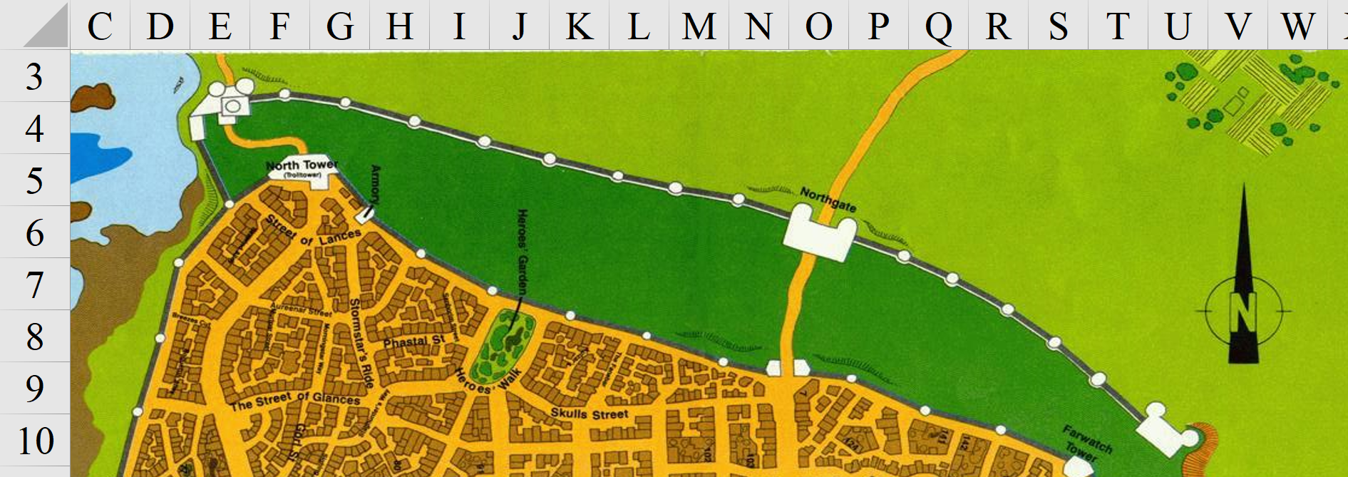

The journey to Waterdeep had been entirely uneventful, and by the time they got to within 200’ of the North Gate, they were all longing for a foot massage. The sentries atop the guard towers viewed them with caution, and as a wagon was let out of the gates, two guards remained by the open gates as one of them asked, “Identify yourselves!”

Steelshade stepped up. “I am Angren, and this is Atlas, Brene, and Devrion. We are seeking lodging for a few days.”

The city was experiencing a tourism lull, and the guards had been instructed to be relatively liberal in their admission to strangers, despite the last few years’ clandestine incursions. “Then you will likely find plenty of vacancies wherever you look,” said the female guard as she motioned for them to approach. “Do venture into the Trades Ward and the Dock Ward, where you’ll find the majority of our large-scale inns and taverns.”

They entered the city gates, and instantly found themselves in one of the most urbanized parts of the continent.

“Thank you, we will,” Steelshade said. She led the group through the city’s streets toward the Trades Ward, which was near the southern end of the city.

It took them the better half of an hour to meander through the streets and find their way to the Trades Ward, but once they were there, they had nearly every option available to them. All manner of inn, tavern, hostel, and shop was before them, and all they had to do was make a choice.

“I think this one,” Atlas said at length. The inn in question looked clean from the outside, while the sign read, “The Charger and Eagle”.

A smaller sign advertised individual baths, and Brene sighed. “Sold.”

“Let’s go see, then.” Steelshade went to the door and stepped inside, followed by Atlas, Brene, and Devrion.

The lady running the establishment was a halfling of about 60 years of age. Her name was Kri’afi, and she ran as clean an operation on the inside as it was on the outside. The fees were 2 gold coins per night, and the selection of food and drink was halfling-oriented, but versatile. They suspected for a moment that the beds would be halfling sized, but they were all fit for 6’ tall folks, two to a room.

The obvious choice was to put Atlas and Brene in one room and Devrion and Steelshade in another, and the human and halfling pushed their two mattresses against one another to have more room to play and snooze. It was still Morning, and they were anything but weary, so they thought they’d venture back out and explore the city.

“Seriously?” Devrion sighed and fished out one of his coin purses. He paid the innkeeper and ushered the group away from the counter. He held up the room keys. “We need to talk.”

The quartet made their way to their rooms, which were located next to each other. Devrion picked one at random, and led his companions inside. He closed the door and turned to them. “How is it that none of you have any money?”

“The last time I tried to earn anything, I nearly got cut in two by a redhead with a greatsword,” Pussyfoot huffed. “Don’t blame me.”

Steelshade shrugged. “It’s been a while since that last guard job, and I haven’t needed anything.”

“I spent the last of what I had on a book,” Atlas admitted.

Devrion looked at each of them in turn. “Okay, then. As of now, we have ninety-eight gold among us. That’s enough for a little while, but we need to think about how to earn more.”

“We could sell something,” Pussyfoot suggested. “Do we really need that golem thing?”

“I have some jewelry that we can sell, along with the golem,” Steelshade offered.

Devrion sighed. “Okay, so that’s good. We can go do that.”

“I want a bath and clean clothes, first,” Pussyfoot said firmly. “I smell like a campfire.”

“We can go out after lunch, then.”

~*~

Highsun

They took a good while to bathe and restore their mindsets and were once again ready to face the day. Before seeing to lunch, they went to the market district and enquired about shops that traded in magic items. They visited a few shops until they found just the right one: The Unfurled Scroll, and therein they met a fellow by the name of Awgust. He was a moderately friendly spellscale, even if a bit aloof, which was common for those of his unusual race, and his shop was decorated in as flamboyant and eccentric manner as his body.

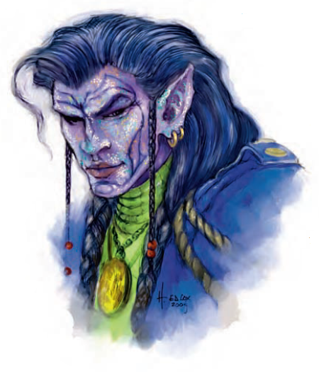

There were lavish tapestries that hung on the walls of the ample shop’s front area, and all manner of lower-level magic item displayed in cases while a few suits of mithral armor adorned the corners of the room. Within moments of introducing himself, he squinted as he looked closer at the four heroes, and parted his lips to say, “By the gods! You are the heroes of Aasterinian!”

Steelshade lowered her eyes and bit her lip. Atlas, seeing her discomfiture, spoke up. “Thank you for that, kind Sir. We have found an item in our travels that you may be interested to purchase, if I may.”

The group laid out the components for the stained glass golem. “If there are good people who could make use of this device, then we would like to sell it,” the archivist finished.

The spellscale marveled at the craft, and smiled as if he were trying to appraise the components. “Whhhhell!” he exclaimed, rubbing his beardless chin. “For the heroes ran the demons of the Abyss from Baldur’s Gate, and graciously gave away the treasure they’d relieved from those villains, I can part with an even 8,000 gold and take these bits off your hands. It’ll take some curating to get this piece to exhibiting condition, and another few hours to implement the magic that should render a stained glass golem out of this.”

Atlas nodded. “That will do very well, thank you.”

“A word, if I may,” Devrion interjected. “This is a powerful and deadly construct, especially in the wrong hands. We would be... irritated... if it fell to those who mean harm to good people.” The half-elf smiled, but his eyes were cold.

Awgust nodded, and looked the warmage in the eye. “Waterdeep has some pretty tight safeguards against evildoers now. I’m sure you’ve heard of Destiny’s Gambit, whose constituents have seen to it that the worshippers of Umberlee and other ill-meaning gods remain outside its walls.”

They did indeed know of this band; Steelshade herself had taken after Lauren, a legendary duskblade who lived a bit north of Waterdeep and occasionally visited. She said, “We have.”

“Yes, well, I’ll be damned if I sell any of my wares to those whose ways are unwelcome in our fair city,” said the spellscale before asking them if they preferred the funds in gold, platinum, or a combination of both.

Devrion nodded. “Thank you. I know that I wouldn’t want to cross Destiny’s Gambit.” He glanced at Pussyfoot, who just rolled her eyes in exasperation.

“We will take the gold coins,” Atlas said. When they were paid, he took out a hundred coins for each of the four to have in their purses, put 3,800 in his haverpack, and gave the remaining 3,800 to Steelshade for her haverpack.

“Thank you,” Atlas said to the spellscale when they were done. “Oh, a question. We need to visit the Whalebones. Is there anyone we can talk with about taking us there?”

The spellscale thought for a moment, as if going through a list of mariners, and suggested, “There’s a woman by the same of Saffron in the Dock Ward. She’d be the person to ask. She runs a fishery, and keeps a tally of the incoming and outgoing vessels that trade with her. If I’m not mistaken, some of her associates go through the Whalebones on their way to Maztica... some may even have that as their destination before returning to the City of Splendors,” he referred to Waterdeep.

“Thank you,” Atlas said.

The group went in search of Saffron in the Dock Ward. Along the way, they sampled some of the food available from the street vendors, and even tried a new sort of sweetened sparkling water, served over ice.

~*~

Filling their bellies with some peppered corn on their way there, the heroes asked around enough times to be guided to Saffron’s office, which was a sturdy building on Dock Street overlooking the Great Harbor.

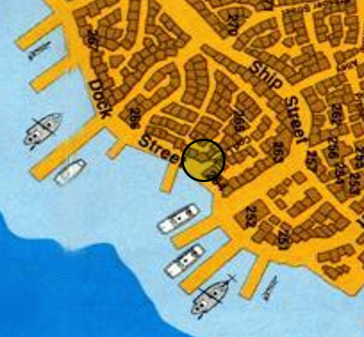

A dwarven knave of perhaps 20 years was at the front desk, and after some asking, proceeded to get Saffron from the back office. She was an elven woman, at least 100 years old, and with jet-black hair bound up in a trio of horizontal buns. “Yes?” she asked, not having any context for being asked to come out but seeing some wealth adorning the heroes before her. “What can we do for you?”

<< Amin Angren’halya, naa melloneamin, Atlas, Devrion, ar’ Brene, >> Steelshade said politely. << Lye anta talaluva a’ Whalebones sairato. >>

The elf understood perfectly, but wondered why the draconic drow wanted to leave her friends out of the conversation, or did she? << A’ Whalbûna, eh? >> she confirmed as she opened a leather-bound ledger with the year 1384 etched on the cover in Elvish script. << Dajh. Kofri ba’atuf spedit oth Whalbûna just this morning, and has been unloading cargo. She should be ready to sail at morrow. Are you looking to book passage or ship freight, or both? >> the elf continued in Elven.

<< We wish to book passage for the four of us, >> Steelshade answered. << No freight: just the gear you see on us now. >>

<< We can certainly make that happen, >> Saffron replied. << I can tell from your wares that you are a highly apt band of adventurers, so I’ll dispense with the offer of security, but know that it is available if you wish. >>

<< I think we will be fine, >> Steelshade says with a smile. << At what hour should we be here tomorrow? >>

<< The ship will leave about an hour past sunrise. The reservation will cost you 30 gold apiece, half of which is refundable if you change your minds. The prevailing winds at this time put the journey at three—maybe three-and-a-half—days, >> Saffron estimated, << but I cannot promise how the gods will guide the breeze. >>

<< Understood, >> Devrion said in Elven.

Saffron took in the jungle half-elf’s visage, and found him cute, but said nothing of it. << Very well. I’ll be glad to secure passage for you if you’ve the coin on you now. I believe the fare is another 50 apiece, 15 of which will come from your deposit, so a total of 140 gold for the four of you. The ship’s name is the Krakenbane, and her captain is an aquatic elf named Thessalia. You may be able to find her aboard now, but she’ll likely be there before sunrise tomorrow. >>

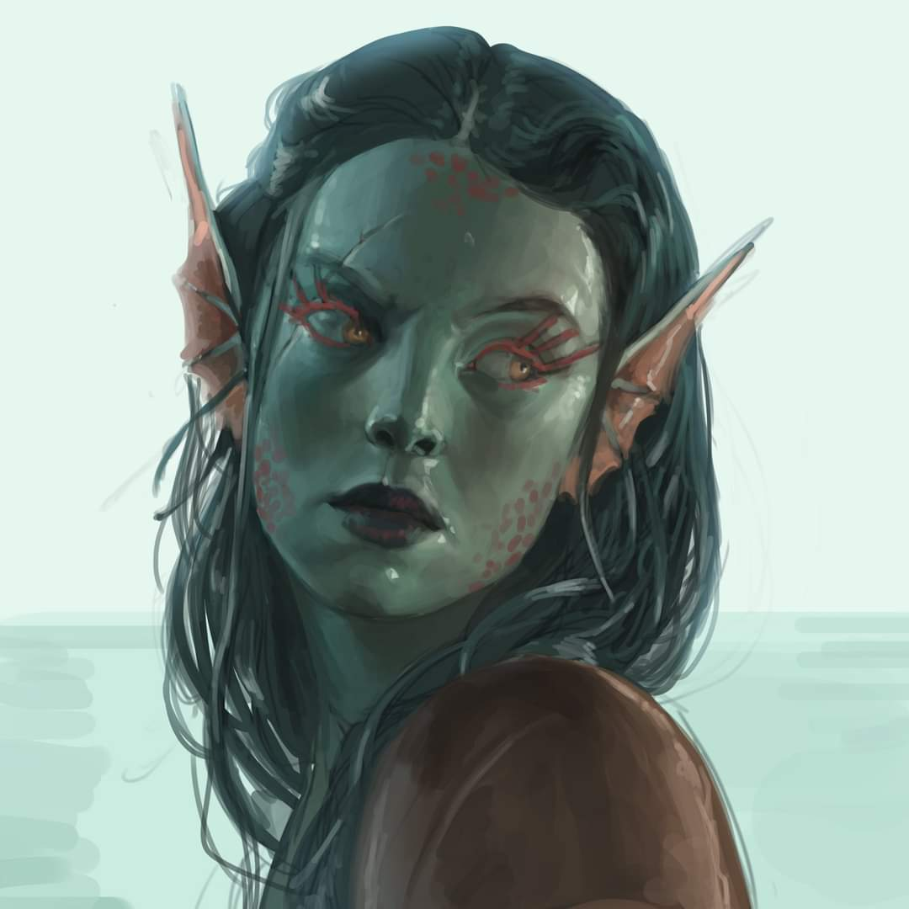

<< Pazha, di’vir, >> Atlas thanked her as he produced the coins.

<< We will be here, >> Atlas confirmed.

<< I will pay it, >> Devrion said, as he had the full amount with him. He gave the woman 140 gold coins, smiling slightly as he caught her look, pocketing the other 56 coins.

With their business concluded, the quartet went back to the open market area to browse. Pussyfoot paid close attention to who might be paying them more mind than normal while she glanced over the shops’ wares. Devrion and Atlas stopped to look at an impressive selection of scrolls, books, and other writings mundane and magical, while Steelshade browsed through a shop with cloaks, tunics, and other clothing.

Pussyfoot stepped up next to her, noting that the menfolk were out of earshot. << So, what are you going to do about Devrion? >>

The drow looked down at her. << What do I do about what? >>

<< Oh, come on, Angren. You saw elf girl back there. She was sizing him up for her bed. >>

Angren shrugged. << I can’t do anything to stop that. >>

<< Look, you’re my friend, and you’ve been good to us. Devrion likes you, Angren. You do know that, right? >>

<< I know. >> She fell silent as she considered a fine woolen cloak.

<< And? >>

<< And, what? You want me to climb into his bed? I don’t even know what I’m supposed to do there. >>

<< Yes. The mechanics are instinctive, Angren. It just comes, you know? >>

<< No, I don’t. >> She turned to face her friend, and crouched down so they could be at the same level. Some small folk considered this insulting, but Brene appreciated it. << That’s the thing. We haven’t known each other very long, and I have no clue about how a physical relationship is supposed to work. I see you and Atlas, of course, but Devrion is the first man who’s wanted to do more than poke me. I’ve never wanted to be poked, and the last man who tried is in pieces somewhere in the Chionthar. >>

Brene sighed. << Okay, I know you elves move slowly, but you’ve known each other for a year. Just think about it. It’d be sad if someone more ambitious moved in. >> She smiled crookedly. << You wouldn’t be able to chop them up for fish food. >>

Angren straightened. << I’ll think about it, >>

<< Thank you. >>

In truth, it was unlikely that Saffron would do anything to get Devrion into her bed before they left for the Whalebones, and seeing as they had no motive to return to Waterdeep, and could go virtually anywhere in the cosmos with the snap of Atlas’ fingers, the shipping entrepreneur wouldn’t be a threat to Angren’s timetable to copulation, if there even was one.

They found just about all of the lower-level scrolls that they needed, and if they wanted to pick up some higher-level stuff, Awgust’s shop would likely be able to accommodate them.

The group surveyed what they had, and decided their current stock was sufficient.

When they were done with shopping, they went back to the inn for dinner, and then went to bed early. Tomorrow was starting very early, and they wanted to take advantage of the real beds.

Their rooms were as they’d left them, and as they settled to sleep, they contemplated the presence of their deity in their rituals and lives.

~*~

At Dawn, they began to ready themselves for the day ahead, and by the time they went downstairs, the innkeeper was serving ostrich eggs and walloped equine meat for breakfast. The menu put the price at 3 silver pieces per serving, and the recommendation for a full-sized human was two servings.

They ate breakfast, and gathered their travel rations, both at the inn, and at a couple of food vendors along the way. Steelshade picked up some fresh fruits and vegetables that would keep for a few days. Arriving at the docks, they went to find the Krakenbane, and her captain, Thessalia.

It didn’t take long to find the vessel, even though they’d not gone by to inspect it the day before. It was a frigate outfitted for combat, but with a few cannons missing from their intended locations along the sides of the hull. They approached the plank, and an eyepatch-donning dwarf with gold teeth asked, “Oy, who be ye?”

They presented the handwritten notes that Saffron had given them, and the dwarf then nodded, warning, “I keep a tight ship, and expect ye ta follow the rules,” he pointed upwards where presumably they’d be able to see the written rules once they’d boarded. Making their way up the plank, they stepped onto the main deck, were greeted by a woman who fit Thessalia’s description, and presented her with their boarding passes.

“I hope Sven wasn’t too curt with you. He takes security as seriously as it takes to keep stowaways out, and is worth every coin he earns; I promise. You’ll find your quarters on the topmost deck,” she meant the one below the current deck. “Your rooms are B4 through B7. Let me know before we set sail—which is in about a bell’s toll’s time—if you need anything else that’s not already there.”

“He was just doing his job,” Steelshade replied with a smile. “We will look at the rooms.”

The four went to the rooms, picking them by silent consent. They each went in and looked at what was available. The accommodations were as cramped as one might have imagined on a ship originally built with military intentions, but the cots were large enough for a short human, and each had a nightstand with a single drawer. There was no lighting other than the single window that each room had, so nights would be dark for one without a candlestick or magical means, and one of the posted rules was ‘no candles’. This was common on any wooden vessel, as a lit candle in a room with no one awake was a recipe for a fire on the high seas.

The rest of the rules were fairly mundane: no fighting, no stealing... that sort of thing. All in all, there was nothing out of order here, nothing unexpected.

“I have a *light* spell,” Devrion told Atlas, “if you really need something to see with. It lasts three hours.”

“Brene can see, and I can use my sunrod in a dire situation,” Atlas replied.

The four put up their possessions, and stepped out onto the deck to watch while the ship got underway.

~*~

They stood on the portside deck as the ship put distance between itself and the mainland, heading southwest towards the Whalebones, where they would moor for a full day as they unloaded their cargo and reloaded the vessel with another shipment. Thessalia gave an overview of the expected journey ahead, and stated to those who had return tickets that because the winds couldn’t blow them directly northeast, their trajectory would take the ship south towards the northernmost Moonshaes, whereupon they would moor for another day and repeat the loading and unloading process before heading back towards the Sword Coast and stopping at a few ports along the way before repeating the cycle.

The four heroes had not purchased a return ticket, but were told that there would likely be enough room for them to return on the Krakenbane if they so wished, and if not, there were ships that would come every tenday or so to travel along similar routes. In any case, the next three days or so would be spent enjoying the bobbing of the ship and watching the fishers do what they did best.

Captain Thessalia checked in on everyone as the sun began to dip into the horizon, and announced a complementary dinner—lemon-marinated fish—followed by some entertainment: a juggling act and some music. “It’s not every day that performers come aboard the ship,” she announced, adding that the troupe had not had quite enough coin to cover their fare, so the rest of the passengers were in for a special treat.

Atlas and Brene retired to his cabin in the early afternoon to enjoy some private time, while Angren and Devrion sat in the bows and watched the porpoises play in the ship’s bow wave. Few words passed between them as they just enjoyed the day.

That evening, they all attended the dinner and entertainment.

~*~

The next day, the sun rose over the eastern waters as the Krakenbane continued southwest. As the heroes rose and came out of their cabins, Captain Thessalia and her first mate—a human named Godson—were discussing a tear along the main sail that needed patching. They noted Atlas and his shorter friends coming out, and nodded a greeting to both. The sunlight was welcome in the midst of the westward, Deepwinter wind, and could smell the smoke of ganja emanating from three sailors’ spliffs as they stood at the aft of the vessel after their evening shifts.

There was nary a bird in sight here on the high seas, and the fishing nets were raised after a night’s successful round of fishing, the bounty of which now swam in a vat. They would drain the vat shortly before arriving at the Whalebones, and sell the deep sea fish to the locals, whose diet was generally limited to freshwater and shore-loving varieties of sea life. Such a catch padded their profits, and added nutritive diversity to the diet of the citizens of the Whalebones.

The quartet started their own preparations for the day. Steelshade found a clear spot on the deck, whereupon she drew her sword and went through her training moves. Although she had more to learn about the sword fighting and spellcasting combination that was the duskblade, she was also eager to start training in the warblade’s art. She focused on a spell, and mouthed the words without casting it as her sword flashed in a combination move.

Devrion stepped off to the side, and went through his own mental spellcasting routine. The more magic he used, the more spells he could retain at one time. But, he knew that the same magic wore on him. Most people never attained to his level, and many of those who did cast their spells after careful study. Memorizing a new spell took him longer, but he could unleash several of them before exhausting himself for the day.

Atlas sat in his room, and prepared himself for his devotions. His allegiance to Aasterinian was a relatively new decision, and so he still felt a bit awkward as he settled into his daily prayers. It had been refreshing to meet the avatar, and he thanked his deity for that blessing.

Pussyfoot, dressed in tight-fitting pants, her sandals, and a long-sleeved blouse, stood talking with a pair of sailors. She’d won two coppers on a bet that they couldn’t tie her hands to she couldn’t escape, and now the wager was five coppers that she couldn’t open a padlocked hand chest one of them had presented to her. The chest was well made, a family heirloom of the Third Mate’s, and it took the rogue all of five seconds to open the lock with her ordinary tools. The owner groaned and dropped the coins in her hand. She grinned and offered them back, but the man shook his head with a laugh. “I should pay the price for betting against you,” he said.

All in all, they’d made some friends aboard, and perhaps had even garnered the resentment of a few who’d lost some coins in their wagers against their talents.

~*~

21 Deepwinter

The next day, as the sun rose high above them, after they’d cleared the halfway point in their journey, came a peril that would prove to be a trial of their collective prowess. To the southwest, they spotted a shoal of what a sailor woman atop the crow’s nest had first identified as marlins and shortly thereafter as possibly porpoises. However, within seconds, the human’s voice called down with significant concern as she pronounced a much more ominous prospect, “Kuo-toaaaa!”

From within their cabins, Devrion and Steelshade heard the words, and were alarmed and roused from their respective thoughts.

Captain Thalassia—who was at the helm—had Godson sound the alarm, and by the time the heroes came up and onto the upper deck, the entire crew was busy preparing for the incoming gang of seemingly starved enemies swimming towards them. A few men and women with harpoon launchers were already positioned along the bow, with some retracting their strung harpoons and others releasing them.

There must have been at least 20 of them, and Atlas’ experience with this species told him that they were a more barbaric tribe than he’d ever encountered. The crew of 12 would likely have been overrun with them if the heroes were not aboard, and this looked to be a decisive moment of resolve.

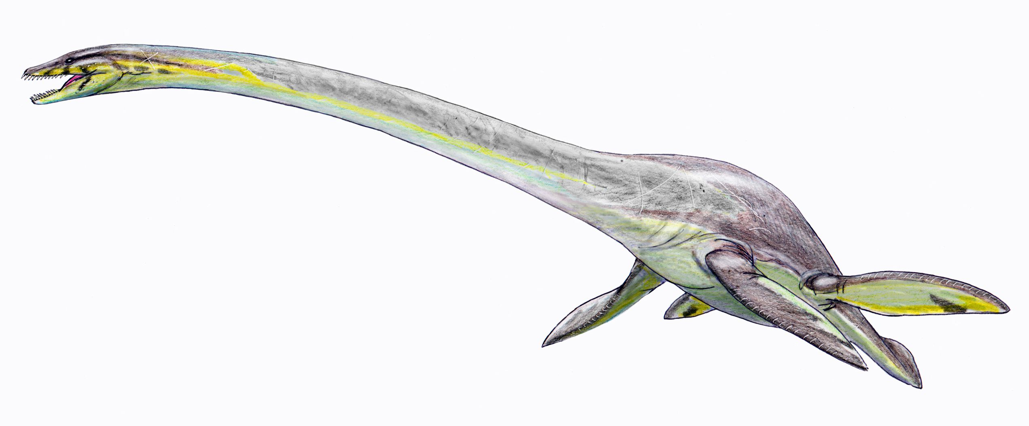

And then, at the back of their haphazard formation was a quartet of riders atop an elasmosaur. The beast surfaced, head first, then neck, then the rest of its body, and it headed straight for the ship.

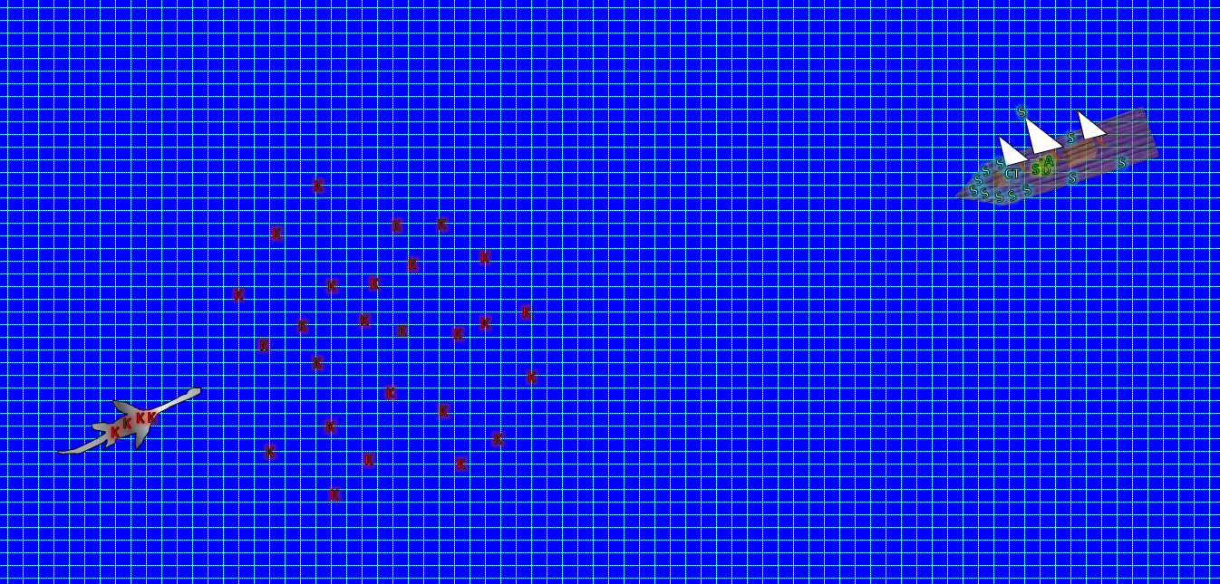

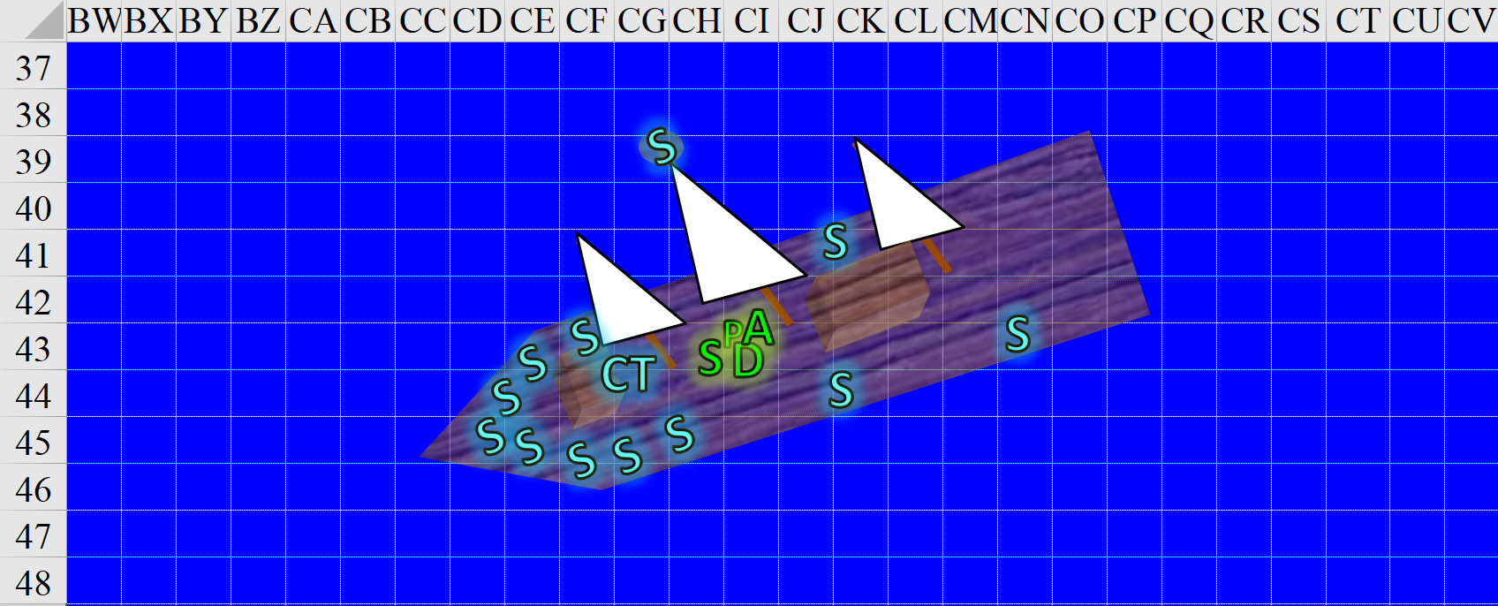

Round 1

|  |  |  |  |  |  |
| --- | --- | --- | --- | --- | --- |
| **Character** | **Group** | **Initiative** | **Roll** | **Modified Roll** | **Move** |
| Steelshade | 1 | 5 | 16 | 21 | 20’ |
| Devrion | 1 | 2 | 17 | 19 | 30’ |
| Angren | 1 | 6 | 6 | 12 | 30’ |
| Atlas | 1 | 2 | 9 | 11 | 30’ |
| Crazed Kuo-toa | 3 | 1 | 8 | 9 | 20’/50’ |
| Sailors | 2 | 2 | 6 | 8 | 30’ |

With the sails already slackened, the ship had slowed to a near standstill by now.

Atlas held his prayers until the enemies came a little closer.

Brene moved up close to her lover, to help defend him if the creatures should make it aboard. She climbed up the main mast a few feet, and looked all around the ship for any other enemies.

|  |  |  |  |  |  |  |
| --- | --- | --- | --- | --- | --- | --- |
| **Skill** | **Rank** | **Ability & Mod.** | **Misc. Mods.** | **Total** | **Roll** | **Check** |
| **Brene, Climb** | 10 | **Str (+1)** | 2 | **13** | 15 | 28 |

*See map.*

Steelshade moved toward the ship’s bow so she could meet any enemies that tried to board. She also cast *dragonskin [expired on Round 1701]* on herself.

*Steelshade gained 5 to FFAC and AC.*

Devrion gathered himself and considered his enemies. He pointed at the creature with the riders, centering the spell on the creature’s midsection. “Otiluke fagyasztó gömbje!” *[Otiluke’s Freezing Sphere, expired on Round 18]*

|  |  |  |  |  |
| --- | --- | --- | --- | --- |
| **Character** | **Save vs.**  *Otiluke’s Freezing Sphere* | **Ranks** | **Roll** | **Check** |
| Elasmosaur | Reflex | 9 | 8 | 17 |
| Crazed Kuo-toa | Reflex | 5 | 1 | 6 |
| Crazed Kuo-toa | Reflex | 5 | 5 | 10 |
| Crazed Kuo-toa | Reflex | 5 | 3 | 8 |
| Crazed Kuo-toa | Reflex | 5 | 11 | 16 |

*Fail5.*

*Dmg to elasmosaur: 56 cold.*

*Dmg to each crazed kuo-toa: 49 cold.*

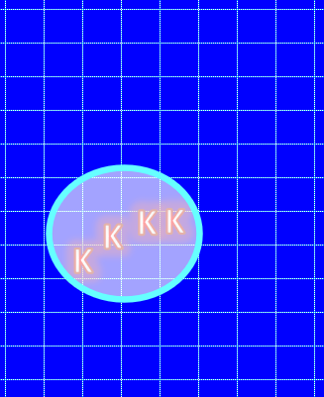

The four kuo-toa riding the elasmosaur froze to death as the dinosaur cringed at the pain of the cold sphere, diving down into the choppy waters.

The rest of the kuo-toa continued their swim towards the ship. Some reached it, and began to climb up the sides.

|  |  |  |  |  |
| --- | --- | --- | --- | --- |
| **Character** | **Check** | **Ranks** | **Roll** | **Check** |
| Crazed Kuo-toa | Climb | 1 | 7 | 8 |
| Crazed Kuo-toa | Climb | 1 | 18 | 19 |
| Crazed Kuo-toa | Climb | 1 | 4 | 5 |
| Crazed Kuo-toa | Climb | 1 | 10 | 11 |
| Crazed Kuo-toa | Climb | 1 | 15 | 16 |

*See below.*

Two of them reached the deck, while others fell back into the waters.

None of the heroes could spot the elasmosaur now that it had dove back into the sea.

The sailors shot harpoons into the kuo-toa-infested water, while others drew their rapiers.

|  |  |  |  |  |  |  |  |  |  |
| --- | --- | --- | --- | --- | --- | --- | --- | --- | --- |
| **Character** | **Attack Type** | **Damage** | **BAB** | **Dex Mod+** | **Other+** | **Total Score** | **Roll** | **Total** | **Notes** |
| Captain Thalassia | Heavy Crossbow | 1d10 | 7 | 3 | 2 height | 12 | 4 | 16 |  |
| Sailors | Harpoon | 1d10 (30’) + ensnare | 3 | 1 | 2 height | 6 | 11 | 17 | DC 10+dmg |
| Sailors | Harpoon | 1d10 (30’) + ensnare | 3 | 1 | 2 height | 6 | 12 | 18 | DC 10+dmg |
| Sailors | Harpoon | 1d10 (30’) + ensnare | 3 | 1 | 2 height | 6 | 9 | 15 | DC 10+dmg |
| Sailors | Harpoon | 1d10 (30’) + ensnare | 3 | 1 | 2 height | 6 | 15 | 20 | DC 10+dmg |
| Sailors | Harpoon | 1d10 (30’) + ensnare | 3 | 1 | 2 height | 6 | 12 | 18 | DC 10+dmg |
| Sailors | Harpoon | 1d10 (30’) + ensnare | 3 | 1 | 2 height | 6 | 12 | 18 | DC 10+dmg |
| Sailors | Harpoon | 1d10 (30’) + ensnare | 3 | 1 | 2 height | 6 | 6 | 12 | DC 10+dmg |

*Miss, hit, hit, miss, hit, hit, hit, miss.*

*Dmg to kuo-toa 1: 8.*

*Dmg to kuo-toa 2: 9.*

*Dmg to kuo-toa 3: 6.*

*Dmg to kuo-toa 4: 7.*

*Dmg to kuo-toa 5: 3.*

|  |  |  |  |  |
| --- | --- | --- | --- | --- |
| **Character** | **Save vs.**  Ensnare | **Ranks** | **Roll** | **Check** |
| Crazed Kuo-toa 1 | Reflex vs. DC 18 | 5 | 16 | 21 |
| Crazed Kuo-toa 2 | Reflex vs. DC 19 | 5 | 20 | 25 |
| Crazed Kuo-toa 3 | Reflex vs. DC 16 | 5 | 10 | 15 |
| Crazed Kuo-toa 4 | Reflex vs. DC 17 | 5 | 3 | 8 |
| Crazed Kuo-toa 5 | Reflex vs. DC 13 | 5 | 19 | 24 |

*Success, success, fail, fail, success. Kuo-toa 3 and 4 were ensnared, moving at ½ speed and unable to run/charge.*

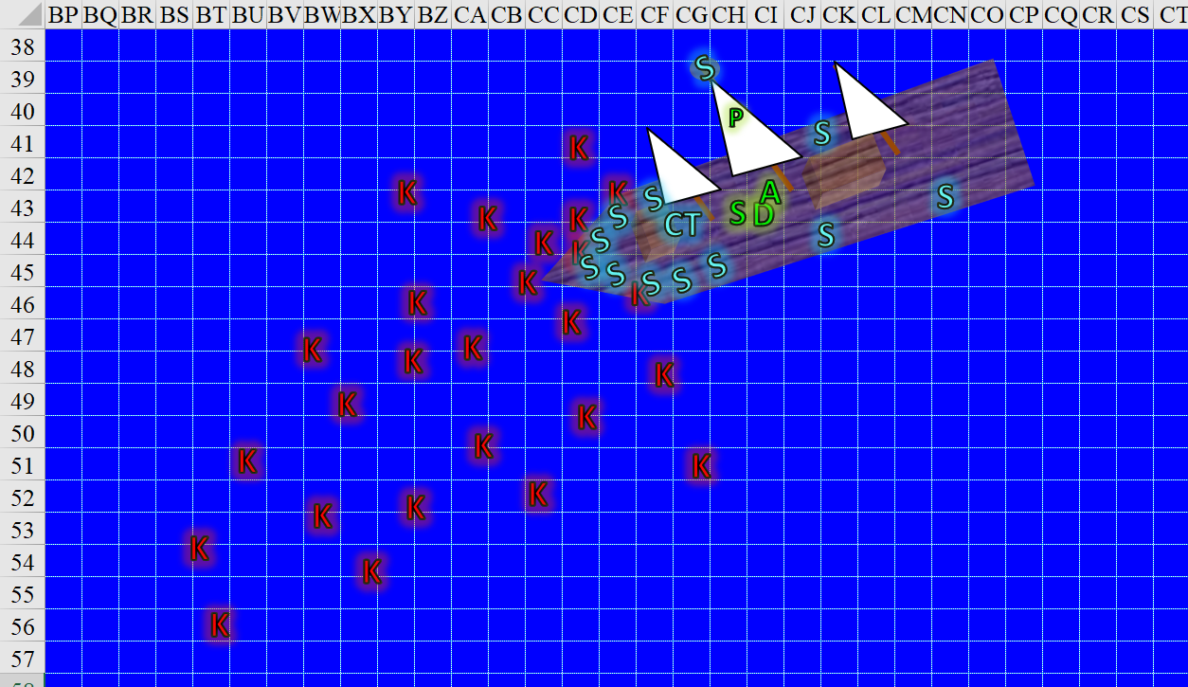

Round 2

Steelshade ran to the bow, drew her blade, and attacked the first kuo-toa she could reach with her scimitar.

|  |  |  |  |  |  |  |  |  |  |  |
| --- | --- | --- | --- | --- | --- | --- | --- | --- | --- | --- |
| **Melee Weapon** | **Dmg** | **D+** | **TH+** | **Crit** | **x** | **Type** | **Wt.** | **Atk** | **Roll** | **Check** |
| Shattermantle Bloodstone Falchion +3 | 2d4 | +7 +3 | 3 | 18 | 2 | Slashing | 8.0 | +27 | 6 | 33 |

*Hit. Dmg: 4 + 7 + 3 = 14.*

Devrion focused on the sailors and his companions. “Tűzpajzs!”

*Mass Fire Shield [expired on Round 19] with Fire damage.*

Pussyfoot clambered down and stepped up next to Atlas, her dagger drawn. The rogue turned to watch the after end of the ship, since the creatures could come aboard from any direction.

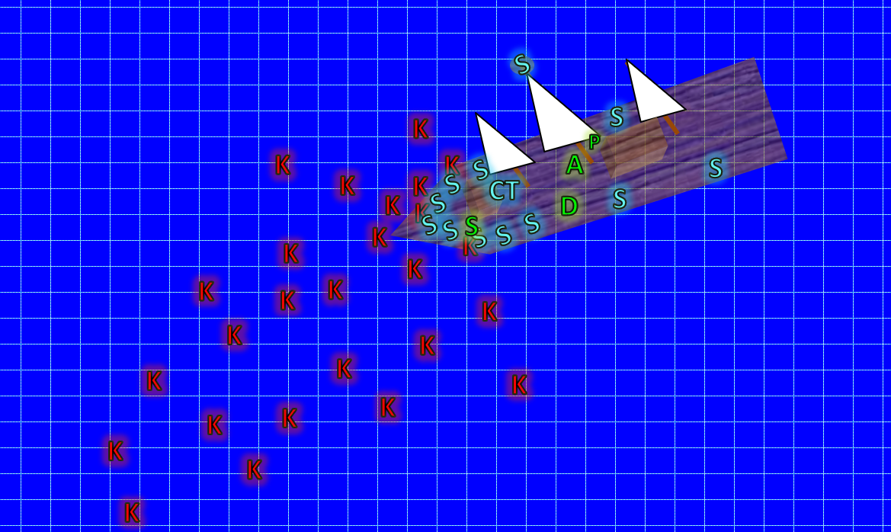

Atlas murmured a prayer, and then he opened his mouth wide and ROARED!

|  |  |  |  |  |
| --- | --- | --- | --- | --- |
| **Character** | Save vs.  *lion’s roar* | **Ranks** | **Roll** | **Check** |
| Crazed Kuo-toa 1 – 5 | Fortitude | 4 | 3 | 7 |
| Crazed Kuo-toa 6 – 10 | Fortitude | 4 | 10 | 14 |
| Crazed Kuo-toa 11 – 15 | Fortitude | 4 | 9 | 13 |
| Crazed Kuo-toa 16 – 20 | Fortitude | 4 | 1 | 5 |
| Crazed Kuo-toa 21 – 22 | Fortitude | 4 | 9 | 13 |
| Elasmosaur | Fortitude | 15 | 18 | 33 |

*Fail22.*

*Dmg to all crazed kuo-toa: 36 sonic.*

*Dmg to elalmosaur: ½ x 27 = 13 sonic.*

All of the kuo-toa died on the spot, leaving the crew startled from the sound but nonetheless grateful.

Round 3

The elasmosaur was wounded by the sound as well, despite being underwater, and Steelshade now caught its body fleeing southward.

Captain Thalassia turned to Steelshade, who had managed to wound one of the crazed kuo-toa before Atlas’ roar destroyed their brains, and huffed, “Phew! I thank you and your brethren. Our crew alone could not have managed to fend this many kuo-toa off.”

“Captain!” Godson wiped his brow. “I can’t help but notice that these kuo-toa are famished. Look at their ribs. Some look as though they’ve carved demonic symbols onto their own hides.”

They beheld the few that had made it aboard, and agreed that these naked warriors were nothing like any kuo-toa that the mariners had ever seen. Normally they wore some manner of armor, charms, and adornments; these looked like they’d never seen a civilized kuo-toa enclave, if such a thing could be said to exist. There also appeared to be no command structure, no apparent leader donning regalia, and their attack was relatively poorly coordinated—if at all. It was more of a mad, impetuous rush to destroy the humanoids with little other motive.

Upon hearing the reference to demons, Atlas came closer and recognized the half-healed carvings as being very reminiscent of those he’d beheld on the centaurs they’d fought half a multiverse away. “This is no coincidence,” he warned his friends and the crew of the Krakenbane.

“We’re being watched,” Steelshade said flatly. “If that is true, then they know that these,” she gestured to the dead koa-toa, “would have little chance against us. They will probably try again.”

Brene stepped up next to Atlas and pulled him down for a kiss. “I’d say leave some for the rest of us, but I’ll make an exception. These creatures are just sad.”

“We must be on our guard,” Devrion said as he stepped up next to Steelshade. “We will help stand watch until we reach our destination.”

The rest of the day was uneventful. They’d half-expected the elasmosaur to return, but the animal stayed clear of the ship for good, and as night settled upon them, the heroes felt an increased need to be vigilant. They decided—as Devrion has pledged—to take guard shifts through the night and sleep in part during the next day.

~*~

Daybreak came, and Captain Thalassia announced after reading her charts that they should be only a few hours away from shore. Her forecast proved to be true, for within six hours, they could see the coastline of the southernmost isle of the Whalebones. The land ahead—called Sedesty Island—was one of four larger islands in the archipelago, and was reputed by the sailors’ claims to boast a population of 250 on the off season, which was now. The locals were mostly humans, half-elves, half-orcs, and members of other bastard races who had been outcast by the more populated islands. The life there was simple, and the heroes wondered how they could best use this island to gather themselves before investigating Malcanthet’s location. They’d not mentioned this to the sailors, seeing as this would likely only alarm them; they suspected that if a demon of her caliber was dwelling in an archipelago, she’d likely be in a more populated island.

Within a half-hour of having spotted land, the ship was close enough to see the pier. However they’d expected it to be manned at this time of Morning, but it appeared barren from a few thousand feet away.

The Captain looked concerned, and confirmed, “Odd. They’re usually quite busy at this time with smaller boats coming in from the night’s fishing.”

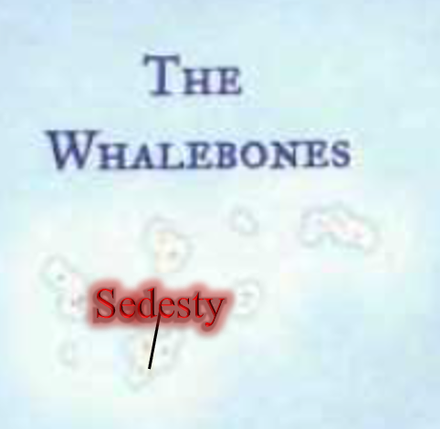

Coming closer, the frigate was approaching the pier, slowing down as the men and women that manned it expressed increasing concern at the lack of any local seamen in sight.

When it became clear that no one was visible, Steelshade turned to the captain. “I would recommend that you not dock here. Instead, let us leave from here, and move offshore, or visit another port in these islands, if there is one. There is something wrong, and we will go check the village.”

The Captain nodded, sighing, “We will leave you with a dinghy to-”

“Oh, no need,” Steelshade interrupted, producing their magic carpet. “We have our own means.”

“Ah. Very well.” The sailors stopped the ship before it reached the pier. There were a handful of rowboats beached to their north, but again, no one taking their bounty to the fishwives’ stations, which were also empty.

The heroes hopped onto the carpet, and thanked the Captain and her crew for the lift. “Next time you come to the island, verify that there are people ashore before mooring. We may have left by then, but if not, we’ll likely be nearby to hitch a ride back to the mainland.”

“Godspeed, heroes of Aasterinian,” Captain Thalassia bid them, and with a few more encouraging words from the crew, the carpet set off for the pier.