*Chapter 4: Sedesty Island*

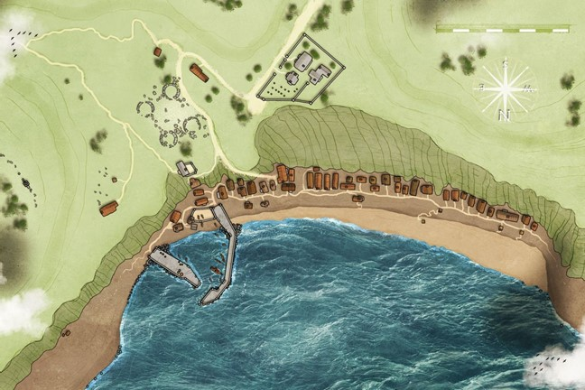

They made it to the crooked pier with no trouble, and from there, the path north led them to the abandoned shore.

Devrion lifted the carpet until it was fifty feet above the pier, and then he flew it over the water, fifty feet off the beach. They surveyed the entire village east to west, looking for any sign of life. There was indeed life: albatrosses, a stray dog, and shoals of fishes evident along the surface of the shore, just before the break line, but as for humanoids, there were none about. Devrion thought to look for footsteps along the beach, none were evident, so the desolation must have been in effect since before the last high tide.

The southwestward breeze brought with it the faint hint of smoke, which might have meant that a campfire was near, or perhaps that a nearby village had been razed to the ground days ago.

“Let’s fly over there,” Steelshade said as she pointed at the keep. Devrion lifted the carpet to a hundred feet as he crossed over the houses, and he circled the keep, staying fifty feet from the outer wall.

Suddenly and without warning, an unnatural accumulation of clouds manifested where a mostly clear sky had been above them, and from it, a rainstorm manifested within seconds.

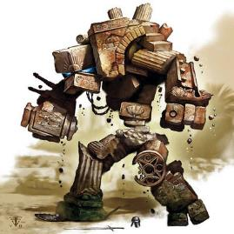

It was then that they noted movement to their immediate west. What had looked like an inanimate pile of rubble was actually a golem of some sort, and it hurled a rock at the carpet.

|  |  |  |  |  |  |  |  |  |  |  |
| --- | --- | --- | --- | --- | --- | --- | --- | --- | --- | --- |
| **Character** | **Attack Type** | **Damage** | **BAB** | **Str Mod+** | **Dex Mod+** | **W+** | **Other+** | **Total Score** | **Roll** | **Total** |
| Ruin Elemental | Rock, Thrown | 2d6+9 | 10 | 9 | 9 | 0 | 0 | 19 | 4 | 23 |

*Hit (carpet), miss (Devrion). Dmg to carpet: 7 + 9 = 16.*

The rock punched a hole through the carpet and bounced off of Devrion’s armor.

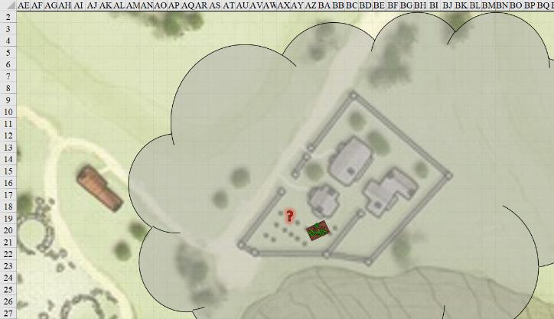

Round 1

|  |  |  |  |  |  |
| --- | --- | --- | --- | --- | --- |
| **Character** | **Group** | **Initiative** | **Roll** | **Modified Roll** | **Move** |
| Devrion | 1 | 6 | 17 | 23 | 30’ |
| Unidentified enemy | 2 | 1 | 19 | 20 | 20’/50’ |
| Atlas | 1 | 2 | 16 | 18 | 30’ |
| Brene | 1 | 6 | 7 | 13 | 30’ |
| Steelshade | 1 | 5 | 4 | 9 | 20’ |

At an altitude of 100’, Devrion immediately started the carpet into a climb. “Fekete fény!” *[blacklight, expired on Round 18]* He cloaked the carpet and its passengers in a black sphere to help throw off the creature’s aim as he climbed and turned away from it.

The unidentified golem-like creature likely did not throw another rock, now unable to spot the carpet beyond the *blacklight*.

The other three immediately sat down, as they were unable to see anything.

“Oh, this sucks,” Pussyfoot grumbled.

“Well, it beats having the carpet damaged,” Steelshade answered. “Atlas, what do you know about whatever-that-was?”

Atlas considered the creature he’d seen. “It’s a golem, and most of them are immune to magic.”

Round 2

“Yeah, and that’s why I’m running,” Devrion put in.

“Good call,” Atlas said as he considered what he knew about golems, and how they might better fight them. However, because they hadn’t been within 60’ of the golem, Atlas wasn’t able to tap into his Dark Knowledge to gain much insight into the creature’s vital spots.

Round 3

“As long as we have this globe up, we can be seen for a league,” Steelshade pointed out.

Round 4

“I’ll put us down near the beach,” Devrion said. He passed over the houses, and as he was about to dispel the *blacklight* and set the carpet down on the sand, he spotted a spellcaster-type figure flying towards them. It was about 100’ to their north, level with them, and was coming from the same direction as the keep, though they hadn’t seen where it was before it had come flying headlong towards the black orb.

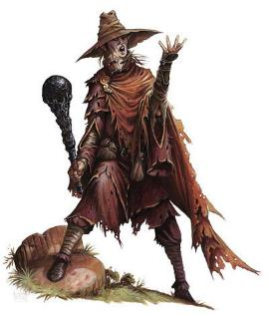

Casting *spike stones [expired on Round 12,004]* all around the *blacklight’*s spell effect, it was able to significantly hamper the carpet’s movement towards the beach. Devrion tried to slow the craft down, able to do so after having moved 15’ south and down, remaining at an altitude of 50’.

|  |  |  |  |  |  |  |
| --- | --- | --- | --- | --- | --- | --- |
| **Save vs.**  *spike stones* | **Rank** | **Ability**  **& Mod.** | **Misc.**  **Mods.** | **Total** | **Roll** | **Check** |
| **Atlas, Reflex** | **6** | **Dex (+2)** | 13 | 21 | 20 | 41 |
| **Brene, Reflex** | **11** | **Dex (+6)** | 0 | 17 | 19 | 36 |
| **Devrion, Reflex** | **6** | **Dex (+2)** | 3 | 11 | 4 | 15 |
| **Steelshade, Reflex** | **5** | **Dex (+2)** | 3 | 10 | 14 | 24 |

*Success, success, fail, success. Devrion did not save for ½ damage.*

*Dmg to Atlas: ½ x 14 = 7 [92/99].*

*Dmg to Brene: 9 [90/99].*

*Dmg to Devrion: ½ x 10 = 5 [94/99].*

*Dmg to Steelshade: ½ x 8 = 4 [175/179].*

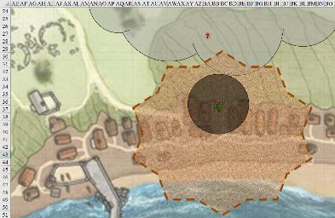

Round 5

Atlas could not see outside of the *blacklight* spell, and thus could not behold the stranger who was doing this to them.

Devrion was the only one among the heroes who could see anything at this point, and spotted the golem crashing through the stone wall of the keep. Between them and the golem was the hatted spellcaster now slowing down and seemingly preparing some other magical incantation. The warmage dismissed the blacklight spell so the others could see to fight. “Take it,” he said to Pussyfoot.

The rogue took control of the carpet, and Devrion focused his ire on the spellcaster. He pointed at the enemy mage. “Szétesik!” *[disintegrate]*

|  |  |  |  |  |
| --- | --- | --- | --- | --- |
| **Character** | **Save vs.**  *disintegrate* | **Ranks** | **Roll** | **Check** |
| Unidentified enemy | Fortitude | 12 | 10 | 22 |

*Success. Dmg: 19 magic.*

The spiked stones around them fell to the sandy ground, some splashing in the shallow waves and remaining in place once they’d dropped. As the unidentified stranger flew closer, Atlas was able to identify the fey as a ruin chanter, and proceeded to isolate its weaknesses.

|  |  |  |  |  |  |  |  |
| --- | --- | --- | --- | --- | --- | --- | --- |
| **Skill** | **Rank** | **Ability & Mod.** | **Misc. Mods.** | **Total** | **Roll** | **Check** | **Notes** |
| **Atlas, Knowledge: Arcana** | 16 | **Int (+5)** | 2 | 23 | 8 | 31 | Trivial Knowledge |
| **Atlas, Knowledge: Arcana** | 16 | **Int (+5)** | 2 | 23 | 13 | 36 | Trivial Knowledge, best of 2 rolls |

*Dark Knowledge: Foe ~ Success by 20+. PCs gain 3d6 weapon damage bonus against the ruin chanter.*

The ruin chanter began to chant a demoralizing ditty, and pointed at Devrion, manifesting an *infirmity of mind [expired on Round 605]* effect.

|  |  |  |  |  |  |  |  |
| --- | --- | --- | --- | --- | --- | --- | --- |
| **Save vs.**  *infirmity of mind* | **Rank** | **Ability & Mod.** | **Misc. Mods.** | **Total** | **Roll** | **Check** | **Notes** |
| **Devrion, Fortitude** | **6** | **Con (+1)** | 3 | 10 | 12 | 22 | +2 vs. Enchantments |

*Fail.*

Devrion immediately took on a frail and wrinkly appearance, and fell subject to a magical *confusion*.

*1d100 = 69. Devrion fled away from caster at top possible speed.*

At an altitude of 50’, Devrion jumped southwestwardly off the carpet at full speed with little concern for his own safety.

*Falling dmg: 18.*

*Spike stone dmg: 2 [74/99].*

Devrion got up and was ready to continue running right through the spiked stones towards the southwest.

Meanwhile, there were now two golem-like creatures, which Atlas could only assume to be ruin elementals, running southward, and plowing right through the spiked stones.

Still level with the ruin chanter at an altitude of 50, the carpet floated as Atlas spoke to give his friends an edge over the flying enemy.

Steelshade grinned humorlessly. “Go get him.” The duskblade cast *swift fly*, Quick Cast *dimension hop* to put her behind the ruin chanter, channeled *disintegrate* through Arkenlyl, empowered her attacks (Arcane Strike +4), and full-attacked the fey.

|  |  |  |  |  |  |  |  |  |  |  |
| --- | --- | --- | --- | --- | --- | --- | --- | --- | --- | --- |
| **Melee Weapon** | **Dmg** | **D+** | **TH+** | **Crit** | **x** | **Type** | **Wt.** | **Atk** | **Roll** | **Check** |
| Shattermantle Bloodstone Falchion +3 | 2d4 | +7 +3 | 3 + 4 | 18 | 2 | Slashing | 8.0 | +31 | 9 | 40 |
| SB Falchion +3, 2nd Attack | 2d4 | +7 +3 | 3 + 4 | 18 | 2 | Slashing | - | +26 | 4 | 30 |
| SB Falchion +3, 3rd Attack | 2d4 | +7 +3 | 3 + 4 | 18 | 2 | Slashing | - | +21 | 20 | 41 |
| SB Falchion +3, 4th Attack | 2d4 | +7 +3 | 3 + 4 | 18 | 2 | Slashing | - | +16 | 10 | 26 |

*Hit, miss, threat, miss. 1d20 = 5 + 17 = 22, not a critical hit.*

*Dmg: (3 + 7 + 3 + 11 Arcane Strike + 7 DK foe) + (6 + 7 + 3 + 11 Arcane Strike+ 7 DK foe) = 13 + 16 = 29 + 22 + 14 = 65 + disintegrate.*

|  |  |  |  |  |
| --- | --- | --- | --- | --- |
| **Character** | **Save vs.**  *disintegrate* | **Ranks** | **Roll** | **Check** |
| Ruin Chanter | Fortitude | 12 | 17 | 29 |

*Success. Dmg: 15 magic.*

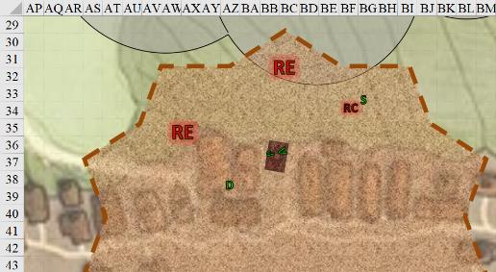

Round 6

|  |  |  |  |  |  |
| --- | --- | --- | --- | --- | --- |
| **Character** | **Group** | **Initiative** | **Roll** | **Modified Roll** | **Move** |
| Ruin Chanter | 2 | 11 | 19 | 30 | 40’ |
| Devrion | 1 | 6 | 17 | 23 | 30’ |
| Atlas | 1 | 2 | 16 | 18 | 30’ |
| Brene | 1 | 6 | 7 | 13 | 30’ |
| Steelshade | 1 | 5 | 4 | 9 | 20’ |

Due to some unexplainable force *[I had mistakenly put his initiative at +1; it should be +11]*, the alacritous ruin chanter was able to act more quickly than he had before, and now cast *infirmity of body [expired on Round 606]* upon Steelshade.

|  |  |  |  |  |  |  |
| --- | --- | --- | --- | --- | --- | --- |
| **Save vs.**  *infirmity of body* | **Rank** | **Ability & Mod.** | **Misc. Mods.** | **Total** | **Roll** | **Check** |
| **Steelshade, Fortitude** | 10 | **Con (+3)** | 3 | 16 | 4 | 20 |

*Fail. Steelshade suffered –6 penalty to Strength, Dexterity, and Constitution.*

|  |  |
| --- | --- |
| **Strength** | 19 |
| **Dexterity** | 8 |
| **Constitution** | 10 |

Aside from becoming immediately weaker and slower, Steelshade’s white hair turned gray, her skin wrinkled, and her posture stooped.

Devrion continued running southwestward through spike stones and shanties, madder than a hatter, and reached the beach.

*Dmg: 28 [46/99].*

Atlas kept an eye on the two ruin elementals as Brene lowered the carpet and flew towards Devrion.

|  |  |  |  |  |  |  |
| --- | --- | --- | --- | --- | --- | --- |
| **Skill** | **Rank** | **Ability & Mod.** | **Misc. Mods.** | **Total** | **Roll** | **Check** |
| **Pussyfoot, Use Magic Device** | 10 | **Cha (+0)** | 0 | **10** | 15 | 25 |

*Success.*

Steelshade cast *swift fly* to stay airborne, channeled *touch of idiocy [expired on Round ]* through her blade, and empowered her strike (Arcane Strike +4) as she full-attacked the creature again.

|  |  |  |  |  |  |  |  |  |  |  |
| --- | --- | --- | --- | --- | --- | --- | --- | --- | --- | --- |
| **Melee Weapon** | **Dmg** | **D+** | **TH+** | **Crit** | **x** | **Type** | **Wt.** | **Atk** | **Roll** | **Check** |
| Shattermantle Bloodstone Falchion +3 | 2d4 | +4 +3 | 3 + 4 | 18 | 2 | Slashing | 8.0 | +28 | 18 | 46 |
| SB Falchion +3, 2nd Attack | 2d4 | +4 +3 | 3 + 4 | 18 | 2 | Slashing | - | +23 | 17 | 40 |
| SB Falchion +3, 3rd Attack | 2d4 | +4 +3 | 3 + 4 | 18 | 2 | Slashing | - | +18 | 2 | 20 |
| SB Falchion +3, 4th Attack | 2d4 | +4 +3 | 3 + 4 | 18 | 2 | Slashing | - | +13 | 4 | 17 |

*Hit, hit, miss, miss. Dmg: (2 + 7 + 3 + 14 + 9 DK foe) + (5 + 7 + 3 + 11 + 8 DK foe) = 26 + 27 + 17 DK foe = 70 + touch of idiocy.*

*Ability dmg: -3 to Int, Wis, and Cha.*

One ruin elemental charge-attacked Devrion, while the other charge-attacked Atlas now that the carpet had reached Devrion.

|  |  |  |  |  |  |  |  |  |
| --- | --- | --- | --- | --- | --- | --- | --- | --- |
| **Character** | **Attack Type** | **Damage** | **BAB** | **Str Mod+** | **Other+** | **Total Score** | **Roll** | **Total** |
| Ruin Elemental | Slam (Devrion) | 1d8+9 | 10 | 9 | 2 charge | 21 | 4 | 25 |
| Ruin Elemental | Slam (Atlas) | 1d8+9 | 10 | 9 | 2 charge | 21 | 11 | 32 |

*Miss, hit. Dmg to Atlas: 7 + 9 + 2 = 18 [74/99].*

Atlas spread his hands and uttered a brief prayer, casting *end to strife [expired on Round 24]*. The elementals suddenly stopped flailing their appendages offensively.

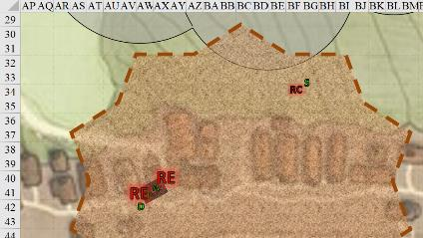

Round 7

The ruin chanter noted that Steelshade hesitated, and studied her mannerisms.

The ruin elementals wanted to attack Brene and Atlas, but were compelled to stay their wrath, and thus, ran northwards as the storm over the ruined keep began to subside.

Devrion ran like a madman along the beach and out of the spiked stones.

*Dmg: 16 [30/99].*

Brene flew the carpet 5’ up to avoid the spike stones, and followed Devrion getting behind and above him.

Steelshade cast *swift fly* to keep herself airborne, and looked at the ruin chanter. “We will stop attacking you, if you don’t attack us. We just want to look at the town.” With that she flew off after her companions.

The ruin chanter began to sing a dirge commemorating his ruins’ past glory to inspire courage or inspire greatness in itself and its allies.

|  |  |  |  |  |
| --- | --- | --- | --- | --- |
| **Character** | **Check** | **Ranks** | **Roll** | **Check** |
| Ruin Chanter | Perform (Chant) | 30 | 11 | 41 |

*See below.*

|  |  |  |  |  |  |  |  |
| --- | --- | --- | --- | --- | --- | --- | --- |
| **Save vs.**  *Fascinate* | **Rank** | **Ability & Mod.** | **Misc. Mods.** | **Total** | **Roll** | **Check** | **Notes** |
| **Atlas, Will** | **11** | **Wis (+4)** | 13 | 28 | 5 | 33 | +2 vs. Enchantment |
| **Brene, Will** | **6** | **Wis (+1)** | 0 | 7 | 1 | 8 |  |
| **Devrion, Will** | **11** | **Wis (+1)** | 3 | 15 | 2 | 17 | +2 vs. Enchantments |
| **Steelshade, Will** | **10** | **Wis (+2)** | 3 | 15 | 20 | 35 | +2 vs. Enchantments |

*Fail4. All PCs suffer –4 to skill checks made as reactions, such as Listen and Spot checks.*

Atlas murmured another prayer, and reached down to tap Devrion on the shoulder, but became fascinated by the ruin chanter’s dirge.

“Alas, alas, alas, the Pale Night descended upon Sedesty, my lass,

And with her were Ugudenk and Malcanthet crass sass.

Three fortnights and a half have come to pass

And nary a peep from a god or goddess

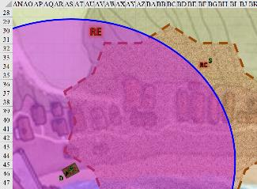

Round 8

“He’s got a good point, you know,” Brene said as Devrion stopped running, turned around and joined the others in listening to the fey creature deliberating his spiel.

“Nay, no redemption, nor restoration;

Not an omen of hope or a hint of salvation.

All that remains is the masonry’s erosion,

Parchments that were once scrolls and bottles that were once potions.”

Steelshade was compelled to listen, but at this moment, the fey stopped chanting, and gave her the option to speak and/or cast another *swift fly* spell.

Steelshade cast another *swift fly* spell, and went back to join the others.

The chanter returned towards the keep, as did the elementals, albeit slowly, and did not go through the breaches in the wall that the elementals had just managed to break. Instead, they stood there facing the heroes, and the chanter floated right above the wall in a defensive posture.

Rounds 9 – 11

They continued to look at the defenders of the keep in amazement for a while until Atlas came out of the fascinated effect and said, “We haven’t much time until my spell ends and they can attack again.”

“I’m not sure that they will unless we approach,” Steelshade was less than certain.

Atlas murmured a few words and touched Devrion’s shoulder, casting *greater restoration*.

When Devrion came back to himself, Steelshade put him on the carpet. “Brene, take us away from here.”

Brene piloted the carpet along the coast, moving eastward and away from the keep.

~*~

Minutes later, the coastline turned sharply northward.

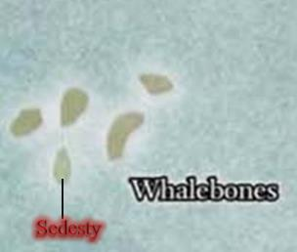

Atlas and Steelshade had a vague notion of the location of the larger islands, but they also knew from Captain Thalassia’s anecdotes that the seas between them were peppered with smaller outcroppings of vegetated land surrounded by sandy beaches.

“Should we circle this island or continue on to another island?” asked Brene.

Brene took the carpet up to 800’ above the water while they waited for Steelshade to recover, following the coastline eastward, and then turning northward.

The island was longer along its north-south axis than along its east-west shoreline, and it took them the better part of an hour to reach Sedesty’s larger settlement, which from a height of 800’ appeared to be populated with hundreds of bumbling zombies.

“Well, that’s not a place we want to go,” Atlas observed. “Let’s check the rest of the island.” He looked around at the area, seeing if the other side of this island – or other islands – were visible.

Devrion also looked all around them. “I’m sorry that I couldn’t resist that thing’s compulsion,” he said quietly to Angren.

“Well, it did something to me, too,” she replied.

“Speaking of which,” the warmage said as he extracted his wand of *cure light wounds*. He used it to heal himself, after which he would tend to Steelshade, and Atlas.

*Devrion healed 7 + 2 = 9 hps [39/99].*

*Devrion healed 6 + 2 = 8 hps [47/99].*

“What are we going to do?” Brene asked. “We were plain lucky this time.”

*Devrion healed 4 + 2 = 6 hps [53/99].*

“Well, Angren probably could have killed that chanter with a few more blows,” Atlas pointed out.

*Devrion healed 1 + 2 = 3 hps [56/99].*

“Yeah, but he, it, whatever, he was just defending his territory, right?” Brene looked at her lover.

*Devrion healed 5 + 2 = 7 hps [63/99].*

“Most likely, yes,” Atlas agreed. “They had to stop when I used that prayer on them, though.”

*Devrion healed 8 + 2 = 10 hps [73/99].*

“Okay, but what if they’d really wanted us dead? That prayer only lasts a short time, and then we’d been in even more trouble. Are we sure we can do this?”

*Devrion healed 3 + 2 = 5 hps [78/99].*

*Devrion healed 4 + 2 = 6 hps [84/99].*

“No,” Angren replied, “I’m not. But, what real choice do we have?” She pointed at the village. “Look at that, all of those people. That’s worse than simply being murdered. Their corpses are weapons.”

*Devrion healed 2 + 2 = 4 hps [88/99].*

*Devrion healed 1 + 2 = 3 hps [91/99].*

“We can go the hell back home,” the halfling retorted. “That’s the choice we have!”

*Devrion healed 3 + 2 = 5 hps [96/99].*

“Then what? We tell Aasterinian ‘Sorry, this is all too hard for us’?” Devrion shook his head.

*Devrion healed 5 + 2 = 7 hps [99/99].*

“I really don’t care what you tell him. I’d rather do that than end up like them.”

*Steelshade healed 4 + 2 = 6 hps [179/179].*

Angren looked at the village for a moment. “Let’s keep looking. It’s risky, because anyone on the ground can see us against the sky.”

*Atlas healed 5 + 2 = 7 hps [81/99].*

“We can stay up here for a short time to get the lay of the land, and then we can land and walk to anyplace interesting,” Atlas suggested.

*Atlas healed 6 + 2 = 8 hps [89/99].*

Angren nodded. “Okay. Ten minutes, and then we decide where to land.”

*Atlas healed 6 + 2 = 8 hps [97/99].*

“Got it,” Brene replied with a sigh. “And what about me?” she asked, still being slightly injured.

*Atlas healed 3 + 2 = 5 hps [99/99].*

*Wand of CLW had 33 charges left.*

|  |  |  |  |  |  |
| --- | --- | --- | --- | --- | --- |
| **Character** | **Melee** | **Total Damage** | **Healing** | **HPs** | **Current HPs** |
| **Atlas** | 25 | 25 | 25 | 99 | 99 |
| **Devrion** | 69 | 69 | 69 | 99 | 99 |
| **Brene** | 9 | 9 |  | 99 | 90 |
| **Angren** | 4 | 4 | 4 | 179 | 179 |

There were three large islands—one to the northeast, another to the north, and another barely visible in the far northeast—as well as about a dozen smaller islands between the carpet and the three large islands on the horizon.

Atlas and Devrion looked closely for any other settlements or signs of habitation, both on the island they were over, and on the others. It took a while to cover the rest of the coastline, and they only saw three settlements along the coast, two of which appeared to be unpopulated, and one of which was populated by bumbling zombies.

Steelshade shielded her eyes as she peered outward. “Okay, let’s check one of these empty villages. We really do need to land before someone nasty comes looking for us.”

Brene picked one of the empty villages, and approached from seaward, aiming for a point three hundred yards away, where they could set the carpet down and walk from there.

They backtracked from the point set down on the western end of the island, where there appeared to be not a soul left. This was less than a settlement. From the looks of it, a handful of families had built some shanties here, and with no pier, it appeared that rowboats could either ferry goods to and from ships that passed, or they might just have been a local fishery economy that supplemented their diet with temperate crops and whatever animals they could domesticate. A single corral looked like it might have been built with goats in mind, but no animals dwelled therein now. The place was desolate.

They remained on the carpet, half-expecting some vile creature to ambush them, but nothing stirred except for the vegetation against the breeze.

After a moment, the quartet stepped off the carpet. Steelshade rolled it up and put it away in her haversack, while Brene walked toward the tree line, her senses on high alert. Devrion and Atlas walked forward a few steps, spreading out into their combat formation to protect the rogue. They saw, heard, and smelled nothing that would alert them to danger, and noted that the smell of smoke—which they’d discerned was coming from a few burned buildings in the first village with zombies that they’d spotted—was absent here. The trees were sparse, as the soil here was sandy and nutrient-poor, and there were no footprints or other signs of traffic in recent days.

“It’s been at least half a tenday since anyone has set foot here,” Steelshade surmised.

Brene led the way, with Steelshade a few steps behind, and then Devrion and Atlas trailed them. They walked for a few minutes until the shore and the shantytown were about a quarter of a mile behind them. A skittish red squirrel peered down at them from a tree trunk, but nothing else stirred around them.

They returned to the shantytown, taking in the desolation. It must have been a nice place for the residents when they were here, but not even their livestock could be accounted for.

Brene searched each of the buildings as the others covered her and kept watch.

~*~

“Nothing?” asked Steelshade as Brene came out of the last shanty.

“Odds and ends, all mundane. These were a humble people. They ate fish and what little they could produce here on these plots,” reported the rogue. “Along the northernmost shack are some footsteps headed northward; other than that, no trace of anything notable.”

“All right, then we go north. Can you tell how many and who they might be?”

As they walked with the carpet tucked into the haversack, Brene looked closely at the tracks, noting number, size, depth, stride length, shoes or bare feet, in an effort to determine who may have made the tracks. “They are likely humans... humanoids for certain. They herded goats with them as they left, and if they continued in this direction, they veered inland and into that forest rather than skirting the coastline.”

“How many?” Devrion asked.

“Mmmm... at least a dozen, but certainly less than thirty,” Brene posited. “A few wore sandals; most wore heeled boots or shoes.”

“Let’s see where they lead,” Steelshade said. “They apparently had some warning, and there must be somewhere that they felt was safe.”

While the ladies followed the tracks, the guys kept their eyes moving for anything that might be watching them.

“They just look like tracks to me,” Devrion said quietly to Atlas. “What’s to see?”

“I confess, I don’t see much in them, either.” The archivist looked behind them, just to be sure.

~*~

Brene was correct that the tracks continued in a mostly straight line towards the inland forest that led them slightly up in altitude. They ventured about a half-mile towards that tree line—which was much thicker than the forest closer to the shantytown—and noted an incoming cluster of clouds on the far eastern horizon, an omen of what would perhaps be a light snowfall later that day.

Steelshade frowned. “Those clouds are moving quickly.”

Atlas peered at them to see if he thought they were natural or not, and based on his knowledge of this latitude, he suspected that they were.

The four were warmly dressed for the weather, with the three from the more southerly lands wearing heavier clothing than Steelshade, who hailed from the North.

Brene kept tracking the residents, while the others watched around them as they went along.

~*~

As they approached the forested area, they took note of a fallow field through which they walked. It had not been ploughed for at least two seasons, but had freshly bored holes large enough to suggest that ankhegs lived here. “We should be cautious,” Steelshade was familiar enough with the creatures to warn her comrades. She could tell by the droppings that this was exactly what lived here, and at any moment they could be ambushed from below. Then their worries were at least in part dispelled when they saw the bodies of what looked like two adult anhkegs—a male and a larger female—belly up and drying in the cool sunlight. This didn’t mean that there were no others, but it was highly likely, as ankhegs were cannibalistic, and would surely have eaten these two if there were any survivors. The bodies had no bite marks on them, but had several round burn spots and lateral slashes, suggesting that magical and edged weapon damage did them in.

They thought to get back on the carpet but opted not to, given how little a threat an ankheg—or even several—posed to them, and continued, listening for any tremors underneath them. Within a minute, they’d cleared the defunct ankheg territory and were in the midst of a white birch forest.

“You know,” Atlas said as he thought back on what the ruin chanter had said, “we are probably walking into something that will make the ruin chanter seem pleasant.”

“Why?” Devrion grimaced.

“It mentioned Pale Night, Ugudenk, and Malcanthet. Those are very powerful demon lords, indeed. We would stand no chance at all against them, especially the first. It is not good to even say her name. The chanter said they were here seven weeks ago.”

Brene turned to protest, and Steelshade held up her hand. “For what it’s worth, Brene, yes, we should just go home. Aasterinian sent us here, though, and she won’t just abandon us with no help.”

The halfling snorted. “That we will see about if we stay here.”

“Still, if these villagers are still alive and safe, then there might be a way,” Devrion pointed out.

Steelshade smiled at the warmage. “That is why we should keep looking.”

They kept on walking silently, and saw that they were on a noticeably trod trail that had likely been in use before the ankhegs colonized the spot behind them. There were more of the red squirrels here that they’d spotted earlier, but now they also heard a faint chanting up ahead. It sounded nothing like the ruin chanter, and was definitively female and humanoid. Atlas, the tallest of them, could barely see a woman wearing white robes with her back to them seemingly casting a light-based spell. She must have been 100’ or so away, and had likely not heard the heroes on account of her own singing. They could not make out the melody, but it seemed to be a somber one.



The group stopped while the magic users attempted to identify the spell she was casting. Upon closer inspection, it appeared that the woman was singing to a fey creature made of light, though from this distance, they weren’t certain.

“Stay here,” Brene said. The halfling whispered the words to activate her scout’s headband *[**true seeing, expired in 1 minute]*, moved off the trail and crept up closer to the woman.

|  |  |  |  |  |  |  |
| --- | --- | --- | --- | --- | --- | --- |
| **Skill** | **Rank** | **Ability & Mod.** | **Misc. Mods.** | **Total** | **Roll** | **Check** |
| **Brene, Hide** | 10 | **Dex (+6)** | 4 | **20** | 10ish | ?? |
| **Brene, Move Silently** | 10 | **Dex (+6)** | 0 | **16** | 10ish | ?? |

*See below.*

The rogue got within 35’ of the woman, and noted from her ears that she was a half-elf, or perhaps just a short-eared elf. She was likely a druid, and was speaking to a will-o-wisp-type fey, though there was no indication of hostility on the part of either one. Will-o-wisps were notoriously wicked, and Brene would have expected that even with an evil druid, the fey beast would have been hostile from the onset of their encounter. The woman was singing in Elven, and the words translated into:

<< O, ye, the light that nourishes the forest,

Be free and honor thy creators.

Space and time are yours to warm—cozy,

Mother of all things into which life was first breathed. >>

Brene carefully moved away, and went back to the others.

|  |  |  |  |  |  |  |
| --- | --- | --- | --- | --- | --- | --- |
| **Skill** | **Rank** | **Ability & Mod.** | **Misc. Mods.** | **Total** | **Roll** | **Check** |
| **Brene, Hide** | 10 | **Dex (+6)** | 4 | **20** | 15ish | ?? |
| **Brene, Move Silently** | 10 | **Dex (+6)** | 0 | **16** | 5ish | ?? |

*See below.*

She got about 20’ before she stepped on a branch under a layer of leaves and made a snapping noise that probably alerted the elf. More importantly, to her left, she spotted a snow lynx now perching on a rock, meowing ferally as if to point her out.

“Identify yourself, stranger,” the woman’s voice called out from behind Bene. It was not the stern voice of a warrior, nor the haunting voice of a ruin chanter, and had perhaps the frail tinge of a startled and worried civilian.

The halfling sighed and turned to face the woman. “I am Brene, and I’m not here to harm you.”

By now, the half-elf—if that’s what she was—had noticed the other three heroes. “What brings you all here?” she asked in Common as another few snow lynxes appeared from within the foliage, peering curiously at Brene.

The others walked forward, and Brene introduced each of them in turn. “We come at our goddess’ bidding,” Brene continued. “We see that a great tragedy has befallen the people here, and we intend to set it aright, if we can.”

“Your goddess? Who is your goddess?” the stranger asked as her cats encircled Brene, though in a manner more curious than menacing.

The being of light retreated spatially as its luminosity shyly diminished.

“She is Aasterinian,” Brene replied.

“Ah, the daughter of Io Himself!” the druid was impressed.

Atlas stayed silent while he thought about the woman and the setting to see if anything looked familiar. She seemed to be a druidic disciple, though nothing pointed to her being particularly powerful relative to himself.

Devrion and Steelshade kept an eye out around them as Brene talked.

~*~

After initial introductions and conversation, the heroes learned that the woman—a mostly elven half-elf, what was referred to as a half-human elf *[see DMG 171]*—was named Ginis. Her light-based friend was an elusive fey whose body had been destroyed during the siege upon the land by powerful, demonic necromancers who’d laid waste the shantytown whence they’d come and nearly slain her. The remaining life spirit of the fey creature—named Arjun of Toril—sought to stay in this place and bless the woods, but there were forces far more powerful than Arjun and Ginis that lingered on the island. Ginis went on to describe a vile orb that fed off of the energies of the vegetation in the forest, and had already blighted patches of the forest along its northeastern confines. “My albatross friends tell me that this western shore was spared the worst of the brunt of the necromancers’ brutal raping of the land and its inhabitants. From what they tell, every settlement on the island has been rendered lifeless.”

The heroes confirmed this from their own observations, and the woman did her best to not weep for her fellow residents. She was only a transient frequenter of the shantytown, preferring to live among the snow lynxes alongside Arjun, but felt a familial connection to some of them. “And now they’re all dead.”

“What happened to the bodies?” asked Atlas.

She answered: “I saw a few of them walking through the forest, making way northeastward, but they were zombies by that time, and I have no powers to reverse such a fate.”

“We are following tracks made by villagers who lived on the coast. Are they well?” Brene asked.

“I know not,” she admitted. “I believe you’re referring to the zombies that I mentioned. Even the livestock were turned.”

Atlas spoke up. “I fear we may have been the catalyst of this,” the archivist said quietly. “We have apparently angered followers of Pale Night and Ugudenk, who seek to release Malcanthet from her prison. Do you know anything of this prison?”

Ginis shook her head, “Nay, we have no prisons here. Sedesty has a pillory, but we are a no-captivity island.” It was evident that the woman had an understanding of the scope of which Atlas spoke.

“And the other islands near here,” Steelshade asked. “Might they contain such a magical prison?”

She shrugged, “I’ve not visited the other islands, but if you speak of a magical prison, anything is possible.” The threat here is not a prison, but the source of the evil that still permeates over Sedesty—I believe—is the orb of which I spoke.”

Looking at the others gathered, “We must find out if Dromedar was working with this Who character and where this Whovillen lives.”

“There is the small matter of the ruin chanter who has taken up residence there,” Steelshade said heavily, “but I understand.”

“Perhaps,” Atlas glanced at Steelshade in consternation, “we can help destroy or drive off this orb. Can you tell us more about it?”

Ginis explained more, describing Sedesty Island and its various settlements, the largest of which was Port Sedesty, where Captain Thalassia had almost docked her ship hours ago. As a native of the island, she’d spent most of her life in this forest and its outskirts near the shantytown named Backbone by a woman who’d first brought her family there generations ago.

Distant thunder reached them, though they’d been unable to see the lightning that preceded it through the copses of the trees around them. One lynx meowed with feral concern, anticipating a storm. Atlas, and to a lesser degree, Steelshade, both expected snowfall to reach them by the day’s end, perhaps even by Highsun.

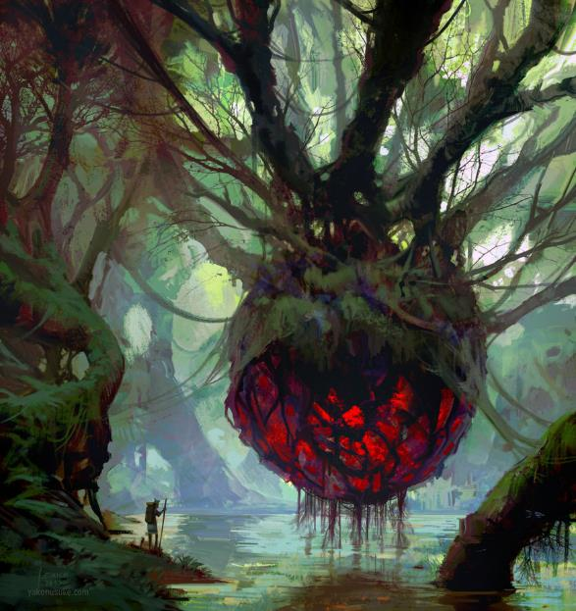

Ginis returned to the topic of the malignant orb, which she’d not seen, but had heard about from a magpie. The more detailed description given now concerned the heroes even more, thought it also gave them a sense of resolve, for by the profile that Ginis provided, they were able to deduce that this orb was akin to those spherical membranes inside the macrodemon, Pale Night, had housed her organs and bodily fluids.

“By Aasterinian!” Devrion exclaimed, adding nothing in words, but shaking his head in anticipation of what challenge lay before them.

Steelshade followed up with, “Where can we find this orb?”

“By the magpie’s account,” Ginis replied, “It is to the northeast, where the zombies were headed on their unholy pilgrimage.”

“Ginis, would you be willing to be our guide?” Steelshade asked.

|  |  |  |  |  |  |  |
| --- | --- | --- | --- | --- | --- | --- |
| **Skill** | **Rank** | **Ability & Mod.** | **Misc. Mods.** | **Total** | **Roll** | **Check** |
| **Steelshade, Diplomacy** | 5 | **Cha (+2)** | 2 | 9 | 17 | 26 |

*See below.*

She was hesitant at first, but the druid quickly came around to the idea, given the apparent prowess of the band of four. As the lynxes became more relaxed around the strangers, Ginis inhaled deeply before speaking, and nodded, “I will do so, for it appears that you are perhaps our island’s only hope in bringing balance and health to this island.”

~*~

Ginis led the heroes along the forest, with about half of her cats coming along with them, though they remained dispersed, scouting for the druid. The trek took a few hours through what at times was far thicker foliage than they’d expected in a temperate forest. Snow had not yet fallen, but they could tell by the dropping temperatures that came with the prevailing wind that it soon would.

Brene walked with Ginis, with Steelshade a few steps behind them. Atlas and Devrion followed behind the duskblade. No one had weapons in hand, though Steelshade carried her shield on her arm. If trouble arose, Brene and Steelshade would put themselves between the druid and any threats, while Devrion and Atlas would employ their spells.

Ginis led them until they began to spot signs of blight in the forest, by which time several of her lynxes had already complained that they’d wanted to turn back. She now pointed northeast and pronounced with an ominous tone, “The path ahead is surely to lead you to the orb, and to the demons you seek. Tread lightly, and fight well, heroes. I would not fare as well, but know that the gratitude of the forest’s creatures is with you, as is our moral support. I will call a prayer to the four winds as you continue, and give you the strength of our woodland allies.”

Steelshade knew those words were little more than comforting, for what could red squirrels and banyans do to help their plight against Ugudenk and Malcanthet?

Steelshade’s faith was with Aasterinian, not the forest creatures, she thought. “Let’s see what we can find,” she told her companions.

“Trouble,” Brene replied. “It’s just trouble.” The rogue shook her head and started forward, with Steelshade, Devrion and Atlas following.

Steelshade looked at Ginis. “We will do our best.” Then, the duskblade moved off after the rogue.

They walked for another twenty minutes or so along a barely beaten path littered with the scat of small predators—likely lynxes or something that size—until they began to smell the telltale scent of death in the westbound breeze that had ferried them from the mainland to this archipelago.

Steelshade and Atlas looked at one another with the knowing look that this was not a dead body, but likely a demon; the hint of sulfur was too dominant to have been rotting mortal flesh.

Rounds 1 – 4

“Gather around,” Atlas said. He laid his hands on each of his companions in turn, and then himself, as he said a prayer over them. *[Chasing Perfection, expired on Rounds 181 (Brene), 182 (Devrion), 183 (Steelshade), and 184 (Atlas)].*

*All PCs gained +4 to all ability scores.*

When he was done, Steelshade drew her blade, and everyone moved forward with Brene in the lead. They crossed the dimly lit forest into a sparser collection of conifers and temperate bushes, noting the clouds approaching with a few plumes of snowfall in the far east.

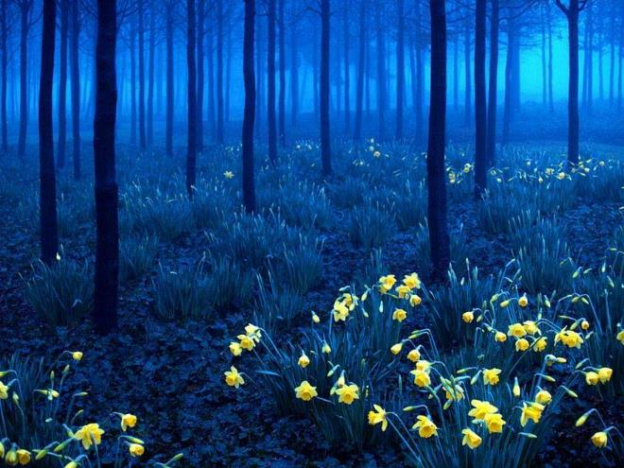

Moving forward came with the increasing intensity of the sulfurous scent they’d recently detected, except that now, coupled with it, was the hint of dead bodies, specifically the sweet, apple-like scent of dead ankhegs that they’d smelled hours earlier before encountering Ginis. They passed a few holes in the ground large enough for ankhegs, and became concerned that they’d be ambushed by such vermin, but what they happened upon was far worse.

Slightly uphill from them, they saw a pair of huge vermin feasting upon the carcasses of an entire brood of ankhegs, young and adults alike. They’d likely been munching on them for the past day or so, and given that the heroes were downwind of the demonic vermin devouring the ankhegs they hadn’t been noticed until now, when Devrion stepped in such a way that made enough noise for one of the demonic arthropods to turn around and zero in on the four humanoids.

Atlas immediately identified the demons as bebiliths, and knew that these were an overt creation of Pale Night—the macrodemon they’d recently slain. The second bebilith noticed the first one turning, and its attention was also roused. The two creatures of the Abyss turned their bodies to face the heroes, and at this point, a confrontation was inevitable.

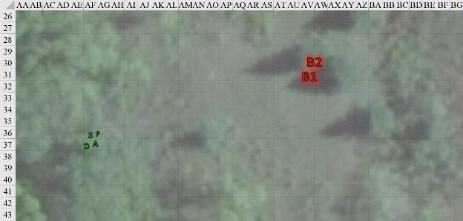

Round 100

|  |  |  |  |  |  |
| --- | --- | --- | --- | --- | --- |
| **Character** | **Group** | **Initiative** | **Roll** | **Modified Roll** | **Move** |
| Brene | 1 | 6 | 12 | 18 | 30’ |
| Atlas | 1 | 2 | 15 | 17 | 30’ |
| Bebiliths | 2 | 5 | 7 | 12 | 40’/20’ |
| Devrion | 1 | 6 | 2 | 8 | 30’ |
| Steelshade | 1 | 5 | 2 | 7 | 20’ |

“By the gods, they are *ugly!*” Brene said as she readied her shortbow. At a touch from Atlas, she didn’t extract an arrow, though.

Atlas spread his hands wide and murmured a brief prayer *[brilliant aura, expired on Round 118]*. Steelshade’s blade, Atlas’ shillelagh, Devrion’s crossbow bolts, and Brene’s arrows all glowed with a bright light, as did the rest of their weapons.

*All PCs’ weapons gained brilliant aura bonuses, ignoring bebilith’s armor bonuses, but not natural armor.*

The archivist then began to consider what he knew about these creatures that may help. “They have webs,” he warned.

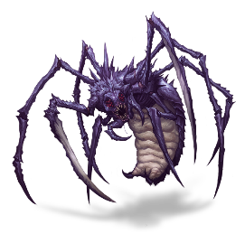

The bebiliths immediately sprinted towards the heroes, unable to shoot their webs far enough to entrap them.

Devrion pointed to a spot between the creatures. “Fekete csápok!” *[Evard’s black tentacles, expired on Round 118]*. Then, the warmage quickly moved to flank the creatures. “Stay away from the tentacles!”

Steelshade cast *dragonskin [expired on Round 1800]* on herself.

*Steelshade gained +5 to FF AC and AC.*

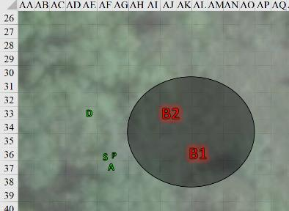

Round 101

Brene stepped back behind Steelshade, drew an arrow, and fired her shortbow with the magicked arrows twice at the closest demon.

|  |  |  |  |  |  |  |  |  |  |
| --- | --- | --- | --- | --- | --- | --- | --- | --- | --- |
| **Ranged Weapon** | **Dmg.** | **D+** | **TH+** | **Critical** | **Rng.** | **Wt.** | **Atk** | **Roll** | **Check** |
| Shortbow +2 | 1d4 | 2 | 2 | x3 | 60’ | 2.0 | +23 | 18 | 41 |
| Shortbow, 2nd Shot | 1d4 | 2 | 2 | x3 | 60’ | - | +18 | 10 | 28 |

*Hit, hit. Dmg: (4 + 2) + (2 + 2) = 6 + 4 = 10.*

Atlas murmured a few words, and then he threw his head back and laughed loudly *[Chaav’s laugh, expired on Round 281]*.

*Steelshade gained +2 to attacks and saves against fear effects, plus 2 + 18 = 20 temporary hit points [199/179].*

|  |  |  |  |  |
| --- | --- | --- | --- | --- |
| **Character** | **Save vs.**  *Chaav’s laugh* | **Ranks** | **Roll** | **Check** |
| Bebilith | Will | 9 | 18 | 27 |
| Bebilith | Will | 9 | 16 | 25 |

*Success, success. No effect on bebiliths.*

Atlas then moved with Devrion.

|  |  |  |  |  |  |  |  |  |  |
| --- | --- | --- | --- | --- | --- | --- | --- | --- | --- |
| **Melee Weapon** | **Dmg** | **D+** | **TH+** | **Critical** | **Type** | **Wt.** | **Atk** | **Roll** | **Check** |
| *Evard’s Black Tentacles* | Grapple/1d6+10 | 0 | 0 | x2 | Bludgeon | 0.0 | 26 | *1* | 27 |
| *Evard’s Black Tentacles* | Grapple/1d6+10 | 0 | 0 | x2 | Bludgeon | 0.0 | 26 | 11 | 37 |

*See below.*

|  |  |  |  |  |  |  |
| --- | --- | --- | --- | --- | --- | --- |
| **Character** | **Attack Type** | **BAB** | **Str Mod+** | **Total Score** | **Roll** | **Total** |
| Bebilith 1 | Opposed Grapple | 12 | 17 | 29 | 5 | 34 |
| Bebilith 2 | Opposed Grapple | 12 | 17 | 29 | 20 | 49 |

*Both grapples failed.*

The bebiliths got out of the tentacles, then stepped out of the area of effect, preparing to eat the heroes.

Devrion and Steelshade waited to see if the demons could defeat Atlas’ spell before they acted.

Devrion pointed at the monstrous creature coming for him (B2). “Halál ujja!” *[finger of death]*.

|  |  |  |  |  |
| --- | --- | --- | --- | --- |
| **Character** | **Save vs.**  *finger of death* | **Ranks** | **Roll** | **Check** |
| Bebilith | Fortitude | 16 | 5 | 21 |

*Fail.*

The bebilith died on the spot, crumpling into a husk of vermin carapace. Devion spoke again. “Gyors légy!” *[swift fly]*. He lifted himself 40’ straight up and prepared to attack the other creature.

Steelshade cast *swift fly*, lifted up, and attacked the remaining demon from above. She empowered her strike (Arcane Strike +3), and channeled the *vampiric touch* spell stored in Arkenlyl.

|  |  |  |  |  |  |  |  |  |  |  |
| --- | --- | --- | --- | --- | --- | --- | --- | --- | --- | --- |
| **Melee Weapon** | **Dmg** | **D+** | **TH+** | **Crit** | **x** | **Type** | **Wt.** | **Atk** | **Roll** | **Check** |
| Shattermantle Bloodstone Falchion +3 | 2d4 | +9 +3 +4d4 | 3 + 4 | 18 | 2 | Slashing | 8.0 | +35 | 9 | 44 |

*Hit. Dmg: 5 + 9 + 3 + 8 + 28 Vampiric = 53.*

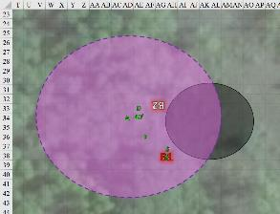

Round 102

Brene pulled out one of her scrolls of *enervation* and read it while pointing at the remaining demon. Then, she ran to flank the demon for her next ranged attack.

|  |  |  |  |  |  |  |
| --- | --- | --- | --- | --- | --- | --- |
| **Skill** | **Rank** | **Ability & Mod.** | **Misc. Mods.** | **Total** | **Roll** | **Check** |
| **Brene, Use Magic Device** | 10 | **Cha (+2)** | 0 | **12** | 18 | 30 |

*Success.*

|  |  |  |  |  |
| --- | --- | --- | --- | --- |
| **Ranged Weapon** | **Dmg.** | **Atk** | **Roll** | **Check** |
| Ranged Touch Attack | 1d4 negative levels | +21 | **20** | 41 |

*Threat (auto-hit). Dmg: 1 negative level.*

Atlas spoke softly *[spiritual weapon, expired on Round 120]*, and a magical light crossbow appeared in front of the demon, initially swirling and finally becoming green. It then attacked the bebilith as Atlas then backed away from the demon.

|  |  |  |  |  |  |  |  |  |  |
| --- | --- | --- | --- | --- | --- | --- | --- | --- | --- |
| **Ranged Weapon** | **Dmg.** | **D+** | **TH+** | **Critical** | **Rng.** | **Wt.** | **Atk** | **Roll** | **Check** |
| Spiritual Light Crossbow | 1d8 | wild | 0 | 19-20, x2 | - | - | +15 | 13 | 28 |

*Hit. Dmg: 6 + 4 acid = 10.*

The remaining bebilith fired its web upon Steelshade

|  |  |  |  |  |  |  |  |  |
| --- | --- | --- | --- | --- | --- | --- | --- | --- |
| **Character** | **Attack Type** | **Damage** | **BAB** | **Dex Mod+** | **Other+** | **Total Score** | **Roll** | **Total** |
| Bebilith | Web, 10’ incr. (30’ max) | DC 24 | 12 | -1 | -4 | 7 | 14 | 21 |

*Hit. Entangle.*

|  |  |  |  |  |
| --- | --- | --- | --- | --- |
| **Melee Weapon** | **Dmg** | **Atk** | **Roll** | **Check** |
| Grapple | Grapple | +28 | 10 | 38 |

*Pretty much beats any opposed roll.*

A few feet above the bebilith, the duskblade burst through the entangling demon goo as her *swift fly* spell began to fade.

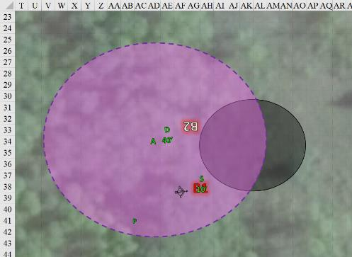

Spotting what appeared to be a tree moving towards them in the distance, Devrion settled back to the ground, and dismissed the *tentacles* spell. He moved closer to the demon, not wanting to cast anything with Steelshade in the way, and announced the approaching tree to the northeast, though none of them could see it from the ground.

Steelshade cast *swift fly*, empowered her blade again (+3), channeled *shocking grasp*, and full attacked the demon.

|  |  |  |  |  |  |  |  |  |  |  |
| --- | --- | --- | --- | --- | --- | --- | --- | --- | --- | --- |
| **Melee Weapon** | **Dmg** | **D+** | **TH+** | **Crit** | **x** | **Type** | **Wt.** | **Atk** | **Roll** | **Check** |
| Shattermantle Bloodstone Falchion +3 | 2d4 | +9 +3 +3d4 | 3 +3 | 18 | 2 | Slashing | 8.0 | +31 | 6 | 37 |
| SB Falchion +3, 2nd Attack | 2d4 | +9 +3 +3d4 | 3 +3 | 18 | 2 | Slashing | - | +26 | 14 | 40 |
| SB Falchion +3, 3rd Attack | 2d4 | +9 +3 +3d4 | 3 +3 | 18 | 2 | Slashing | - | +21 | 17 | 38 |
| SB Falchion +3, 4th Attack | 2d4 | +9 +3 +3d4 | 3 +3 | 18 | 2 | Slashing | - | +16 | 18 | 34 |

*Hit, hit, hit, hit. Dmg: (8 + 9 + 3 + 5 + 18 electric) + (2 + 9 + 3 + 8) + (8 + 9 + 3 + 6) + (4 + 9 + 3 + 5) = 25 + 22 + 26 + 21 + 18 electric = 112.*

The demon died as the duskblade slashed at it four times.

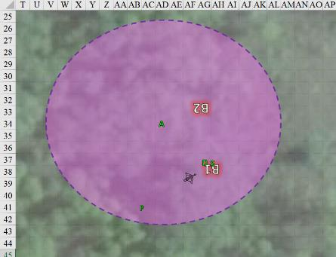

Round 103

Brene moved more to her right to get a flanking shot, and braced for whatever nasty tree was coming their way.

Atlas directed his *spiritual weapon* for another attack, anticipating the advent of the tree, which did not yet come into view.

Devrion and Steelshade each cast *swift fly*, and lifted up sixty feet to look for whatever might be advancing on them.

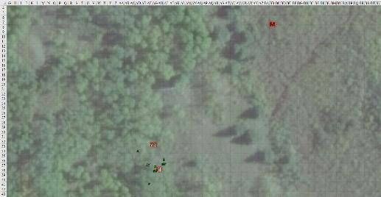

Round 104

|  |  |  |  |  |  |
| --- | --- | --- | --- | --- | --- |
| **Character** | **Group** | **Initiative** | **Roll** | **Modified Roll** | **Move** |
| Manitou | 2 | 10 | 19 | 29 | fly 50’ |
| Devrion | 1 | 6 | 20 | 26 | 30’ |
| Brene | 1 | 6 | 12 | 18 | 30’ |
| Steelshade | 1 | 5 | 12 | 17 | 20’ |
| Atlas | 1 | 2 | 7 | 9 | 30’ |

The demonic creature that looked like a cross between a dead tree and a sickened dryad came closer as it emitted a frightful moan.

|  |  |  |  |  |  |  |  |
| --- | --- | --- | --- | --- | --- | --- | --- |
| **Save vs.**  Frightful Presence | **Rank** | **Ability & Mod.** | **Misc. Mods.** | **Total** | **Roll** | **Check** | **Notes** |
| **Atlas, Will** | **11** | **Wis (+6)** | 13 | 30 | 13 | 43 |  |
| **Brene, Will** | **6** | **Wis (+3)** | 0 | 9 | 12 | 21 | +2 vs. Fear |
| **Devrion, Will** | **11** | **Wis (+3)** | 3 | 17 | 17 | 34 |  |
| **Steelshade, Will** | **10** | **Wis (+4)** | 3 | 17 | 16 | 33 |  |

*Success, fail, success, success. Brene suffered -2 to attacks, saving throws, skill checks, and ability checks.*

It was a horrific tangle of ghostly, thorny vines, each terminating in a jaw of razon-sharp, wood-like teeth, and prepared to avenge its bebilith brethren.

“Légy!” Devrion cast *swift fly*, remained about 60’ above the ground, and said “Hold!” to Steelshade in warning, and pointed behind and to the side of the oncoming apparition. “Napsugár!” *[sunbeam]*

|  |  |  |  |  |
| --- | --- | --- | --- | --- |
| **Character** | **Save vs.**  *sunbeam* | **Ranks** | **Roll** | **Check** |
| Manitou | Reflex | 15 | 6 | 21 |

*Fail vs. all six beams. Dmg: 17 + 15 + 14 + 8 + 14 + 15 = 83 fire. Partial damage negated.*

Brene moved toward the creature’s flank, not as far as she would have liked to *[speed = 20’]* and fired her shortbow at the creature. The arrows still held Atlas’ enchantment.

|  |  |  |  |  |  |  |  |  |  |  |
| --- | --- | --- | --- | --- | --- | --- | --- | --- | --- | --- |
| **Ranged Weapon** | **Dmg.** | **D+** | **TH+** | **Critical** | **Rng.** | **Wt.** | **Atk** | **Roll** | **Check** | **Properties** |
| Shortbow +2 | 1d4 | 2 | 2 | x3 | 60’ | 2.0 | +23 | 5 | 28 | Sneak Attack 9d6 |

*Hit. Dmg: 3 + 2 + 36 Sneak = 41.*

Steelshade, not wanting to get caught in Devrion’s spell, let herself sink to the ground, while she cast *haste [expired on Round 122]* and *soul of anarchy [expired on Round 704]* on herself.

*Steelshade gained +5 to Escape Artist checks and grapple checks to resist or escape a grapple. Her natural weapons became chaotic-aligned for the purpose of overcoming damage reduction.*

Atlas selected the approaching arboreal demon, which he identified as a manitou, redirected the crossbow’s attack towards the shambling demon, and cast *true seeing [expired on Round 284]* to be sure the demon wasn’t sneaking something else up on them.

The acid-spitting crossbow attacked the shambling demon.

|  |  |  |  |  |  |  |  |  |  |
| --- | --- | --- | --- | --- | --- | --- | --- | --- | --- |
| **Ranged Weapon** | **Dmg.** | **D+** | **TH+** | **Critical** | **Rng.** | **Wt.** | **Atk** | **Roll** | **Check** |
| Spiritual Light Crossbow | 1d8 | wild | 0 | 19-20, x2 | - | - | +15 | **20** | 35 |

*Threat. 1d20 = 7 = 15 = 22, critical hit. Dmg: (2 x 8) + 2 acid = 12. Acid damage negated.*

Seeing nothing hidden anywhere, the archivist then delved into his foreknowledge to gain an advantage for his companions.

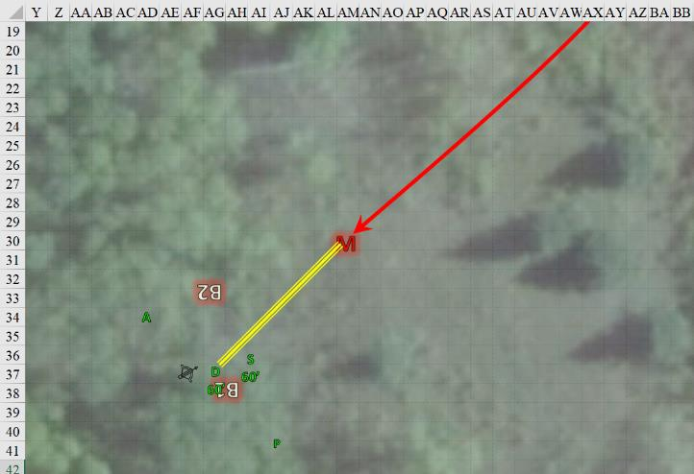

Round 105

Atlas began to gain Dark Knowledge over the manitou.

|  |  |  |  |  |  |  |  |
| --- | --- | --- | --- | --- | --- | --- | --- |
| **Skill** | **Rank** | **Ability & Mod.** | **Misc. Mods.** | **Total** | **Roll** | **Check** | **Notes** |
| **Atlas, Knowledge: The Planes** | 21 | **Int (+8)** | 5 | 34 | 6 | 40 | Trivial Knowledge |
| **Atlas, Knowledge: The Planes** | 21 | **Int (+8)** | 5 | 34 | 14 | **48** | Trivial Knowledge**, best of 2 rolls** |

*Success exceeds 20: Allies gained +3d6 bonus to weapon damage rolls made against the target creatures.*

The manitou cast *call lightning storm [expired on Round 254]* and fired a bolt at Devrion.

|  |  |  |  |  |  |  |
| --- | --- | --- | --- | --- | --- | --- |
| **Save vs.**  *call lightning storm* | **Rank** | **Ability & Mod.** | **Misc. Mods.** | **Total** | **Roll** | **Check** |
| **Devrion, Reflex** | **6** | **Dex (+4)** | 3 | 13 | 5 | 18 |

*Fail. Dmg: 15 electric [84/99].*

The creature then levitated to about 20’ above the ground.

The acidic crossbow fired once again at the demon.

|  |  |  |  |  |  |  |  |  |  |
| --- | --- | --- | --- | --- | --- | --- | --- | --- | --- |
| **Ranged Weapon** | **Dmg.** | **D+** | **TH+** | **Critical** | **Rng.** | **Wt.** | **Atk** | **Roll** | **Check** |
| Spiritual Light Crossbow | 1d8 | wild | 0 | 19-20, x2 | - | - | +15 | 17 | 19 |

*Miss.*

“Légy!” Devrion cast *swift fly* again, and then pointed at the demon “A halál ujja!” *[finger of death]*

|  |  |  |  |  |
| --- | --- | --- | --- | --- |
| **Character** | **Save vs.**  *finger of death* | **Ranks** | **Roll** | **Check** |
| Manitou | Fortitude | 16 | 20 | 36 |

*Success. Dmg: 8 + 18 = 26 negative energy [evil].*

Brene ran though the underbrush *[move action]*, her sandals affording her unimpeded passage, pulled up next to a tree, and shot the demon once more *[standard action]*.

|  |  |  |  |  |  |  |  |  |  |  |
| --- | --- | --- | --- | --- | --- | --- | --- | --- | --- | --- |
| **Ranged Weapon** | **Dmg.** | **D+** | **TH+** | **Critical** | **Rng.** | **Wt.** | **Atk** | **Roll** | **Check** | **Properties** |
| Shortbow +2 | 1d4 | 2 | 2 | x3 | 60’ | 2.0 | +23 | 16 | 39 | Sneak Attack 9d6 |

*Hit. Dmg: 4 + 2 + 34 Sneak = 40.*

This was nearly enough collective offensive power to bring it down, Steelshade noted as she cast *swift fly* once more, lifted up, and charged the demon, finding that the channeling of *disintegrate* through her blade was unnecessary, and instead empowering her attacks (+4).

|  |  |  |  |  |  |  |  |  |  |  |
| --- | --- | --- | --- | --- | --- | --- | --- | --- | --- | --- |
| **Melee Weapon** | **Dmg** | **D+** | **TH+** | **Crit** | **x** | **Type** | **Wt.** | **Atk** | **Roll** | **Check** |
| Falchion +3 | 2d4 | +9 +3+ 4d4 | 3 + 4 + 2  Charge | 18 | 2 | Slashing | 8.0 | +37 | 10 | 47 |

*Hit. Dmg: 3 + 9 + 3 + 2 Charge + 14 Arcane = 31.*

Atlas saw them bringing down the beast, and then said, “For future reference, this is a manitou. They’re immune to fire, electricity, and acid, and resistant to cold, so we put up a good fight against one of the harder-to-slay demons.”

The floating, green crossbow sat idle for the moment.

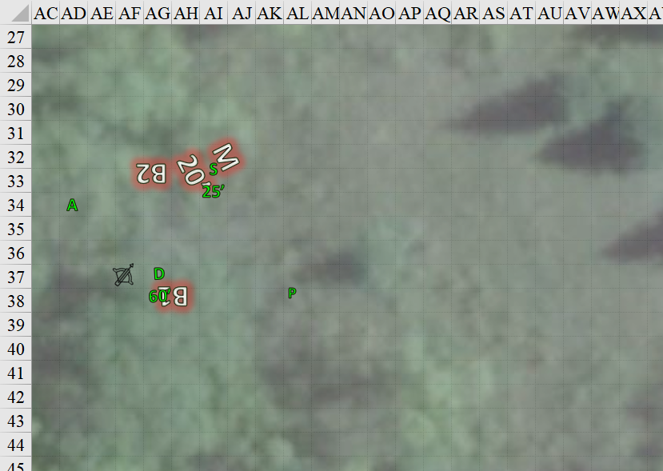

Round 106 – 110

“Check them, but be quick,” Atlas said. “Our spells are running low, and we need to rest before we continue ahead.”

With no other enemies in sight, and Atlas’ *true seeing* ability aiding his scanning for threats, the heroes looked at one another for any other well-coordinated actions.

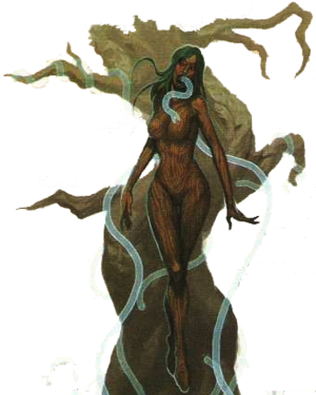

Even with this ability, the seasoned archivist saw only despair in the manitou’s corpse, which now revealed the truest illusion he’d ever beheld. A disembodied woman-spirit forever tearing itself from a tree trunk whilst psychic snakes shot out from her mouth. The snakes stopped emerging seconds after the manitou’s head hit the ground, and now the crossbow and its caster remained vigilant despite the woeful sight of the manitou.

“Shield your eyes from the sight of this corpse,” Atlas warned the others, but by now they’d all looked upon it, and taken a sincere pity in its dying. “Its flesh beckons to be resurrected, as it knows not that it cannot be brought back once destroyed.”

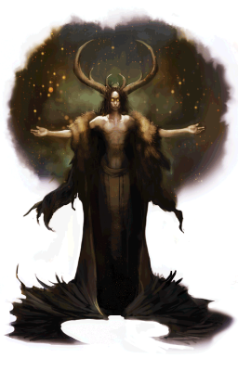

“Outsider fallout,” Devrion called it, having already seen a completely different woman now as clearly as the half of the sky above him that would soon be overcast as well. The corpse had been a horn- or antler-bearing demoness in her day, and had cast a mushroom-cloud-shaped form of etherealness behind her that at most angles had made her look like part of a tree, but she was no tree; she was a beautiful, Infernal goddess, and needed to be served by someone.

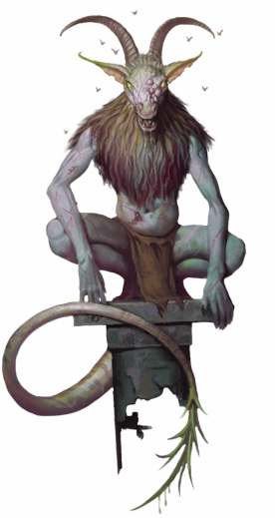

“Snow cometh,” Pussyfoot announced ominously, diverting her eyes from the beastly corpse before her, a horned, caprine fellow that had been moments from making a meal of their souls.

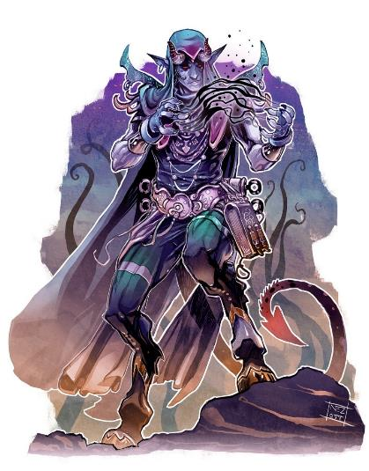

Having already checked the body, Steelshade had instead seen a definitively male and draconic fellow up close, though not of Aasterinian. He’d smelled and born every telltale sign of Tiamat that any dragonfolk ever did, and though she did not recognize him personally, her instant identification of a faithful to the Dragon who Rivals All Dragons caused her to sweat lightly as she checked the manitou’s remains, while Devrion and Brene checked the dead spider demons for anything of interest.

Coming back to a huddle, Steelshade sighed, “They carry nothing of value on them. The bebilith are brutally unkempt, and the manitou was mostly evil and chaos essences that are now gone. Its illusory sheen wore off by the time you said to divert your gaze.” She was disappointed that the draconic man had been a figment of her own psyche and not the enemy they’d actually slain.

Round 111

The scent of sulfur was now guiding them, even without the druid’s advice to continue northeastwardly. The forest thickened up ahead, and were predominantly of the baobab-like trees that Ginis had described. The four heroes looked at one another as they continued towards the innermost part of Sedesty Island.

“Let’s get out of here,” Steelshade said next. “We need to rest until morning before we go further.”

Brene nodded and began to retrace their steps, with the others following.

~*~

More than once, the party turned back to see bat-winged scouts hundreds of feet above them, conveniently out of spell range. Only once did a quasit glide downward amongst the thin tree line only to turn back before it was seen.

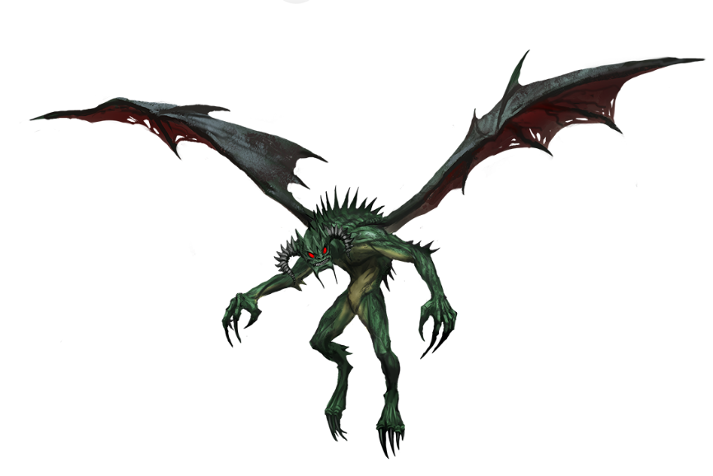

The party had backtracked a mile, and the snowfall had just caught up with them. The weather would quickly cool to freezing temperatures as the warm ground melted more and more of the initial flakes that fell, already in full size. They heard the distant cackle of a demon possibly approaching or possibly already in the midst of demonic acts.

Atlas stopped, looked around for a moment, and then he nodded. “Okay, I can get us back to right here, or anywhere along this trail, in the morning. Gather around.”

The others complied, and Atlas brought to mind the campsite where they’d first met the unicorn herd. He prayed a brief prayer... *[greater plane shift]*.