*Chapter 5: Sweet Home Krigala*

And with this, they were back on Krigala in the Beastlands.

“No place like home,” the jungle half-elf sighed as the sounds of the rippling cascade brought him back to the nightless realm of Krigala, where they’d been only days ago.



The quartet looked around the area, with Devrion using the carpet as an observation post. Once they were sure that the area was safe, they made camp and rested for the “evening”.

Atlas looked over his prayer book with a frown. Some of his prayers hadn’t had the effect he’d wanted, and he pondered over the selection of prayers he wanted for the next day. The archivist looked up as Brene plopped down next to him.

|  |  |  |  |  |
| --- | --- | --- | --- | --- |
| *Daily Prayers* | | | | |
| **Prayer** | **Level** | **Electric** | **DC** | **Cast?** |
| Read Magic | 0 | 0 | 18 | q |
| Detect Magic | 0 | 0 | 18 | q |
| Message | 0 | 0 | 18 | q |
| Cure Minor Wounds | 0 | 0 | 18 | q |
| Sanctuary | 1 | 0 | 19 | q |
| Endure Elements | 1 | 0 | 19 | q |
| Cure Light Wounds | 1 | 0 | 19 | q |
| Entangle | 1 | 0 | 19 | q |
| Bless | 1 | 0 | 19 | q |
| Spell Flower | 1 | 0 | 19 | q |
| Summon Monster I | 1 | 0 | 19 | q |
| Cure Moderate Wounds | 2 | 0 | 20 | q |
| Identify | 2 | 0 | 20 | q |
| Silence | 2 | 0 | 20 | q |
| Spiritual Weapon | 2 | 0 | 20 | þ |
| Flaming Sphere | 2 | 0 | 20 | q |
| Restoration, Lesser | 2 | 0 | 20 | q |
| Cure Moderate Wounds | 2 | 0 | 20 | q |
| Dispel Magic | 3 | 0 | 21 | q |
| Call Lightning | 3 | 1 | 22 | q |
| Stone Shape | 3 | 0 | 21 | q |
| Summon Nature’s Ally III | 3 | 0 | 21 | q |
| Footsteps of the Divine | 3 | 0 | 21 | q |
| Heart’s Ease | 3 | 0 | 21 | q |
| Footsteps of the Divine | 3 | 0 | 21 | q |
| Restoration | 4 | 0 | 22 | q |
| Restoration | 4 | 0 | 22 | q |
| Freedom of Movement | 4 | 0 | 22 | q |
| Freedom of Movement | 4 | 0 | 22 | q |
| Divine Storm | 4 | 0 | 22 | q |
| Divination | 4 | 0 | 22 | q |
| Flame Strike | 5 | 0 | 23 | q |
| Flame Strike | 5 | 0 | 23 | q |
| Flame Strike | 5 | 0 | 23 | q |
| True Seeing | 5 | 0 | 23 | þ |
| True Seeing | 5 | 0 | 23 | q |
| Chaav’s Laugh | 5 | 0 | 23 | þ |
| Chasing Perfection | 6 | 0 | 24 | þ |
| Chasing Perfection | 6 | 0 | 24 | þ |
| Chasing Perfection | 6 | 0 | 24 | þ |
| Chasing Perfection | 6 | 0 | 24 | þ |
| Dispel Magic, Greater | 6 | 0 | 24 | q |
| Restoration, Greater | 7 | 0 | 25 | q |
| Plane Shift, Greater | 7 | 0 | 25 | þ |
| Plane Shift, Greater | 7 | 0 | 25 | q |
| Withering Palm | 7 | 0 | 25 | q |
| Lion’s Roar | 8 | 0 | 26 | þ |
| Brilliant Aura | 8 | 0 | 26 | þ |
| Brilliant Aura | 8 | 0 | 26 | q |
| Discern Location | 8 | 0 | 26 | q |
| End to Strife | 9 | 0 | 27 | þ |
| End to Strife | 9 | 0 | 27 | q |
| Gate | 9 | 0 | 27 | q |

“You look unhappy,” she said as she held up a slice of cheese. “Eat.”

“Everything isn’t solved with food, Brene,” he said with a wry smile.

“Okay, take me to the creek and wash me,” she grinned.

“Sex doesn’t solve everything, either.”

“Hm,” she grumbled. “So, what’s up?”

“I don’t like some of the prayers I’d prepared for today. These demons are incredibly powerful.”

“They’re dead, and we’re not.” Brene shrugged.

“The ruin chanter isn’t dead,” Atlas reminded her.

The halfling wrinkled her nose. “Ew. Don’t remind me.”

The pair sat and talked for a few moments, and then Brene sighed. “I need a bath, and you’re just the man to give me one. Come on.” Atlas nodded, and the two of them went off to bathe in the creek.

Angren and Devrion sat near the tiny cooking fire and pondered the day’s events. They spoke occasionally as they ate and prepared to rest.

~*~

Back on the Prime Material Plane...

Snow fell over the Highsun day, and would soon cover the hillsides of Sedesty Island.

Having spied on the quartet right before they’d disappeared, a stick figure of a batlike demon swooped down like a peregrine falcon, spreading his wings to parachute into a graceful, snarling landing near the spot whence the party had just vanished. << Kill! >> the quasit simply blurted as it studied the surrounding area. Within a minute, a dozen or so uridezu had hopped and sprinted the rest of the way over, and as many quasits were perched atop branches, wondering where the heroes had gotten off to.

A few more minutes passed, and the whole lot of local quasits and uridezu had gathered ‘round, and a greater demon now stepped into the fore of the *plane shifted* entry point, wondering where its exit point might have been. This great demon was barely humanoid, and its surface glowed green, giving its gaunt, slimy patches a morbidly gruesome guise. << Kill! >> the quasit who’d first arrived on the scene pointed to the arbitrary point in space where the heroes had stood, and repeated the only word his weakened mind could fathom. It was clear now that all of the lesser demons also glowed a bit green under the falling snow, as they had been rendered gelatinous by their wrathful lord. The seemingly humanoid demon prince almost immediately reverted to one of its most basal configurations, and inhaled deeply before speaking.

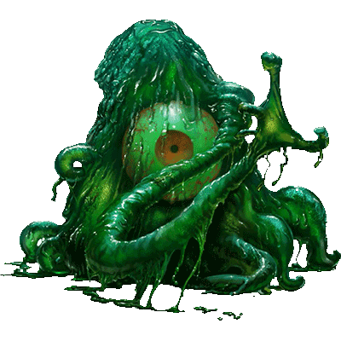

<< Motherrrrr, >> the young demon prince snarled in Abyssal, << We may have a problem. >>

~*~

Elsewhere, but nearby, the heart of the forest’s darkness palpitated with the knowledge bestowed upon this demon prince’s spawnmother whose hunger would not go unquenched. The nascent mind of the reborn Pale Night nymph fluttered within its cocoon in the palpitator that lay in waiting in the forest, envisioning itself instead to be in the midst of the far more comfortingly nightmarish confines of the Abyss, where screams swirled like smoke in the breeze.

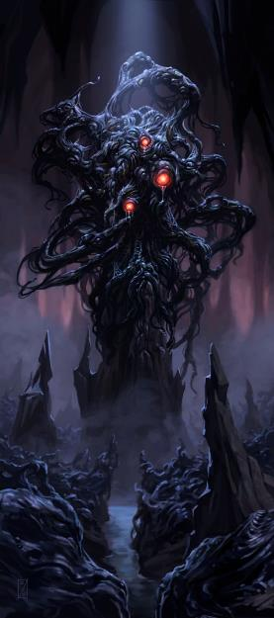

<< We will *crush* that which stands in our way, >> the spawnmother mind gland replied to its son, the Demon Lord Juiblex. Soon, both the Demon Lord, and his mother, Pale Night, would exist in their ultimate forms here on this plane, and would constitute the sole destroyers of all that thrived here.

<< Destiny is uncertain, >> one of the demons in the telepathic link said before another was summoned.

<< Ah... >> the maternal demon’s mind spoke into her elder son’s ear. << My favored, approach, that I might let you prove your faith. >>

Casting a *trace teleport* spell, Prince Juiblex immediately became aware of the teleportation effects that lingered within his midst. He then knew the exact termination point of the teleportation effect, and studied that termination point.

|  |  |  |  |  |
| --- | --- | --- | --- | --- |
| **Character** | **Check**  *trace teleport* | **Ranks** | **Roll** | **Check** |
| Juiblex | CL | 20 – 5 circumstance | 20 | 35 |

*See below.*

Gaining a glimpse of the teleportation effect’s termination point only long enough for him to get a brief look at the area, he was unable to scrutinize it in detail. << We return to our mother. >>

~*~

Having eaten, the heroes had lost track of time in the forever-diagonal incline of the afternoon sun, and though they were shielded from it under the trees, there crept a daytime breeze throughout the hillside and passing tributary. By chronography, it was still technically late morning, a bit past an eleventh toll, but not a twelfth.

“Should we prepare our spell now? Seems a bit early,” one of the heroes proposed. “Are there any we could use to conjure food?”

Atlas nodded. The archivist started to get himself comfortable in his asana before his preparatory recitations.

And as they began to feel as though they were safe from harm, a tear in the fabric of spacetime grew to the size of a portal large enough for the Demon Prince to step through it, plus a few quasits and uridezu who squeezed through at the archdemon’s feet.

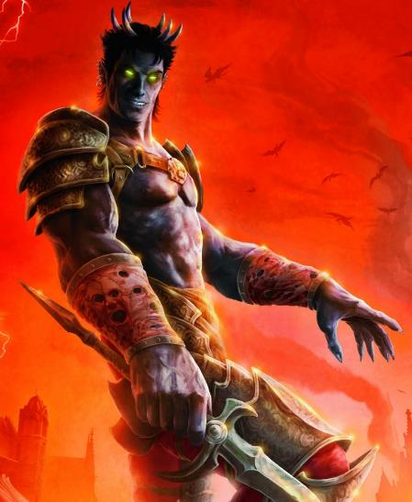

<< Mother said you’d be hiding here, near her uterine resting grounds. >> the words were spoken in Abyssal, and thus were not understood by any of the heroes.

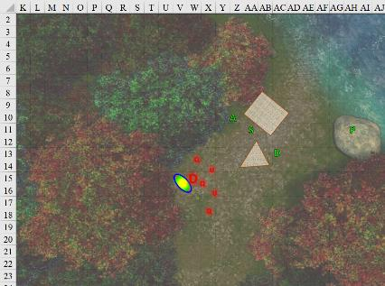

Round 400

|  |  |  |  |  |  |
| --- | --- | --- | --- | --- | --- |
| **Character** | **Group** | **Initiative** | **Roll** | **Modified Roll** | **Move** |
| Devrion | 1 | 6 | 14 | 20 | 30’ |
| Steelshade | 1 | 5 | 15 | 20 | 20’ |
| Brene | 1 | 6 | 12 | 18 | 30’ |
| Demonic Forces | 2 | 13 | 2 | 15 | 30’ |
| Atlas | 1 | 2 | 5 | 7 | 30’ |

Devrion set his plate aside and stood up, crushing a black pearl as he began to prestidigitate. “You’re not invited to dinner.” He pointed to a spot behind the demon. “Halál köre!” *[circle of death, 54 HD]*

|  |  |  |  |  |
| --- | --- | --- | --- | --- |
| **Character** | **Save vs.**  *circle of death* | **Ranks** | **Roll** | **Check** |
| Quasit 1 | Fortitude | 3 | 19 | 22 |
| Quasit 2 | Fortitude | 3 | 13 | 16 |
| Quasit 3 | Fortitude | 3 | 20 | 23 |
| Uridezu 1 | Fortitude | 6 | 10 | 16 |
| Uridezu 2 | Fortitude | 6 | 6 | 12 |

*Fail, fail, success, fail, fail. Quasits 1 and 2, and both uridezu, died instantly.*

The uridezu fizzled and crackled as did two of the quasits present. Only the heftiest of the latter was able to snarl through that effect unscathed. The Demon Prince—far too mighty to succumb to such an incantation—sighed at his stray livestock perishing at his feet.

Steelshade quick-cast *dimension hop* (to V14), channeled *shocking grasp* through her blade, and empowered her strikes (+4) as she full-attacked the demon prince.

|  |  |  |  |  |  |  |  |  |  |  |
| --- | --- | --- | --- | --- | --- | --- | --- | --- | --- | --- |
| **Melee Weapon** | **Dmg** | **D+** | **TH+** | **Crit** | **x** | **Type** | **Wt.** | **Atk** | **Roll** | **Check** |
| Shattermantle Bloodstone Falchion +3 | 2d4 | +9 +3 + 4d4 | 3 + 4 | 18 | 2 | Slashing | 8.0 | +31 | 18 | 49 |
| SB Falchion +3, 2nd Attack | 2d4 | +9 +3+ 4d4 | 3 + 4 | 18 | 2 | Slashing | - | +26 | 11 | 37 |
| SB Falchion +3, 3rd Attack | 2d4 | +9 +3+ 4d4 | 3 + 4 | 18 | 2 | Slashing | - | +21 | 17 | 38 |
| SB Falchion +3, 4th Attack | 2d4 | +9 +3+ 4d4 | 3 + 4 | 18 | 2 | Slashing | - | +16 | 16 | 32 |
| Greater Truedeath Crystal | 1d6 | vs. | undead | - | - | - | - | - | - | - |

*Hit, hit, hit, miss. Dmg: (7 + 9 + 3 + 15 Arcane + 14 Electric) + (4 + 9 + 3 + 20 Arcane) + (5 + 9 + 3 + 11 Arcane) = 19 + 16 + 17 + 46 Arcane + 14 Electric = 112 – 6 to SR. Electric damage negated.*

Brene, who was sitting with Atlas, stood up, plucked out one of her scrolls of *enervation*, and read it while pointing at the demon prince.

|  |  |  |  |  |  |  |
| --- | --- | --- | --- | --- | --- | --- |
| **Skill** | **Rank** | **Ability & Mod.** | **Misc. Mods.** | **Total** | **Roll** | **Check** |
| **Brene, Use Magic Device** | 10 | **Cha (+2)** | 0 | **12** | 14 | 26 |

*Success.*

|  |  |  |  |  |
| --- | --- | --- | --- | --- |
| **Ranged Weapon** | **Dmg.** | **Atk** | **Roll** | **Check** |
| Ranged Touch Attack | 1d4 negative levels | +21 | 3 | 24 |

*Dmg: 3 negative levels; i.e., -3 to attacks, saves, and checks, and -15 HPs.*

With the *planar shift* conduit closing behind him, the Demon Prince ?

The quasit that remained fled southward on wing. Alone and unable to bring down the band that he now took to be a wily wu jen half-elf, a spiky half-orc swashbuckler, a skulky incantatrix, and a hesitant priest, the Demon Prince had seen enough. *Plane shifting* back out to whence he’d came, he left only the scent of camphor and musk behind him.

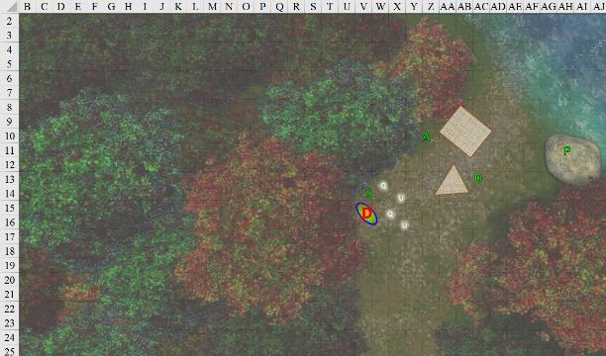

Round 401

And just like that, they’d put a Demon Prince in his place for the time being. There were telltale signs that the Demon Prince—whichever one he was—had spent the greatest of his daily mojo by then, and the same was the case with the lesser demons.

“Who *was* that?” Steelshade had been impressed by the musculature of the demon’s face.

“That had to be none other than Graz’zt himself,” Atlas reported.

“But in a lesser form,” Devrion had to speculate.

“Likely, or he would not have succumbed to Brene’s *enervation* spell,” Atlas provided a diagnosis of the events.

“Lesser form or not,” Brene sighed, “He *was* dreamy.”

“Be careful, sisters,” Devrion tried to remind the two, “Even the manitou elicited a pity reaction from us. These demons have the capacity to sway our compassion and hesitation. Do *not* hesitate to put this Graz’zt down if he comes for us again.”

The forest was alive with the sounds of birds once more.

“What do we do if there’s another incursion?” asked Brene.

Atlas and Steelshade—the two senior tacticians—looked at one another.

“We go back to Waterdeep,” Steelshade answered as she swapped out her crystals on her sword and kukri, placing the Arcane Steel one in Arkenlyl, and the Trudeath one in her kukri.

“Let’s finish our meal first,” Atlas suggested. “Then we can use the carpet to move elsewhere to camp.”

The others agreed, so they sat down to finish their meal.

~*~

Other than the attack by the demon who knew where they were, there was no interruption to their meal and as that wound up to a cleanup, one of them wondered aloud, “Should we take the carpet to an undisclosed location and *plane shift* from there? Seems we’re leaving a clear planar trail if we put an entry point so close to our conduit’s exit point.” They were cognizant of the Plane’s workings enough that they could suspect Graz’zt, heir apparent to the Abyss itself, but wounded and taxed by the time he’d materialized before the heroes, could likely trace their transplanar teleportations to just about anywhere. While a Devil Lord would have wanted to prevent being spotted making trouble in Waterdeep, a Demon Lord couldn’t have cared less... and might have found it what flavored the story as he would further lay waste tavern and temple alike.

~*~

The horned, batlike fiend swooped high above the tree line, surveying the layout of Krigala’s inland valleys. A single firelight caught his attention, and within minutes, he was spying from afar the happenings of a clade of unicorns and their jackalwere collaborators seemingly enslaving centaurs.

This would make for good bedtime storytelling, thought the quasit, as he perched on a branch far enough from detectability, getting the wits to swoop closer down in time.

After their meal, the group stored their gear, boarded the carpet, and flew an hour away from the campsite in the opposite direction from the demon corpse they’d found here before. They looked for a suitable place to land and camp for the evening.

They were in a nondescript location that they couldn’t have found by any nearby landmarks if they tried, and set down to sleep.

Brene and Atlas slept together. Since Angren and Devrion didn’t really sleep, anyway, they arranged themselves so they ccould see the entire area around their campsite.

~*~

The rest was unexpectedly uneventful. They’d anticipated having to deal with a pack of hunter demons between the hours of daylight that they’d spent horizontally, the human and halfling arose to find their elven-descended friends at the perimeter of the campsite, discussing philosophy with whispered voices.

The group rose, broke fast, and made their spells ready for the day.

“Are we going back to the island?” Brene asked.

“I don’t think we have much choice,” Atlas replied. “Aasterinian is surely watching over us, so I think we should.”

Angren and Devrion nodded in agreement. “Let’s go, then.”

Atlas gathered everyone around, and cast *greater plane shift* to bring them to the beach where they’d found the footprints.

It was now about midnight, and it had snowed for hours, leaving a blanket of snow about 3 to 4 inches deep. Backbone, the shantytown, was as desolate as it had been during the day. To their north were the footprints they’d spotted earlier that day, plus their own, and beyond were the fallow fields where they’d found a dead clutch of ankhegs.

“That’s odd,” Atlas said as he determined the local time, having started to sleep in the afternoon. “I would have thought our bodies would have more accurately determined the time here.”

Brene gazed up their trail for a moment, and then turned to the others. “I think we should go in from a different direction, and not follow our old trail.”

“Either way, we have our spells back,” Devrion said, “and I agree about going back in from another direction. Maybe we can fly up the beach for a couple of miles, and then walk in from there.”

“I like that idea,” Steelshade said. She took out the carpet. “Brene, you’re flying.”

“Got it.” The quartet stepped onto the carpet, and Brene guided it north, fifty feet above the water, and a hundred feet offshore from the surf line.

~*~

They headed north until they all agreed that they were at about the latitude at which the demons had attacked them, and concluded that they should head east again to get to that location, so they did just that. They continued inland for a few more minutes, noting that the snow had melted off the treetops, breaking the monotony of the white ground against the darkness above and around them. “How will we know where the location was?” Brene asked, still guiding the carpet eastward.

“I don’t know, but I suspect we will find out,” Steelshade said. “Find a place to set us down, but be ready for trouble.”

Brene guided the carpet to the closest place she could find to land.

They stepped off the carpet, and put their boots into about 6 inches of inland snow under a crescent moon.

Atlas looked at his diminutive lover. “Can you manage, Brene?”

The halfling glanced down to her feet, where the snow came up to just above her ankles. “I think I can manage,” she said. “Let’s go.”

The group started off inland, with Brene leading, Steelshade a half-dozen paces behind her, Devrion next, and then Atlas.

~*~

They trekked in the cold of the night for about an hour, and at about the point when Brene’s fingers were chilled to the bone and she could take no more, they happened upon what appeared to be demonic—or perhaps just large reptilian—footprints. “These head directly east,” Devrion stated the obvious.

None of them were experienced trackers, but perhaps they could try to track this bipedal being down.

Brene paced the distance between the tracks in an effort to guess how large the creature was. “It’s about the size of one of those bebiliths,” she guessed.

“Oh, is that all? Pppft!” Devrion snorted.

“Oh, blow it out your hat,” Brene huffed.

“Children,” Atlas rumbled. “Behave, now.”

Steelshade chuckled softly as they continued along.

~*~

Within the hour, as the wee hours of the night manifested and a rolling fog meandered over the landscape, they began to smell the sulfurous fumes coming from a more wooded area up ahead. The general character of the forest was becoming more familiar to them, and while they were not on the same path as before—in fact, they were on no beaten path at all—the vegetation and topography were such that they anticipated encountering demons at any moment.

Then they heard a scream—neither humanoid nor animal—coming from the upwind east, and the sound sent shrill waves of unease up their spines. From the sound of it, it was likely another bebilith.

Steelshade motioned for Brene to work her way further north as they continued eastward, so the rogue turned northeast. Everyone tried to be quiet as they picked their way through the woods.

They walked for a few more minutes until most of the heroes heard movement to the south.

Brene motioned for the others to stop, and then she carefully moved south 50’, and stopped to listen.

|  |  |  |  |  |  |  |  |  |  |
| --- | --- | --- | --- | --- | --- | --- | --- | --- | --- |
| **Character** | **Attack Type** | **Damage** | **BAB** | **Dex Mod+** | **W+** | **Other+** | **Total Score** | **Roll** | **Total** |
| ? | Ranged Touch Attack | Varies | 4 | 9 | 0 | 0 | 13 | 7 | 20 |

*Hit. 1d100 = 26, displacement bypassed. Dmg: See below.*

A green ray from the south hit her shoulder, and she became instantly covered in a shimmering emerald field that Devrion and Steelshade identified as a *dimensional anchor*. Whoever did this was aware that the heroes liked to *plane shift* away from unfavorable combat conditions, and thus they could confidently assume that they were in the midst of demons familiar with them.

A handful of quasits and uridezu emerged from the woods to the south.

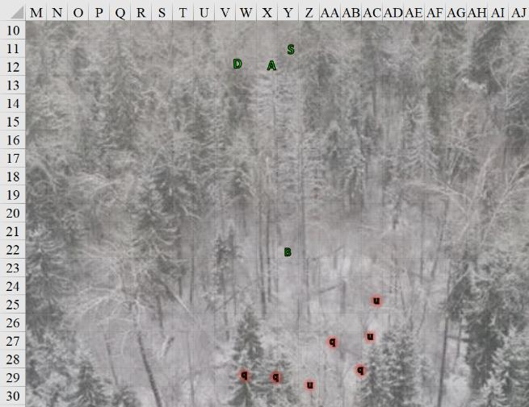

Round 1

|  |  |  |  |  |  |
| --- | --- | --- | --- | --- | --- |
| **Character** | **Group** | **Initiative** | **Roll** | **Modified Roll** | **Move** |
| Graz’zt | 2 | 13 | 18 | 31 | 30’ |
| Brene | 1 | 6 | 15 | 21 | 30’ |
| Uridezu | 2 | 3 | 12 | 15 | 30’ |
| Devrion | 1 | 6 | 7 | 13 | 30’ |
| Quasits | 2 | 3 | 9 | 12 | 40’ |
| Atlas | 1 | 2 | 8 | 10 | 30’ |
| Steelshade | 1 | 5 | 3 | 8 | 20’ |

Graz’zt—the Dark Prince and patron of corrupt rulers and decadence—made his presence known, though they could not spot him. He now spoke in Common, saying: “You’re mine now. Mother will want to see your heads, but I shall feed the rest to my pets.”

Brene turned and ran back toward Atlas.

The uridezu succumbed to their basal instincts and started chasing after Brene as soon as she turned tail, not quite able to charge-pounce-attack her on this round.

Devrion pointed to a spot behind Brene, as to not catch her in the spell’s effect. “Földrengés!”

Instinctively, the quasits flew upward into the air as soon as the trembling began.

Beyond the far end of the earthquake, a chain-toting, heavily pierced balor appeared on what had become a battlefield. Amidst the trees, the visibly wounded turned to look at the heroes, who now beheld the heroes and flew across the widest breach between the trees, smashing a few on its way towards them.

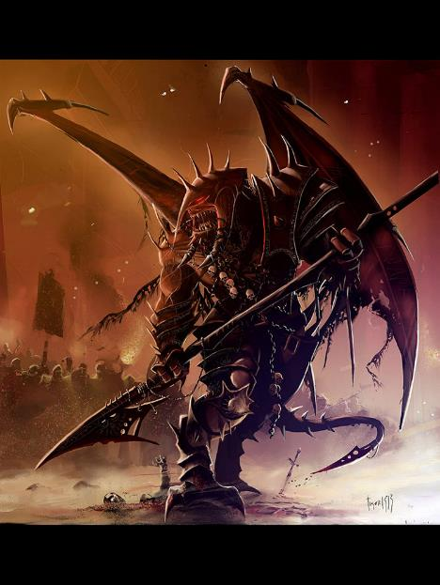

“Stovegullet,” Atlas identified the demon by name, and guessed that he’d been badly beaten in an unfair fight. The human then murmured a brief prayer *[lion’s roar, bonuses expired on Round 181]*, and then he opened his mouth wide and roared.

|  |  |  |  |  |
| --- | --- | --- | --- | --- |
| **Character** | **Save vs.**  *lion’s roar* | **Ranks** | **Roll** | **Check** |
| Quasit | Fortitude | 3 | 5 | 8 |
| Quasit | Fortitude | 3 | 10 | 13 |
| Quasit | Fortitude | 3 | 2 | 5 |
| Quasit | Fortitude | 3 | 13 | 16 |
| Uridezu | Fortitude | 6 | 1 | 7 |
| Uridezu | Fortitude | 6 | 5 | 11 |
| Uridezu | Fortitude | 6 | 7 | 13 |

*Fail7.*

*Dmg to quasit 1: 32 sonic.*

*Dmg to quasit 2: 44 sonic.*

*Dmg to quasit 3: 40 sonic.*

*Dmg to quasit 4: 47 sonic.*

*Dmg to uridezu 1: 52 sonic.*

*Dmg to uridezu 2: 38 sonic.*

*Dmg to uridezu 3: 35 sonic.*

*Balor has spell resistance.*

|  |  |  |  |  |
| --- | --- | --- | --- | --- |
| **Atlas: *Lion’s Roar*** | **Dmg.** | **Atk** | **Roll** | **Check** |
| Bypass Spell Resistance | 9d8 sonic | +18 | 10 | 28 |

*Success (barely).*

|  |  |  |  |  |
| --- | --- | --- | --- | --- |
| **Character** | **Save vs.**  *lion’s roar* | **Ranks** | **Roll** | **Check** |
| Balor | Fortitude | 22 | 5 | 27 |

*Success. Saves for ½ damage. Dmg: ½ x 42 = 21 sonic.*

*PCs gain +1 to attacks and saves against fear effects, plus 1 + 18 = 19 temporary hps.*

All four quasits and two of the three uridezu were instantly cast asunder with the sonic blast that resounded like the roar of a savannah lion. The balor shrugged off much of the effect as it approached.

Steelshade channeled *shocking grasp* through her blade, and stepped up to the sole rat-demon chasing Brene.

|  |  |  |  |  |  |  |  |  |  |  |  |
| --- | --- | --- | --- | --- | --- | --- | --- | --- | --- | --- | --- |
| **Melee Weapon** | **Dmg** | **D+** | **TH+** | **Crit** | **x** | **Type** | **Wt.** | **Atk** | **Roll** | **Check** | **Properties** |
| Shattermantle Bloodstone  Falchion +3 | 2d4 | +9 +3 | 3 | 18 | 2 | Slashing | 8.0 | +30 | 11 | 41 |  |
| Greater Crystal  of Arcane Steel | +1 to touch spells | 1 | +1 | - | - | - | - | - | - | - | +1 to  *shocking grasp* DC  (not applicable) |

*Hit. Dmg: 5 + 9 + 3 + 22 electric = 39 – 2 to SR.*

Steelshade successfully brought the count of accounted-for lesser demons out of the way, then faced the incoming balor, who was lustful for a worthy adversary.

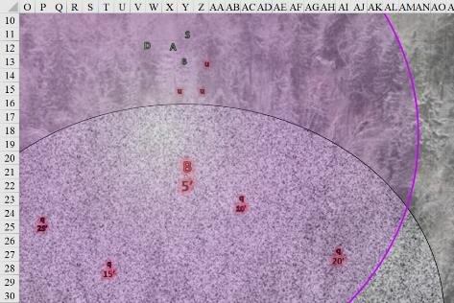

Round 2

Graz’zt was pleased that his summoning spell had brought his balor thrall, Stovegullet. He saw Steelshade cut down his last pet, and targeted her with a *greater dispel magic* spell.

|  |  |  |  |  |  |  |
| --- | --- | --- | --- | --- | --- | --- |
| **Character** | **Attack Type** | **Damage** | **CL** | **Total Score** | **Roll** | **Total** |
| Graz’zt | Greater Dispel Magic | Greater Dispel Magic | 20 | 10 | 3 | 13 |

*Fail. No dispelling took place.*

Brene moved to her right and fired her shortbow at the balor. She intended to work to the creature’s flank to gain her best advantage against it.

|  |  |  |  |  |  |  |
| --- | --- | --- | --- | --- | --- | --- |
| **Skill** | **Rank** | **Ability & Mod.** | **Misc. Mods.** | **Total** | **Roll** | **Check** |
| **Brene, Hide** | 10 | **Dex (+8)** | 4 | **22** | 9 | 31 |

*Likely successful.*

|  |  |  |  |  |  |  |  |  |  |  |
| --- | --- | --- | --- | --- | --- | --- | --- | --- | --- | --- |
| **Ranged Weapon** | **Dmg.** | **D+** | **TH+** | **Critical** | **Rng.** | **Wt.** | **Atk** | **Roll** | **Check** | **Properties** |
| Shortbow +2 | 1d4 | 2 | 2 | x3 | 60’ | 2.0 | +24 | 3 | 27 | Sneak Attack 9d6 |

*Hit. Dmg: 1 + 39 Sneak = 40.*

Devrion pointed at the demon. “A halál ujja!” *[finger of death]*.

|  |  |  |  |  |
| --- | --- | --- | --- | --- |
| **Character** | **Save vs.**  *finger of death* | **Ranks** | **Roll** | **Check** |
| Balor | Fortitude | 22 | 6 | 28 |

*Success. Saves for partial damage. Dmg: 9 + 18 = 27 magic.*

Atlas said a brief prayer and touched Steelshade as she prepared to receive the demon *[chasing perfection, expired on Round 182]*.

*Steelshade gained +4 to all six base abilities.*

He then focused on the balor and determined how best to attack the creature.

|  |  |  |  |  |  |  |  |
| --- | --- | --- | --- | --- | --- | --- | --- |
| **DK: Tactics Check** | **Rank** | **Ability & Mod.** | **Misc. Mods.** | **Total** | **Roll** | **Check** | **Notes** |
| **Atlas, Knowledge: The Planes** | 21 | **Int (+8)** | 5 | 34 | 10 | 44 | Trivial Knowledge |
| **Atlas, Knowledge: The Planes** | 21 | **Int (+8)** | 5 | 34 | 20 | 54 | Trivial Knowledge, **best of 2 rolls** |

*Beats by 20+. PCs gain +3 to BAB vs. balors.*

Steelshade cast *swift fly*, channeled *bigby’s clenched fist [expired on Round 20]* through her blade, and empowered her attacks *[Arcane Strike +4]*, then she flew at the balor and struck it.

|  |  |  |  |  |  |  |  |  |  |  |  |
| --- | --- | --- | --- | --- | --- | --- | --- | --- | --- | --- | --- |
| **Melee Weapon** | **Dmg** | **D+** | **TH+** | **Crit** | **x** | **Type** | **Wt.** | **Atk** | **Roll** | **Check** | **Properties** |
| Shattermantle Bloodstone  Falchion +3 | 2d4 | +9 +3 | 3 + 4  Arcane + 3 DK | 18 | 2 | Slashing | 8.0 | +34 | 1 | 35 |  |
| SB Falchion +3, 2nd Attack | 2d4 | +9 +3 | 3 + 4  Arcane + 3 DK | 18 | 2 | Slashing | - | +30 | 17 | 47 |  |
| SB Falchion +3, 3rd Attack | 2d4 | +9 +3 | 3 + 4  Arcane + 3 DK | 18 | 2 | Slashing | - | +24 | 5 | 30 |  |
| SB Falchion +3, 4th Attack | 2d4 | +9 +3 | 3 + 4  Arcane + 3 DK | 18 | 2 | Slashing | - | +20 | 10 | 30 |  |
| Greater Crystal of Arcane Steel | +1 to touch spells | 1 | +1 | - | - | - | - | - | - | - | +1 to spell DC |

*Miss, hit, hit, hit. Dmg: (4 + 9 + 3 + 9 Arcane + 17 electric) + (7 + 9 + 3 + 9 Arcane) + (4 + 9 + 3 + 9 Arcane) = 25 + 28 + 25 = 78 + – 6 to SR.*

The *clenched fist* began slapping Stovegullet. Steelshade is channeling it this round, so I presume it will strike at the same time she’s slicing and dicing.

|  |  |  |  |  |  |
| --- | --- | --- | --- | --- | --- |
| **Melee Weapon** | **Dmg** | **Atk** | **Roll** | **Check** | **Properties** |
| Bigby’s Clenched Fist | 1d8+11+stun | 17 | 6 | 23 | Fortitude DC 21 |

*Hit. Dmg: 7 + 11 = 18 = stun.*

|  |  |  |  |  |
| --- | --- | --- | --- | --- |
| **Character** | **Save vs.**  Stun | **Ranks** | **Roll** | **Check** |
| Balor | Fortitude | 22 | 2 | 24 |

*Success. Stun negated.*

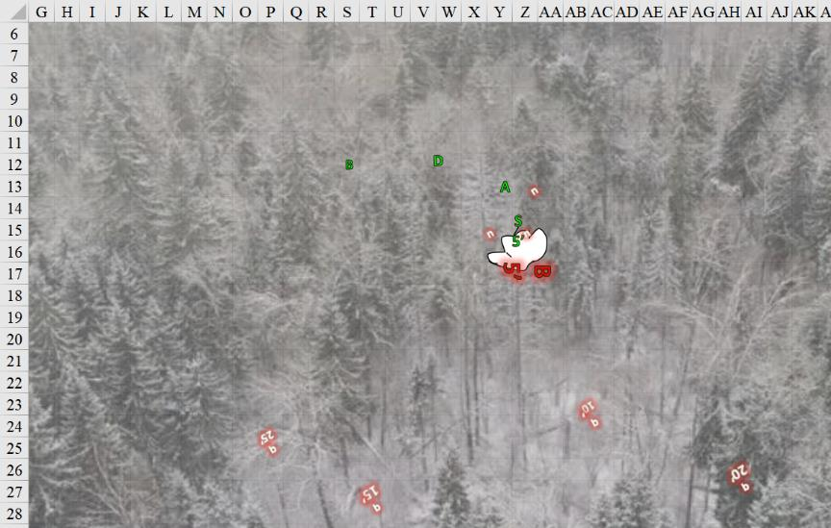

The degenerate balor was further weakened by the heroes, and it became evident that they could finish it in moments. However, the demon *teleported* itself out of harm’s way and faced the consequences of its cowardice, or perhaps it was about to return once it was healed.

Round 3

Graz’zt floated into view, hovering at about 10’ above the 15’ tree line.

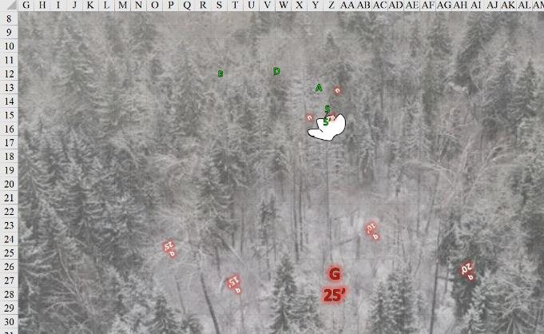

He’d seen enough of their antics, and was now about to either strike a bargain or lay them waste. He then cast *trap the soul* upon Steelshade.

|  |  |  |  |  |  |  |
| --- | --- | --- | --- | --- | --- | --- |
| **Save vs.**  *trap the soul* | **Rank** | **Ability & Mod.** | **Misc. Mods.** | **Total** | **Roll** | **Check** |
| **Steelshade, Will** | 10 | **Wis (+4)** | 3 | 17 | 11 | 28 |

*Fail. NOTE: +2 vs. all spells doesn’t apply to spell-like abilities, though I might have considered it if it had made a difference. It would not have here.*

Steelshade’s life-essence was sucked up into a materialized gem now within Graz’zt’s fingertips. Atlas knew this to mean that said gem would now hold their friend’s trapped entity indefinitely or until the gem was broken and the life force released, which would allow the material body to reform. It was reputed that some of the trapped victims were often required to perform a service immediately upon being freed.

“You who did me the favor of slaying my mother must all submit to my will, and be tried by the gauntlet, or you will face my most perverse wraths,” threatened the arch-demon.

Brene unexpectedly was warded with the same *chasing perfection* buffs that had just been placed on Steelshade, and saw what Atlas now identified as a Delayed Mass metamagic effect.

*Brene gained +4 to all six base abilities.*

The rogue walked back to her remaining companions. “How about you give us back our friend, and you won’t get hurt?” she called to the demon.

Devrion knew not why he was also being bestowed with this boon, but the spell rippled unto him as well, and unto Atlas.

*Devrion gained +4 to all six base abilities.*

The warmage held up his hand. “Maybe we should let Atlas talk?”

Atlas identified the metamatic effect as divine in nature, spotted what he guessed was Aasterinian’s signature totem abstracts, and knew that their goddess was amidst their struggle.

*Atlas gained +4 to all six base abilities.*

The archivist crossed his arms. “While you can best us easily enough,” Atlas called out, “our goddess won’t be such an easy conquest. Release our friend back to us unharmed, and then we can talk.” The archivist reviewed what he knew of the demon lord.

|  |  |  |  |  |  |  |  |
| --- | --- | --- | --- | --- | --- | --- | --- |
| **Atlas, DK: Puissance** | **Rank** | **Ability & Mod.** | **Misc. Mods.** | **Total** | **Roll** | **Check** | **Notes** |
| **Knowledge: The Planes** | 21 | **Int (+8)** | 5 | 34 | 14 | 48 | Trivial Knowledge, **best of 2 rolls** |
| **Knowledge: The Planes** | 21 | **Int (+8)** | 5 | 34 | 11 | 45 | Trivial Knowledge |

*Beats by 20+. PCs gain +3 to saves vs. Graz’zt.*

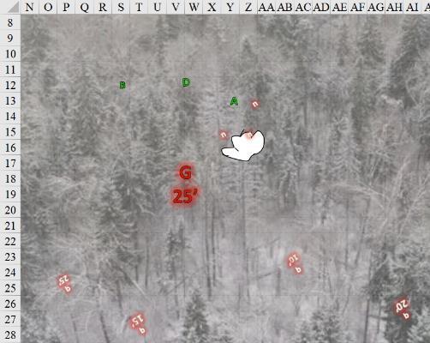

Round 4

Graz’zt smiled and replied, “I wish I could trap your soul as well, so I could subdue you all simultaneously.” He then cast *dominate person* on the charmingly handsome warmage, who seemed to be the most suggestible and weaponizable among them.

|  |  |  |  |  |  |  |  |
| --- | --- | --- | --- | --- | --- | --- | --- |
| **Save vs.**  *dominate person* | **Rank** | **Ability & Mod.** | **Misc. Mods.** | **Total** | **Roll** | **Check** | **Notes** |
| **Devrion, Will** | **11** | **Wis (+3)** | 3 | 17 | 18 | 35 | +2 vs. Enchantments |

*Success. Effect negated.*

Brene quickly extracted one of her scrolls of *enervation* and read it while pointing at the demon lord.

|  |  |  |  |  |  |  |
| --- | --- | --- | --- | --- | --- | --- |
| **Skill** | **Rank** | **Ability**  **& Mod.** | **Misc.**  **Mods.** | **Total** | **Roll** | **Check** |
| **Brene, Use Magic Device** | 10 | **Cha (+2)** | 0 | **12** | 14 | 26 |

*Success.*

|  |  |  |  |  |
| --- | --- | --- | --- | --- |
| **Ranged Weapon** | **Dmg.** | **Atk** | **Roll** | **Check** |
| Ranged Touch Attack | 1d4 negative levels | +22 | 7 | 29 |

*Hit. Dmg: 2 negative levels = -2 to BAB, Saves, and Checks, and -10 hps.*

“Oh, I will feast upon the organs in your body whose equivalents in my mother’s corpse you sliced open,” Graz’zt was both jubilated and vengeful about the row over his mother.

Devrion pointed at the demon’s hand, where he held Steelshade’s crystal prison. “A hang gömbje!”

*Dmg: 38 sonic.*

|  |  |  |  |  |
| --- | --- | --- | --- | --- |
| **Character** | **Save vs.**  *Orb of Sound* | **Ranks** | **Roll** | **Check** |
| Graz’zt | Fortitude | 25 | 1 | 26 |

*Success. Deafening effect negated.*

Atlas said a brief prayer *[protection from evil, expired on Round 184]* and touched Devrion.

*Devrion gained +2 to AC and Saves vs. Fear against/from evil creatures + other wards.*

The duskblade’s body materialized from the explosion caused by the breaking of the gem that had encased her spirit. Steelshade was a bit bewildered, but free from the demon’s hold.

*Not sure if this is canon-kosher, but there was no hardness description on the gem, so I’m ruling that she’s free.*

Round 5

“Fools! Your deaths could have been easy.” And like his balor minion had done when it was almost vanquished, Graz’zt—too—teleported to another location.

A dozen or so quasits about a quarter-mile to the southeast leapt out of a giant, sprawling elm whose snow-capped top they could barely see. They could recognize the flight patterns of the demonic silhouettes and noted their startled body language as they haphazardly got their bearings before converging on a northbound pattern, heading straight for the heroes now.

“Over 1000’ away,” Atlas gauged, suspecting that Graz’zt had not teleported very far at all, and was likely under that pine, or perhaps that was a demonic trap’s lure calling for them.

Atlas prayed again and touched Brene’s shoulder *[protection from evil, expired on Round 185]*.

*Brene gained +2 to AC and Saves vs. Fear against/from evil creatures + other wards.*

They were buffing up for an escalation of the fight with the dozen quasits headed their way.

Steelshade blinked and looked around as she settled to the ground. “Okay, let’s not do that again.” She spoke a few words *[dragonskin, expired on Round 1706]*, and her skin turned scaly, blending with her features.

*Steelshade gained +5 to FF AC and AC.*

Atlas stepped over to the duskblade and prayed again, *[protection from evil, expired on Round 186]*. “This will help.”

Brene readied her bow and watched the quasits come toward them.

Devrion touched his chest. “Mágus páncél!” *[mage armor, expired on Round 10806]*

*Devrion gained +4 to FF AC and AC.*

At a horizontal distance of 750’, and still just above the low treetops, the quasits homed in on their prospective targets, with Steelshade and Atlas being the two most popular marks. One quasit then darted away behind a tree, and soon thereafter, every other quasit had done the same. Wings flapped, and cackles echoed across the snowy pines, some of which now shook some snow off their copses and boughs. The *clenched fist* wouldn’t last much longer—another minute perhaps.

The *Bigby’s clenched fist* hovered in place before Steelshade regained her bearings. She then commanded it to ______.

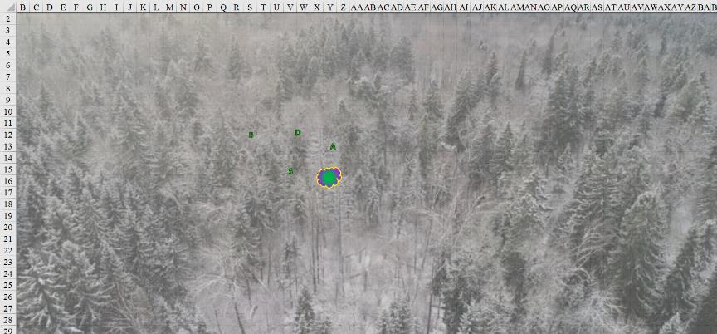

Round 6

They could tell that quasits were scurrying and creeping about, and on occasion saw one or two glide across trees.

Atlas prayed once more *[protection from evil, expired on Round 187]* and touched his own chest.

*Atlas gained +2 to AC and Saves vs. Fear against/from evil creatures + other wards.*

Devrion eyed the distance to the oncoming creatures as he heard them throughout the snowy forest. “They’re still coming. Wait until they get in range.”

Brene checked behind them, just in case. “Keep your eyes open in case Dipstick teleports in behind us.”

Steelshade cast *haste [expired on Round 23]* on herself, and brought the Fist to hover just above her head.

*Steelshade and allies gained +1 to BAB, AC, and Reflex saves, plus extra move or attack.*



The quasits continued to approach, though they were stealthy enough to be mostly hidden and silent while doing so. Steelshade could only hear a few of them coming, but Brene’s perceptive senses also allowed her to note a few sneakers out of the corner of her field of vision once or twice.

Round 7

|  |  |  |  |  |  |
| --- | --- | --- | --- | --- | --- |
| **Character** | **Group** | **Initiative** | **Roll** | **Modified Roll** | **Move** |
| Brene | 1 | 6 | 15 | 21 | 30’ |
| Quasits | 2 | 7 | 9 | 16 | 40’ |
| Devrion | 1 | 6 | 7 | 13 | 30’ |
| Atlas | 1 | 2 | 8 | 10 | 30’ |
| Steelshade | 1 | 5 | 3 | 8 | 20’ |

Brene kept watch behind and around them, letting the others worry about what was in front of them for the moment.

The quasits were probably not doing anything overt yet.

Devrion held his spells, awaiting a clear target.

Atlas took a moment to pray again while pointing at Brene *[dispel magic on dimension anchoring]*.

|  |  |  |  |  |  |
| --- | --- | --- | --- | --- | --- |
| **Ranged Weapon** | **Targeting** | **Rng.** | **Atk** | **Roll** | **Check** |
| Dispel Magic | *dimensional anchor* | 280’ | +18 | 17 | 35 |

*Success.*

Brene’s *dimensional anchoring* effect ended.

Steelshade likewise held her attacks until she had a clear target for the Fist.

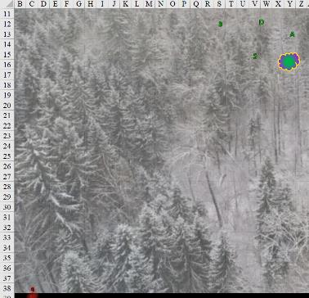

Round 8

Brene spotted a quasit to their right *[southwest]*.

“Let’s move north,” Atlas said. “They’re trying to encircle us.”

The group turned and moved northward, maintaining their spacing in the woods.

Round 9

There had indeed been a crescent-shaped advancement from the south, which they could now see a bit better as each hero was able to spot between 3 and 5 quasits at a time now, each between 60’ and 150’ away.

“Our enchantments will expire if we don’t act soon,” Atlas reminded his companions.

The four looked at each other for a moment, and then Devrion nodded. “Let’s go see what our friend is up to. We will deal with the quasits.”

Seeing more quasits coming for them a few hundred feet away, the group returned south, with Brene and Steelshade in the lead, and Devrion and Atlas following, ten feet apart.

Round 10

Two quasits got brave and started to fly towards them. These were larger than the previous quasits they’d encountered, almost as large as a dretch.

“Are you sure to want to do that?” Steelshade called out in Common. “You’re that tired of living?”

The group kept moving toward the tree, watching closely for the quasits.

Round 11

Each quasit was about 50’ from the group, and others were surely within a comparable radius of their midst.

“This’ll be light fighting dretches in a more picturesque landscape,” Steelshade steeled her nerves.

“And with a more pleasant scent in the air,” added Devrion.

Steelshade and company kept moving forward toward the archdemon’s presumed location: south. The *fist* followed.

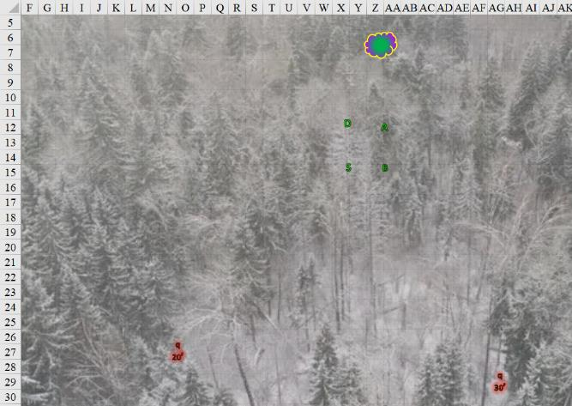

Round 12

Quasits converged, and now they were four in view on the heroes, but not before some could react. Flapping towards them from the southern panorama, as if carried by the scent of sulfur in the otherwise crisp, snowy air, were now five.

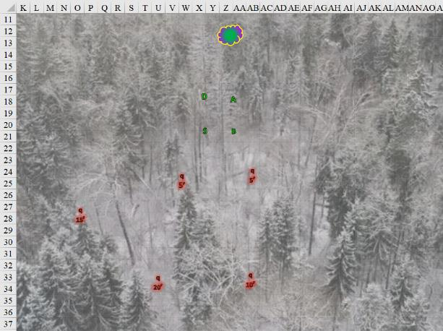

|  |  |  |  |  |  |
| --- | --- | --- | --- | --- | --- |
| **Character** | **Group** | **Initiative** | **Roll** | **Modified Roll** | **Move** |
| Brene | 1 | 6 | 17 | 23 | 30’ |
| Steelshade | 1 | 5 | 18 | 23 | 20’ |
| Atlas | 1 | 2 | 12 | 14 | 30’ |
| Quasits | 2 | 7 | 3 | 10 | 40’ |
| Devrion | 1 | 6 | 4 | 10 | 30’ |

Brene waited for the closest quasit, bow in hand and arrow strung.

Steelshade sent the *hand* after the quasit closest to her. The *hand* rushed over to intercept the quasit that would swoop down to rake her.

|  |  |  |  |  |  |
| --- | --- | --- | --- | --- | --- |
| **Melee Weapon** | **Dmg** | **Atk** | **Roll** | **Check** | **Properties** |
| Bigby’s Clenched Fist | 1d8+11+stun | 17 | 12 | 29 | Fortitude DC 21 |

*Hit. Dmg: 7 + 11 = 18 + stun.*

|  |  |  |  |  |
| --- | --- | --- | --- | --- |
| **Character** | **Save vs.**  *clenched fist* | **Ranks** | **Roll** | **Check** |
| Dire Quasit | Fortitude | 11 | 18 | 29 |

*Success. Stun effect negated.*

As the frontline pair swooped down, the second wave, got into diving position and four more quasits came into view. These were dragoons among quasits, nothing like honor-bound samurai, nor like coin-bought mercenaries, but something altogether distinct, reveling in the wrath of their master as one would expect thrallic demons to do by moral-political gravitation. Graz’zt’s presence was felt by those more attuned to the moment.

Seeing this, Atlas murmured a brief prayer, and then he opened his mouth and *[lion’s roar, expired on Round 182]* roared once more.

|  |  |  |  |  |  |
| --- | --- | --- | --- | --- | --- |
| **Character** | **Save vs.**  *lion’s roar* | **Ranks** | **Roll** | **Check** |  |
| Dire Quasit 1 | Fortitude | 11 | 16 | 27 |  |
| Dire Quasit 2 | Fortitude | 11 | 15 | 26 |  |
| Dire Quasit 3 | Fortitude | 11 | 20 | 31 |  |
| Dire Quasit 4 | Fortitude | 11 | 15 | 26 |  |
| Dire Quasit 5 | Fortitude | 11 | 10 | 21 |  |
| Dire Quasit 6 | Fortitude | 11 | 2 | 13 |  |
| Dire Quasit 7 | Fortitude | 11 | 19 | 30 |  |
| Dire Quasit 8 | Fortitude | 11 | 14 | 25 |  |
| Dire Quasit 9 | Fortitude | 11 | 3 | 14 |  |
| Dire Quasit 10 | Fortitude | 11 | 1 | 12 |  |
| Dire Quasit 11 | Fortitude | 11 | 12 | 23 |  |
| Dire Quasit 12 | Fortitude | 11 | 20 | 31 |  |

*Success, success, success, success, fail, fail, success, fail, fail, fail, fail, success.*

*Base damage to each quasit: 43 sonic + stun for 1 round.*

*Dmg to Dire Quasit 1: ½ x 43 = 21 sonic [dead].*

*Dmg to Dire Quasit 2: ½ x 43 = 21 = sonic.*

*Dmg to Dire Quasit 3: ½ x 43 = 21 = sonic.*

*Dmg to Dire Quasit 4: ½ x 43 = 21 = sonic.*

*Dmg to Dire Quasit 5: 43 sonic + stun [dead].*

*Dmg to Dire Quasit 6: 43 sonic + stun [dead].*

*Dmg to Dire Quasit 7: ½ x 43 = 21 = sonic.*

*Dmg to Dire Quasit 8: 43 sonic + stun.*

*Dmg to Dire Quasit 9: 43 sonic + stun.*

*Dmg to Dire Quasit 10: 43 sonic + stun.*

*Dmg to Dire Quasit 11: 43 sonic + stun.*

*Dmg to Dire Quasit 12: ½ x 43 = 21 = sonic.*

*All PCs gained +1 to attacks and saves against fear effects.*

*Atlas gained 4 + 18 = 22 temporary hit points [205/179].*

*Brene gained 6 + 18 = 24 temporary hit points [122/99].*

*Devrion gained 1 + 18 = 19 temporary hit points [118/99].*

*Steelshade gained 8 + 18 = 26 temporary hit points [205/179].*

Several quasits dropped to the ground, stunned by the archivist’s spell. One or two might have died on the spot.

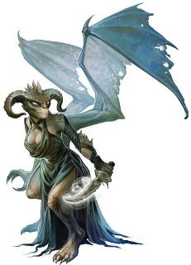

The quasits that persisted—each in its respective way more developed, anthropomorphic, and/or muscular—swooped down and targeted Brene and Steelshade. One had invisible wings.

|  |  |  |  |  |  |  |  |  |  |
| --- | --- | --- | --- | --- | --- | --- | --- | --- | --- |
| **Character** | **Attack Type** | **Damage** | **BAB** | **Dex Mod+** | **Total Score** | **Roll** | **Total** | **Crit** | **Threat** |
| Dire Quasit 1 | Claw | 1d3+poison | 4 | 5 + 2 charge  + 2 height | 13 | ***20*** | 33 | 20 | þ |
| Dire Quasit 2 | Claw | 1d3+poison | 4 | 5 + 2 charge  + 2 height | 13 | 4 | 17 | 20 | ý |

*Threat (Brene), miss (Steelshade). 1d20 = 4 + 11 = 17, not a critical hit. Dmg: 1 + Poison [98/99].*

|  |  |  |  |  |  |  |
| --- | --- | --- | --- | --- | --- | --- |
| **Save vs.**  Poison | **Rank** | **Ability & Mod.** | **Misc. Mods.** | **Total** | **Roll** | **Check** |
| **Brene, Fortitude** | **6** | **Con (+3)** | 0 | **9** | 9 | 18 |

*Success. Poison damage negated.*

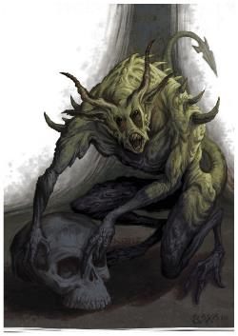

Atlas could tell that all these quasits were warded by *mage armor* spells, and he found it queer that some along the periphery were now casting spells. One cast *magic missile* upon Brene.

*Dmg: 3 + 1 = 4 magic [force] [118/99].*

Another seemed to have cast something Divination-related, as her eyes were now lit up brightly.

Devrion targeted the quasit with the magic missile ability, and returned the favor with his own spell. “Mágikus rakéta!”

*Dmg: 15 + 5 = 20 magic [force].*

The last missile was just enough to convince it to die.

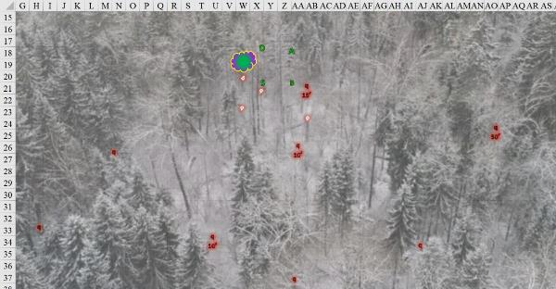

Round 13

Brene fired her bow at the quasit above her.

|  |  |  |  |  |  |  |  |  |  |  |
| --- | --- | --- | --- | --- | --- | --- | --- | --- | --- | --- |
| **Ranged Weapon** | **Dmg.** | **D+** | **TH+** | **Critical** | **Rng.** | **Wt.** | **Atk** | **Roll** | **Check** | **Properties** |
| Shortbow +2 | 1d4 | 2 | 2 – 2 height | x3 | 60’ | 2.0 | +23 | 2 | 25 | Sneak Attack 9d6 |
| Shortbow, 2nd Shot | 1d4 | 2 | 2 – 2 height | x3 | 60’ | - | +18 | 13 | 31 | Sneak Attack 9d6 |

*Hit, hit. Dmg: (4 + 2 + 28 Sneak) + (1 + 2 + 23 Sneak) = 34 + 26 = 60.*

She overcame the *mage armor* protection and brought down the fiendish razer.

Steelshade was going to steer the *fist* to the attacker to her southwest, but with this quasit down, she instead cast *swift fly*, and struck the closest southeastern foe—the same enemy that the *fist* attacked, reserving her other spells for more powerful foes.

|  |  |  |  |  |  |  |  |  |
| --- | --- | --- | --- | --- | --- | --- | --- | --- |
| **Melee Weapon** | **Dmg** | **D+** | **TH+** | **Type** | **Atk** | **Roll** | **Check** | **Properties** |
| Shattermantle Bloodstone Falchion +3 | 2d4 | +9 +3 | 3 | Slashing | +32 | 13 | 45 | Arkenlyl, or Mageblade |
| Greater Crystal of Arcane Steel | +1 to touch spells | 1 | +1 | - | - | - | - | +1 to spell DC |
| Bigby’s Clenched Fist | 1d8+11+stun | +0 | - | - | 17 | 14 | 31 | Fortitude DC 21 |

*Hit, hit.*

*Dmg from falchion: 6 + 9 + 3 = 18 – 2 to SR.*

*Dmg from fist: 6 + 11 = 17 + stun.*

|  |  |  |  |  |
| --- | --- | --- | --- | --- |
| **Character** | **Save vs.**  Stun | **Ranks** | **Roll** | **Check** |
| Dire Quasit | Fortitude | 11 | 10 | 21 |

*Success. Stun effect negated.*

Atlas looked at Glowing Eyes, said a few words, and pointed downward.

|  |  |  |  |  |
| --- | --- | --- | --- | --- |
| **Character** | **Save vs.** | **Ranks** | **Roll** | **Check** |
| Dire Quasit | Reflex | 14 | 20 | 34 |

*Success. Saves for ½ damage.*

*Dmg: ½ x (23 holy + 23 fire) = 11 holy + 12 fire = 23. Fire damage negated.*

Despite the *flame strike* spell’s potential for wreaking havoc on its ill-disposed victims, the fire-resistant quasit sneered at the dose of goodie-good energy that seared its inconvertible, demonic flesh.

There were only two dire quasits in the dozen at this point that posed a threat, and they came at the humanoids with the pomp of a thousand-fiend squadron. One cast *lesser orb of fire* upon Brene.

*Dmg: 6 fire [112/99].*

|  |  |  |  |  |  |  |
| --- | --- | --- | --- | --- | --- | --- |
| **Save vs.**  *lesser orb of fire* | **Rank** | **Ability & Mod.** | **Misc. Mods.** | **Total** | **Roll** | **Check** |
| **Brene, Fortitude** | **6** | **Con (+3)** | 0 | **9** | 18 | 27 |

*Success. Dazed effect negated.*

The other dared to go toe to toe with the mightiest melee foe.

|  |  |  |  |  |  |  |  |  |  |
| --- | --- | --- | --- | --- | --- | --- | --- | --- | --- |
| **Character** | **Attack Type** | **Damage** | **BAB** | **Str Mod+** | **Dex Mod+** | **Total Score** | **Roll** | **Total** | **Notes** |
| Dire Quasit | Claw 1 | 1d3+poison | 4 | 0 | 5 | 9 | 4 | 13 | Fort DC 13 |

*Miss.*

A few other stunned quasits writhed for the moment, some beginning to get up and stretch their cramped wings with foul words of retribution upon their poorly inhibited lips.

Devrion picked out the quasit that Atlas hadn’t dispatched. “Mágikus rakéta!”

*Dmg: 14 + 5 + 6 = 25 magic [force].*

And down went that quasit as well.

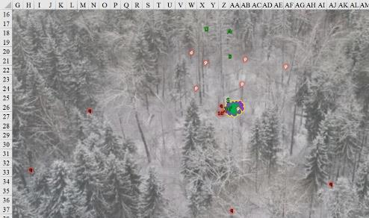

Round 14

Brene was about to knock down that very quasit, but instead picked her next target near Steelshade, and fired into that airborne melee.

|  |  |  |  |  |  |  |  |  |  |  |
| --- | --- | --- | --- | --- | --- | --- | --- | --- | --- | --- |
| **Ranged Weapon** | **Dmg.** | **D+** | **TH+** | **Critical** | **Rng.** | **Wt.** | **Atk** | **Roll** | **Check** | **Properties** |
| Shortbow +2 | 1d4 | 2 | 2 | x3 | 60’ | 2.0 | +25 | 10 | 35 | Sneak Attack 9d6 |
| Shortbow, 2nd Shot | 1d4 | 2 | 2 | x3 | 60’ | - | +20 | 18 | 38 | Sneak Attack 9d6 |

*Hit, hit. Dmg: (4 + 2 + 30 Sneak) + (3 + 2 + 27 Sneak) = 36 + 32 = 68.*

She tore the poor quasit in half before it hit the ground.

Steelshade cast *swift fly* again, and seeing that her immediate opponent was split in half and on the ground, she and the *fist* charge-attacked the next contender for quasit supremacy, adding her scimitar’s slice to the *fist’s* attack for good measure.

|  |  |  |  |  |  |  |  |
| --- | --- | --- | --- | --- | --- | --- | --- |
| **Melee Weapon** | **Dmg** | **D+** | **TH+** | **Atk** | **Roll** | **Check** | **Properties** |
| Shattermantle Bloodstone Falchion +3 | 2d4 | +9 +3 | 3 | +32 | 10 | 42 | Arkenlyl, or Mageblade |
| Bigby’s Clenched Fist | 1d8+11+stun | +0 | - | 17 | 2 | 19 | Fortitude DC 21 |

*Hit, miss. Dmg: 6 + 9 + 3 = 18 – 2 to SR.*

And though the *fist* missed, the scimitar’s slice was more than enough to end the demon’s existence.

Atlas grimaced as his spell had little effect. “They’re wearing us down.”

“Not at all,” Steelshade called back, feeling otherwise. “This is the last of them now,” she then turned her attention southward once more.

Nevertheless, Atlas reached for his knowledge about these foul creatures (DK: Tactics), while he extracted his Eternal Wand of Haste *[expired on Round 19]* and tapped Devrion with it.

*Devrion, Brene, and Atlas gained +1 to BAB, AC, and Reflex saves, plus extra movement or attack.*

|  |  |  |  |  |  |  |  |
| --- | --- | --- | --- | --- | --- | --- | --- |
| **Atlas, Skill** | **Rank** | **Ability & Mod.** | **Misc. Mods.** | **Total** | **Roll** | **Check** | **Notes** |
| **Know: The Planes** | 21 | **Int (+8)** | 5 | 34 | 2 | 36 |  |
| **Know: The Planes** | 21 | **Int (+8)** | 5 | 34 | 10 | 44 | Trivial Knowledge, **best of 2 rolls** |

*Beats DC by 20+; PCs gain +3 to hit quasits.*

No longer stunned, the handful of dire quasits took flight once more. One cast *lesser orb of cold* upon Devrion while another cast *lesser orb of acid*, both upon Atlas.

|  |  |  |  |  |  |  |  |  |  |  |
| --- | --- | --- | --- | --- | --- | --- | --- | --- | --- | --- |
| **Character** | **Attack Type** | **Damage** | **BAB** | **Str Mod+** | **Dex Mod+** | **W+** | **Other+** | **Total Score** | **Roll** | **Total** |
| Dire Quasit | Ranged Touch Attack | 1d8 cold | 4 | 0 | 5 | 0 | 0 | 9 | 11 | 20 |
| Dire Quasit | Ranged Touch Attack | 1d8 acid | 4 | 0 | 5 | 0 | 0 | 9 | 3 | 12 |

*Hit, miss. Dmg to Devrion: 1 cold [117/99].*

The third motherless ne’er-do-well flapped its way in for some melee love, but not quite reaching Brene.

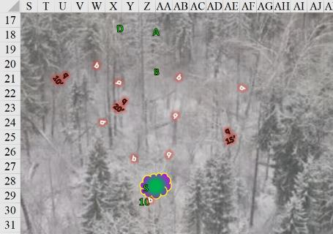

Devrion gave his attention to the closest quasit (U21). “Mágikus rakéta!”

*Dmg: 12 + 5 + 6 = 23 magic [force].*

This destroyed the quasit in midair.

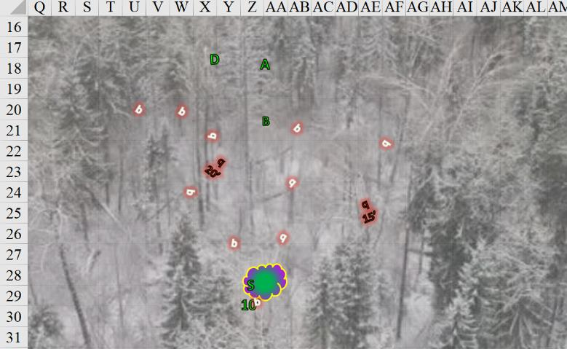

Round 15

Brene shot at the quasit bearing down on her.

|  |  |  |  |  |  |  |  |  |  |  |
| --- | --- | --- | --- | --- | --- | --- | --- | --- | --- | --- |
| **Ranged Weapon** | **Dmg.** | **D+** | **TH+** | **Critical** | **Rng.** | **Wt.** | **Atk** | **Roll** | **Check** | **Properties** |
| Shortbow +2 | 1d4 | 2 | 2 + 3 DK | x3 | 60’ | 2.0 | +28 | 19 | 47 | Sneak Attack 9d6 |
| Shortbow, 2nd Shot | 1d4 | 2 | 2 + 3 DK | x3 | 60’ | - | +23 | **20** | 43 | Sneak Attack 9d6 |

*Hit, threat. 1d20 = 18 + 20 = 38, critical hit. Dmg: ([2 x 2] + 2 + 29 Sneak) + (4 + 2 + 27 Sneak) = 35 + 33 = 68.*

The quasit landed at her feet, face first, sliding until its head was between her legs. Only one was not yet done for.

Steelshade picked the unengaged quasit, cast *swift fly*, and attacked in conjunction with the *fist*.

|  |  |  |  |  |  |  |  |  |  |
| --- | --- | --- | --- | --- | --- | --- | --- | --- | --- |
| **Melee Weapon** | **Dmg** | **D+** | **TH+** | **Crit** | **x** | **Atk** | **Roll** | **Check** | **Properties** |
| Shattermantle Bloodstone Falchion +3 | 2d4 | +9 +3 | 3 + 3 DK | 18 | 2 | +35 | 2 | 34 | Arkenlyl, or Mageblade |
| SB Falchion +3, 2nd Attack | 2d4 | +9 +3 | 3 + 3 DK | 18 | 2 | +30 | 19 | 46 |  |
| SB Falchion +3, 3rd Attack | 2d4 | +9 +3 | 3 + 3 DK | 18 | 2 | +25 | 16 | 38 |  |
| SB Falchion +3, 4th Attack | 2d4 | +9 +3 | 3 + 3 DK | 18 | 2 | +20 | 20 | 37 |  |
| Greater Crystal of Arcane Steel | +1 to touch spells | 1 | +1 | - | - | - | - | - | +1 to spell DC |
| Bigby’s Clenched Fist | 1d8+11+stun | +0 | + 3 DK | - | - | 20 | 12 | 29 | Fortitude DC 21 |

*Hit, threat, hit, threat. 1d20, 8 + 27 + 3 DK = 38; 23 + 27 + 3 DK = 39. Both are critical hits.*

*Dmg from falchion: (4 + 9 + 3) + ([2 x 6] + 9 + 3) + (7 + 9 + 3) + ([2 x 5] + 9 + 3) + (5 + 9 + 3) = 16 + 24 + 19 + 22 + 17 = 98 – 8 to SR.*

*Dmg from clenched fist: 8 + 11 = 19 + stun.*

The quasit died before it could even be stunned, now looking more like butchered meat ready for the shipping cart than like the quasit that relished in death moments before. Launched by the mighty blow of the *clenched fist*, the remains hit a snowy tree as the sounds of movement to the south confirmed that there would be more to contend with here than a dozen quasits.

Atlas, however, saw no other quasits for the moment, and stayed his plea for Dark Knowledge on quasits.

One or two quasits struggled to rise and face the humanoids, but were too badly wounded to do so. Graz’zt hovered into a place from which he could see them perfectly, though they could not yet see him, and spoke in a much raspier voice than they’d heard him using before. They couldn’t quite make out the words, but the dusting off of snow from the trees to the south forecast the entry of a giant quasit-like being. Atlas took a moment to identify it: yes, it had the facial features and horns of a quasit, which likely aided it in riling up the lesser fiends into a murderous frenzy, but it had the scope and volume of the balor that had not had the substance to face them to the death. This *was* Graz’zt, albeit in a devolved, raging manifestation than his usual princely self. He’d been studying the heroes, and was now about to test raw brawn against them to see what that would spur.

But if it was one thing that their recent experience and the demon’s own reputation had clarified, it was that Graz’zt would bide his time taking them down, and would likely be in a position to choose the place and time of their conflicts more often than not. In fact, with enough determination, Atlas suspected that Graz’zt would even conjecture an arena whose structure would complement his own prowess, and diminish the decisiveness of the party’s strengths and qualities. They were now locked into a zero-sum relationship wherein the continued existence of Graz’zt and any of the four heroes constituted a continued need for violence between the two factions.

It was then that Atlas recalled a queer and indiscernible omen that had come to him by way of Aasterinian years ago right before he’d left Mintar to pursue quests of grander scales. In the original Draconic, the quote read: << Lo, for there broke open the schism between the Children of Ao, Io, and Bahamut and the Spawn of the Fling between Asmodeus and Pale Night. And one of our own should be there to recount it to the world and to the children who were born years after it. >>

The demon lord smiled; its quasit-like mouth took on a slightly more humanoid semblance, mostly to accommodate for accent, and spoke again in Common, “I will be having stew of you tonight. You will not go to waste as we celebrate our proliferation tonight.”

He then telekinetically guided towards the center of the heroes’ midst what looked like *symbol of death* but was in fact *symbol of persuasion*, and its 60’ radius encompassed all four humanoids before he set it down to burst.

|  |  |  |  |  |  |  |  |
| --- | --- | --- | --- | --- | --- | --- | --- |
| **Save vs.**  *symbol of persuasion* | **Rank** | **Ability & Mod.** | **Misc. Mods.** | **Total** | **Roll** | **Check** | **Notes** |
| **Atlas, Will** | **11** | **Wis (+6)** | 13 | 30 | 18 | 48 | +2 vs. Enchantments |
| **Brene, Will** | **6** | **Wis (+3)** | 0 | 9 | 6 | 15 |  |
| **Devrion, Will** | **11** | **Wis (+3)** | 3 | 17 | 7 | 24 | +2 vs. Enchantments |
| **Steelshade, Will** | **10** | **Wis (+4)** | 3 | 17 | 4 | 21 | +2 vs. Enchantments;  +2 vs. all spells |

*Success, fail, fail, fail. Brene, Devrion, and Steelshade were charmed by Graz’zt.*

Atlas was able to hold back the demon’s sway, but the other three were completely sold on deepening their love for him a the moment.

As during their last encounter, Devrion could tell that Graz’zt had shown up to the party already wounded. The warmage now thought that Graz’zt was a swell guy... and then he felt the compulsion move away to where he could still think. There was no negotiating with the arch-demon, but their chances seemed slim against such a personage, wounded or not. His fleeting thoughts settled on Angren, and his resolve firmed as he thought of her in the demon’s thrall. The warmage pointed his finger at the demon. “A halál ujja!” [*finger of death*]

|  |  |  |  |  |
| --- | --- | --- | --- | --- |
| **Character** | **Save vs.**  *finger of death* | **Ranks** | **Roll** | **Check** |
| Graz’zt | Fortitude | 25 | 14 | 39 |

*Success.*

*Dmg: 8 + 18 = 26.*

The warmage could tell that the demon lord was going to be a bit tougher to crack with spells. They would have to get lucky to pierce his passive defenses while Steelshade sliced into him... if she could.

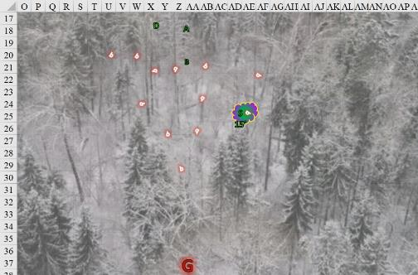

Round 16

Brene found Graz’zt very comely, and wanted him to feel welcome in his new role as their leader. She, too, felt the compulsion lift from her, and she wasted no time in attacking the demon. She moved to her left and fired her bow at the demon.

|  |  |  |  |  |  |  |  |  |  |  |
| --- | --- | --- | --- | --- | --- | --- | --- | --- | --- | --- |
| **Ranged Weapon** | **Dmg.** | **D+** | **TH+** | **Critical** | **Rng.** | **Wt.** | **Atk** | **Roll** | **Check** | **Properties** |
| Shortbow +2 | 1d4 | 2 | 2 + 3 DK | x3 | 60’ | 2.0 | +28 | 16 | 44 | Sneak Attack 9d6 |

*Hit. Dmg: 2 + 2 + 30 Sneak = 34.*

Steelshade lusted after Graz’zt, and all other considerations at this point seemed fleeting and futile, so she smiled seductively at him – and then the compulsion faded. She snarled as she realized his trickery, and immediately directed the *fist* to attack him.

|  |  |  |  |  |  |
| --- | --- | --- | --- | --- | --- |
| **Melee Weapon** | **Dmg** | **Atk** | **Roll** | **Check** | **Properties** |
| Bigby’s Clenched Fist | 1d8+11+stun | 17 + 3 DK | 10 | 30 | Fortitude DC 21 |

*Miss.*

Then, she Quick Cast *dimension hop* (to AA38), channeled *shocking grasp* though her blade, and empowered the strikes (+4).

|  |  |  |  |  |  |  |  |
| --- | --- | --- | --- | --- | --- | --- | --- |
| **Melee Weapon** | **Dmg** | **D+** | **TH+** | **Atk** | **Roll** | **Check** | **Properties** |
| Shattermantle Bloodstone  Falchion +3 | 2d4 | +9 +3 + 4d4 | 3 + 4 Arc + 3 DK | +39 | 5 | 44 |  |
| SB Falchion +3,  2nd Attack | 2d4 | +9 +3 + 4d4 | 3 + 4 Arc + 3 DK | +34 | 16 | 50 |  |
| SB Falchion +3,  3rd Attack | 2d4 | +9 +3 + 4d4 | 3 + 4 Arc + 3 DK | +29 | 11 | 40 |  |
| SB Falchion +3,  4th Attack | 2d4 | +9 +3 + 4d4 | 3 + 4 Arc + 3 DK | +24 | 7 | 31 |  |
| Greater Crystal  of Arcane Steel | +1 to touch spells | 1 | +1 | - | - | - | +1 to spell DC |

*Hit, hit, hit, miss. Dmg: (6 + 9 + 3 + 12 Arcane + 22 electric) + (8 + 9 + 3 + 10 Arcane) + (3 + 9 + 3 + 14 Arcane) = 30 + 30 + 29 + 22 electric = 111 – 6 to SR. Electric damage negated.*

Graz’zt had been significantly wounded, and had a look of sincere astonishment and regret at having come out here with such light backup. His fast healing helped, but his ego was as scarred as his abdomen would soon be. The demon lord looked fiercely upon the duskblade, and teleported away to his safe space before cursing her the way he’d wanted to.

|  |  |  |  |  |
| --- | --- | --- | --- | --- |
| **Character** | **Check** | **Ranks** | **Roll** | **Check** |
| Graz’zt | Concentration | 40 | 13 | 53 |

*Guaranteed success.*

They’d just wounded him far more than before, and the Abyssal Prince would likely return with an additional expeditionary force to pit against them... unless the heroes beat Graz’zt to the punch. Perhaps this was a war of attrition, with each side trying to vie for the power to choose when and where to attack the other in order to weaken and slay that opposing faction. So far, the only losses had been Graz’zt’s.

Atlas thought of the significance of this conflict on a greater scale, wondering what ripple in the balance of power they would be calling to action if they were to slay such a central node in the multiverse’s hierarchy. The archivist walked with Devrion as he thought about their dilemma. On any other day, they would have simply left, since, in his estimation, their chances of actually killing the arch-demon were very low. Then again, they probably didn’t have to actually kill him to win the day. Further, there were obviously other forces at work on their side. “We need to keep moving,” he told his companions.

“Pussy,” Devrion sighed and shook his head as the self-preserving demon royal disappeared. He then moved south to rejoin Steelshade, taking advantage of the *haste* enchantment to move more quickly.

Pussyfoot looked at him for a moment as if he’d called her, then realized the jungle man was being vulgar. She also went to join Steelshade. “What, you didn’t expect him to stand there and let us bitch slap him, did you? He’s a demon lord, for cat’s sake.”

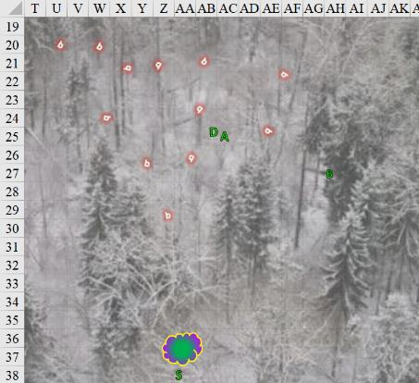



Rounds 17 – 19

As he walked, Atlas wracked his brain, considering the odd situation, and formulated a plan of action that they might possibly survive. All the demon had to do was summon enough minions to run them out of spells for the day, and then they would be down to just their melee weapons. Sooner than later, they would be overwhelmed – unless their deific, unseen helpers were more active than it seemed at the moment.

Thinking it over, if he’d had any additional minions to send, he likely would have by now. The balor’s condition suggested that Graz’zt didn’t have much mojo when it came to summoning, or that he was in a low rut of late. Either way, the Demon Lord was losing street credit with the quartet of heroes.

The *clenched fist* expired and dematerialized.

Steelshade waited for the others to catch up. “He’s smart enough to retreat, and he’s badly hurt, too. If that wasn’t the case, we’d be dead now. This whole situation is really odd to me.”

With the group reassembled, they moved south toward the tree and whatever else awaited them.

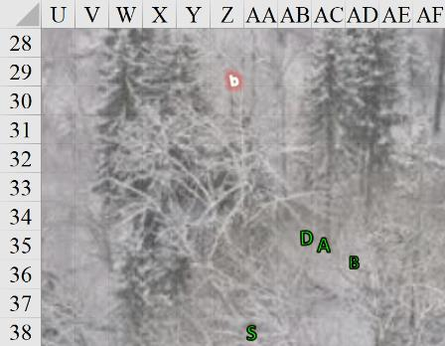

Rounds 20 – 25

Atlas surmised, “He is testing our strength, and dispensing with the bravado. He knows there’s only one of him, and would be a fool to create a simulacrum of himself, lest he put his own fate on the plate.”

Steelshade shook her head. “I don’t know what Aasterinian has in mind, but I don’t think it involves us being the main ingredients in a stew. Let’s go see what’s next to fight.”

They all walked onward and southward.

Rounds 26 – 38

They’d walked for not too long along the snow, and began to trace the commotion made by the quasits a minute ago. The scent of the Abyss grew stronger as the infrequent but regular sound of whispers in the wind made itself evident. Cool under the snowcapped evergreens, the quartet of heroes pressed on.

Rounds 39 – 54

The sound of a reptilian cackle caused them to pause for a moment to get a better sense of distance and time. By the sounds of it, they could likely reach whatever that sound was within a few minutes, if the creature was stationary, though it might have required a slight southwestern detour. They continued directly south for the time being.

Rounds 55 – 58

The unignorable hum and pulse that the druid woman had warned them about was now imminently close, though deceivingly so, for they could only tell that it was to their southwest now, so southwest they turned.

Rounds 59 – 62

They didn’t get much farther, as before them, perhaps a few hundred feet away, they could see the trees coated by a bloody membrane that encapsulated entire hectares of land and space above it. The flesh seemed sickly to Brene—much like Pale Night when they were within her—and the heroes knew they were nearly at the orb that surely lay within this hemispherical enclosure.

Brene wrinkled her nose. “Why can’t they just have a house or something? Blood and guts everywhere!”

“They are demons, my love,” Atlas replied with a grim smile.

“Besides, some of the most desperately evil people I’ve known had beautiful palaces and homes,” Devrion observed.

“That is true,” Steelshade said. “They are even more evil, since they simply don’t care about anyone or anything besides themselves.” The duskblade stepped around a stunted tree. “Come, let’s not keep our friend waiting.”

Rounds 63 – 65

Walking closer and noting that the snow here was melted almost completely, they were now about 50’ from the membrane, which they could tell was torn in dozens of places, and that was just on the parts that they could see from their vantage point.

A breeze kicked up, furthering the drop and drip of snow and water from the nearby branches. The heat that emanated from the massive dome could now be felt.

And then they spied an even more ominous thing: emerging from the ruptures in the membrane were now citizens of somewhere, perhaps this island. As they reached the bottom of a fissure, their weight further opened a wound in the macrodemon’s morphology.

“Mimi!” Brene stared as she spotted her great aunt stumbling towards her from the bloody membrane. The halfling woman had been almost legendary in Athkatla – at least before she had been caught stealing from a powerful nobleman. The rogue had been tried and hanged for her crimes four years earlier. Still, she’d taught Brene her craft, and now Brene felt tears roll down her cheeks. “By the gods, Mimi! What happened?”

“I... know nothing,” her dear aunt replied, looking at her as if she’d stolen something.

Devrion came to a stop as he spied a tall, dark-skinned woman in the group headed his way. “Eleefa?” Her black hair was a matted mess on her head, and her once fine dress was shredded and hung from her slim frame in rags. Once, she’d been a powerful ruler, and a feared mistress of her house. Devrion has once served her, though he’d moved on when her petty cruelty became more than he could stomach. Curiously, she’d treated Devrion well, and the warmage had tried to steer her onto a better path. Eleefa had been found dead one morning, apparently having been bitten by an asp sometime in the night. Rumor said that her poison had been administered by someone besides the snake, but no one bothered with more than a cursory investigation, which turned up nothing.

“You were right, boy. There was no snake in my room the night the poison brought me here,” Eleefa declared with the fullness of mind. “My offender is here somewhere, and is paying for much more than what he done to me.”

Atlas looked over the group, and then he spotted a familiar face. “Bothar?” The young man shuffling towards him had been one of Atlas’ few friends on the streets of Telflamm. He’d also been a minor thug in the Shadowmasters’ service, where he’d participated in extortion and street crime. Atlas had tried to have Bothar come away with him to escape that life, but the man had been killed in a street fight before Atlas could leave.

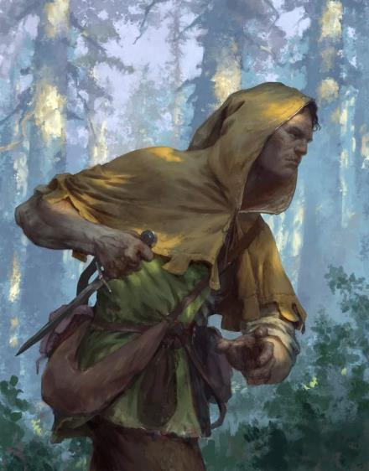

The thug from Telflamm squinted, but did no recognize Atlas, instead asking, “Are you the xylophone player I’m supposed to see about a package?”

Most of the fugitives of the membrane dome were saying similar nonsense, either to themselves, each other, or to the heroes as they passed by.

Steelshade watched as the others stopped and named some of the people walking toward them. She looked, and then she spotted a drow among the group. “Jhaldrym Icharyd,” she said quietly.

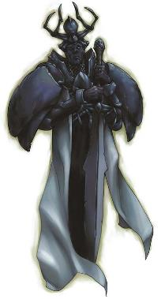

He was further away, but the older man was definitely coming towards her. She’d known him when she was a girl, as he was her mother’s advocate within the drow community. Oh, he still served Lloth, but for some reason, he had a soft spot for the “Little Fang”, as he’d dubbed her. She’d heard that he’d passed quietly some ten years earlier of an unnamed illness.

Rounds 66 – 69

There were, of course, those who were perfect strangers among them, who were also now getting free from some former captivity. The first wave of fugitives seemed more whole, for the most part, compared to the second wave of slower, partly gelatinized slaves and fodder folk.

These were all evil folks. Some had hidden it well before their loved ones and neighbors, while others had flaunted it in all their irreverent splendor; in either case, their dispositions and deeds had landed them a role in the Abyssal Revolution that was apparently poised to populate the island with demons and petitioners alike.

Distant thunder followed lightning by about four seconds, and by the time their eyes had again adjusted to the darkness, the men, women, and children were walking as if bewildered, mostly towards the heroes. They did not seem hostile, but in the party’s experience, that meant nothing when possession was at play, and this was a likely forecast.

The sound of a muffled scream within the dome came and went with a crunchy chew, as if the screaming victim had been eaten alive. In reaction, most of the fugitives scampered northward and otherwise away from the dome, which now appeared to be emitting its own internal lightning as a spellcaster or other magic source let off a *chain lightning* spell or something the like.

Rounds 70 – 72

“Where will you go now?” asked Bothar, then strangers, as they passed on their way along the melting snow and silent trees. “What do you intend to do?”

“We are going that way,” Atlas replied as he pointed toward the lightning. “We intend to put a stop to this.” The quartet kept moving, since their enchantments were slowly expiring.

“Then...” the words now came out strained, “… you will allll diiiiieeeeee!”

Round 73

And with this, each of the fugitives started to turn to a greenish ooze.

Atlas reacted first. He murmured a brief prayer, and then cut loose another of his magical roars.

*Current lion’s roar effects extended to PCs until Round 253 (was 192).*

*Base dmg to Abyssal petitioners: 53 sonic.*

|  |  |  |  |  |
| --- | --- | --- | --- | --- |
| **Character** | **Save vs.**  *lion’s roar* | **Ranks** | **Roll** | **Check** |
| Petitioner | Fortitude | 0 | 17 | 17 |
| Petitioner | Fortitude | 0 | 3 | 3 |
| Petitioner | Fortitude | 0 | 14 | 14 |
| Petitioner | Fortitude | 0 | 10 | 10 |
| Petitioner | Fortitude | 0 | 8 | 8 |
| Petitioner | Fortitude | 0 | 2 | 2 |
| Petitioner | Fortitude | 0 | 4 | 4 |
| Petitioner | Fortitude | 0 | 2 | 2 |
| Petitioner | Fortitude | 0 | 17 | 17 |
| Petitioner | Fortitude | 0 | 18 | 18 |
| Petitioner | Fortitude | 0 | 13 | 13 |
| Petitioner | Fortitude | 0 | 13 | 13 |
| Petitioner | Fortitude | 0 | 14 | 14 |
| Petitioner | Fortitude | 0 | 13 | 13 |
| Petitioner | Fortitude | 0 | 9 | 9 |
| Petitioner | Fortitude | 0 | 11 | 11 |
| Petitioner | Fortitude | 0 | 4 | 4 |
| Petitioner | Fortitude | 0 | 17 | 17 |
| Petitioner | Fortitude | 0 | 9 | 9 |
| Petitioner | Fortitude | 0 | 20 | 20 |
| Petitioner | Fortitude | 0 | 9 | 9 |
| Petitioner | Fortitude | 0 | 15 | 15 |
| Petitioner | Fortitude | 0 | 16 | 16 |
| Petitioner | Fortitude | 0 | 4 | 4 |
| Petitioner | Fortitude | 0 | 14 | 14 |
| Petitioner | Fortitude | 0 | 3 | 3 |
| Petitioner | Fortitude | 0 | 10 | 10 |
| Petitioner | Fortitude | 0 | 4 | 4 |
| Petitioner | Fortitude | 0 | 18 | 18 |
| Petitioner | Fortitude | 0 | 4 | 4 |

*All saves fail. Dmg to each petitioner: 53 sonic.*

All gelatinous petitioners died where they stood, liquefying further into pools of green slime, which each hero could be sure was acidic.

A good chunk of the dome was within the 120’-radius of Atlas that was affected by the sonic blast, and the membrane around this entire subsection instantly shattered, leaving exposed a heap of bubbling, green mucus atop which there floated lesser babau now, either quite dead or shaking their heads in astonishment and bewilderment at the sight of the four heroes. The rest of the dome was also caving in now due to structural instability, and at its center, barely out of Atlas’ visible impact horizon, there glowed a pulsating orb about five times the size of the ones that Brene had poked and sliced back in Pale Night’s dying corpse lodged into Krigala.

Devrion had an understanding of the arcane nature of what he was beholding, and Brene understood the Planes well enough to be aware of the various varieties of babau, and the slime in which they thrived. However, it was Atlas who understood full well and in a far more comprehensive way that although the babau were the spawn of Graz’zt, their natural habitat was not usually Graz’zt’s style, and as he now gazed upon a Huge, beastly, humanoid figure emerging from behind the even larger orb to the distant south, he tilted his head and began to formulate a hypothesis: could this “Graz’zt” figure actually be a fictive rendition—a copy of Graz’zt—made and manipulated by Juiblex? They’d already been dealing with numerous Juiblex-themed minions since Krigala, and the Demon Lord they’d faced seemed to hardly live up to his reputation.

Round 74

The Huge humanoid took a few steps forward, and Atlas recognized it as a taller, leaner version of the quasit-faced Graz’zt avatar they’d faced just minutes ago, but now, the lean, masculine figure was composed of a translucent, lemon-green, gel-like substance that just screamed of Juiblex’s last stand. He’d likely find out soon enough, as the gelatinous giant was coming at them, drawing upon the lifeforce of the babau and other demons he passed along his jaunt.

The warmage was anything but indecisive, and he immediately seized the opportunity to strike. He pointed at the sphere. “Otiluke fagyasztó gömbje!” *[Otiluke’s freezing sphere]*

*Denied Reflex save. Dmg: 50 cold. Partial damage negated.*

Atlas delved into his memories to help his companions fight this demon.

*PCs already have Puissance—+3 to saves—vs. Graz’zt. This role now applies to DK: Foe.*

|  |  |  |  |  |  |  |  |
| --- | --- | --- | --- | --- | --- | --- | --- |
| **Atlas, DK: Foe** | **Rank** | **Ability & Mod.** | **Misc. Mods.** | **Total** | **Roll** | **Check** | **Notes** |
| **Atlas, Know: The Planes** | 21 | **Int (+8)** | 5 | 34 | 10 | 44 | Trivial Knowledge |
| **Atlas, Know: The Planes** | 21 | **Int (+8)** | 5 | 34 | 19 | 53 | Trivial Knowledge, **best of 2 rolls** |

*Beats by 20+. PCs gain +3d6 weapon damage vs. Graz’zt.*

Brene held her bow and waited for the demon to get closer. At a touch from Steelshade, she stayed close to the duskblade.

Steelshade motioned to her friends to get in line behind her, and she made sure that she had her Cube of Force in her shield hand. She planned to activate it if anything nasty came her way from the advancing demon.