*Chapter 6: The First Orb*

With the membrane pierced, and the heat of the mound no longer contained, the little snow that lingered in the vicinity of the dome was dripping away so fast that within a minute, it would all be liquid. The heat wasn’t so much harmful as it was uncomfortable for the heroes.

Scores of babau remained on the mucous layer of goo atop the bushes and young trees that sustained it. Having been crushed down to a pillowy heap of wood and leaves, most of the trees had already died, and those that might recover would likely display a shape that would warn others of what had happened here.

Atlas could tell why the babau were not wreaking havoc upon them at this very instant: they were larvae. The premature demons would soon detach from the placental goo stations under their abdomens, and once that happened, they would be unleashed upon this world. The heroes had an opportunity to put a stop to that, but first they would have to obliterate the orb that Devrion had already begun to weaken with a cold explosive.

The being they’d been fighting all along—whether it was Graz’zt or Juiblex, or some vile expression of both—floated over at an eager speed, casting a unidentified spell upon himself. His mint-green flesh came between the heroes and the red orb behind him, and they could see the orb’s red light turning gray through the gel-like flesh of the Graz’zt manifestation. “My way would have left you flattened by now. You are but appetizers in the making.”

The sexual attraction and admiration for the demon was no longer overtaking them. He was a disgusting, gelatinous rendition of Graz’zt, and with every encounter, their adversary grew ever weaker, and ever more desperate in his attempts to protect his mother. Except that Graz’zt had likely no motive to protect his mother. The true Graz’zt was mightier than what they’d stood against, far more cunning, and likely had no direct connection to this impostor fiend whose guise was less and less convincing with every encounter.

Atlas was now fairly confident that this was Juiblex’s best rendition of Graz’zt, and while convincing to the average mortal, it made sense for Pale Night to use Juiblex to pin their collective misdeeds on the son who strayed from his mother’s side, making it easier for him to be removed from existence if he were to be hunted down by heroes such as themselves. It was a diversion tactic, but one that would be rendered moot by the slaying of Juiblex and Pale Night. Or perhaps Graz’zt *was* behind this, and had actually led the heroes here, only to end up merged with his lesser sibling, Juiblex, into this incoming being. How tragic a fate would that be?

With his acidic burst bastard sword in one hand, he now began a floating charge towards Steelshade, his feet being about 5’ above the snotty canopy crushing the trees and bushes beneath it.

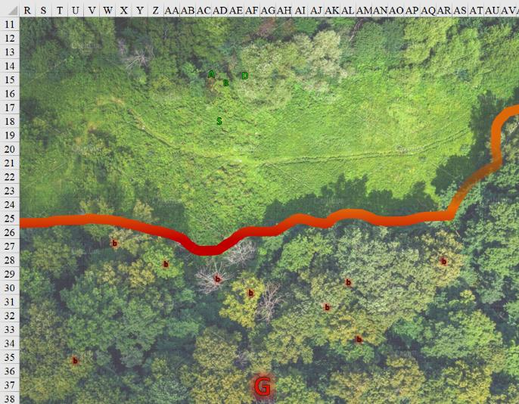

Round 75

Atlas continued to study the demon, looking for ways to better attack it. “Watch him, he spits acid.”

|  |  |  |  |  |  |  |  |
| --- | --- | --- | --- | --- | --- | --- | --- |
| **Atlas, DK: Tactics** | **Rank** | **Ability & Mod.** | **Misc. Mods.** | **Total** | **Roll** | **Check** | **Notes** |
| **Knowledge: The Planes** | 21 | **Int (+8)** | 5 | 34 | 20 | 54 | Trivial Knowledge, **best of 2 rolls** |
| **Knowledge: The Planes** | 21 | **Int (+8)** | 5 | 34 | 4 | 38 | Trivial Knowledge |

*Beats by 20+. PCs gain +3 to attacks vs. Graz’zt.*

Brene, taking a chance to flank the creature, moved to her left and loosed two arrows at the demon.

|  |  |  |  |  |  |  |  |  |  |
| --- | --- | --- | --- | --- | --- | --- | --- | --- | --- |
| **Ranged Weapon** | **Dmg.** | **D+** | **TH+** | **Critical** | **Rng.** | **Atk** | **Roll** | **Check** | **Properties** |
| Shortbow +2 | 1d4 | 2 | 2 | x3 | 60’ | +29 | 9 | 37 | Sneak Attack 9d6 |
| Shortbow, 2nd Shot | 1d4 | 2 | 2 | x3 | 60’ | +23 | 17 | 40 | Sneak Attack 9d6 |

*Hit (DK Tactics made the difference), hit. Dmg: (2 + 2 + 9 DK + 34 Sneak) + (2 + 2 + 10 DK + 33 Sneak) = 47 + 47 = 94.*

Devrion pointed at the pod, leaving the demon for the next spell. “Tűzgömb!” *[fireball]*

*Denied Reflex save. Dmg: 51 fire. Partial damage negated.*

Steelshade cast *protection from energy (Acid) [expired on Round 1875]* on herself, and moved forward to meet the demon.

*Steelshade gained 120 points of protection against Acid damage.*

The Abyssal royal smirked and charge-attacked Steelshade from up above.

|  |  |  |  |  |  |  |  |  |  |  |
| --- | --- | --- | --- | --- | --- | --- | --- | --- | --- | --- |
| **Character** | **Attack Type** | **Damage** | **BAB** | **Str Mod+** | **Dex Mod+** | **W+** | **Other+** | **Total Score** | **Roll** | **Total** |
| Graz’zt | Acidic Burst  Bastard Sword +2 | 2d8+18+1d6  acid,17-20 | 25 | 8 | 9 | 0 | 2 charge  + 2 height | 37 | 18 | 54 |

*Threat. 1d20 = 12 + 37 = 49, critical hit. 1d100 = 97, concealment bypassed.*

*Dmg: (2 x 13) + 18 + 2 charge + 1 acid = 47.*

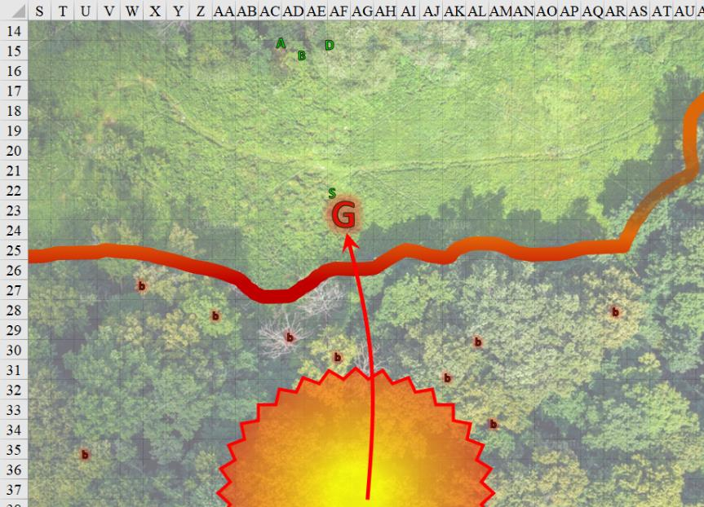

Round 76

The *fireball* had consumed the massive orb, but much work remained to be done before it could be said that the deed was completed. The membrane and drying wood underneath now caught on fire, releasing premature babau nymphs that began to break free from their suckling embrace with the membrane. The nascent demons’ instinct would soon lead them down to the clearing around the dome to come and eat them, or perhaps they’d eat the nymphs still attached. Such was the circle of the afterlife.

Steelshade grunted as the demon’s blade skipped off her shield, jarring her to her bones. She couldn’t take too many more of those hits, but now it was her turn. She channeled the stored *vampiric touch [hp bonus expired in 1 hour]* spell in Arkenlyl, empowered her strikes (+4), and full attacked the demon.

|  |  |  |  |  |  |  |  |
| --- | --- | --- | --- | --- | --- | --- | --- |
| **Melee Weapon** | **Dmg** | **D+** | **TH+** | **Atk** | **Roll** | **Check** | **Properties** |
| Shattermantle Bloodstone Falchion +3 | 2d4 | +9 +3 + 4d4 AS + 3d6 DK | 3 + 4 AS  + 3 DK | +39 | 11 | 50 | Vampiric Touch |
| SB Falchion +3, 2nd Attack | 2d4 | +9 +3 + 4d4 AS + 3d6 DK | 3 + 4 AS  + 3 DK | +34 | 6 | 40 |  |
| SB Falchion +3, 3rd Attack | 2d4 | +9 +3 + 4d4 AS + 3d6 DK | 3 + 4 AS  + 3 DK | +29 | 12 | 41 |  |
| SB Falchion +3, 4th Attack | 2d4 | +9 +3 + 4d4 AS + 3d6 DK | 3 + 4 AS  + 3 DK | +24 | 9 | 33 |  |
| Greater Crystal of Arcane Steel | +1 to touch spells | 1 | +1 | - | - | - | +1 to spell DC |

*Hit, hit, hit, miss.*

|  |  |  |  |  |  |
| --- | --- | --- | --- | --- | --- |
| **Ranged Weapon** | **Dmg.** | **TH+** | **Atk** | **Roll** | **Check** |
| Bypass SR (Spell Power) | Vampiric Touch | 4 | +21 | 17 | 38 |

*Success. Dmg: (5 + 9 + 3 + 8 AS + 14 DK + 32 Vampiric) + (7 + 9 + 3 + 8 AS + 17 DK) + (1 + 9 + 3 + 12 AS + 13 DK) = 39 + 44 + 38 + (32 x 1½) Vampiric = 169 – 6 to SR.*

*Steelshade gained 48 hps [179/179].*

Brene opened one of her scrolls of *enervate*, and pointed at the demon as she read it. She’d already done this, and the demon lord hadn’t been the same since. Perhaps more of the same medicine was in order.

|  |  |  |  |  |  |  |
| --- | --- | --- | --- | --- | --- | --- |
| **Skill** | **Rank** | **Ability & Mod.** | **Misc. Mods.** | **Total** | **Roll** | **Check** |
| **Brene, Use Magic Device** | 10 | **Cha (+2)** | 0 | **12** | 18 | 30 |

*Success.*

|  |  |  |  |  |
| --- | --- | --- | --- | --- |
| **Ranged Weapon** | **Dmg.** | **Atk** | **Roll** | **Check** |
| Ranged Touch Attack | 1d4 negative levels | +23 | 2 | 25 |

*Hit.*

|  |  |  |  |  |  |
| --- | --- | --- | --- | --- | --- |
| **Ranged Weapon** | **Dmg.** | **TH+** | **Atk** | **Roll** | **Check** |
| Overcome SR | Enervation | 4 + 3 | +7 | 6 | 13 |

*Fail. Spell effects fail.*

Graz’zt, withered bit by bit by these inscrutable nuisances, full-attacked Steelshade.

|  |  |  |  |  |  |  |  |  |  |  |
| --- | --- | --- | --- | --- | --- | --- | --- | --- | --- | --- |
| **Character** | **Attack Type** | **Damage** | **BAB** | **Str Mod+** | **W+** | **Total Score** | **Roll** | **Total** | **Crit** | **Threat** |
| Graz’zt | Acidic Burst  Bastard Sword +2 | 2d8+18+1d6 acid,17-20 | 22 | 8 | 2 | 32 | 17 | 49 | 20 | ý |
| Graz’zt | Sword, 2nd Attack | 2d8+18+1d6 acid,17-20 | 17 | 8 | 2 | 27 | ***20*** | 42 | 20 | þ |
| Graz’zt | Sword, 3rd Attack | 2d8+18+1d6 acid,17-20 | 12 | 8 | 2 | 22 | 2 | 26 | 20 | ý |
| Graz’zt | Sword, 4th Attack | 2d8+18+1d6 acid,17-20 | 7 | 8 | 2 | 17 | 8 | 25 | 20 | ý |

*Threat, threat, miss, miss. 1d20 = 2 + 32 = 24, 19 + 27 = 41, 2nd hit is critical. 1d100 = 56, 58, concealment bypassed.*

*Dmg: (10 + 18 + 3 acid) + ([2 x 5] + 18 + 3 acid) = 28 + 28 + 6 acid = 62. Acid damage absorbed by protection [123/179].*

Seeing that the fire did some damage, Atlas called down a *flame strike* on the pod and its environs.

*Denied Reflex save. Dmg: 22 fire + 22 holy [good] = 44. Partial fire damage negated.*

Now that the demon was close enough, Devrion pointed at it and spoke sharply. “A halál ujja!!” *[finger of death]*

|  |  |  |  |  |
| --- | --- | --- | --- | --- |
| **Character** | **Save vs.**  *finger of death* | **Ranks** | **Roll** | **Check** |
| Graz’zt | Fortitude | 22 | 1 | 23 |

*Fail.*

|  |  |  |  |  |
| --- | --- | --- | --- | --- |
| **Ranged Weapon** | **Dmg.** | **Atk** | **Roll** | **Check** |
| Bypass Spell Resistance | Finger of Death | 18 | 16 | 34 |

*Success.*

“I see what you’re trying to do, gamechanger,” Graz’zt seemed to be looking at Devrion while fighting Steelshade. “I’ll fuck you up last.” Then Graz’zt died on the spot.

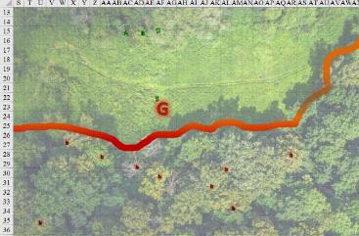

Round 77

A handful of maturing babaus were now evident among their more premature counterparts, and these now unstuck themselves from the slimy dome and began crawling over to the heroes. It wouldn’t make for too big a challenge, but if more of them came, it may have delayed their appointment with the orb.

Steelshade backed away from the demon’s crumbling corpse, avoiding the mess of acid and other goo. She flexed her shield arm, and made sure that she still had a grip on her cube. She then activated her Healing Belt, using all three charges.

*Steelshade gained 17 hps [140/179].*

Brene ran to her friend’s side and tapped her with her Wand of Serious Wounds.

*Steelshade gained 17 + 6 = 23 hps [163/179].*

Atlas also moved forward and, saying a brief prayer *[cure moderate wounds]*, touched Steelshade’s shoulder.

*Steelshade gained 5 + 10 = 15 hps [178/179].*

Devrion moved close to his companions. “We have to be over there.” He aimed at an open spot north of the orb, then reached out for Atlas and Steelshade, and Brene touched Atlas. “Dimenziós ajtó!” *[dimension door]*

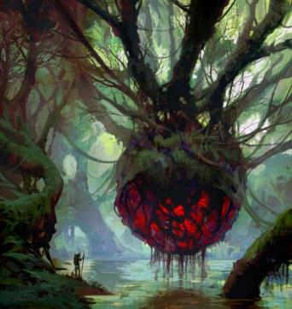

Round 78

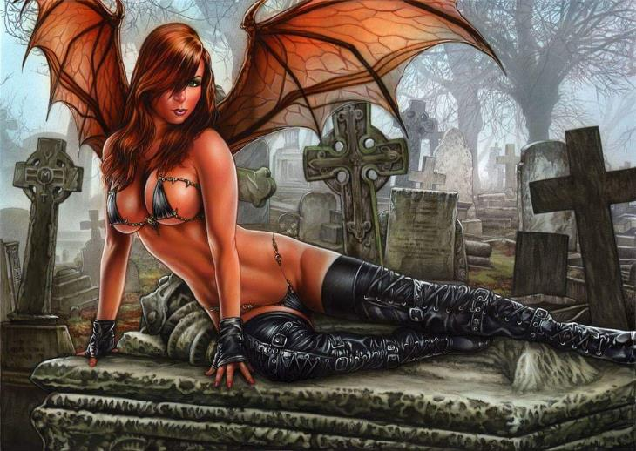

The vegetation around the orb was now destroyed, and the placental organ now rested on decaying goo. It tore itself into a seam that burst open with a menagerie of demons. There was an armanite, a clutch of babaus, a handful of gelatinous succubae, and among them a majestic *and* gelatinous lilitu, immediately distinguished by Atlas from the succubae by her hooves and unique horns.

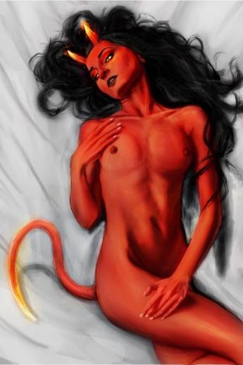

These enemies had taken on the forms of Graz’zt’s creatures, but they were clearly composed of the stuff of Juiblex, and the compositional style had them guessing as to just how much involvement Graz’zt had in all of this. Had they ever been interacting with Graz’zt, or someone whose strings were being pulled by that demon?

Devrion had teleported them to a patch of the forest wherein the membrane had partly caved in, so Devrion and Steelshade now had their boots stuck in some goo while Atlas and Brene were now standing on some crushed branches and trunks.

As the last of the babau used its legs for the first time to exit the motherly orb, the orb closed up its labial fold again, and began to heal itself.

The warmage ignored the mess at his feet, and pointed to a spot in the center of the group they faced. “Halál köre!” *[circle of death]*

*48 HD, Armanite (9 HD) and lilitu (14 HD) unaffected.*

*5 Succubae x 6 HD = 30 HD; 2 Babau x 7 HD = 14 HD; 44 HD slain.*

Every succubus in the sky dropped to her death, as did two babau in the loosening clutch.

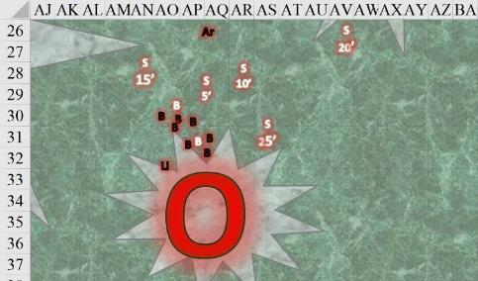

Atlas said a brief prayer *[dispel evil]* and reached over to touch Steelshade. The duskblade was enveloped in a white, shimmering glow.

Brene fired her bow at the armanite.

|  |  |  |  |  |  |  |  |  |  |
| --- | --- | --- | --- | --- | --- | --- | --- | --- | --- |
| **Ranged Weapon** | **Dmg.** | **D+** | **TH+** | **Critical** | **Rng.** | **Wt.** | **Atk** | **Roll** | **Check** |
| Shortbow +2 | 1d4 | 2 | 2 | x3 | 60’ | 2.0 | +25 | *1* | 26 |
| Shortbow, 2nd Shot | 1d4 | 2 | 2 | x3 | 60’ | - | +20 | 5 | 25 |

*Miss, hit. Dmg: 1.*

Steelshade moved forward so that she was closest to the armanite that would be upon them in seconds.

And in fact, the armanite eagerly chose Steelshade as his most worthy adversary, charge-attacking her with his already pointed lance.

|  |  |  |  |  |  |  |  |  |  |
| --- | --- | --- | --- | --- | --- | --- | --- | --- | --- |
| **Character** | **Attack Type** | **Damage** | **BAB** | **Str Mod+** | **W+** | **Other+** | **Total Score** | **Roll** | **Total** |
| Armanite | Acidic Burst Lance | 2d6+7+1d6 acid/x3 | 9 | 5 | 0 | 2 charge | 14 | 3 | 17 |

*Miss.*

The lancer galloped by, and missed his mark, now vulnerable to attacks of opportunity from the half-dragon’s archivist friend. Atlas swiped at the creature with his Blackthorn Shillelagh as it went by.

|  |  |  |  |  |  |  |  |  |  |
| --- | --- | --- | --- | --- | --- | --- | --- | --- | --- |
| **Melee Weapon** | **Dmg** | **D+** | **TH+** | **Critical** | **Type** | **Wt.** | **Atk** | **Roll** | **Check** |
| Blackthorn Shillelagh +2 | 1d6 | +5+2 | 2 | x2 | Bludgeon | 1.5 | +8 | 19 | 27 |

*Hit. Dmg: 6 + 5 + 2 = 13.*

The blood-orange-hued lilitu made a roundabout trajectory as she studied Devrion’s body language, and chose him as her target, casting *fly* and gaining about 20’ of altitude, saying something in a language that none of them understood. The voluptuous woman with a flawless figure now approached the warmage as the remaining babau did their best to use their legs for the first time, some better than others. Three of them reached Steelshade, but not before the lot of them activated their *darkness* ability.

*OOC: All creatures in the area gain concealment (20% miss chance). Even creatures that can normally see in such conditions (such as with darkvision or lowlight vision) have the miss chance in an area shrouded in magical darkness.*

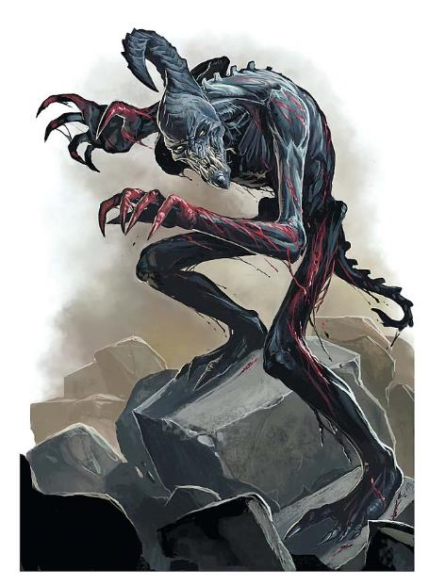

Steelshade did her best to fight off three separate attacks.

|  |  |  |  |  |  |  |  |  |  |
| --- | --- | --- | --- | --- | --- | --- | --- | --- | --- |
| **Character** | **Attack Type** | **Damage** | **BAB** | **Str Mod+** | **Other+** | **Total Score** | **Roll** | **Total** | **Threat** |
| Babau 1 | Claw | 1d6+5 | 7 | 5 | 2 charge | 14 | ***20*** | 34 | þ |
| Babau 2 | Claw | 1d6+5 | 7 | 5 | 2 charge | 14 | 16 | 30 | ý |
| Babau 3 | Claw | 1d6+5 | 7 | 5 | 2 charge | 14 | 9 | 23 | ý |

*Threat, miss, miss. 1d20 = 14 + 14 = 28, not a critical hit. 1d100 = 17, concealment not bypassed.*

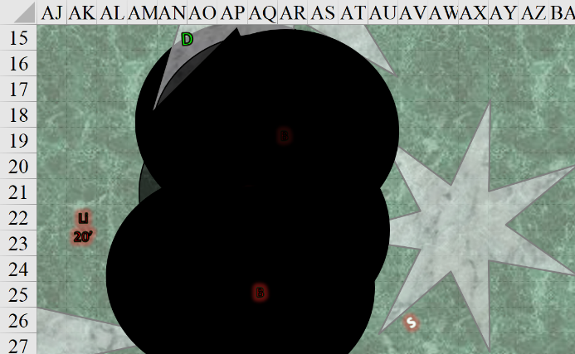

Round 79

Atlas knew full well that by destroying Graz’zt here on the Material Plane, his vile essence would only awaken on his home plane, and he’d be back up to no good within minutes. They’d have to track him and Juiblex to the cores of their Abyssal lairs if they truly wanted to create a power vacuum in the Lower Planes.

The placental orb pulsated as it did its best to cook up some more ready-made demons. Armanites were particularly difficult to gestate, as their weapons and armor developed right along with them, and the orb churned with pain as the lance and armor’s spikes gestated.

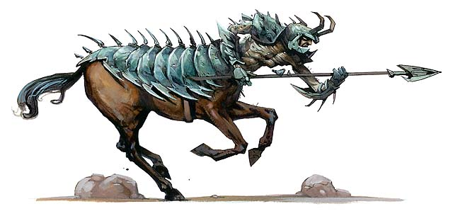

The armanite turned his attention towards Atlas, impaling his lance into the ground and drawing his Unholy Heavy Flail. Oh, what a fun time the centaurian demon would have cutting down the archivist!

The lilitu got closer to the heroes and performed what was referred to as Dark Speech *[DC = 10 + 14 + 10 = 34]*, though this was nothing like Atlas’ Dark Knowledge.

*The lilitu lost 3 Cha.*

The sounds the lovely, horned figure emitted caused her to become demonically frightening as she hissed sibilant words that befouled even the moment itself, instantly sowing despair across the immediate area whose boundaries were currently indiscernible.

|  |  |  |  |  |  |  |
| --- | --- | --- | --- | --- | --- | --- |
| **Save vs.**  Dark Speech | **Rank** | **Ability & Mod.** | **Misc. Mods.** | **Total** | **Roll** | **Check** |
| **Atlas, Will** | **11** | **Wis (+6)** | 13 | 30 | 19 | 49 |
| **Brene, Will** | **6** | **Wis (+3)** | 0 | 9 | 2 | 11 |
| **Devrion, Will** | **11** | **Wis (+3)** | 3 | 17 | 6 | 23 |
| **Steelshade, Will** | **10** | **Wis (+4)** | 3 | 17 | 15 | 32 |

*Success, fail, fail, fail. No mechanical effect on these heroes, but see below.*

Atlas remained calm, but the other three felt a surge of loathing for the lilitu that they could hardly contain. “This bitch gotta go,” were words waiting to be taken to action.

The babau were nowhere near as crafty in their tactics, though hopefully theirs might have some consequence. They desperately lunged at Brene and Angren.

|  |  |  |  |  |  |  |  |  |  |
| --- | --- | --- | --- | --- | --- | --- | --- | --- | --- |
| **Character** | **Attack Type** | **Damage** | **BAB** | **Str Mod+** | **Dex Mod+** | **Other+** | **Total Score** | **Roll** | **Total** |
| Babau 1 | Claw 1 | 1d6+5 | 7 | 5 | 1 | 0 | 12 | 19 | 31 |
| Babau 1 | Claw 2 | 1d6+5 | 7 | 5 | 1 | 0 | 12 | 6 | 18 |
| Babau 1 | Bite | 1d6+2 | 7 | 0 | 1 | 0 | 7 | 6 | 13 |
| Babau 2 | Claw 1 | 1d6+5 | 7 | 5 | 1 | 0 | 12 | 7 | 19 |
| Babau 2 | Claw 2 | 1d6+5 | 7 | 5 | 1 | 0 | 12 | 13 | 25 |
| Babau 2 | Bite | 1d6+2 | 7 | 0 | 1 | 0 | 7 | 12 | 19 |
| Babau 3 | Claw 1 | 1d6+5 | 7 | 5 | 1 | 0 | 12 | 9 | 21 |
| Babau 3 | Claw 2 | 1d6+5 | 7 | 5 | 1 | 0 | 12 | **20** | 32 |
| Babau 3 | Bite | 1d6+2 | 7 | 0 | 1 | 0 | 7 | 9 | 16 |
| Babau 4 | Claw | 1d6+5 | 7 | 5 | 1 | 2 charge | 14 | 2 | 16 |
| Babau 5 | Claw | 1d6+5 | 7 | 5 | 1 | 2 charge | 14 | 5 | 19 |
| Babau 6 | Bite | 1d6+2 | 7 | 0 | 1 | 2 charge | 9 | 1 | 10 |
| Babau 7 | Claw | 1d6+5 | 7 | 5 | 1 | 2 charge | 14 | 5 | 19 |

*Targeting Steelshade*

*Miss8, threat. 1d20 = 8 + 12 = 20, not a critical hit. 1d100 = 03, concealment not bypassed.*

*Targeting Brene*

*Miss4.*

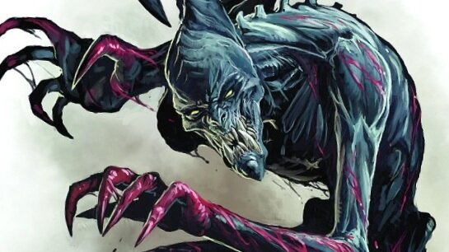

“Heathens, be forewarned,” the orb had the courtesy to speak in Common, or perhaps it was something else whose disembodied voice was coming from its direction. “Aasterinian means to devour you herself, though not with the same ferocity as I would. She will feed off your sweat and labor for an age to come, while I would make your steep path of suffering a quick one, and would make of your flesh and souls a handsome set of minionry.”

The babau seethed with voracity as they heard their supreme dominatrix beginning to negotiate with their intended food supply. The newly hatched spawns protested by becoming that much more dire in their resolve, and spikes now protruded from their flesh as they readied themselves for another round of retaliation from their blinded adversaries.

He said another prayer *[true seeing, expired on Round 259]* and touched his own head. He then moved closer to Steelshade. “I’m here,” he called as he realized that these were a type of babau unfamiliar to him, and unlike the garden variety, they weren’t actually casting *darkness*, but *blacklight*, which allowed them—but not the heroes—to see within the magical darkness.

Brene moved back in an attempt to get out of the darkness. She also activated her Scout’s Headband, using all three charges to gain *true seeing [expired on Round 89]*. She then looked for the armanite who was threatening her lover.

Devrion stepped to his right to avoid the encroaching darkness effect. He pointed his finger at the lilitu. “A halál ujja!” *[finger of death]*

|  |  |  |  |  |
| --- | --- | --- | --- | --- |
| **Character** | **Save vs.**  *finger of death* | **Ranks** | **Roll** | **Check** |
| Lilitu | Fortitude | 13 | 17 | 30 |

*Success. Saves for partial damage.*

*Dmg: 11 + 18 = 29.*

“Those tricks don’t work on me, son, but I will work a trick on you,” the newborn lilitu threatened Devrion in Common.

Steelshade launched a furious counterattack, and stood her ground at Atlas moved behind her.

|  |  |  |  |  |  |  |  |  |  |  |
| --- | --- | --- | --- | --- | --- | --- | --- | --- | --- | --- |
| **Melee Weapon** | **Dmg** | **D+** | **TH+** | **Crit** | **x** | **Type** | **Wt.** | **Atk** | **Roll** | **Check** |
| Shattermantle Bloodstone  Falchion +3 | 2d4 | +9 +3 | 3 – 4 dark | 18 | 2 | Slashing | 8.0 | +28 | 16 | 44 |
| SB Falchion +3, 2nd Attack | 2d4 | +9 +3 | 3 – 4 dark | 18 | 2 | Slashing | - | +23 | 15 | 38 |
| SB Falchion +3, 3rd Attack | 2d4 | +9 +3 | 3 – 4 dark | 18 | 2 | Slashing | - | +18 | 1 | 19 |
| SB Falchion +3, 4th Attack | 2d4 | +9 +3 | 3 – 4 dark | 18 | 2 | Slashing | - | +13 | 1 | 14 |

*Hit, hit, miss, miss. Dmg: (3 + 9 + 3) + (4 + 9 + 3) = 15 + 16 = 31.*

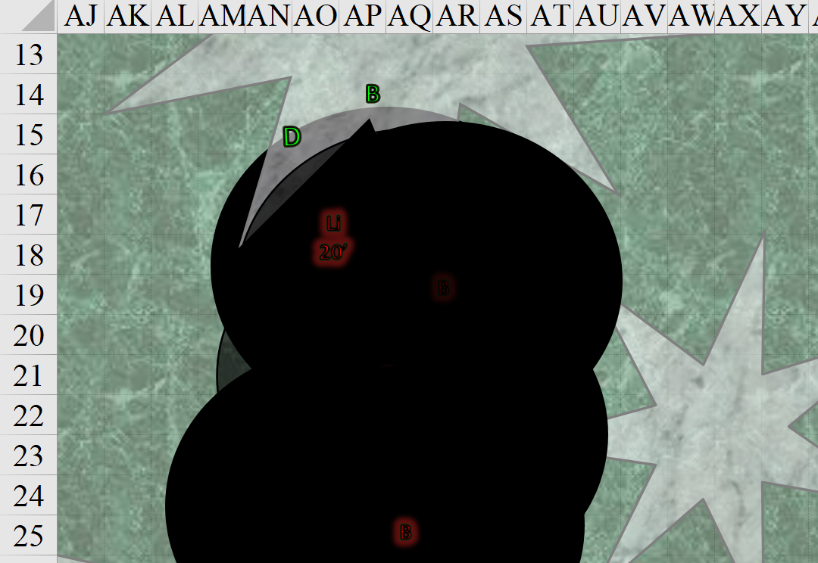

Round 80

<< Kill! >> the armanite commanded the other demons to put down the humanoid quartet.

Atlas cast *true seeing [expired on Round 260]* on Steelshade, and she could now see the babau before her. Each of them was dealing with two or three demons.

Brene put away her bow and entered again the magically dark area, then drew her dagger and rushed the armanite who was attacking Atlas, but did not have time to attack.

Steelshade backed away as she sliced and diced at the three creatures before her.

|  |  |  |  |  |  |  |  |  |  |  |
| --- | --- | --- | --- | --- | --- | --- | --- | --- | --- | --- |
| **Melee Weapon** | **Dmg** | **D+** | **TH+** | **Crit** | **x** | **Type** | **Wt.** | **Atk** | **Roll** | **Check** |
| Shattermantle Bloodstone Falchion +3 | 2d4 | +9 +3 | 3 | 18 | 2 | Slashing | 8.0 | +32 | 18 | 50 |
| SB Falchion +3, 2nd Attack | 2d4 | +9 +3 | 3 | 18 | 2 | Slashing | - | +27 | 2 | 29 |
| SB Falchion +3, 3rd Attack | 2d4 | +9 +3 | 3 | 18 | 2 | Slashing | - | +22 | 14 | 36 |
| SB Falchion +3, 4th Attack | 2d4 | +9 +3 | 3 | 18 | 2 | Slashing | - | +17 | 16 | 33 |

*Hit, hit, hit. Dmg: (6 + 9 + 3) + (4 + 9 + 3) + (5 + 9 + 3) = 18 + 16 + 17 = 51.*

She was able to kill the first one she’d attacked, leaving her two fully healthy, newly hatched babau to decapitate.

Devrion had not finished off the lilitu. Resolving to do that, he zapped her with a *magic missile*.

*Dmg: 10 + 5 + 6 = 21 magic [force].*

The babau did their worst.

|  |  |  |  |  |  |  |  |  |
| --- | --- | --- | --- | --- | --- | --- | --- | --- |
| **Character** | **Attack Type** | **Damage** | **BAB** | **Str Mod+** | **Total Score** | **Roll** | **Total** | **Targeting** |
| Babau 1 | Claw 1 | 1d6+5 | 7 | 5 | 12 | 14 | 26 | Steelshade |
| Babau 1 | Claw 2 | 1d6+5 | 7 | 5 | 12 | 8 | 20 | Steelshade |
| Babau 1 | Bite | 1d6+2 | 7 | 0 | 7 | 8 | 15 | Steelshade |
| Babau 2 | Claw 1 | 1d6+5 | 7 | 5 | 12 | 1 | 13 | Steelshade |
| Babau 2 | Claw 2 | 1d6+5 | 7 | 5 | 12 | 14 | 26 | Steelshade |
| Babau 2 | Bite | 1d6+2 | 7 | 0 | 7 | 12 | 19 | Steelshade |
| Babau 3 | Claw 1 | 1d6+5 | 7 | 5 | 12 | 8 | 20 | Steelshade |
| Babau 3 | Claw 2 | 1d6+5 | 7 | 5 | 12 | 18 | 30 | Steelshade |
| Babau 3 | Bite | 1d6+2 | 7 | 0 | 7 | 13 | 20 | Steelshade |
| Babau 4 | Claw 1 | 1d6+5 | 7 | 5 | 12 | 12 | 24 | Atlas |
| Babau 4 | Claw 2 | 1d6+5 | 7 | 5 | 12 | 2 | 14 | Atlas |
| Babau 4 | Bite | 1d6+2 | 7 | 0 | 7 | 3 | 10 | Atlas |
| Babau 5 | Claw 1 | 1d6+5 | 7 | 5 | 12 | 16 | 28 | Brene |
| Babau 5 | Claw 2 | 1d6+5 | 7 | 5 | 12 | 15 | 27 | Brene |
| Babau 5 | Bite | 1d6+2 | 7 | 0 | 7 | 5 | 12 | Brene |
| Babau 6 | Claw 1 | 1d6+5 | 7 | 5 | 12 | 8 | 20 | Brene |
| Babau 6 | Claw 2 | 1d6+5 | 7 | 5 | 12 | 9 | 21 | Brene |
| Babau 6 | Bite | 1d6+2 | 7 | 0 | 7 | 7 | 14 | Brene |
| Babau 7 | Claw 1 | 1d6+5 | 7 | 5 | 12 | 8 | 20 | Devrion |
| Babau 7 | Claw 2 | 1d6+5 | 7 | 5 | 12 | 13 | 25 | Devrion |
| Babau 7 | Bite | 1d6+2 | 7 | 0 | 7 | 20 | 27 | Devrion |

*Miss20, threat (Devrion). 1d20 = 3 + 7 = 10, not a critical hit. Dmg: 6 + 2 = 8 [109/99].*

The lilitu flew down to Devrion and stung him.

|  |  |  |  |  |  |  |  |
| --- | --- | --- | --- | --- | --- | --- | --- |
| **Character** | **Attack Type** | **Damage** | **BAB** | **Str Mod+** | **Total Score** | **Roll** | **Total** |
| Lilitu | Stinger 1 | 1d4+3+poison | 14 | 3 | 22 | 17 | 39 |

*Hit. Dmg: 2 + 3 = 5 + poison [104/99].*

|  |  |  |  |  |  |  |
| --- | --- | --- | --- | --- | --- | --- |
| **Save vs.**  Poison | **Rank** | **Ability**  **& Mod.** | **Misc.**  **Mods.** | **Total** | **Roll** | **Check** |
| **Devrion, Fortitude** | **6** | **Con (+3)** | 3 | 12 | 5 | 17 |

*Fail. Dmg: 8 Wisdom.*

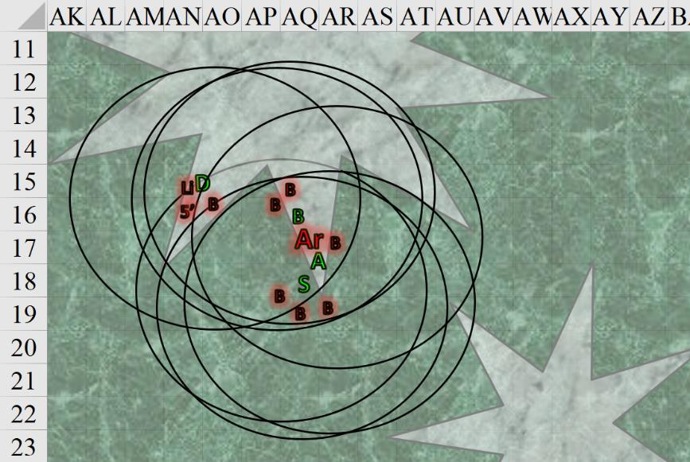

Round 81

Steelshade saw that the warmage was in serious trouble, so she rushed to defend him. She cast *swift fly*, Quick Cast *dimension hop*, channeled *shocking grasp* through her blade, and empowered her strikes (+3). She popped up right behind the lilitu and waled on her ass with a full attack. “Bitch!”

|  |  |  |  |  |  |  |  |  |  |  |  |
| --- | --- | --- | --- | --- | --- | --- | --- | --- | --- | --- | --- |
| **Melee Weapon** | **Dmg** | **D+** | **TH+** | **Crit** | **x** | **Type** | **Wt.** | **Atk** | **Roll** | **Check** | **Properties** |
| Shattermantle Bloodstone  Falchion +3 | 2d4  +5d6 electric | +9 +3 + 3d4 AS | 3 + 3 AS | 18 | 2 | Slashing | 8.0 | +32 | 15 | 47 | Shocking Grasp |
| SB Falchion +3,  2nd Attack | 2d4 | +9 +3 + 3d4 AS | 3 + 3 AS | 18 | 2 | Slashing | - | +27 | 17 | 44 |  |
| SB Falchion +3,  3rd Attack | 2d4 | +9 +3 + 3d4 AS | 3 + 3 AS | 18 | 2 | Slashing | - | +22 | 13 | 35 |  |
| SB Falchion +3,  4th Attack | 2d4 | +9 +3 + 3d4 AS | 3 + 3 AS | 18 | 2 | Slashing | - | +17 | 4 | 21 |  |
| Greater Crystal  of Arcane Steel | +1 to touch spells | 1 | +1 | - | - | - | - | - | - | - | +1 to spell DC |

*Hit, hit, hit, miss. Dmg: (8 + 9 + 3 + 6 Arcane + 16 electric) + (3 + 9 + 3 + 12 Arcane) + (6 + 9 + 3 + 7 Arcane) = 26 + 27 + 25 + 16 electric = 94. Electric damage negated.*

The swordswoman made a note to herself that most demons of her caliber were fully immune to electricity.

Devrion cast *swift fly* and lifted up 50’ and back 10’ to gain some fighting room. He pointed at the lilitu. “Mágikus rakéta!” *[magic missile]*

*Dmg: 13 + 5 + 6 = 24 magic [force].*

The demoness moaned with pleasure as the missiles struck her hips and buttocks. “That’ll cost you an hour on the rack, love.”

In reality—and Steelshade could tell—this was all bravado. The arch-succubus was going down.

Atlas and Brene went after the armanite.

|  |  |  |  |  |  |  |  |  |  |
| --- | --- | --- | --- | --- | --- | --- | --- | --- | --- |
| **Melee Weapon** | **Dmg** | **D+** | **TH+** | **Critical** | **Type** | **Wt.** | **Atk** | **Roll** | **Check** |
| Blackthorn Shillelagh +2 | 1d6 | +5+2 | 2 | x2 | Bludgeon | 1.5 | +8 | 17 | 25 |
| 2nd Attack | 1d6 | +5+2 | 2 | x2 | Bludgeon | - | +3 | 13 | 16 |

*Hit, miss. Dmg: 5 + 5 + 2 = 12.*

|  |  |  |  |  |  |  |  |  |  |  |
| --- | --- | --- | --- | --- | --- | --- | --- | --- | --- | --- |
| **Melee Weapon** | **Dmg** | **D+** | **TH+** | **Critical** | **Type** | **Wt.** | **Atk** | **Roll** | **Check** | **Properties** |
| Keen Dagger of Wounding +2 | 1d3+2 | 3+? | 2 | 19-20, x2 | Prc/Slash | 0.5 | +20 | 10 | 30 | Sneak Attack 9d6 |
| Dagger, 2nd Attack | 1d3+2 | 3+? | 2 | 19-20, x2 | Prc/Slash | - | +15 | 8 | 23 | Sneak Attack 9d6 |

*Hit, miss. Dmg: 3 + 2 + 3 + 32 Sneak = 40.*

This was not quite enough pain to cause the armanite in order to bring it down, but they could tell they were close to finishing the job.

Too tall to fight with the halfling properly, the armanite full-attacked Atlas and asked, “Why would you come to harm the Mother, Pale Night? She is all beauty!”

|  |  |  |  |  |  |  |  |  |  |
| --- | --- | --- | --- | --- | --- | --- | --- | --- | --- |
| **Character** | **Attack Type** | **Damage** | **BAB** | **Str Mod+** | **W+** | **Other+** | **Total Score** | **Roll** | **Total** |
| Armanite | Unholy Heavy Flail | 2d8+7+1d6 evil/19-20 | 9 | 5 | 1 | 0 | 15 | 13 | 27 |
| Armanite | Flail, 2nd Shot | 2d8+7+1d6 evil/19-20 | 9 | 5 | 1 | 0 | 15 | 19 | 33 |

*Miss, threat. 1d20 = 19 + 15 = 34, critical hit. Dmg: (2 x 6) + 7 + 5 evil = 24 [97/99].*

Nearly dead, the lilitu full-attacked Devrion.

|  |  |  |  |  |  |  |  |
| --- | --- | --- | --- | --- | --- | --- | --- |
| **Character** | **Attack Type** | **Damage** | **BAB** | **Dex Mod+** | **Total Score** | **Roll** | **Total** |
| Lilitu | Stinger 1 | 1d4+3+poison | 14 | 8 | 22 | 9 | 31 |
| Lilitu | Stinger 2 | 1d4+3+poison | 14 | 8 | 22 | 1 | 23 |
| Lilitu | Stinger 3 | 1d4+3+poison | 14 | 8 | 22 | 16 | 38 |
| Lilitu | Stinger 4 | 1d4+3+poison | 14 | 8 | 22 | 14 | 36 |
| Lilitu | Claw 1 | 1d6+1 | 12 | 8 | 20 | 7 | 27 |
| Lilitu | Claw 2 | 1d6+1 | 12 | 8 | 20 | 13 | 33 |

*Miss, miss, hit, hit, miss, miss. Protection from Evil helped here.*

*Dmg: (1 + 3) + (3 + 3) = 10 + poison2 [94/99].*

|  |  |  |  |  |  |  |
| --- | --- | --- | --- | --- | --- | --- |
| **Save vs.**  Poison | **Rank** | **Ability & Mod.** | **Misc. Mods.** | **Total** | **Roll** | **Check** |
| **Devrion, Fortitude** | **6** | **Con (+3)** | 3 | 12 | 11 | 23 |

*Success. No Wisdom damage.*

She then backed away from Devrion westward and upward 5’, still adjacent to Steelshade, who noted that the lilitu had a vestigial bronze strap-on swinging.

The babau fought back.

|  |  |  |  |  |  |  |  |  |
| --- | --- | --- | --- | --- | --- | --- | --- | --- |
| **Character** | **Attack Type** | **Damage** | **BAB** | **Str Mod+** | **Total Score** | **Roll** | **Total** | **Notes** |
| Babau 2 | Claw 1 | 1d6+5 | 7 | 5 | 12 | 5 | 17 | Steelshade |
| Babau 2 | Claw 2 | 1d6+5 | 7 | 5 | 12 | 17 | 29 | Steelshade |
| Babau 2 | Bite | 1d6+2 | 7 | 0 | 7 | 8 | 15 | Steelshade |
| Babau 3 | Claw 1 | 1d6+5 | 7 | 5 | 12 | 17 | 29 | Steelshade |
| Babau 3 | Claw 2 | 1d6+5 | 7 | 5 | 12 | 4 | 16 | Steelshade |
| Babau 3 | Bite | 1d6+2 | 7 | 0 | 7 | 3 | 10 | Steelshade |
| Babau 4 | Claw 1 | 1d6+5 | 7 | 5 | 12 | 10 | 22 | Atlas |
| Babau 4 | Claw 2 | 1d6+5 | 7 | 5 | 12 | 16 | 28 | Atlas |
| Babau 4 | Bite | 1d6+2 | 7 | 0 | 7 | 12 | 19 | Atlas |
| Babau 5 | Claw 1 | 1d6+5 | 7 | 5 | 12 | 12 | 24 | Brene |
| Babau 5 | Claw 2 | 1d6+5 | 7 | 5 | 12 | 7 | 19 | Brene |
| Babau 5 | Bite | 1d6+2 | 7 | 0 | 7 | 18 | 25 | Brene |
| Babau 6 | Claw 1 | 1d6+5 | 7 | 5 | 12 | 11 | 23 | Brene |
| Babau 6 | Claw 2 | 1d6+5 | 7 | 5 | 12 | 15 | 27 | Brene |
| Babau 6 | Bite | 1d6+2 | 7 | 0 | 7 | 15 | 22 | Brene |
| Babau 7 | Claw 1 | 1d6+5 | 7 | 5 | 12 | 17 | 29 | Devrion |
| Babau 7 | Claw 2 | 1d6+5 | 7 | 5 | 12 | 15 | 27 | Devrion |
| Babau 7 | Bite | 1d6+2 | 7 | 0 | 7 | 19 | 26 | Devrion |

*Miss18.*

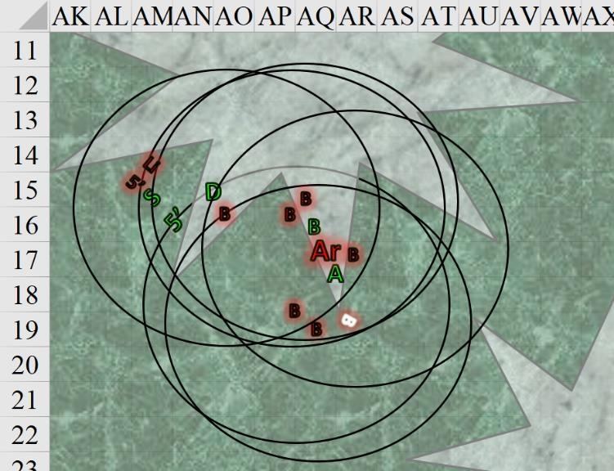

Round 82

Steelshade, noting that the demoness was still focused on Devrion and not on her, launched another flanking aerial attack. She cast *swift fly* and *critical strike*, channeled *inflict serious wounds* through her falchion, and empowered her strikes (+3), in a bid to finish the demon.

|  |  |  |  |  |  |  |  |
| --- | --- | --- | --- | --- | --- | --- | --- |
| **Melee Weapon** | **Dmg** | **D+** | **TH+** | **Atk** | **Roll** | **Check** | **Properties** |
| Shattermantle Bloodstone  Falchion +3 | 2d4 | +9 +3  +3d4 AC | 3 + 3 | +35 | 7 | 42 | Critical Range 15 – 20  Inflict Serious Wounds |
| SB Falchion +3,  2nd Attack | 2d4 | +9 +3  +3d4 AC | 3 + 3 | +30 | 2 | 32 |  |
| SB Falchion +3,  3rd Attack | 2d4 | +9 +3  +3d4 AC | 3 + 3 | +25 | 13 | 38 |  |
| SB Falchion +3,  4th Attack | 2d4 | +9 +3  +3d4 AC | 3 + 3 | +20 | 14 | 34 |  |
| Greater Crystal  of Arcane Steel | +1 to touch spells | 1 | +1 | - | - | - | +1 to spell DC |

*Hit, hit, hit, hit. Dmg: (4 + 9 + 3 + Arcane + 16 ISW) + (8 + 9 + 3 + Arcane) + (3 + 9 + 3 + Arcane) + (6 + 9 + 3 + Arcane) = 16 + 20 + 15 + 18 + 16 ISW = 69 + 16 negative energy = 85.*

And this ended the lilitu’s short existence on the Material Plane.

Devrion pointed at the closest babau. “Gömb erő!” *[orb of force]*

|  |  |  |  |  |  |  |  |
| --- | --- | --- | --- | --- | --- | --- | --- |
| **Ranged Weapon** | **Dmg.** | **D+** | **TH+** | **Atk** | **Roll** | **Check** | **Notes** |
| Ranged Touch Attack | 10d6 force | +6 Warmage Edge | 1 | 12 | 19 | 31 | Weapon Focus Included |

*Hit. Dmg: 35 + 6 WE = 41 magic [force].*

The damage was hurtful, but not lethal, to the babau.

Atlas and Brene tag teamed the armanite.

|  |  |  |  |  |  |  |  |  |  |  |
| --- | --- | --- | --- | --- | --- | --- | --- | --- | --- | --- |
| **Melee Weapon** | **Dmg** | **D+** | **TH+** | **Critical** | **Type** | **Wt.** | **Atk** | **Roll** | **Check** | **Notes** |
| Blackthorn Shillelagh +2 | 1d6 | +5+2 | 2 | x2 | Bludgeon | 1.5 | +8 | 8 | 16 |  |
| 2nd Attack | 1d6 | +5+2 | 2 | x2 | Bludgeon | - | +3 | 5 | 8 |  |
| Keen Dagger of Wounding +2 | 1d3+2 | 3+? | 2 | 19-20, x2 | Prc/Slash | 0.5 | +20 | 8 | 28 | Sneak Attack 9d6 |
| Dagger, 2nd Attack | 1d3+2 | 3+? | 2 | 19-20, x2 | Prc/Slash | - | +15 | 16 | 31 | Sneak Attack 9d6 |

*Miss, miss, hit, hit. Dmg: (1 + 2 + 3 + 36 Sneak) + (3 + 2 + 3 + 34 Sneak) = 42 + 42 = 84.*

Brene was able to bring down the vicious armanite, who dropped his unholy flail.

The remaining babau did babau things.

|  |  |  |  |  |  |  |  |  |
| --- | --- | --- | --- | --- | --- | --- | --- | --- |
| **Character** | **Attack Type** | **Damage** | **BAB** | **Str Mod+** | **Total Score** | **Roll** | **Total** | **Targeting** |
| Babau 2 | Claw 1 | 1d6+5 | 7 | 5 | 12 | 2 | 14 | Steelshade |
| Babau 2 | Claw 2 | 1d6+5 | 7 | 5 | 12 | 19 | 31 | Steelshade |
| Babau 2 | Bite | 1d6+2 | 7 | 0 | 7 | 15 | 22 | Steelshade |
| Babau 3 | Claw 1 | 1d6+5 | 7 | 5 | 12 | 18 | 30 | Steelshade |
| Babau 3 | Claw 2 | 1d6+5 | 7 | 5 | 12 | 4 | 16 | Steelshade |
| Babau 3 | Bite | 1d6+2 | 7 | 0 | 7 | 6 | 13 | Steelshade |
| Babau 4 | Claw 1 | 1d6+5 | 7 | 5 | 12 | 13 | 25 | Atlas |
| Babau 4 | Claw 2 | 1d6+5 | 7 | 5 | 12 | 18 | 30 | Atlas |
| Babau 4 | Bite | 1d6+2 | 7 | 0 | 7 | 5 | 12 | Atlas |
| Babau 5 | Claw 1 | 1d6+5 | 7 | 5 | 12 | 5 | 17 | Brene |
| Babau 5 | Claw 2 | 1d6+5 | 7 | 5 | 12 | 6 | 18 | Brene |
| Babau 5 | Bite | 1d6+2 | 7 | 0 | 7 | 19 | 26 | Brene |
| Babau 6 | Claw 1 | 1d6+5 | 7 | 5 | 12 | 19 | 31 | Brene |
| Babau 6 | Claw 2 | 1d6+5 | 7 | 5 | 12 | 20 | 32 | Brene |
| Babau 6 | Bite | 1d6+2 | 7 | 0 | 7 | 1 | 8 | Brene |
| Babau 7 | Claw 1 | 1d6+5 | 7 | 5 | 12 | 17 | 29 | Devrion |
| Babau 7 | Claw 2 | 1d6+5 | 7 | 5 | 12 | 19 | 31 | Devrion |
| Babau 7 | Bite | 1d6+2 | 7 | 0 | 7 | 20 | 27 | Devrion |

*Miss16. 1 threat each to Brene and Devrion, 1d20 = 4 + 12 = 16, 8 + 7 + 15 = 22, no critical hits. 1d100 = 04, displacement bypassed.*

*Dmg to Brene: 4 + 5 = 9 [103/99].*

*Dmg to Devrion: 4 + 2 = 6 [88/99].*

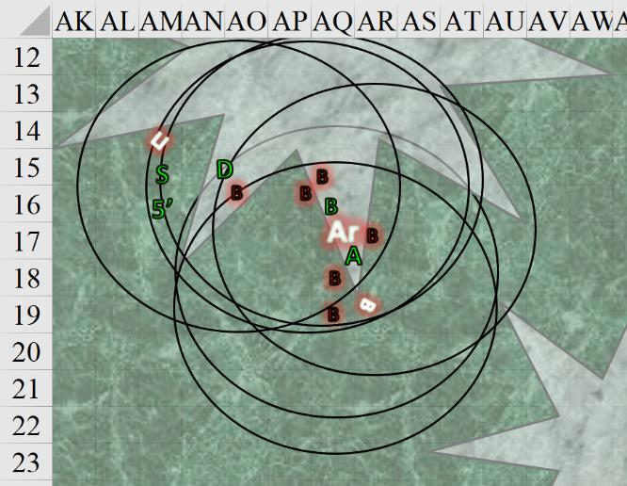

Round 83

Atlas thumped on the nearest enemy, while Brene picked an enemy she could flank in their overlapping spheres of darkness, and attacked it.

|  |  |  |  |  |  |  |  |  |  |  |
| --- | --- | --- | --- | --- | --- | --- | --- | --- | --- | --- |
| **Melee Weapon** | **Dmg** | **D+** | **TH+** | **Critical** | **Type** | **Wt.** | **Atk** | **Roll** | **Check** | **Notes** |
| Blackthorn Shillelagh +2 | 1d6 | +5+2 | 2 | x2 | Bludgeon | 1.5 | +8 | 15 | 23 |  |
| 2nd Attack | 1d6 | +5+2 | 2 | x2 | Bludgeon | - | +3 | 2 | 5 |  |
| Keen Dagger of Wounding +2 | 1d3+2 | 3+? | 2 | 19-20, x2 | Prc/Slash | 0.5 | +20 | 3 | 23 | Sneak Attack 9d6 |
| Dagger, 2nd Attack | 1d3+2 | 3+? | 2 | 19-20, x2 | Prc/Slash | - | +15 | 20 | 35 | Sneak Attack 9d6 |

*Hit, miss, hit, threat. 1d20 = 15 + 15 = 30, critical hit.*

*Dmg: (5 + 5 + 2) + (1 + 2 + 3 + 30 Sneak) + ([2 x 2] + 2 + 3 + 25 Sneak) = 12 + 36 + 34 = 82.*

And they did manage to kill that babau, reducing the count for Team Demon to 5 until the orb vomited out another handful of ne’er-do-wells to deal with them.

Steelshade landed and attacked the closest enemy: the one threatening Devrion.

|  |  |  |  |  |  |  |  |  |  |  |
| --- | --- | --- | --- | --- | --- | --- | --- | --- | --- | --- |
| **Melee Weapon** | **Dmg** | **D+** | **TH+** | **Crit** | **x** | **Type** | **Wt.** | **Atk** | **Roll** | **Check** |
| Shattermantle Bloodstone Falchion +3 | 2d4 | +9 +3 | 3 + 2 landing  from flight | 18 | 2 | Slashing | 8.0 | +34 | 5 | 39 |
| SB Falchion +3, 2nd Attack | 2d4 | +9 +3 | 3 | 18 | 2 | Slashing | - | +27 | 19 | 46 |
| SB Falchion +3, 3rd Attack | 2d4 | +9 +3 | 3 | 18 | 2 | Slashing | - | +22 | 19 | 41 |
| SB Falchion +3, 4th Attack | 2d4 | +9 +3 | 3 | 18 | 2 | Slashing | - | +17 | 17 | 34 |

*Hit, hit, hit, hit. Dmg: (5 + 9 + 3) + (4 + 9 + 3) + (5 + 9 + 3) + (7 + 9 + 3) = 17 + 16 + 17 + 19 = 69.*

That one went down too, leaving Devrion safe from immediate harm.

Devrion cast *swift fly*, rising up above the darkness effect. He pointed to a spot on the other side of the orb, far enough to avoid catching his friends in his spell. “Földrengés!” *[earthquake]*

|  |  |  |  |  |
| --- | --- | --- | --- | --- |
| **Character** | **Save vs.**  *earthquake* | **Ranks** | **Roll** | **Check** |
| Babau | Reflex | 6 | 3 | 9 |
| Babau | Reflex | 6 | 13 | 19 |
| Babau | Reflex | 6 | 6 | 12 |

*Fail, success, fail.*

There were three babau still stuck into the goo around the orb, and two of them babau slipped and fell prone, breaking their underdeveloped limbs and screaming in agony.

*1d100 = 30, 73, 36.*

All three avoided slipping into fissures that opened up all around them.

The orb, on the other hand, was partly engulfed by the fissures underneath it, and effectively eviscerated from below, collapsing like melting jelly with chunks of flesh amongst it.

*Dmg: 400. Partial damage negated.*

The babau among the heroes gasped in horror upon seeing what had happened to the organ that spawned them, and as a handful of other babau about 1000’ away spotted the heroes and started to come this way, it was evident that the death of Pale Night’s organ was having an effect on all of the demonic life, which was now turning completely gelatinous, moving slower, but now smoking with acidic flesh.

|  |  |  |  |  |  |  |  |  |
| --- | --- | --- | --- | --- | --- | --- | --- | --- |
| **Character** | **Attack Type** | **Damage** | **BAB** | **Str Mod+** | **Total Score** | **Roll** | **Total** | **Targeting** |
| Babau 2 | Claw 1 | 1d6+5+2d6 acid | 7 | 5 | 12 | 16 | 28 | Atlas |
| Babau 2 | Claw 2 | 1d6+5+2d6 acid | 7 | 5 | 12 | 2 | 14 | Atlas |
| Babau 2 | Bite | 1d6+2+2d6 acid | 7 | 0 | 7 | 4 | 11 | Atlas |
| Babau 3 | Claw 1 | 1d6+5+2d6 acid | 7 | 5 | 12 | 3 | 15 | Atlas |
| Babau 3 | Claw 2 | 1d6+5+2d6 acid | 7 | 5 | 12 | 12 | 24 | Atlas |
| Babau 3 | Bite | 1d6+2+2d6 acid | 7 | 0 | 7 | 19 | 26 | Atlas |
| Babau 5 | Claw 1 | 1d6+5+2d6 acid | 7 | 5 | 12 | 14 | 26 | Brene |
| Babau 5 | Claw 2 | 1d6+5+2d6 acid | 7 | 5 | 12 | 19 | 31 | Brene |
| Babau 5 | Bite | 1d6+2+2d6 acid | 7 | 0 | 7 | 14 | 21 | Brene |
| Babau 6 | Claw 1 | 1d6+5+2d6 acid | 7 | 5 | 12 | 16 | 28 | Brene |
| Babau 6 | Claw 2 | 1d6+5+2d6 acid | 7 | 5 | 12 | 12 | 24 | Brene |
| Babau 6 | Bite | 1d6+2+2d6 acid | 7 | 0 | 7 | 13 | 20 | Brene |

*Miss12.*

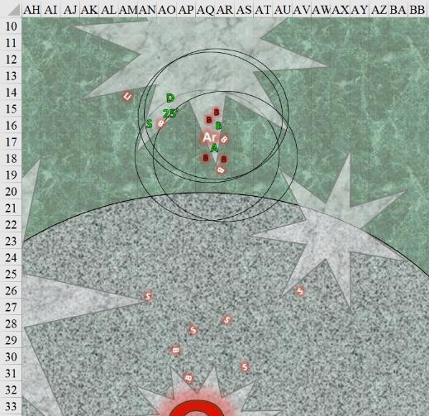

Round 84

Now that their mother organ was destroyed, the babau felt a sense of urgency in killing these guys, so they went at them some more.

|  |  |  |  |  |  |  |  |  |
| --- | --- | --- | --- | --- | --- | --- | --- | --- |
| **Character** | **Attack Type** | **Damage** | **BAB** | **Str Mod+** | **Total Score** | **Roll** | **Total** | **Targeting** |
| Babau | Claw 1 | 1d6+5+2d6 acid | 7 | 5 | 12 | 5 | 17 | Atlas |
| Babau | Claw 2 | 1d6+5+2d6 acid | 7 | 5 | 12 | 18 | 30 | Atlas |
| Babau | Bite | 1d6+2+2d6 acid | 7 | 0 | 7 | 16 | 23 | Atlas |
| Babau | Claw 1 | 1d6+5+2d6 acid | 7 | 5 | 12 | 3 | 15 | Atlas |
| Babau | Claw 2 | 1d6+5+2d6 acid | 7 | 5 | 12 | 13 | 25 | Atlas |
| Babau | Bite | 1d6+2+2d6 acid | 7 | 0 | 7 | 2 | 9 | Atlas |
| Babau | Claw 1 | 1d6+5+2d6 acid | 7 | 5 | 12 | 3 | 15 | Brene |
| Babau | Claw 2 | 1d6+5+2d6 acid | 7 | 5 | 12 | 9 | 21 | Brene |
| Babau | Bite | 1d6+2+2d6 acid | 7 | 0 | 7 | 15 | 22 | Brene |
| Babau | Claw 1 | 1d6+5+2d6 acid | 7 | 5 | 12 | 13 | 25 | Brene |
| Babau | Claw 2 | 1d6+5+2d6 acid | 7 | 5 | 12 | 15 | 27 | Brene |
| Babau | Bite | 1d6+2+2d6 acid | 7 | 0 | 7 | 3 | 10 | Brene |

*Miss12.*

The heroes looked at the four remaining babau before them, and spotted maybe a dozen coming at them from at least 1000’ away to the south, southeast, and southwest. This was to be their last stand, their final rage against the dying of their darkness.

Steelshade joined Brene and Atlas, and the three of them commenced to administering more punishment on their attackers. The drow was a killing machine, powering through her enemies, while the halfling ducked and weaved, striking with deadly precision as she drifted among them like smoke. Atlas just beat the life out of them with his stick. Steelshade cordially motioned for Atlas to go first, and he did.

|  |  |  |  |  |  |  |  |  |  |
| --- | --- | --- | --- | --- | --- | --- | --- | --- | --- |
| **Melee Weapon** | **Dmg** | **D+** | **TH+** | **Critical** | **Type** | **Wt.** | **Atk** | **Roll** | **Check** |
| Blackthorn Shillelagh +2 | 1d6 | +5+2 | 2 | x2 | Bludgeon | 1.5 | +8 | 17 | 25 |
| Shillelagh, 2nd Attack | 1d6 | +5+2 | 2 | x2 | Bludgeon | - | +3 | 14 | 17 |

*Hit, miss. Dmg: 6 + 5 + 2 = 13.*

Next was Brene, who took a 5’ step northward, then lunged and parried against the twin babau before her.

|  |  |  |  |  |  |  |  |  |  |  |
| --- | --- | --- | --- | --- | --- | --- | --- | --- | --- | --- |
| **Melee Weapon** | **Dmg** | **D+** | **TH+** | **Critical** | **Type** | **Wt.** | **Atk** | **Roll** | **Check** | **Properties** |
| Keen Dagger of Wounding +2 | 1d3+2 | 3+? | 2 | 19-20, x2 | Prc/Slash | 0.5 | +20 | 3 | 23 | Sneak Attack 9d6 |
| Dagger, 2nd Attack | 1d3+2 | 3+? | 2 | 19-20, x2 | Prc/Slash | - | +15 | 18 | 33 | Sneak Attack 9d6 |

*Hit, hit. Dmg: (1 + 2 + 3 + 34 Sneak) + (2 + 2 + 3 + 37 Sneak) = 40 + 44 = 84.*

One of the identical babau threatening Brene dropped to the ground, hopelessly dead. Steelshade had by now completed her charge-attack against the remaining twin.

|  |  |  |  |  |  |  |  |  |  |  |
| --- | --- | --- | --- | --- | --- | --- | --- | --- | --- | --- |
| **Melee Weapon** | **Dmg** | **D+** | **TH+** | **Crit** | **x** | **Type** | **Wt.** | **Atk** | **Roll** | **Check** |
| Shattermantle Bloodstone Falchion +3 | 2d4 | +9 +3  +2 charge | 3 + 2 charge | 18 | 2 | Slashing | 8.0 | +34 | 11 | 45 |

*Hit. Dmg: 5 + 9 + 3 + 2 charge = 19.*

Devrion, who couldn’t see a thing inside the magical darkness, decided to deal with the last of the attackers. “Repülni!” He stayed in place above the darkness, and pointed at the remains of the orb. “Tűzgömb!” *[swift fly and fireball]*

*No save allowed. Dmg: 42 fire. Partial damage negated.*

The warmage saw yet another hemisphere of *blacklight* darkness disappearing as bodies of demons were now lying dead or bumbling over to be dealt with summarily and decisively. The others, whose *true seeing* abilities were still perfectly in place, saw the same: a battlefield with the larvae of the demon queen. They were here because of Pale Night, and they would purge the area of her reproductive tissues as the greenish sky loomed overhead.

Devrion, whose field of vision contained more of the sky than those of the others at the moment, cocked his head quizzically at the green hue of the night sky that he hadn’t noted before.

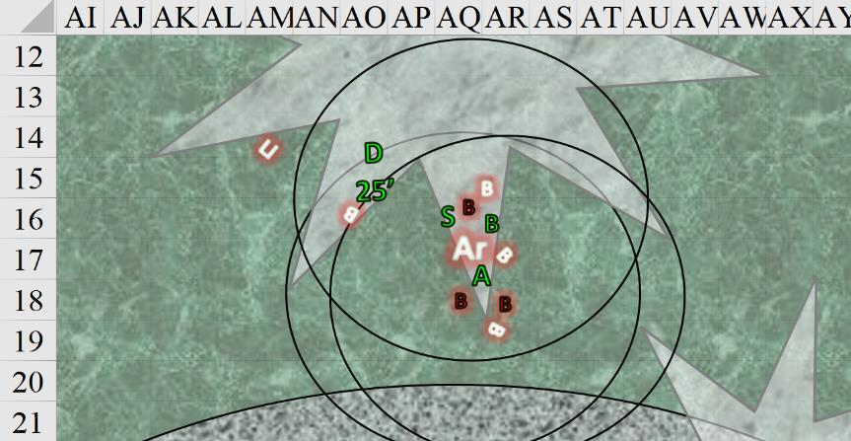

Round 85

The famished babau—just three of them now—continued to try to get a bite out of the heroes.

|  |  |  |  |  |  |  |  |  |
| --- | --- | --- | --- | --- | --- | --- | --- | --- |
| **Character** | **Attack Type** | **Damage** | **BAB** | **Str Mod+** | **Total Score** | **Roll** | **Total** | **Targeting** |
| Babau 3 | Claw 1 | 1d6+5+2d6 acid | 7 | 5 | 12 | 10 | 22 | Atlas |
| Babau 3 | Claw 2 | 1d6+5+2d6 acid | 7 | 5 | 12 | 14 | 26 | Atlas |
| Babau 3 | Bite | 1d6+2+2d6 acid | 7 | 0 | 7 | 10 | 17 | Atlas |
| Babau 5 | Claw 1 | 1d6+5+2d6 acid | 7 | 5 | 12 | 12 | 24 | Brene |
| Babau 5 | Claw 2 | 1d6+5+2d6 acid | 7 | 5 | 12 | 14 | 26 | Brene |
| Babau 5 | Bite | 1d6+2+2d6 acid | 7 | 0 | 7 | 8 | 15 | Brene |
| Babau 6 | Claw 1 | 1d6+5+2d6 acid | 7 | 5 | 12 | 12 | 24 | Brene |
| Babau 6 | Claw 2 | 1d6+5+2d6 acid | 7 | 5 | 12 | 4 | 16 | Brene |
| Babau 6 | Bite | 1d6+2+2d6 acid | 7 | 0 | 7 | 15 | 22 | Brene |

*Miss9.*

The lesser demons were out of their league in melee combat, even against a spellcaster and a shifty rogue. The two continued their strategy.

|  |  |  |  |  |  |  |  |  |  |
| --- | --- | --- | --- | --- | --- | --- | --- | --- | --- |
| **Melee Weapon** | **Dmg** | **D+** | **TH+** | **Critical** | **Type** | **Wt.** | **Atk** | **Roll** | **Check** |
| Blackthorn Shillelagh +2 | 1d6 | +5+2 | 2 | x2 | Bludgeon | 1.5 | +8 | 7 | 15 |
| Shillelagh, 2nd Attack | 1d6 | +5+2 | 2 | x2 | Bludgeon | - | +3 | 4 | 7 |

*Miss, miss.*

Brene helped Steelshade to flank-attack the babau to her northwest.

|  |  |  |  |  |  |  |  |  |  |  |
| --- | --- | --- | --- | --- | --- | --- | --- | --- | --- | --- |
| **Melee Weapon** | **Dmg** | **D+** | **TH+** | **Critical** | **Type** | **Wt.** | **Atk** | **Roll** | **Check** | **Properties** |
| Keen Dagger of Wounding +2 | 1d3+2 | 3+? | 2 | 19-20, x2 | Prc/Slash | 0.5 | +20 | 8 | 28 | Sneak Attack 9d6 |
| Dagger, 2nd Attack | 1d3+2 | 3+? | 2 | 19-20, x2 | Prc/Slash | - | +15 | 13 | 28 | Sneak Attack 9d6 |

*Hit, hit. Dmg: (3 + 2 + 3 + 30 Sneak) + (2 + 2 + 3 + 32 Sneak) = 38 + 39 = 77.*

Brene slew the babau before her.

To top it off, Steelshade was in town. The duskblade saw that her immediate target was destroyed, and thus she charge-attacked the already wounded one to whom she had a direct line of attack.

|  |  |  |  |  |  |  |  |  |
| --- | --- | --- | --- | --- | --- | --- | --- | --- |
| **Melee Weapon** | **Dmg** | **D+** | **TH+** | **Crit** | **x** | **Atk** | **Roll** | **Check** |
| Shattermantle Bloodstone Falchion +3 | 2d4 | +9 +3  + 2 charge | 3  + 2 charge | 18 | 2 | +34 | 9 | 41 |

*Hit. Dmg: 7 + 9 + 3 + 2 = 21.*

One good knock from Atlas should finish it off, thought Angren.

Devrion cast his spell again to remain airborne, and he launched another *fireball* into the approaching group from the south.

*No saves allowed. Dmg to each: 37 fire.*

They were seared, but not quite dead yet.

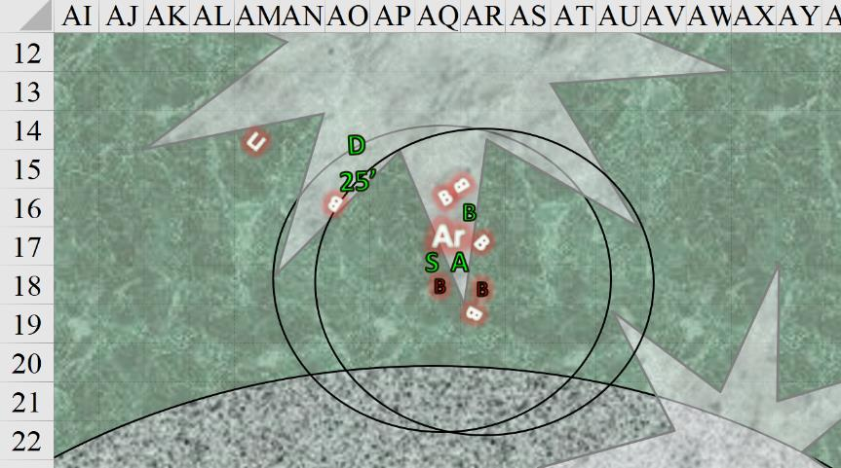

Round 86

The two remaining babau snapped and clawed at Steelshade and Atlas.

|  |  |  |  |  |  |  |  |  |
| --- | --- | --- | --- | --- | --- | --- | --- | --- |
| **Character** | **Attack Type** | **Damage** | **BAB** | **Str Mod+** | **Total Score** | **Roll** | **Total** | **Targeting** |
| Babau | Claw 1 | 1d6+5+2d6 acid | 7 | 5 | 12 | 18 | 30 | Steelshade |
| Babau | Claw 2 | 1d6+5+2d6 acid | 7 | 5 | 12 | 12 | 24 | Steelshade |
| Babau | Bite | 1d6+2+2d6 acid | 7 | 0 | 7 | 3 | 10 | Steelshade |
| Babau | Claw 1 | 1d6+5+2d6 acid | 7 | 5 | 12 | 12 | 24 | Atlas |
| Babau | Claw 2 | 1d6+5+2d6 acid | 7 | 5 | 12 | 11 | 23 | Atlas |
| Babau | Bite | 1d6+2+2d6 acid | 7 | 0 | 7 | 19 | 26 | Atlas |

*Miss6.*

Atlas, Brene, and Steelshade finished off the two demons near them.

|  |  |  |  |  |  |  |  |  |  |
| --- | --- | --- | --- | --- | --- | --- | --- | --- | --- |
| **Melee Weapon** | **Dmg** | **D+** | **TH+** | **Critical** | **Type** | **Wt.** | **Atk** | **Roll** | **Check** |
| Blackthorn Shillelagh +2 | 1d6 | +5+2 | 2 | x2 | Bludgeon | 1.5 | +8 | 15 | 23 |
| Shillelagh, 2nd Attack | 1d6 | +5+2 | 2 | x2 | Bludgeon | - | +3 | 18 | 21 |

*Hit, hit. Dmg: (6 + 5 + 2) + (4+ 5 + 2) = 13 + 11 = 24.*

That last blow killed the babau southeast of Atlas. Brene came around and stepped around that freshly killed individual, then jabbed once.

|  |  |  |  |  |  |  |  |  |  |  |
| --- | --- | --- | --- | --- | --- | --- | --- | --- | --- | --- |
| **Melee Weapon** | **Dmg** | **D+** | **TH+** | **Critical** | **Type** | **Wt.** | **Atk** | **Roll** | **Check** | **Properties** |
| Keen Dagger of Wounding +2 | 1d3+2 | 3+? | 2 | 19-20, x2 | Prc/Slash | 0.5 | +20 | 13 | 33 | Sneak Attack 9d6 |

*Hit. Dmg: 3 + 2 + 3 + 31 Sneak = 39.*

Steelshade ended this whimper of a struggle for existence.

|  |  |  |  |  |  |  |  |  |  |  |
| --- | --- | --- | --- | --- | --- | --- | --- | --- | --- | --- |
| **Melee Weapon** | **Dmg** | **D+** | **TH+** | **Crit** | **x** | **Type** | **Wt.** | **Atk** | **Roll** | **Check** |
| Shattermantle Bloodstone Falchion +3 | 2d4 | +9 +3 | 3 | 18 | 2 | Slashing | 8.0 | +32 | 16 | 48 |
| SB Falchion +3, 2nd Attack | 2d4 | +9 +3 | 3 | 18 | 2 | Slashing | - | +27 | 8 | 35 |
| SB Falchion +3, 3rd Attack | 2d4 | +9 +3 | 3 | 18 | 2 | Slashing | - | +22 | 20 | 42 |
| SB Falchion +3, 4th Attack | 2d4 | +9 +3 | 3 | 18 | 2 | Slashing | - | +17 | 14 | 31 |

*Hit4. Dmg: (5 + 9 + 3) + (6 + 9 + 3) + (4 + 9 + 3) + (5 + 9 + 3) = 17 + 18 + 16 + 17 = 68.*

That left the final babau extra headless. The magical *blacklight* effect dissipated, no longer sustained by the will of any nearby babau.

Devrion let himself float to the ground while he sent yet another *fireball* out to the approaching demons.

*No saves allowed. Dmg to each: 41 fire.*

The largest clutch of faraway babau withered and collapsed, but there were at least another eight coming from the far southeast and southwest. Because they were spaced out apart so much that a *fireball* could not have encompassed them all, the warmage would have to wait until they were closer to their aspired convergence point.

“We can put these down with blades alone,” Atlas suggested conserving the rest of their spells.

Steelshade looked around and based on the few stragglers she could see, she estimated a good 70 – 90 more swings before she could call it a night if she did it alone. If there were others, the four of them could likely prune the area, letting the demons come to them by lighting a torch and singing a ditty. Within the hours, they could have finished a perimeter check, skewered the last half-dozen stragglers, and declared the area relatively demon free.

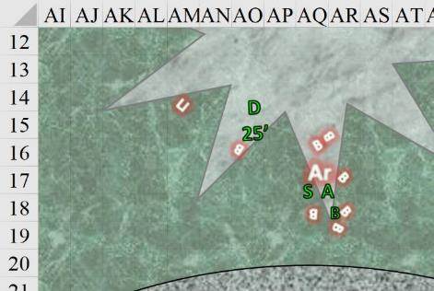

~*~

<< Yessss, kill! >> the unobtrusive quasit grinned and whispered to himself as he peeped upon a conversation ensuing. He’d been feeding his master—Graz’zt—information as he got it, having been spying on a herd of unicorns—aided by jackalweres—in Krigala who were holding captive a dozen centaurs or so. The quasit had learned that these jackalweres were the Krigalite-reborn spirits of souls whose morality dwelled in the gray area between something exemplary of the spawn of Graz’zt—which jackalweres were—and the carefree but well meaning unicorns with whom these jackalweres cavorted.

<< Kill! >> the verbal quasit who had escaped death at the hands of the four heroes muttered. He’d entered the Krigala campsite through Graz’zt’s reckless *greater plane shift* portal, and had fled before their warmage could zap them. He was now learning from the words he was overhearing that the forces of righteousness were amassing on Krigala against the prophesized overture on the part of Pale Night to turn this layer of the Beastlands into a direct analog of the Abyss, and therefore, just another one of its myriad layers.

He would tell his master.

~*~

Round 87

“Atlas, what do you make of that?” Devrion pointed to the greenish sky above them, landing back on the ground. The warmage picked his way over to the others as he spoke.

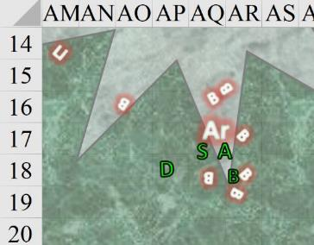

Steelshade and Brene wiped down their blades, and the rogue looked around for anything useful the demons may have dropped.

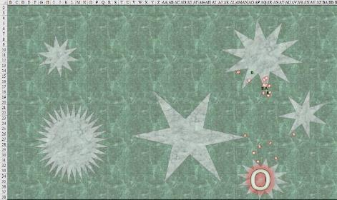

The archivist looked up and pondered what he saw. The panorama was an abhorrent blight upon nature. The druid woman—if she were here—would surely have wretched at the sight of what was before him. Green blood puddled near the bodies that spilled it, and now there began to fall a green rain that answered Devrion’s question at first with a trickle.

*Dmg to each PC: 1 acid.*

|  |  |  |  |  |  |  |  |  |  |  |  |  |  |  |  |
| --- | --- | --- | --- | --- | --- | --- | --- | --- | --- | --- | --- | --- | --- | --- | --- |
| **Character** | **TAC** | **FFAC** | **AC** | **Melee** | **Fire** | **Cold** | **Acid** | **Evil/ Neg** | **Magic/ Force** | **Total Damage** | **Temp** | **Healing** | **HPs** | **Calcul. Total** | **Current HPs** |
| **AtlasPfE** | **15** | **26** | **30** | 19 |  |  | 1 | 5 |  | 25 | 22 |  | 99 | 74 | 96 |
| **DevrionPfE** | **15** | **28** | **32** | 29 |  | 1 | 1 |  |  | 31 | 19 |  | 99 | 68 | 87 |
| **BrenePfE** | **20** | **24** | **32** | 10 | 6 |  | 1 |  | 4 | 21 | 24 |  | 99 | 78 | 102 |
| **AngrenPfE/DE** | **19** | **40** | **44** | 103 |  |  | 2 |  |  | 105 | 26 | 77 | 179 | 151 | 177 |

“How nice,” Steelshade sighed as the acidic rain started. “Gather round,” she said as she found a relatively solid and blood-free place to stand. The others gathered around her, and she extracted her Cube of Force and pressed the #1 face.

Round 105

They weathered the brief storm uneventfully after that, though it lasted about twice as long as Atlas had forecast.

When the rain stopped, Steelshade deactivated the force shield. “Anyone see where the demons are?”

All around them that was not the native foliage was now withering. Acid was evaporating; babau and other demons were crumbling and melting, and the forest was returning to its previous, natural state, though it would take years to grow back its verdant fullness. By morning, there might not be a trace of the demons’ presence, other than the destruction.

Brene stepped over and replaced her missing eighteen arrows from Steelshade’s quiver. “You don’t use them, anyway,” she said with an unrepentant grin.

“That’s because I’m not a sneaky little critter like you.”

“I love you, too,” Brene snarked as she finished loading her quiver.

The demons were by now melting or even evaporating, as their essence was already being drawn back to the Abyss, and there was little the heroes could do about that. The trajectory of the fumes would transcend explanation within the framework of a single planar notion of space, but it would be a lasting time before these demons would coalesce with their destination and once again be used to make more demons.

“Let’s use the carpet,” Steelshade said as she produced it. With the others’ help, she carefully unrolled it without allowing it to touch the ground. Brene climbed aboard first to control it, and then the others followed. They quartered the area, looking for anything useful the demons may have left behind. Once the carpet was underway, Brene extracted her Wand of *Cure Serious Wounds* and healed Steelshade with it.

*Steelshade gained 19 + 6 = 25 hps [179/179]*

They now made sure that the demons were either gone, or dead, having to land a few times and put down some death-defiant demons.

As they flew near the western edge of the forest shattered by Devrion’s Earthquake spell, Steelshade spotted something huge charging in out of the dark. It was another of the bebiliths they’d fought earlier. The duskbade stepped off the carpet, while Devrion took flight. Atlas took over the carpet and lifted it out of the demon’s reach, while Brene prepared her bow.

The ensuing combat lasted less than a minute. Steelshade bore the brunt of the creature’s wrath as it charged her. She stepped aside at the last instant to avoid being run down, and one of the creature’s claws nearly broke her shield arm as it tried to rend her armor away. She slashed at the demon in return. After a flurry of attacks from Steelshade, where she channeled Inflict Serious Wounds and used her higher spell powers to empower her strikes, while Devrion hammered the demon with Magic Missiles, and Brene sniped at it from her perch aboard the carpet, the creature gave one last great heave and collapsed on the broken ground.

~*~

“That about all of them?” Brene asked in the dark.

“I think so,” Atlas replied with a sigh.

They’d flown high and low over just about every part of this patch of goo-covered forest, and had extinguished another handful of demonic beings and tissues, and were now pretty confident that the lot of them were headed back as primeval essence to the Abyss via the Astral Plane. They achieved an altitude of 100’ and discussed what to do now.

“We should find Ginis,” Devrion put in as he closed his eyes for a moment. “She can help restore the forest.”

“That’s a good idea,” Steelshade agreed as she leaned against Devrion’s shoulder.

Atlas steered the carpet back to the forest just northeast of Backbone, where they’d met the druid.

~*~

The night passed, and in the darkness, the crew had veered off course a bit, so by the time they found Backbone and touched down on the ankheg cemetery to its northeast, there was likely an hour left of starlight, after which the eastern horizon would turn violet, then pink, and then orange in announcement of sunrise.

They landed.

All was quiet.

Brene stepped down from the carpet and looked around. “Let me go ahead a little. Druids are usually up with the sun, so maybe she’s still asleep.” Atlas let her move ahead 50’, and then he followed with the carpet.

“She may also not have come all the way back. She could’ve camped out along the way,” someone said as they surveyed the horizon all around them and saw nothing of note.

“All right,” Devrion sighed. “Let’s go find her.”

Everyone stepped off the carpet, and Steelshade rolled it and stored it away.

The group started off, retracing their earlier steps and watching for anything suspicious.

The heroes were mighty, but they were poor trackers at best, and as dawn approached, they admitted that they’d not gotten far. They reached a spot where the snow had been beaten by a small group of deer, and their own tracks had been obfuscated. They successfully found their way back to the humanoid-only tracks, and Brene recognized her own footprints.

“Dammit,” Brene sighed. “We’re going in circles.”

“We need to rest, anyway,” Steelshade said with a sigh of her own. “We have to regain our magic before we can fight again. Let’s find a place to rest.” She looked around for a suitable place to set up their small tent and make a cooking fire.

“I think our druid friend will find us soon enough,” Devrion said as he helped Steelshade set up the campsite.