*Chapter 7: Lork*

A brass dragon munched on buckets of ripened raspberries and stared down. << Atlas… >>

“Yes?”

<< Atlas! >>

<< Yes, >> Atlas now said in Celestial as if waking up from one dream and into another.

<< You have broken Pale Night at the Backbone. Her remaining organs, tissues, and reproductive units have *gated* elsewhere. Purge them and slay her demonic spawns. >>

The dream then ended as abruptly and suddenly as it had begun.

~*~

They slept well into mid-morning, weary as the mighty heroes were, and by this time, they were already surrounded by a ring of lynxes either perching atop a rock, or casually staring and sniffing. One of the lynxes resumed her half-human elven form, and greeted the heroes once they were awake.

“Oh, Ginis!” Brene said loudly enough to rouse Devrion, who was still snoozing as the others got to their feet in anticipation of some conflict. “We’ve been searching for you.”

The mood, however, was calm, and the druid’s face showed gladness to see them, as much as curiosity and concern over what had transpired. “The birds have spoken to me all morning with tales of a great stand against unnatural forms embodying malice.” The druid then realized that she should clarify, “Ah, and I should mention that I don’t usually leave tracks—even in the snow—so trying to find me by tracking would not have worked.”

Brene said, “Yeah, I got that about half-way here, when I realized that it was only our tracks and occasionally those of the lynxes that we were following.”

“So,” the curious druid knew that much hung in the balance of their relative gains against the demonic forces, “Did you finish it?”

Atlas looked up from his seat on a rock, where he’d been feeding one of the lynxes a leftover bit of sausage from breakfast. His prayerbook lay open on his lap, and he closed it with a sigh. “It’s definitely not over, at least for us. Aasterinian told me that we need to pursue the demons to finish them.”

“But, what about the people here? We saw all of those zombies,” Brene said. “Should we just leave and let whatever people may have survived to now fend for themselves?”

“That’s a good question,” Steelshade mused as she turned to the druid. “How many others are here that haven’t been corrupted by the demons?”

“I have heard chirps and squawks that the town of Lork to the west,” the druid referenced a location consistent with where they’d spotted zombies, “was overrun with demons who possessed the townsfolk. All now lie dead there, but I suspect some might have fled into the forest.”

Brene sighed. “We can’t just run off and leave the people to fend for themselves against whatever creatures are left.”

“Sedesty has that ruin chanter in residence now,” Devrion put in. “It probably won’t bother anyone unless they try to approach the town.”

“I agree with Brene,” Atlas said. “We need to make sure that the demons are well and truly gone before we move on.”

Steelshade looked at the druid. “We may as well start with Lork.”

Ginis said some encouraging words as the quartet packed up their stuff, got back on the carpet, and took off for Lork.

~*~

Lork was a grim sight. Men, women and children had been possessed by demons, and upon the Orb’s destruction—Atlas suspected—the demons had either abandoned the bodies or disappeared altogether. The nature of this infestation was still quite murky. They remained on the carpet, hovering at an altitude of 5’ to 15’, and seeing about 40 or 50 bodies overall, which was slightly less than Ginis’ population estimate for this seaside village overlooking a smaller island with nearly zero vegetation. Perhaps there were others inside the dozen or so buildings that made up the center of the settlement.

“They might have left another of those gods-be-damned ruin chanters,” Devrion said darkly. “Let’s be on our guard.”

“Or something worse,” Brene agreed. “Let me off, and I’ll have a look around while you watch my back.” She turned on Devrion. “And I mean my *back*.”

The warmage held up his hands in surrender as Atlas and Steelshade chuckled.

“If you see anything, scoot back outside,” Steelshade reminded the rogue.

The rogue hopped down and moved ahead, with the carpet following fifty feet back and twenty feet above the ground. Everyone was ready to fight.

~*~

Within a few minutes, it was evident that neither demons nor ruin chanters were afoot. The population of the village had been reduced to zero.

A squirrel stirred in the distance, but no other fauna was evident. Even carrion birds were avoiding the partly desiccated corpses.

Albatrosses flew overhead, scouring the eastern coastline for food from low altitudes.

Devrion grimaced as he looked around. “Will anyone ever want to live in these buildings again after this?” He tried to estimate how large the village was, and how wide an area contained most of the corpses. It must have been between 15 and 20 acres, with roughly a dozen buildings in the central 8 or 9 acres, and another dozen interspersed along the peripheries adjacent to the receding forest.

“It would take much of my power to destroy this village, and even then I could only affect the central part of it,” the warmage said. He looked at his companions. “What should we do?”

“We can’t just leave them here like this,” Brene said.

“Let’s see if we can find some survivors,” Steelshade suggested. “It’s their home, not ours.”

Everyone else agreed, so Atlas took the carpet on a course that skirted the edge of the village.

~*~

They returned to center, and shook their heads. Devrion sighed, “Not one fisherman.”

The four stood silently for a moment as Atlas lifted the carpet over the ruined town. Brene sniffed and dabbed at her eyes with a small kerchief. “Even the little ones,” she said after a moment. “If I ever needed a reminder of why we must fight, this is it.”

“Toril is a harsh place in many ways,” Atlas spoke quietly. “The gods war, and we must live with the outcome. Some say that evil has the same right to exist as good. That is a lie. Evil cannot create anything, it only corrupts what has been made. The demons did not create zombies, they only corrupted the good people here to their own ends. We are only four, and we are far from immortal. You all may do as you will, but I intend to see as many demons punished, if not destroyed for this as I can.”

Brene reached for Atlas’ hand, and looked up at her towering lover. “I will be right there with you.”

The elven folk glanced at each other, and then Steelshade held out her hand. Devrion took it with a grim smile. “We will be there, too,” Steelshade said.

The moment soon passed, and everyone took a collective breath.

“Shall we check the rest of the island?” Atlas asked.

“Yes, but stay clear of Sedesty,” Devrion said with a shudder. “One encounter with that ruin chanter was enough.”

Atlas started off northward along the coast, intending to work around the perimeter of the island again, and then go through the center, while remaining clear of Sedesty.

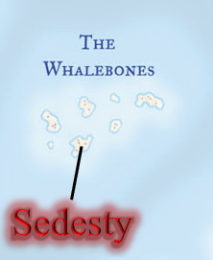

As it had before, the northward path led them to turn sharply westward with he coast’s bend, and soon they were able to see a dozen or so outcroppings of rock that could scarcely be called islands, though a few shrubs and trees had managed to dig their roots into them.

The northern coast was fairly barren, as they remembered it, and it wasn’t long until they were turning back southward towards Backbone, beyond which was a fairly boring stretch to Sedesty Port.

Atlas flew them south to the Backbone, and then he followed the ridgeline westward, taking them to Sedesty Port, which they’d initially hoped to avoid. Atlas skirted the port, and continued inland, while they all looked for any sign of life.

The inland portion of the island—they could now confirm—was almost completely unsettled, and the few structures that they found outside of the handful of settlements that they’d visited were either in disrepair or otherwise abandoned. They’d scoured the island’s coastline, and by the time they’d passed the orb-ravaged area once again and were on the northern shore overlooking the still rising sun, they had a much better sense of the layout of Sedesty Island.

Unlike the previous day, there were not many clouds in the sky, and not a chance of snow. The remaining snow on the ground had already melted about half-way, and the land and vegetation were verdant, save for the annual grasses that had succumbed to the cold weeks ago. By the end of the day, most of the snow would melt.

“That’s it, then,” Atlas sighed. “There’s no one left.”

“What’s next,” Devrion asked.

“Aasterinian says we need to pursue the demons to destroy what’s left of Pale Night,” the archivist replied.

“Why am I not surprised?” Brene asked rhetorically.

“Because you know how this business works by now, I’d expect,” Steelshade said a bit absently. “I think we need to go back to where we first found something of Pale Night, and continue from there.”

Atlas nodded. “I’ll set us down first, and then we can go over there.” He guided to carpet to a spot of open ground, landed it, and allowed Steelshade to put it away. Then, he gathered everyone around, and took them back to where they’d camped near Pale Night’s corpse.

~*~

Back on Krigala, they now stood at the edge of what they considered to be Pale Night’s existence on this plane.

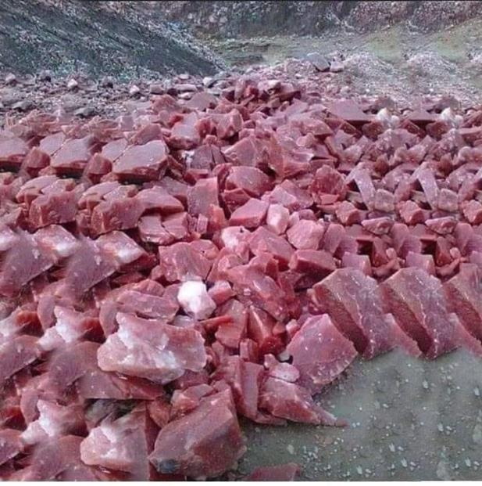

The heroes looked around, spotting no demons in sight, and noting that the fleshen chunks they’d passed days ago were now hardening to stone. This was the back way they’d taken to get into the demon, having emerged from the skull-shaped entrance once their deed was done.

With a single remaining *greater plane shift* spell, Atlas suggested, “We can either retrace our steps or take the carpet to the skull cave and follow our path in reverse.”

“If we’re retracing our steps,” Devrion mused, “then we should visit the unicorns to see if there are more demons here. That would be working back from Sedesty Island.”

Atlas looked at the women, who just shrugged and nodded. “All right, let’s go.”

They mounted up on their carpet and made their way to where they’d last seen the unicorns.

~*~

An hour or so later, they came upon a pair of unicorn sentries whose names they did not remember, and were studied from the ground as their carpet made its way east-northeastwardly towards the hills where they’d last seen the unicorns.

Atlas descended to where he could call to them. “Hello, again. We are searching for demons or their helpers. Have you seen any of them here?”

|  |  |  |  |  |  |  |
| --- | --- | --- | --- | --- | --- | --- |
| **Skill** | **Rank** | **Ability & Mod.** | **Misc. Mods.** | **Total** | **Roll** | **Check** |
| **Atlas, Diplomacy** | 6 | **Cha (+2)** | 0 | 8 | Poor | ?? |

*See below.*

“You are the heroes who brought the jackalweres to us,” one unicorn spoke for both of them. “Why do you continue to seek demons here?”

The heroes could tell that the unicorns were wary of their presence, and quite aware of their prowess, having witnessed it firsthand only days ago.

“We destroyed them in another place,” Brene picked up the narrative, “and we also fought them here after the battle with the unicorns.”

“Yes, we recall your recounting of the events,” the other unicorn said, turning momentarily to his comrade before his muzzle pointed back towards Brene. “We were betrayed by the jackalweres,” he then stated, studying the reactions of the heroes to see if they were genuinely surprised.

Atlas shook his head, while Steelshade and Devrion shared a sigh.

“I speak of a later battle. I’m sorry to hear of the jackalweres,” Brene said. “What happened?”

The two unicorns took a few steps closer, and one of them said, “Come. Dremu will have words with you.”

“We will follow you,” Atlas said.

~*~

They arrived at a whole new encampment, if such it was. At the bank of a dry stream hitherto unknown to the heroes there now rested the dozen or so unicorns that they’d encountered and fought alongside just days ago. Dremu got to his feet, as did Tsuamu, and both approached with concerned looks. Reading the body language—and probably the thoughts—of their fellow unicorns who’d ushered the humanoids here, Dremu greeted them more warmly than they’d expected, and asked, “No doubt Zynphymu and Viriteh here told you that we were double-crossed by the jackalweres only yesterday. Demons seduced them, and allegedly promised them powers beyond their imaginations.”

Tsuamu—less amicable—added, “What do you know of this?”

“Our goddess told us to pursue the demons to their destruction,” Atlas replied evenly. “We have just returned here from Toril after fighting another part of the demon Pale Night. We are still pursuing more parts of her, and so we returned here a short while ago. Your sentries told us of the jackalweres.”

The two unicorn leaders turned to one another with concerned looks, then looking downward before Tsuamu spoke, “Then you truly are as the prophecy foretold: those who will wreak a vacuum in the pantheon of the Demon Lords.”

Dremu nodded, adding, “We are in awe of your position in the development of the cosmic timeline, but we must part ways here, for our part of the Divine Bargain...” then the earth rumbled, and the sky above them darkened into a swirling, green and black cloud that the heroes recognized all too well.

Round 1

The unicorns panicked as they beheld the formation of an avatar of Graz’zt, bearing no likeness to Juiblex. “This ends now!” the Demon Prince pontificated as he manifested an *earthquake spell*.

|  |  |  |  |  |  |  |
| --- | --- | --- | --- | --- | --- | --- |
| **Save vs.**  *earthquake* | **Rank** | **Ability & Mod.** | **Misc. Mods.** | **Total** | **Roll** | **Check** |
| **Atlas, Reflex** | **6** | **Dex (+2)** | 13 | 21 | 2 | 23 |
| **Brene, Reflex** | **11** | **Dex (+6)** | 0 | 17 | 19 | 36 |
| **Devrion, Reflex** | **6** | **Dex (+2)** | 3 | 11 | 17 | 28 |
| **Steelshade, Reflex** | **5** | **Dex (+2)** | 3 | 10 | 15 | 25 |

*Success4.*

|  |  |  |  |  |
| --- | --- | --- | --- | --- |
| **Character** | **Save vs.**  *earthquake* | **Ranks** | **Roll** | **Check** |
| Unicorn, elite | Reflex | 12 | 3 | 15 |
| Unicorn, mid-level | Reflex | 10 | 15 | 25 |
| Unicorn | Reflex | 7 | 10 | 17 |
| Unicorn, elite | Reflex | 12 | 20 | 32 |
| Unicorn, elite | Will | 15 | 5 | 20 |
| Unicorn, mid-level | Fortitude | 12 | 6 | 18 |
| Unicorn, mid-level | Reflex | 10 | 13 | 23 |
| Unicorn, mid-level | Will | 11 | 13 | 24 |
| Unicorn | Fortitude | 9 | 3 | 12 |
| Unicorn | Reflex | 7 | 4 | 11 |
| Unicorn, elite | Reflex | 12 | 20 | 32 |

*Success10, fail2. 2 unicorns fell prone.*

*1d100…*

*Atlas: 88.*

*Brene: 72.*

*Devrion: 47.*

*Steelshade: 73.*

*Unicorns 1 – 3: 86.*

*Unicorns 4 – 7: 44.*

*Unicorns 8 – 11: 91.*

*No character fell into the fissures.*

Quasits, uridezu, dretches, and babau rained down from the sky falling just to the south and southeast of the heroes, making their way to the edge of the shaking ground, knowing their master’s plans and how best to execute them.

Atlas murmured a prayer and touched Steelshade, casting *protection from evil [expired on Round 181]*. He then stepped down from the carpet and called to the unicorns: “RUN!”

*Steelshade gained +2 to AC and Saves vs. Fear (and other protections) against Evil creatures.*

Devrion stepped off the carpet and pointed at a spot in the middle of the demon horde. “Halálkör!” *[circle of death]*

*18d4 = 46 HD.*

|  |  |  |  |  |
| --- | --- | --- | --- | --- |
| **Character** | **Save vs.**  *circle of death* | **Ranks** | **Roll** | **Check** |
| Uridezu [7 HD] | Fortitude | 6 | 3 | 9 |
| Uridezu [7 HD] | Fortitude | 6 | 15 | 21 |
| Dire Quasit [5 HD] | Fortitude | 11 | 14 | 25 |
| Dire Quasit [5 HD] | Fortitude | 11 | 8 | 19 |
| Dire Quasit [5 HD] | Fortitude | 11 | 18 | 29 |
| Dretch [2 HD] | Fortitude | 12 | 3 | 15 |
| Dretch [2 HD] | Fortitude | 12 | 13 | 25 |
| Babau [7 HD] | Fortitude | 10 | 3 | 13 |
| Babau [7 HD]* | Fortitude | 10 | * | * |

*Fail, success, success, fail, success, fail, success, fail, irrelevant (too many HD).*

*1 uridezu, 1 dire quasit, 1 dretch, and 1 babau died, and began to wither and flake away.*

Steelshade stepped off the carpet and cast *dragonskin* on herself. She moved forward to help cover the spellcasters.

Brene moved the carpet back in preparation to circle whichever enemy seemed the most dangerous.

One of the quasits blurted out, << Kill! >> and the minions of Graz’zt lunged towards Steelshade and her friends. Some of the babau began to manifest their *blacklight* effects around them.

The unicorns began casting spells, and spread out a bit in anticipation of magical attacks.

Dremu cast *daylight [expired over 1 hour from now]* upon his horn, illuminating the area around him as the babau brought their magical darkness with them.

Karfmu cast *barkskin [expired over 1 hour from now]* upon herself.

*Karfmu gained +3 to FFAC and AC.*

Tsuamu cast *snake darts*, targeting a dire quasit just south of him.

*Dmg: 7.*

|  |  |  |  |  |
| --- | --- | --- | --- | --- |
| **Character** | **Save vs.**  *snake darts* | **Ranks** | **Roll** | **Check** |
| Dire Quasit | Fortitude | 11 | 11 | 22 |
| Dire Quasit | Fortitude | 11 | 1 | 12 |

*Success, fail. Constitution damage negated once. Dmg: 6 Con.*

The snakes pierced through the dire quasit, one of them poisoning him just enough to bring her to her knees and make her wretch and writhe. The quasit was done for.

Shrikteh got into the frontline, and aimed at Graz’zt, casting *searing light*.

|  |  |  |  |  |  |  |  |
| --- | --- | --- | --- | --- | --- | --- | --- |
| **Character** | **Attack Type** | **Damage** | **BAB** | **Dex Mod+** | **Total Score** | **Roll** | **Total** |
| Shrikteh | Ranged Touch | Searing Light 3d8 | 9 | 4 | 13 | 11 | 24 |

*Hit.*

|  |  |  |  |  |
| --- | --- | --- | --- | --- |
| **Character** | **Check** | **Ranks** | **Roll** | **Check** |
| Unicorn | Bypass SR | 10 | 19 | 29 |

*Bypass SR. Dmg: 17 positive energy.*

Viriteh cast *sanctuary [expired on Round 7]* upon herself, anticipating having to heal others on what was now a battlefield.

Shamu ventured southward a bit, and prepared to enter a fit of rage.

Birimu cast *call lightning*, and hurled a bolt towards one of the dretches.

|  |  |  |  |  |  |  |  |
| --- | --- | --- | --- | --- | --- | --- | --- |
| **Character** | **Attack Type** | **Damage** | **BAB** | **Dex Mod+** | **Total Score** | **Roll** | **Total** |
| Birimu | Call Lightning | 4d6 electric | 8 | 4 | 12 | 19 | 31 |

*Hit. Dmg: 19 electric.*

A dretch sizzled and kicked up as it died.

Pertenteh and Qusamteh drew their bows, and fired upon another dretch just south of them.

|  |  |  |  |  |  |  |  |  |
| --- | --- | --- | --- | --- | --- | --- | --- | --- |
| **Character** | **Attack Type** | **Damage** | **BAB** | **Dex Mod+** | **W+** | **Total Score** | **Roll** | **Total** |
| Pertenteh | Longbow +2 | 1d8+2 | 7 | 5 | 2 | 14 | 5 | 19 |
| Qusamteh | Longbow +2 | 1d8+2 | 6 | 5 | 2 | 13 | 13 | 26 |

*Hit, hit. Dmg: (2 + 2) + (8 + 2) = 4 + 10 = 14.*

And with this, yet another dretch went down.

Kadabteh and Zynphymu were knocked prone, and could do nothing right now.

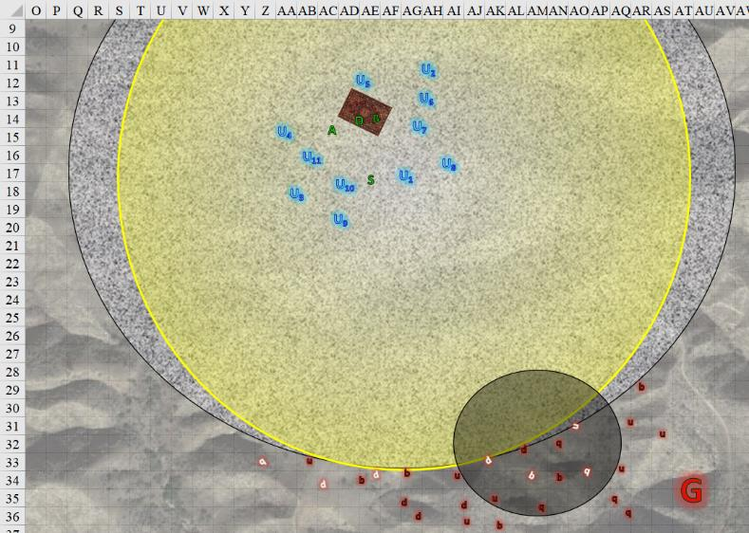

Round 2

Two unicorns got up from their prone position, as the rest cast more spells and did their best to not turn tail and scamper off before Graz’zt.

Kadabteh targeted Graz’zt with a *Melf’s acid arrow* spell.

|  |  |  |  |  |  |  |  |
| --- | --- | --- | --- | --- | --- | --- | --- |
| **Character** | **Attack Type** | **Damage** | **BAB** | **Dex Mod+** | **Total Score** | **Roll** | **Total** |
| Kadabteh | Ranged Touch | Melf’s Acid Arrow 2d4 | 7 | 4 | 11 | 11 | 22 |

*Hit. Dmg: 4 + 2 + 3 = 9 acid over the next 3 rounds. Damage negated.*

The sorcerer was taken aback at how ineffective the spell was against the demon boss.

Zynphymu cast *haste [expired on Round 9]* on the heroes.

*Atlas, Steelshade, and Devrion gained +1 to BAB, TAC, and Reflex Save, plus extra move or attack.*

Atlas *[hastened]* moved to Devrion’s side and cast *protection from evil* *[expired on Round 182]* on him. The archivist then moved toward Brene and prepared to repeat the prayer for her, placing one foot atop the carpet.

*Devrion gained +2 to AC and Saves vs. Fear (and other protections) against Evil creatures.*

Devrion *[hastened]* pointed at Graz’zt. “Lánc villám!” *[chain lightning]*

|  |  |  |  |  |
| --- | --- | --- | --- | --- |
| **Character** | **Save vs.**  *chain lightning* | **Ranks** | **Roll** | **Check** |
| Graz’zt | Reflex | 21 | 5 | 26 |

*Success. Saves for ½ damage. Dmg: ½ x 51 = 25 electric. Damage negated.*

The bolt arced and zapped every other demon in sight.

|  |  |  |  |  |
| --- | --- | --- | --- | --- |
| **Character** | **Save vs.**  *chain lightning* | **Ranks** | **Roll** | **Check** |
| Uridezu | Fortitude | 6 | 7 | 13 |
| Uridezu | Reflex | 8 | 3 | 11 |
| Uridezu | Reflex | 8 | 1 | 9 |
| Uridezu | Reflex | 8 | 8 | 16 |
| Uridezu | Reflex | 8 | 19 | 27 |
| Uridezu | Reflex | 8 | 9 | 17 |
| Uridezu | Reflex | 8 | 16 | 24 |
| Uridezu | Reflex | 8 | 11 | 19 |
| Babau | Reflex | 6 | 8 | 14 |
| Babau | Reflex | 6 | 17 | 23 |
| Babau | Reflex | 6 | 18 | 24 |
| Babau | Reflex | 6 | 3 | 9 |
| Babau | Reflex | 6 | 10 | 16 |
| Dretch | Reflex | 6 | 12 | 18 |
| Dretch | Reflex | 6 | 3 | 9 |
| Dretch | Reflex | 6 | 11 | 17 |
| Dretch | Reflex | 6 | 7 | 13 |
| Dire Quasit | Reflex | 14 | 11 | 25 |
| Dire Quasit | Reflex | 14 | 2 | 16 |
| Dire Quasit | Reflex | 14 | 6 | 20 |
| Dire Quasit | Reflex | 14 | 7 | 21 |

*Uridezu: Fail, fail, fail, fail, success, fail, success, fail.*

*Babau: Fail, success, success, fail, fail. Damage negated.*

*Dretch: fail, fail, fail, fail.*

*Dire quasit: success, fail, fail, success. Partial damage negated.*

*Base damage: ½ x 51 = 25 electric.*

*Damage after save: ½ x ½ x 51 = 12 electric.*

All the dretches died instantly, but the hardier demons pushed on through.

Steelshade *[hastened]* struck hard while she had the chance. She quick-cast *dimension door*, cast *swift fly*, and reappeared directly behind Graz’zt. She channeled keen edge through Arkenlyl, and empowered her strikes (+4) as she full-attacked the demon’s avatar.

|  |  |  |  |  |  |  |  |  |  |  |  |
| --- | --- | --- | --- | --- | --- | --- | --- | --- | --- | --- | --- |
| **Melee Weapon** | **Dmg** | **D+** | **TH+** | **Crit** | **x** | **Type** | **Wt.** | **Atk** | **Roll** | **Check** | **Properties** |
| Shattermantle Bloodstone  Falchion +3 | 2d4 | +7 +3  +3d4 AS | 3 + 4 | 18 | 2 | Slashing | 8.0 | +31 | 17 | 48 |  |
| SB Falchion +3,  2nd Attack | 2d4 | +7 +3  +3d4 AS | 3 + 4 | 18 | 2 | Slashing | - | +26 | 12 | 38 |  |
| SB Falchion +3,  3rd Attack | 2d4 | +7 +3  +3d4 AS | 3 + 4 | 18 | 2 | Slashing | - | +21 | 2 | 23 |  |
| SB Falchion +3,  4th Attack | 2d4 | +7 +3  +3d4 AS | 3 + 4 | 18 | 2 | Slashing | - | +26 | 13 | 29 |  |
| SB Falchion +3,  *haste* | 2d4 | +7 +3  +3d4 AS | 3 + 4 | 18 | 2 | Slashing | - | +31 | 16 | 47 |  |

*Hit, hit, miss, miss, hit. Dmg: (8 + 7 + 3) + (5 + 7 + 3) + (7 + 7 + 3) = 18 + 15 + 17 = 50 - 4 SR.*

Brene started to move, and then she saw Atlas hustling toward her. She waited for the archivist to reach her.

With his horn negating any darkness that would come from the babauk, Dremu walked southward and cast *sound burst* upon an area with three demons in it.

|  |  |  |  |  |
| --- | --- | --- | --- | --- |
| **Character** | **Save vs.**  *sound burst* | **Ranks** | **Roll** | **Check** |
| Uridezu | Fortitude | 6 | 10 | 16 |
| Uridezu | Fortitude | 6 | 18 | 24 |
| Babau | Fortitude | 10 | 6 | 16 |

*Fail, success, fail.*

*Dmg to each: 4 sonic + babau and 1 uridezu are stunned.*

Seeing that lightning did nothing to the babau, Karfmu cast *call lightning* and shot a bolt at one of the rat-like uridezu.

|  |  |  |  |  |  |  |  |
| --- | --- | --- | --- | --- | --- | --- | --- |
| **Character** | **Attack Type** | **Damage** | **BAB** | **Dex Mod+** | **Total Score** | **Roll** | **Total** |
| Karfmu | Call Lightning | 4d6 electric | 10 | 4 | 14 | 6 | 20 |

*Hit. Dmg: 11 electric.*

That nearly downed the uridezu, but not quite.

Tsuamu cast *fireball* upon an area containing Graz’zt and other demons.

|  |  |  |  |  |
| --- | --- | --- | --- | --- |
| **Character** | **Save vs.**  *Fireball* | **Ranks** | **Roll** | **Check** |
| Graz’zt | Reflex | 21 | 12 | 33 |
| Uridezu | Reflex | 8 | 11 | 19 |
| Uridezu | Reflex | 8 | 12 | 20 |
| Uridezu | Reflex | 8 | 9 | 17 |
| Dire Quasit | Reflex | 14 | 14 | 28 |
| Dire Quasit | Reflex | 14 | 7 | 21 |
| Dire Quasit | Reflex | 14 | 18 | 32 |
| Babau | Reflex | 6 | 5 | 11 |
| Babau | Reflex | 6 | 14 | 20 |
| Babau | Reflex | 6 | 2 | 8 |

*Success, success, success, fail, success, success, success, fail, success, fail.*

*Base damage: 34 fire.*

*Damage after save: ½ x 34 = 17 fire.*

*Some damage partially or entirely negated.*

|  |  |  |  |  |
| --- | --- | --- | --- | --- |
| **Character** | **Check** | **Ranks** | **Roll** | **Check** |
| Unicorn | Bypass SR | 10 | 15 | 25 |

*Graz’zt damage negated.*

Shrikteh cast *searing light* once again upon Graz’zt.

|  |  |  |  |  |  |  |  |
| --- | --- | --- | --- | --- | --- | --- | --- |
| **Character** | **Attack Type** | **Damage** | **BAB** | **Dex Mod+** | **Total Score** | **Roll** | **Total** |
| Shrikteh | Ranged Touch | Searing Light 3d8 | 9 | 4 | 13 | 18 | 31 |

*Hit.*

|  |  |  |  |  |
| --- | --- | --- | --- | --- |
| **Character** | **Check** | **Ranks** | **Roll** | **Check** |
| Unicorn | Bypass SR | 10 | 2 | 12 |

*Fail to bypass SR.*

The demon lord shrugged off of the magic.

Viriteh cast *shield of faith [expired over an hour from now]*, and moved southward to join Dremu in combat as she poised her horn forward.

Shamu entered a rage and charged southward into battle.

Birimu targeted an uridezu with a lightning bolt.

|  |  |  |  |  |  |  |  |
| --- | --- | --- | --- | --- | --- | --- | --- |
| **Character** | **Attack Type** | **Damage** | **BAB** | **Dex Mod+** | **Total Score** | **Roll** | **Total** |
| Birimu | Call Lightning | 4d6 electric | 8 | 4 | 12 | 12 | 24 |

*Hit. Dmg: 16 electric.*

The uridezu died.

Pertenteh and Qusamteh galloped south and fired upon the uridezu to their immediate south.

|  |  |  |  |  |  |  |  |  |  |
| --- | --- | --- | --- | --- | --- | --- | --- | --- | --- |
| **Character** | **Attack Type** | **Damage** | **BAB** | **Dex Mod+** | **W+** | **Total Score** | **Roll** | **Total** | **Threat** |
| Pertenteh | Longbow +2 | 1d8+2 | 7 | 5 | 2 | 14 | 11 | 25 | ý |
| Qusamteh | Longbow +2 | 1d8+2 | 6 | 5 | 2 | 13 | ***20*** | 33 | þ |

*Hit, threat. 1d20 = 20, critical hit. Dmg: (8 + 2) + [(2 x 5) + 2] = 10 + 12 = 22.*

That uridezu died as well.

Two babau charge-attacked Dremu.

|  |  |  |  |  |  |  |  |  |
| --- | --- | --- | --- | --- | --- | --- | --- | --- |
| **Character** | **Attack Type** | **Damage** | **BAB** | **Str Mod+** | **Other+** | **Total Score** | **Roll** | **Total** |
| Babau | Claw | 1d6+5+2d6 acid | 7 | 5 | 2 charge | 14 | 6 | 20 |
| Babau | Claw | 1d6+5+2d6 acid | 7 | 5 | 2 charge | 14 | 12 | 26 |

*Miss, hit. Dmg: 2 + 5 + 8 acid = 15.*

Two dire quasits took to the skies, seeking worthy marks.

A quasit and an uridezu charge-attacked Dremu.

|  |  |  |  |  |  |  |  |  |  |
| --- | --- | --- | --- | --- | --- | --- | --- | --- | --- |
| **Character** | **Attack Type** | **Damage** | **BAB** | **Str Mod+** | **Dex Mod+** | **Other+** | **Total Score** | **Roll** | **Total** |
| Uridezu | Claw | 1d4+1 | 7 | 1 | 3 | 2 charge | 10 | 5 | 15 |
| Dire Quasit | Claw | 1d3+poison | 4 | 0 | 5 | 2 charge | 11 | 1 | 12 |

*Miss, miss.*

Two other babau charge-attacked Shamu and Qusamteh.

|  |  |  |  |  |  |  |  |  |
| --- | --- | --- | --- | --- | --- | --- | --- | --- |
| **Character** | **Attack Type** | **Damage** | **BAB** | **Str Mod+** | **Other+** | **Total Score** | **Roll** | **Total** |
| Babau | Claw | 1d6+5+2d6 acid | 7 | 5 | 2 charge | 14 | 4 | 18 |
| Babau | Claw | 1d6+5+2d6 acid | 7 | 5 | 2 charge | 14 | 9 | 23 |

*Hit, hit.*

*Dmg to Shamu: 3 + 5 + 7 acid = 15.*

*Dmg to Qusamteh: 6 + 5 + 7 acid = 18.*

Graz’zt turned around and beheld Steelshade. *[Fear, expired on Round 19.]*

|  |  |  |  |  |  |  |
| --- | --- | --- | --- | --- | --- | --- |
| **Save vs.**  Fear | **Rank** | **Ability & Mod.** | **Misc. Mods.** | **Total** | **Roll** | **Check** |
| **Steelshade, Will** | 10 | **Wis (+2)** | 3 | 15 | 10 | 25 |

*Fail. Steelshade panicked, incurring –2 to all Saves and Checks.*

Steelshade dropped her scimitar and fled southeastwardly at top speed (5’ for now) but not before he could cast *unholy blight* upon her.

|  |  |  |  |  |  |  |  |
| --- | --- | --- | --- | --- | --- | --- | --- |
| **Save vs.**  *unholy blight* | **Rank** | **Ability & Mod.** | **Misc. Mods.** | **Total** | **Roll** | **Check** | **Properties** |
| **Steelshade, Will** | 10 | **Wis (+2)** | 3 | 15 | 4 | 19 | +2 vs. all spells |

*Fail. Dmg: ½ (Neutral) x 26 = 13 evil.*

He held his acidic sword firmly as he witnessed the duskblade running away in terror, then contemplated which of the others to pick on next.

*Arrows indicate movement out of an area of effect after the effect took place.*

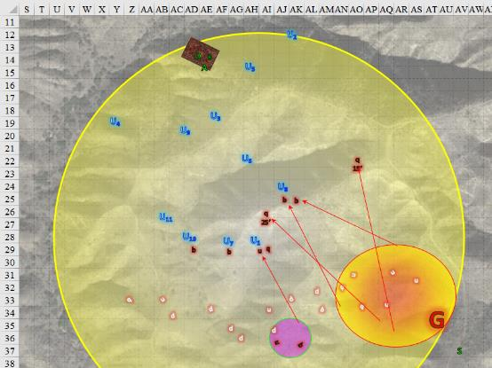

Round 3

Steelshade continued to run towards the southeast, not even looking back.

Atlas cast protection from evil on Brene, and then he turned to face the demon lord.

*Brene gained +2 to AC and Saves vs. Fear (and other protections) against Evil creatures.*

Brene accepted the prayer, and then she moved southwest with the carpet, and fired on the demon lord with her shortbow.

|  |  |  |  |  |  |  |  |  |  |  |
| --- | --- | --- | --- | --- | --- | --- | --- | --- | --- | --- |
| **Ranged Weapon** | **Dmg.** | **D+** | **TH+** | **Critical** | **Rng.** | **Wt.** | **Atk** | **Roll** | **Check** | **Properties** |
| Shortbow +2 | 1d4 | 2 | 2 – 6 range | x3 | 60’ | 2.0 | +17 | *1* | 18 | Sneak Attack 9d6 |

*Miss.*

Devrion bristled as he saw Angren turn and run. He targeted the demon lord, and boosted his next spell, both enlarging and empowering it. “Halál ujja!” *[finger of death, Sudden Enlarged (+0 SL), Sudden Empowered (+0 SL)]*

*Enlarge boost doesn’t change the spell’s properties.*

|  |  |  |  |  |
| --- | --- | --- | --- | --- |
| **Character** | **Save vs.** | **Ranks** | **Roll** | **Check** |
| Graz’zt | Fortitude | 24 | 18 | 42 |

*Success. Dmg: 14 + 18 = 32 magic.*

Strangely, the closest babau also fell where it stood, just south of the unicorn barbarian.

Dremu took a 5’ step and cast *divine storm [duration based on concentration]*.

|  |  |  |  |  |
| --- | --- | --- | --- | --- |
| **Character** | **Check** | **Ranks** | **Roll** | **Check** |
| Dremu | Concentration | 12 | 16 | 28 |

*Spell successfully cast.*

A whirling blade of edged weapons slashed at the demon prince.

|  |  |  |  |  |
| --- | --- | --- | --- | --- |
| **Character** | **Save vs.**  *divine storm* | **Ranks** | **Roll** | **Check** |
| Graz’zt | Reflex | 21 | 4 | 25 |

*Success. No damage on this round.*

Karfmu moved just under one of the flying quasits, and hurled a lightning bolt at him.

|  |  |  |  |  |  |  |  |
| --- | --- | --- | --- | --- | --- | --- | --- |
| **Character** | **Attack Type** | **Damage** | **BAB** | **Dex Mod+** | **Total Score** | **Roll** | **Total** |
| Karfmu | Call Lightning | 4d6 electric | 10 | 4 | 14 | 8 | 22 |

*Hit. Dmg: 18 electric.*

This upset the dire quasit very much, and the latter veered down to take revenge for that potshot.

|  |  |  |  |  |  |  |  |  |  |
| --- | --- | --- | --- | --- | --- | --- | --- | --- | --- |
| **Character** | **Attack Type** | **Damage** | **BAB** | **Dex Mod+** | **Other+** | **Total Score** | **Roll** | **Total** | **Notes** |
| Dire Quasit | Claw | 1d3+poison | 4 | 5 | 2 height | 11 | 2 | 13 | Fort DC 13 |

*Miss.*

Tsuamu aimed high up in the air where the other flying quasit was, and cast *fireball*, seeing now that Graz’zt was highly resistant to such damage.

|  |  |  |  |  |
| --- | --- | --- | --- | --- |
| **Character** | **Save vs.**  *fireball* | **Ranks** | **Roll** | **Check** |
| Dire Quasit | Reflex | 14 | 8 | 22 |

*Success. Saves for ½ damage.*

*Dmg: ½ x 26 = 13 fire. Damage negated.*

The unicorn realized that the quasit was nearly as invulnerable to fire as its master.

Zynphymu cast *invisibility*, then crept southeastward towards the remaining minions.

Being furthest from the action, Shrikteh was out of *searing light* spells, and thus she galloped southward to reinforce the frontlines.

The herd’s other cleric, Viriteh, joined Birimu in melee, casting *holy storm*.

*Dmg to 2 babaus: 8 good (each).*

Shamu full-attacked the adjacent babau.

|  |  |  |  |  |  |  |  |
| --- | --- | --- | --- | --- | --- | --- | --- |
| **Character** | **Attack Type** | **Damage** | **BAB** | **Str Mod+** | **Total Score** | **Roll** | **Total** |
| Shamu | Horn | 1d8+11 | 6 | 9 | 15 | 19 | 34 |
| Shamu | Horn | 1d8+11 | 1 | 9 | 10 | 3 | 13 |

*Hit, miss. Dmg: 8 + 11 = 19.*

That killed the babau.

Birimu hurled a bolt of lightning at the quasit above them.

|  |  |  |  |  |  |  |  |
| --- | --- | --- | --- | --- | --- | --- | --- |
| **Character** | **Attack Type** | **Damage** | **BAB** | **Dex Mod+** | **Total Score** | **Roll** | **Total** |
| Birimu | Call Lightning | 4d6 electric | 8 | 4 | 12 | 18 | 30 |

*Hit. Dmg: 16 electric.*

Birimu could tell that quasit was nearly done for, but it stayed aloft for now.

Pertenteh and Qusamteh , too, noticed the nearly dead quasit overhead, and used their telekinetic arms to launch arrows at it.

|  |  |  |  |  |  |  |  |  |
| --- | --- | --- | --- | --- | --- | --- | --- | --- |
| **Character** | **Attack Type** | **Damage** | **BAB** | **Dex Mod+** | **W+** | **Total Score** | **Roll** | **Total** |
| Pertenteh | Longbow +2 | 1d8+2 | 7 | 5 | 2 | 14 | 11 | 25 |
| Pertenteh | Longbow +2 | 1d8+2 | 2 | 5 | 2 | 9 | 6 | 15 |
| Qusamteh | Longbow +2 | 1d8+2 | 6 | 5 | 2 | 13 | 8 | 21 |
| Qusamteh | Longbow +2 | 1d8+2 | 2 | 5 | 2 | 9 | 14 | 23 |

*Hit, miss, miss, miss. Dmg: 4 + 2 = 6.*

And yes, that single hit brought down the quasit.

Kadabteh hadn’t tried an *acid arrow* on a quasit yet, so she targeted the one still flying around.

|  |  |  |  |  |  |  |  |
| --- | --- | --- | --- | --- | --- | --- | --- |
| **Character** | **Attack Type** | **Damage** | **BAB** | **Dex Mod+** | **Total Score** | **Roll** | **Total** |
| Kadabteh | Ranged Touch | Melf’s Acid Arrow 2d4 | 7 | 4 | 11 | 9 | 20 |

*Hit. Dmg: 5 + 6 + 5 = 16 acid over the next 3 rounds.*

The two demons that had been caught in the *sound burst* started to come out of their stunned stupor, and made their way towards Shrikteh, attacking her.

|  |  |  |  |  |  |  |  |
| --- | --- | --- | --- | --- | --- | --- | --- |
| **Character** | **Attack Type** | **Damage** | **BAB** | **Str Mod+** | **Total Score** | **Roll** | **Total** |
| Uridezu | Claw | 1d4+1 | 7 | 1 | 8 | 13 | 21 |
| Babau | Claw | 1d6+5+2d6 acid | 7 | 5 | 12 | 12 | 24 |

*Hit, hit. Dmg: (2 + 1) + (6 + 5 + 5 acid) = 14 + 5 acid = 19.*

A quasit and an uridezu clawed at Dremu.

|  |  |  |  |  |  |  |  |  |
| --- | --- | --- | --- | --- | --- | --- | --- | --- |
| **Character** | **Attack Type** | **Damage** | **BAB** | **Str Mod+** | **Total Score** | **Roll** | **Total** | **Notes** |
| Uridezu | Claw | 1d4+1 | 7 | 1 | 8 | 3 | 11 |  |
| Dire Quasit | Claw | 1d3+poison | 4 | 0 | 9 | 3 | 12 | Fort DC 13 |

*Miss, miss.*

Graz’zt flew up and out of the *divine storm* of blades, reaching an altitude of about 40’, and got dreadfully close to Brene and Devrion.

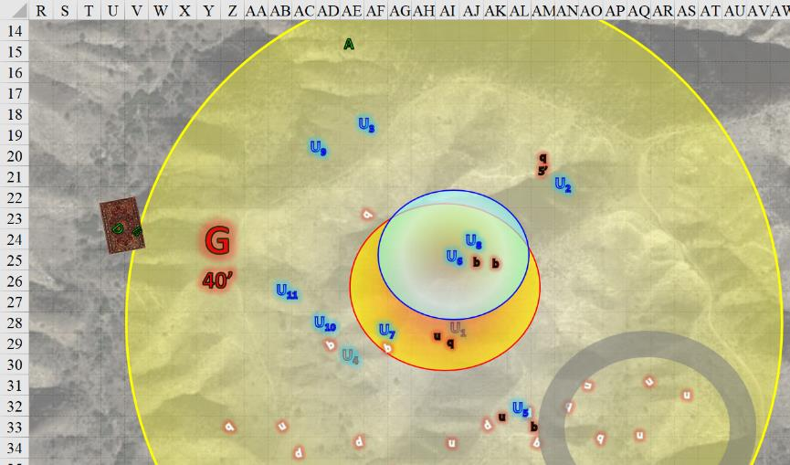

Round 4

Dremu cast *holy storm* upon the quasit and babau before him.

*Dmg to demons: 5 + 7 = 12 good (each).*

The babau died.

Karfmu unleashed another lightning bolt at the landborne quasit.

|  |  |  |  |  |  |  |  |
| --- | --- | --- | --- | --- | --- | --- | --- |
| **Character** | **Attack Type** | **Damage** | **BAB** | **Dex Mod+** | **Total Score** | **Roll** | **Total** |
| Karfmu | Call Lightning | 4d6 electric | 10 | 4 | 14 | 7 | 21 |

*Hit. Dmg: 17 electric.*

That almost killed the dire quasit.

Tsuamu was fending against the flying quasit now, and cast *ice blast* upon it.

|  |  |  |  |  |
| --- | --- | --- | --- | --- |
| **Character** | **Save vs.**  *ice blast* | **Ranks** | **Roll** | **Check** |
| Dire Quasit | Fortitude | 11 | 11 | 22 |

*Success. Effect negated.*

*Invisible*, Zynphymu charge-attacked the uridezu next to Dremu.

|  |  |  |  |  |  |  |  |  |
| --- | --- | --- | --- | --- | --- | --- | --- | --- |
| **Character** | **Attack Type** | **Damage** | **BAB** | **Str Mod+** | **Other+** | **Total Score** | **Roll** | **Total** |
| Zynphymu | Horn | 1d8+8 | 13 | 9 | 2 charge | 24 | 3 | 27 |

*Hit. Dmg: 5 + 8 + 2 charge = 15.*

Shrikteh and Viriteh attacked an uridezu and a babau, respectively.

|  |  |  |  |  |  |  |  |
| --- | --- | --- | --- | --- | --- | --- | --- |
| **Character** | **Attack Type** | **Damage** | **BAB** | **Str Mod+** | **Total Score** | **Roll** | **Total** |
| Shrikteh | Horn | 1d8+8 | 9 | 7 | 16 | 15 | 31 |
| Viriteh | Horn | 1d8+8 | 9 | 7 | 16 | 11 | 27 |

*Hit, hit.*

*Dmg to uridezu: 6 + 8 = 14.*

*Dmg to babau: 2 + 8 = 10.*

The uridezu died.

Having killed a babau moments ago, Shamu charge-attacked another one.

|  |  |  |  |  |  |  |  |  |
| --- | --- | --- | --- | --- | --- | --- | --- | --- |
| **Character** | **Attack Type** | **Damage** | **BAB** | **Str Mod+** | **Other+** | **Total Score** | **Roll** | **Total** |
| Shamu | Horn | 1d8+11 | 6 | 9 | 2 charge | 17 | 5 | 22 |

*Hit. Dmg: 4 + 11 = 15.*

Birimu hurled another bolt of lightning at the quasit threatening her.

|  |  |  |  |  |  |  |  |
| --- | --- | --- | --- | --- | --- | --- | --- |
| **Character** | **Attack Type** | **Damage** | **BAB** | **Dex Mod+** | **Total Score** | **Roll** | **Total** |
| Birimu | Call Lightning | 4d6 electric | 8 | 4 | 12 | 11 | 23 |

*Hit. Dmg: 13 electric.*

The quasit died.

Pertenteh and Qusamteh unleashed arrows upon the remaining uridezu with their magical, telekinetic arms.

|  |  |  |  |  |  |  |  |  |
| --- | --- | --- | --- | --- | --- | --- | --- | --- |
| **Character** | **Attack Type** | **Damage** | **BAB** | **Dex Mod+** | **W+** | **Total Score** | **Roll** | **Total** |
| Pertenteh | Longbow +2 | 1d8+2 | 7 | 5 | 2 | 14 | 10 | 24 |
| Pertenteh | Longbow +2 | 1d8+2 | 2 | 5 | 2 | 9 | 5 | 14 |
| Qusamteh | Longbow +2 | 1d8+2 | 6 | 5 | 2 | 13 | 6 | 19 |
| Qusamteh | Longbow +2 | 1d8+2 | 1 | 5 | 2 | 8 | 8 | 16 |

*Hit, miss, hit, miss. Dmg: (1 + 2) + (4 + 2) = 3 + 6 = 9.*

The uridezu remained a threat, albeit with two arrows sticking out of its side.

Kadabteh got into a better position and released her third *Melf’s acid arrow* upon that remaining uridezu.

|  |  |  |  |  |  |  |  |
| --- | --- | --- | --- | --- | --- | --- | --- |
| **Character** | **Attack Type** | **Damage** | **BAB** | **Dex Mod+** | **Total Score** | **Roll** | **Total** |
| Kadabteh | Ranged Touch | Melf’s Acid Arrow 2d4 | 7 | 4 | 11 | 14 | 25 |

*Hit. Dmg: 6 + 5 + 5 = 16 acid over the next 3 rounds.*

Though badly injured, the uridezu remained on its hind legs.

The demons attacked their assailants.

|  |  |  |  |  |  |  |  |  |
| --- | --- | --- | --- | --- | --- | --- | --- | --- |
| **Character** | **Attack Type** | **Damage** | **BAB** | **Str Mod+** | **Dex Mod+** | **Total Score** | **Roll** | **Total** |
| Uridezu | Claw 1 | 1d4+1 | 7 | 1 | 3 | 8 | ***20*** | 28 |
| Uridezu | Claw 2 | 1d4+1 | 7 | 1 | 3 | 8 | 10 | 18 |
| Uridezu | Bite | 1d6 | 5 | 1 | 3 | 6 | 18 | 24 |
| Uridezu | Tail Slap | 1d2+1 | 7 | 1 | 3 | 10 | 5 | 15 |
| Dire Quasit | Claw 1 | 1d3+poison | 4 | 0 | 5 | 9 | 14 | 23 |
| Dire Quasit | Claw 2 | 1d3+poison | 4 | 0 | 5 | 9 | 13 | 22 |
| Dire Quasit | Bite | 1d4 | 4 | 0 | 5 | 9 | 17 | 26 |
| Babau | Claw 1 | 1d6+5+2d6 acid | 7 | 5 | 1 | 12 | 10 | 22 |
| Babau | Claw 2 | 1d6+5+2d6 acid | 7 | 5 | 1 | 12 | 4 | 16 |
| Babau | Bite | 1d6+2+2d6 acid | 7 | 0 | 1 | 7 | 13 | 20 |
| Babau | Claw 1 | 1d6+5+2d6 acid | 7 | 5 | 1 | 12 | 14 | 26 |
| Babau | Claw 2 | 1d6+5+2d6 acid | 7 | 5 | 1 | 12 | 13 | 25 |
| Babau | Bite | 1d6+2+2d6 acid | 7 | 0 | 1 | 7 | 19 | 26 |
| Babau | Claw 1 | 1d6+5+2d6 acid | 7 | 5 | 1 | 12 | 15 | 27 |
| Babau | Claw 2 | 1d6+5+2d6 acid | 7 | 5 | 1 | 12 | 18 | 30 |
| Babau | Bite | 1d6+2+2d6 acid | 7 | 0 | 1 | 7 | 12 | 19 |

*Targeting Dremu: Threat, miss, hit, miss, miss, miss, hit. 1d20 = 4 + 8 = 12, not a critical hit.*

*Targeting Viriteh: hit, miss, miss.*

*Targeting Birimu: hit, hit, hit.*

*Targeting Shrikteh: hit, hit, hit.*

*Dmg to Dremu: (1 + 1) + (3) + (4) + = 9.*

*Dmg to Viriteh: 6 + 2 + 3 acid = 11.*

*Dmg to Birimu: (2 + 5 + 4 acid) + (5 + 5 + 4 acid) + (5 + 5 + 6 acid) = 7 + 10 + 10 + 14 acid = 41.*

*Dmg to Shrikteh: (6 + 5 + 4 acid) + (5 + 5 + 12 acid) + (1 + 5 + 7 acid) = 11 + 10 + 6 + 23 acid = 50.*

Birimu became the first casualty from the unicorn faction.

Steelshade *[hastened]* made way for nowhere fast.

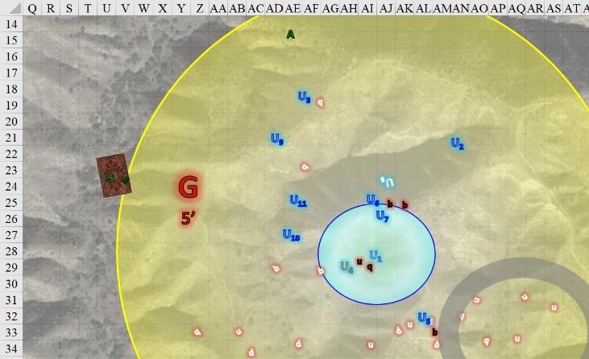

Atlas *[hastened]* faced the attackers, ran forward to close the distance, and let loose a tremendous *[lion’s] roar*.

*Atlas, Brene, Devrion, and the unicorns gained +1 to attacks and saves against fear effects, plus 1 + 18 = 19 temporary hps.*

|  |  |  |  |  |  |  |  |  |  |
| --- | --- | --- | --- | --- | --- | --- | --- | --- | --- |
| **Ranged Weapon** | **Dmg.** | **D+** | **TH+** | **Critical** | **Rng.** | **Wt.** | **Atk** | **Roll** | **Check** |
| Bypass Spell Resistance | varies | - | 0 | - | - | - | +18 | 4 | 22 |

*Fail to bypass Graz’zt’s SR.*

|  |  |  |  |  |
| --- | --- | --- | --- | --- |
| **Character** | **Save vs.**  *lion’s roar* | **Ranks** | **Roll** | **Check** |
| Uridezu | Fortitude | 6 | 17 | 23 |
| Dire Quasit | Fortitude | 11 | 2 | 13 |
| Babau | Fortitude | 10 | 15 | 25 |
| Babau | Fortitude | 10 | 18 | 28 |
| Babau | Fortitude | 10 | 4 | 14 |

*Fail, fail, success, success, fail. 2 babau saves for ½ damage.*

*Base damage: 47 sonic.*

*Damage with save: 23 sonic.*

All but one babau and its master were now left standing after that roar.

Devrion *[hastened]* spoke sharply. “Légy!” *[swift fly?]* He lifted off the carpet, allowing Brene to keep moving southeast. He the warmage extended his palm. “Erőgömb!” *[orb of force]* He then flew back away from the demon in a bid to draw him after himself.

Brene scooted around to the demon’s flank and shot at him twice with her bow.

|  |  |  |  |  |  |  |  |  |  |
| --- | --- | --- | --- | --- | --- | --- | --- | --- | --- |
| **Ranged Weapon** | **Dmg.** | **D+** | **TH+** | **Critical** | **Rng.** | **Wt.** | **Atk** | **Roll** | **Check** |
| Shortbow +2 | 1d4 | 2 | 2 | x3 | 60’ | 2.0 | +23 | 4 | 27 |
| Shortbow, 2nd Shot | 1d4 | 2 | 2 | x3 | 60’ | - | +18 | 8 | 26 |

*Miss, miss.*

Graz’zt gazed upon Brene and Devrion, considering the halfling to be the appetizer, and the half-elf to be the main course. *[Fear, expired on Round 21.]*

|  |  |  |  |  |  |  |  |
| --- | --- | --- | --- | --- | --- | --- | --- |
| **Save vs.**  Fear | **Rank** | **Ability & Mod.** | **Misc. Mods.** | **Total** | **Roll** | **Check** | **Notes** |
| **Brene, Will** | **6** | **Wis (+1)** | 0 | 7 | 17 | 24 | +2 vs. Fear |
| **Devrion, Will** | **11** | **Wis (+1)** | 3 | 15 | 13 | 28 |  |

*Fail, fail. Brene and Devrion panicked, incurring –2 to all Saves and Checks.*

Brene had the wits about her to use the carpet to flee, turning the carpet northwestward, but not yet accelerating.

That left Graz’zt to deal with Atlas.

|  |  |  |  |  |  |  |
| --- | --- | --- | --- | --- | --- | --- |
| **Save vs.**  Fear | **Rank** | **Ability & Mod.** | **Misc. Mods.** | **Total** | **Roll** | **Check** |
| **Atlas, Will** | **11** | **Wis (+4)** | 13 | 28 | 17 | 45 |

*Success. Effect negated.*

He held up a crystal and cast *trap the soul* on the archivist.

|  |  |  |  |  |  |  |
| --- | --- | --- | --- | --- | --- | --- |
| **Save vs.**  *trap the soul* | **Rank** | **Ability & Mod.** | **Misc. Mods.** | **Total** | **Roll** | **Check** |
| **Atlas, Will** | **11** | **Wis (+4)** | 13 | 28 | 7 | 35 |

*Success.*

The crystal shattered in the demon’s hand and the demon was none too pleased. “You are abominations upon the planes, and you will make a meal for Pale Night!”

Devrion almost jumped off the carpet, thinking he could run faster than it could fly, but managed to hold on to its fabric for the moment.

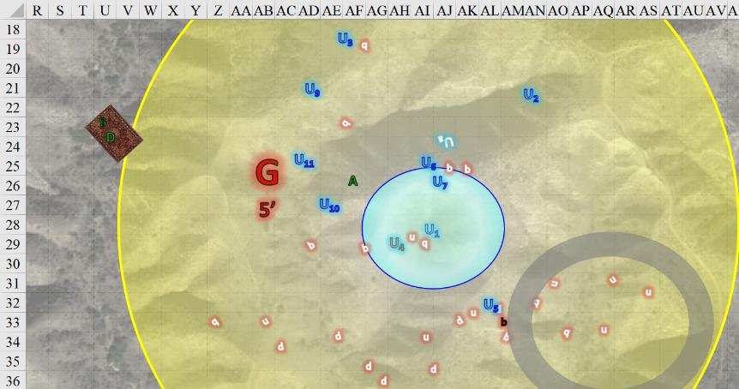

Round 5

The unicorns beheld Graz’zt, and all but Dremu and Tsuamu scampered away.

The single remaining babau chased the unicorns.

Steelshade was over the hill now and out of sight, and Brene and Devrion were speeding away northwestwardly, gaining a bit of reckless altitude in the process.

Atlas murmured a brief prayer *[protection from evil, expired on Round 185]* and gripped his shillelagh. Bereft of his combat-capable friends’ help, the archivist stood no chance alone against Graz’zt, but he would not voluntarily flee and leave his allies.

*Atlas gained +2 to AC and Saves vs. Fear (and other protections) against Evil creatures.*

Unable to attempt to trap Atlas’ soul again today, Graz’zt instead cast *symbol of persuasion [expired in 20 hours]* upon the human.

|  |  |  |  |  |  |  |  |
| --- | --- | --- | --- | --- | --- | --- | --- |
| **Save vs.**  *symbol of persuasion* | **Rank** | **Ability & Mod.** | **Misc. Mods.** | **Total** | **Roll** | **Check** | **Notes** |
| **Will** | **11** | **Wis (+4)** | 13 | 28 | 5 | 33 | +2 vs. Enchantment |

*Success. Effect negated.*

Graz’zt shook his head, then drew his Acidic Burst Bastard Sword +2 and prepared to slice Atlas down. “If I can’t possess you, no one can.”

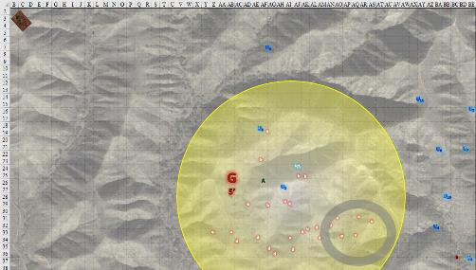

Round 6

Everyone around them was gone now, fleeing in all directions; it was now Atlas and Graz’zt facing one another.

Atlas sent a silent appeal to Aasterinian; “a little help here?”, and then he thought hard to expose a weakness in Graz’zt. He spoke briefly to the demon lord.

|  |  |  |  |  |  |  |  |
| --- | --- | --- | --- | --- | --- | --- | --- |
| **DK: Dread Secret** | **Rank** | **Ability & Mod.** | **Misc. Mods.** | **Total** | **Roll** | **Check** | **Notes** |
| **Atlas, Know: The Planes** | 21 | **Int (+6)** | 5 | 32 | 5 | 37 | Trivial Knowledge |
| **Atlas, Know: The Planes** | 21 | **Int (+6)** | 5 | 32 | 15 | 47 | Trivial Knowledge, **best of 2 rolls** |

*Beats DC by 20+; target is stunned.*

Graz’zt landed somewhat gracefully onto the ground, seething from an uncontrollable sensation for the moment.

Karfmu cast *bear’s endurance [expired on Round 86]* upon himself, and ran towards Dremu.

*Karfmu gained +4 to Constitution.*

Dremu cast *sanctuary [expired on Round 13]* upon himself and shared a few words with his herd brother.

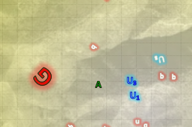

Round 7

Atlas further considered his opponent, murmured another prayer *[chasing perfection, expired on Round 187]*.

*Atlas gained +4 to all six abilities.*

Still under the *haste* effect, he drew upon his Dark Knowledge.

|  |  |  |  |  |  |  |  |
| --- | --- | --- | --- | --- | --- | --- | --- |
| **DK: Puissance** | **Rank** | **Ability & Mod.** | **Misc. Mods.** | **Total** | **Roll** | **Check** | **Notes** |
| **Atlas, Know: The Planes** | 21 | **Int (+6)** | 5 | 32 | 4 | 36 | Trivial Knowledge |
| **Atlas, Know: The Planes** | 21 | **Int (+6)** | 5 | 32 | 11 | 43 | Trivial Knowledge, **best of 2 rolls** |

*Beats DC by 20+; Atlas gained +3 on Saves vs. Graz’zt’s actions.*

He was too far to strike the demon before he could recover, but said demon was about to come towards him. Graz’zt came out of his stunned state, and was rather embarrassed by the dread secret that Atlas had just spoken. With a tear in his eye, the Demon Lord picked up his sword and approached, though he didn’t have time to also attack.

Atlas took the opportunity to club Graz’zt.

|  |  |  |  |  |  |  |  |  |  |
| --- | --- | --- | --- | --- | --- | --- | --- | --- | --- |
| **Melee Weapon** | **Dmg** | **D+** | **TH+** | **Critical** | **Type** | **Wt.** | **Atk** | **Roll** | **Check** |
| Blackthorn Shillelagh +2 | 1d6 | +5+2 | 2 | x2 | Bludgeon | 1.5 | +8 | 9 | 17 |

*Miss.*

Dremu and Karfmu charge-attacked Graz’zt.

|  |  |  |  |  |  |  |  |  |
| --- | --- | --- | --- | --- | --- | --- | --- | --- |
| **Character** | **Attack Type** | **Damage** | **BAB** | **Str Mod+** | **Other+** | **Total Score** | **Roll** | **Total** |
| Dremu | Horn | 1d8+8 | 13 | 9 | 2 charge | 24 | 14 | 38 |
| Karfmu | Horn | 1d8+8 | 10 | 7 | 2 charge | 19 | 19 | 38 |

*Hit, hit. Dmg: (6 + 8 + 2 charge) + (3 + 8 + 2 charge) = 16 + 13 = 29.*

This put another dent on the Demon Lord’s armor, and would give him something to think about tomorrow if he survived. Of course, he would survive; he was Graz’zt! But first, to deal with these pesky unicorns.

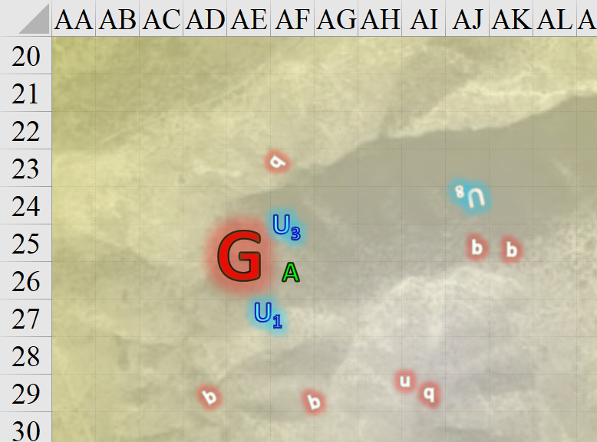

Round 8

One of the quasits nearby murmured, << Kill! >> in Abyssal as it died.

The archivist realized that he wasn’t going to damage Graz’zt with his weapon, and that he had no effective offensive spells, so he used his knowledge of the demon to aid the others.

|  |  |  |  |  |  |  |  |
| --- | --- | --- | --- | --- | --- | --- | --- |
| **Dark Knowledge** | **Rank** | **Ability & Mod.** | **Misc. Mods.** | **Total** | **Roll** | **Check** | **Notes** |
| **K: The Planes (Tactics)** | 21 | **Int (+8)** | 5 | 34 | 2 | 36 | Trivial Knowledge |
| **K: The Planes (Tactics)** | 21 | **Int (+8)** | 5 | 34 | 6 | 40 | Trivial Knowledge**, best of 2 rolls** |
| **K: The Planes (Foe)** | 21 | **Int (+8)** | 5 | 34 | 12 | 46 | Trivial Knowledge**, best of 2 rolls** |
| **K: The Planes (Foe)** | 21 | **Int (+8)** | 5 | 34 | 1 | 35 | Trivial Knowledge |

*Success exceeds 20 for DK Tactics and Foe: Atlas and the unicorns gained +3 to AB and +3d6 to weapon damage rolls made against Graz’zt.*

Graz’zt saw the mere human cracking his knuckles before the fight, and now that the archivist was all buffed up, the Demon Lord tried once again to win him over.

|  |  |  |  |  |  |  |  |
| --- | --- | --- | --- | --- | --- | --- | --- |
| **Save vs.**  *dominate person* | **Rank** | **Ability & Mod.** | **Misc. Mods.** | **Total** | **Roll** | **Check** | **Notes** |
| **Atlas, Will** | **11** | **Wis (+6)** | 13 | 30 | 2 | 32 | +2 vs. Enchantment |

*Success. Effect negated.*

Graz’zt realized he was dealing with no mere human, and readied his sword for a hack-and-slash ending to this affair.

The unicorns attacked the demon.

|  |  |  |  |  |  |  |  |
| --- | --- | --- | --- | --- | --- | --- | --- |
| **Character** | **Attack Type** | **Damage** | **BAB** | **Str Mod+** | **Total Score** | **Roll** | **Total** |
| Dremu | Horn | 1d8+8 | 13 + 3 DK | 9 | 25 | 2 | 27 |
| Karfmu | Horn | 1d8+8 | 10 + 3 DK | 7 | 20 | 8 | 28 |

*Miss, miss.*

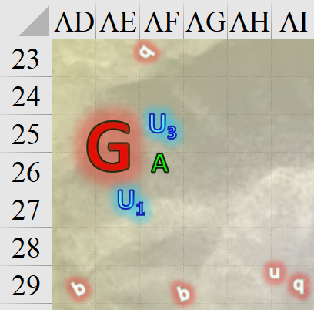

Round 9

Graz’zt was about to start butchering Atlas when he frowned, hearing something coming at him from behind. Before he could turn around, Steelshade’s scimitar was upon her.

|  |  |  |  |  |  |  |  |  |  |  |
| --- | --- | --- | --- | --- | --- | --- | --- | --- | --- | --- |
| **Melee Weapon** | **Dmg** | **D+** | **TH+** | **Crit** | **x** | **Type** | **Wt.** | **Atk** | **Roll** | **Check** |
| Shattermantle Bloodstone Falchion +3 | 2d4 | +7 +3 | 3 + 2 charge + 3 DK | 18 | 2 | Slashing | 8.0 | +32 | 13 | 45 |
| SB Falchion +3, *haste* | 2d4 | +7 +3 | 3 + 2 charge + 3 DK | 18 | 2 | Slashing | - | +32 | 11 | 41 |

*Hit, hit. Dmg: (6 + 7 + 3 + 2 charge + 10 DK) + (5 + 7 + 3 + 6 DK) = 18 + 15 + 16 = 49 – 4 SR.*

Steelshade was not quite in her right headspace, but was quickly recovering from the panic attack. She’d just *dimensioned doored* as far as she could back towards Graz’zt, and had charged the rest of the way.

And no sooner did the duskblade slash at the demon than the rogue could be seen to the northwest, bearing back down upon Graz’zt.

Atlas took a step back and repeated his information for his companions.

*Brene, Devrion, and Steelshade gained +3 to AB and +3d6 to weapon damage rolls made against Graz’zt.*

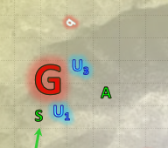

Brene, who was equal parts furious with herself and terrified for her mate, focused on bringing the carpet to the demon’s opposite flank, where she could see that Steelshade was also fighting.

Devrion pushed aside his own thoughts over being frightened away like a child, and focused on killing the big bastard in front of him. He waited until he was in range, and then he extended his palm toward the demon. “Erőgömb!” *[orb of force]*

|  |  |  |  |  |  |  |  |
| --- | --- | --- | --- | --- | --- | --- | --- |
| **Ranged Weapon** | **Dmg.** | **D+** | **TH+** | **Atk** | **Roll** | **Check** | **Notes** |
| Ranged Touch Attack | 10d6 | +4 | 1 + 3 DK | 17 | 10 | 27 | Weapon Focus Included |

*Hit.*

|  |  |  |  |
| --- | --- | --- | --- |
| **Ranged Weapon** | **Atk** | **Roll** | **Check** |
| Bypass Spell Resistance | 18 | 18 | 36 |

*Success. Dmg: 30 + 4 = 34 magic [force].*

The Demon Lord was beginning to wane in might and stamina, it seemed.

Atlas then issued another loud *[lion’s] roar [expired on Round 189]* to inspire his allies.

*Lion’s roar bonuses retained until Round 189.*

|  |  |  |  |
| --- | --- | --- | --- |
| **Ranged Weapon** | **Atk** | **Roll** | **Check** |
| Bypass Spell Resistance | +18 | 13 | 31 |

*Success.*

|  |  |  |  |  |
| --- | --- | --- | --- | --- |
| **Character** | **Save vs.**  *lion’s roar* | **Ranks** | **Roll** | **Check** |
| Graz’zt | Fortitude | 24 | 6 | 30 |

*Saves for ½ damage and avoids stun.*

*Dmg: ½ x 25 = 12 sonic.*

Atlas then stepped back into his previous position and smacked the demon’s balls with his shillelagh.

|  |  |  |  |  |  |  |  |  |  |
| --- | --- | --- | --- | --- | --- | --- | --- | --- | --- |
| **Melee Weapon** | **Dmg** | **D+** | **TH+** | **Critical** | **Type** | **Wt.** | **Atk** | **Roll** | **Check** |
| Blackthorn Shillelagh +2 | 1d6 | +5+2 | 2 + 3 DK | x2 | Bludgeon | 1.5 | +11 | 13 | 24 |

*Miss.*

Graz’zt shook his head as the sound of the *lion’s roar* dissipated throughout the battleground. He considered Steelshade to be the most serious threat to his wellbeing, and thus tried to butcher her alive. Steelshade could tell that the weakness they instilled on him the day before (i.e., negative levels) was still ailing him in his current form.

|  |  |  |  |  |  |  |  |  |  |
| --- | --- | --- | --- | --- | --- | --- | --- | --- | --- |
| **Character** | **Attack Type** | **Damage** | **BAB** | **Str Mod+** | **W+** | **Other+** | **Total Score** | **Roll** | **Total** |
| Graz’zt | Acidic Burst  Bastard Sword +2 | 2d8+18+1d6 acid,17-20 | 24 | 8 | 2 | -3 Power  Attack | 31 | 10 | 41 |
| Graz’zt | Sword, 2nd Attack | 2d8+18+1d6 acid,17-20 | 19 | 8 | 2 | -3 PA | 26 | 15 | 41 |
| Graz’zt | Sword, 3rd Attack | 2d8+18+1d6 acid,17-20 | 14 | 8 | 2 | -3 PA | 21 | 4 | 25 |
| Graz’zt | Sword, 4th Attack | 2d8+18+1d6 acid,17-20 | 9 | 8 | 2 | -3 PA | 16 | 6 | 22 |

*Miss, miss, miss, miss.*

Graz’zt was truly beside himself. Not only had he been unable to bypass her armor on the first two slices, which dinged her, but she dodged the last two blows altogether, leaving him ineffective on four successive swings. This did not bode well for the already wounded overlord of entire layers of the Abyss. Good thing his minions had been eliminated, or they would surely blab to the greater chaotic evil community, and his reputation as a slayer of mortals would be jeopardized.

Dremu and Karfmu attacked the Demon Lord.

|  |  |  |  |  |  |  |  |  |
| --- | --- | --- | --- | --- | --- | --- | --- | --- |
| **Character** | **Attack Type** | **Damage** | **BAB** | **Str Mod+** | **Dex Mod+** | **Total Score** | **Roll** | **Total** |
| Dremu | Horn | 1d8+8 | 13  + 3 DK | 9 | 3 | 25 | 2 | 27 |
| Karfmu | Horn | 1d8+8 | 10  + 3 DK | 7 | 4 | 20 | 14 | 34 |

*Miss, miss.*

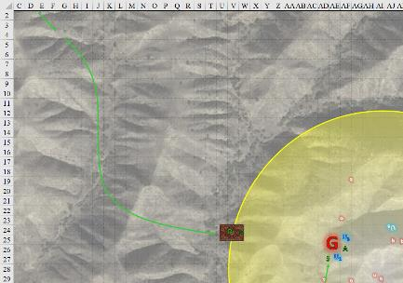

Round 10

The unicorns got another window of opportunity, and tried again with their horns to poke the Abyssal Lord.

|  |  |  |  |  |  |  |  |  |
| --- | --- | --- | --- | --- | --- | --- | --- | --- |
| **Character** | **Attack Type** | **Damage** | **BAB** | **Str Mod+** | **Dex Mod+** | **Total Score** | **Roll** | **Total** |
| Dremu | Horn | 1d8+8 | 13  + 3 DK | 9 | 3 | 26 | 1 | 27 |
| Karfmu | Horn | 1d8+8 | 10  + 3 DK | 7 | 4 | 20 | 15 | 35 |

*Miss, miss.*

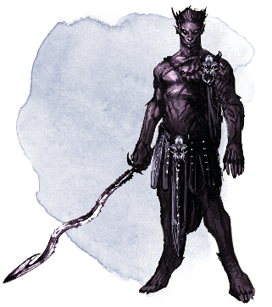

Opting to eschew his Power Attack, Graz’zt maximized accuracy and swung profusely at Steelshade four more times.

|  |  |  |  |  |  |  |  |  |
| --- | --- | --- | --- | --- | --- | --- | --- | --- |
| **Character** | **Attack Type** | **Damage** | **BAB** | **Str Mod+** | **W+** | **Total Score** | **Roll** | **Total** |
| Graz’zt | Acidic Burst Bastard Sword +2 | 2d8+18+1d6 acid,17-20 | 24 | 8 | 2 | 34 | 15 | 49 |
| Graz’zt | Sword, 2nd Attack | 2d8+18+1d6 acid,17-20 | 19 | 8 | 2 | 29 | 12 | 41 |
| Graz’zt | Sword, 3rd Attack | 2d8+18+1d6 acid,17-20 | 14 | 8 | 2 | 24 | 14 | 38 |
| Graz’zt | Sword, 4th Attack | 2d8+18+1d6 acid,17-20 | 9 | 8 | 2 | 19 | 19 | 38 |

*Hit, miss, miss, threat. 1d20 = 1, not a critical hit. Dmg: (2 + 18 +5 acid) + (8 + 18 + 6 acid) = 20 + 26 + 11 acid = 57 [128/179].*

Atlas gave up on his weapon attacks, and focused on keeping Steelshade healthy. He stepped over and touched her, whispering a prayer *[cure moderate wounds]* as he did. He then used his hastened state to step back a bit.

*Steelshade gained 8 + 18 = 26 hps [154/179].*

Brene halted the carpet and fired two more arrows at the flanked demon lord. “Hold still, bitch!” she breathed as she released the string.

|  |  |  |  |  |  |  |  |  |  |  |
| --- | --- | --- | --- | --- | --- | --- | --- | --- | --- | --- |
| **Ranged Weapon** | **Dmg.** | **D+** | **TH+** | **Critical** | **Rng.** | **Wt.** | **Atk** | **Roll** | **Check** | **Properties** |
| Shortbow +2 | 1d4 | 2 | 2 + 3 DK | x3 | 60’ | 2.0 | +26 | 3 | 29 | Sneak Attack 9d6 |
| Shortbow, 2nd Shot | 1d4 | 2 | 2 + 3 DK | x3 | 60’ | - | +21 | 5 | 26 | Sneak Attack 9d6 |
| Shortbow, *haste* | 1d4 | 2 | 2 + 3 DK | x3 | 60’ | - | +26 | 15 | 41 | Sneak Attack 9d6 |

*Miss, miss, hit. Dmg: 3 + 2 + 7 DK + 31 Sneak = 43.*

Devrion spoke again, and launched another *orb of force* against the demon.

|  |  |  |  |  |  |  |  |
| --- | --- | --- | --- | --- | --- | --- | --- |
| **Ranged Weapon** | **Dmg.** | **D+** | **TH+** | **Atk** | **Roll** | **Check** | **Notes** |
| Ranged Touch Attack | 10d6 | +4 | 1 + 3 DK | 17 | 12 | 29 | Weapon Focus Included |

*Hit.*

|  |  |  |  |
| --- | --- | --- | --- |
| **Ranged Weapon** | **Atk** | **Roll** | **Check** |
| Bypass Spell Resistance | 18 | 13 | 31 |

*Fail. Effect negated.*

Steelshade shook off the shock of the demon’s glancing blows and the fine spray of acid that was ruining her best non-magical blouse. The duskblade channeled *vampiric touch* through her falchion, and empowered her strikes (+3) as she full attacked Graz’zt, going toe-to-toe with the demon lord. She had hoped that her displacement cloak would cause Graz’zt’s blows to miss her a bit more often, but she had work to do in any case. The dragonborn drow’s blade was a blur of black and red as she hammered at her huge foe with a flurry of blows that could hardly be perceived, much less followed with the eye.

|  |  |  |  |  |  |  |  |  |  |  |  |
| --- | --- | --- | --- | --- | --- | --- | --- | --- | --- | --- | --- |
| **Melee Weapon** | **Dmg** | **D+** | **TH+** | **Crit** | **x** | **Type** | **Wt.** | **Atk** | **Roll** | **Check** | **Properties** |
| Shattermantle  Bloodstone  Falchion +3 | 2d4 | +7 +3 + 3d4 DK + 3d4 AS | 3 + 3 DK  + 3 AS | 18 | 2 | Slashing | 8.0 | +33 | 6 | 39 | Vampiric Touch |
| SB Falchion +3,  2nd Attack | 2d4 | +7 +3 + 3d4 DK + 3d4 AS | 3 + 3 DK  + 3 AS | 18 | 2 | Slashing | - | +28 | 12 | 40 |  |
| SB Falchion +3,  3rd Attack | 2d4 | +7 +3 + 3d4 DK + 3d4 AS | 3 + 3 DK  + 3 AS | 18 | 2 | Slashing | - | +23 | 14 | 37 |  |
| SB Falchion +3,  4th Attack | 2d4 | +7 +3 + 3d4 DK + 3d4 AS | 3 + 3 DK  + 3 AS | 18 | 2 | Slashing | - | +18 | 12 | 30 |  |
| SB Falchion +3,  *haste* | 2d4 | +7 +3 + 3d4 DK + 3d4 AS | 3 + 3 DK  + 3 AS | 18 | 2 | Slashing | - | +33 | 9 | 42 |  |
| Greater Crystal  of Arcane Steel | +1 to touch spells | 1 | +1 | - | - | - | - | - | - | - | +1 to spell DC |

*Hit, hit, hit, miss, hit. Dmg: (7 + 7 + 3 + 10 DK + 7 AS + Vampiric) + (5 + 7 + 3 + 7 DK + 7 AS) + (4 + 7 + 3 + 9 DK + 5 AS) + (3 + 7 + 3 + 7 DK + 5 AS) = 27 + 29 + 28 + 25 = 109 + Vampiric.*

|  |  |  |  |  |  |
| --- | --- | --- | --- | --- | --- |
| **Steelshade** | **Dmg.** | **TH+** | **Atk** | **Roll** | **Check** |
| Bypass Spell Resistance | Spell Penetration | 2 | +19 | 14 | 33 |

*Success. Dmg: 37 Vampiric.*

*Steelshade [179/179].*

|  |  |  |  |  |  |  |  |  |  |  |  |
| --- | --- | --- | --- | --- | --- | --- | --- | --- | --- | --- | --- |
| **Character** | **TAC** | **FFAC** | **AC** | **Melee** | **Acid** | **Evil/ Neg** | **Total Damage** | **Temp** | **Healing** | **HPs** | **Current HPs** |
| **AtlasPfE** | **15** | **26** | **30** |  |  |  | 0 | 19 |  | 99 | 118 |
| **DevrionPfE** | **15** | **28** | **32** |  |  |  | 0 | 19 |  | 99 | 118 |
| **BrenePfE** | **20** | **24** | **32** |  |  |  | 0 | 19 |  | 99 | 118 |
| **AngrenPfE/DE** | **19** | **40** | **44** | 46 | 11 | 13 | 70 | 56 | 26 | 179 | 179 |

It was too quick for most folks to tell, but the draconic duskblade decapitated the Demon Lord on the third hack. As Graz’zt’s head fell to the floor with a dull thud, the Outer Planes shook.

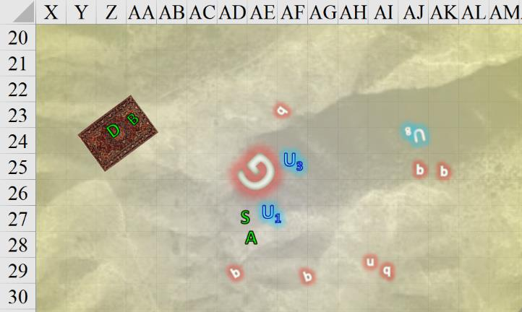

Round 11

Atlas was about to cast *cure serious wounds* on Steelshade again, but was solemnly astonished when she cut down Graz’zt with that last handful of swings.

Brene stayed her next arrow flank, carefully scanning for other demons as her targets.

Devrion pointed his finger at the dead demon lord, but abstained from wasting another spell on the fiend. The half-elf was riding the wave of magic that surged within him, and a tiny part of him grieved for what it cost him.

Steelshade looked the two remaining unicorns, and asked, “Should we see to your brethren?”

The panicked unicorns had just now regained their senses, and could be seen in the distant east dealing with the last of the babau.

Within seconds, the horned equine creatures had put down the demon.

“That’s not the end of him,” Atlas cautioned everyone as he leaned on his weapon to catch his breath. “Like the last one, this is just one of his avatars.”

Brene landed the carpet and went to search the demon’s corpse for anything useful. She pointed to the massive sword. “Can we take that with us?”

Steelshade stripped off her now-smoking shirt and tossed it aside. She extracted a scrap of cloth from a side pocket in her haversack, and began to clean her sword and armor.

Devrion stepped over to help by using his water container to wash the acid off of her. “Are you okay?”

“Not really. I can’t believe I just turned and ran.” Angren looked down her body and began wiping down her breastplate.

“The only one who could stay was Atlas,” the warmage told her softly. “He is a Demon Lord, after all. ‘Fearsome’ is their stock in trade. We were lucky that he’s met us while he’s weakened. I don’t know that we’d survive if he was at full strength, and that goes double if he has powerful minions with him.”

Dremu and Karfmu were duly praiseful and grateful to the humanoids, regaling them with exaggerations of their deeds only moments ago. As the rest of the unicorns started to shuffle into earshot, the party took a better note of what-all they’d slain, and confirmed that Birimu had also been slain in the battle.

The dretches had been the least of foes, but the babau were formidable against several different types of attacks, let alone their arch-demon master. Then there was the need to celebrate Birimu, whose form now sifted into the ground of Krigala as others began to speak her name and mention her deeds.

All in all, they’d done well. Atlas was probably correct in that this was not the end of Graz’zt, but he would at least not be able to manifest here magically for a good while. They would have to hunt him down in his lair and destroy him there if this caper was to truly conclude.

Atlas took a breath and turned to the wounded unicorns. “Is there anyone in need of healing?”

Shrikteh, Shamu, and Qusamteh were wounded, and lined up for some healing from Atlas.

|  |  |  |  |  |  |  |  |  |  |
| --- | --- | --- | --- | --- | --- | --- | --- | --- | --- |
| **Character** | **TAC** | **FFAC** | **AC** | **Melee** | **Acid** | **Total Damage** | **Temp** | **HPs** | **Current HPs** |
| **Dremu** | **14** | **20** | **24** | 7 | 8 | 15 |  | 155 | 140 |
| **Karfmu** | **14** | **17** | **21** |  |  | 0 | 8 | 122 | 130 |
| **Tsuamu** | **14** | **14** | **18** |  |  | 0 |  | 98 | 98 |
| **Zynphymu** | **14** | **14** | **18** |  |  | 0 |  | 98 | 98 |
| **Shrikteh** | **14** | **14** | **18** | 14 | 5 | 19 |  | 90 | 71 |
| **Viriteh** | **18** | **14** | **22** |  |  | 0 |  | 90 | 90 |
| **Shamu** | **10** | **11** | **11** | 8 | 7 | 15 |  | 92 | 77 |
| **Birimu** | **13** | **10** | **13** | 54 | 37 | 91 |  | 82 | **-9** |
| **Pertenteh** | **9** | **11** | **10** |  |  | 0 |  | 82 | 82 |
| **Qusamteh** | **11** | **11** | **12** | 11 | 7 | 18 |  | 82 | 64 |
| **Kadabteh** | **14** | **14** | **18** |  |  | 0 |  | 82 | 82 |

Atlas prayed over each of them in turn, casting *cure light wounds* on Shamu, and *cure moderate* wounds on Shrikteh and Qusamteh.

*Shamu gained 6 + 5 = 11 hps.*

*Shrikteh gained 15 + 10 = 25 hps.*

*Qusamteh gained 7 + 10 = 17 hps.*

The sun continued to shine bright above them as they shook their heads at the evaporating demon carcasses whose essence would return to the Abyss to regain some other castigated form.

One of the unicorns stepped firmly upon the skull of an uridezu that refused to die until that moment. “It really *is* the compassionate thing to do,” he said to those who looked at him as he continued to make his way over to Graz’zt’s splendorous corpse.

Atlas studied their archenemy’s sword.

|  |  |
| --- | --- |
| **Melee Weapon** | **Damage** |
| Acidic Burst Bastard Sword +2 | 2d8+18+1d6 acid,17-20 |

“It’s not as nice as yours, but it makes the biography of its wielder more interesting,” the archivist handed it back to Steelshade, who now beheld it as she held it.

“*I’ll* say!” the duskblade remarked, feeling the comparative imbalance of the bastard sword relative to her usual falchion. “This baby would be a better weapon than Arkenyl against an armored opponent, but a falchion is always a better choice when you don’t know what adversaries the day will bring. For most monsters, holding all enchantments constant, the falchion is by far the more effective and versatile blade.” *[This is not a reflection of D&D mechanics, but of* [*historical considerations*](mailto:https://www.youtube.com/watch?v=_yO8BpynTQo)*.]*

Aside from the sword, they were also guessing that the villain was wearing a mithral glamered suit of full plate. He was not wearing the cloak that they’d seen on him in previous confrontations, nor had he been carrying his befabled steel shield before his demise. His magical component pouch and other few belongings were probably cool to have as trophies, but probably did not have much use value.

Atlas studied the lightweight armor, and then he began removing it from the headless carcass.

“Can you wear that?” Angren stepped over and began helping him with it.

“Given that it’s elven made, I think I can, since it’s a lot lighter than steel plate. It might take some training, but I’ve been thinking of taking up the sword, and this armor would go nicely with it. I wasn’t able to even defend myself against this creature, and I don’t want a repeat performance.” Atlas started on the buckles he could reach as he talked.

The other two gathered around and pitched in, although everyone glanced around regularly and frequently as they worked.

“So, what sort of warrior are you thinking about,” Devrion asked.

“When I was passing through Iriabor, I heard of a paladin of freedom,” the archivist began.

“Oh, by the mother of gods,” Brene groaned. “A paladin? I’d have to get blessed every day just to touch you.”

“That’s probably not a bad idea anyway,” Devrion snickered. “Ow!” He rubbed his head where the halfling had whacked him with a strap buckle.

“No, this isn’t the law bound sort,” Atlas explained. “These paladins are much more about freedom, not the rules. There are still rules, but there’s also more room for individual expression.”

Steelshade recovered the bastard sword’s scabbard, and sheathed the blade. “I don’t think this is a paladin’s weapon.”

“No, but someone will still buy it,” Atlas pointed out. “The armor, being magical, should fit me when I try to put it on.” He held up his hand as Angren cocked her head. “I know. I will have it checked first. For now, let’s just take it and put it away.”

“Better not touch anything of his,” Devrion said. “It’s probably cursed.”

“I’m just looking,” Brene replied as she drew her dagger, and, using it and one of her arrows, poked though the demon’s possessions.

“Do you have anyone who can identify magical items?” Atlas asked the unicorns.

“Zynphymu here does,” Dremu volunteered their resident bard, who went over to check out the body, and its armor and gear.

The quartet paused to await the unicorn’s assessment of the equipment.

~*~

“So?” Devrion tried to read the unicorn bard’s face to get a sense of the value of the findings.

“I would concur with Atlas’ assertion that this is a lesser form of Graz’zt. The armor and other equipment are not quite what they are reputed to be by sages who would know firsthand,” Zynphymu said.

The bard was able to confirm the archivist’s compositional and operational description of the armor, but he could not ascertain its exact armor boost increment. “If I had to guess, it’s in the +2 or +3 camp... not quite worthy of the ultimate Graz’zt, I would guess.”

“Anything cursed or malignant?” asked Steelshade.

“Not to the user, but I definitely wouldn’t want to be on the pointy end of that sword,” Zynphymu half-joked.

“No, it wasn’t much fun at all,” Steelshade replied with a crooked smile. “Damned thing ruined my best blouse, too.” She pointed to the smoking pile of cloth on the ground.

The group removed the armor and packed it away in their haversacks, along with the sheathed sword. When they were done, they boarded their carpet.

***Confirm or edit after reading below.***

“Are you encamped nearby?” Atlas asked.

“We are on a walkabout,” Karfmu said, explaining, “we’re hoping to encamp right near that glade where we first encountered you.”

“Oh, right,” Devrion said. “By the waterfall. Good camping.”

Tsuamu added, “Yes, but we’ll have to set up a ceremony here before we move on... for Birimu’s sake.”

The rest of the unicorns repeated, “For Birimu’s sake.”

~*~

Now that they’d had time to talk without the demons barging in through a translplanar portal, the heroes had discovered that a quasit in Graz’zt’s thrall had been spying on them since the battle against the centaurs, and had effectively lured one of the unicorns—a female scout known as the Lookout—and all of the jackalweres, into betraying the trust of Dremu’s herd. In the end, the shaky alliance between unicorns and jackalweres spiraled into a coalition of jackalweres and centaurs under the banner of Pale Night. The unicorns had been hit by surprise, most of them wounded quite badly, but had stood their ground against their adversaries, and though the factions departed with no casualties that night, an expeditionary force had found the withering remains of the Lookout’s body soon thereafter.

The herd began to gather. As *mage hand* and *prestidigitation* spells were cast, Shrikteh and Viriteh stood in the center of what had now become a circle of unicorns facing inward. *Create food and water* was then cast, as were *consecrate* and a few other preparatory spells in honor of Birimu.

“Come, heroes,” Dremu pointed towards the circle with his horn. “Join us.”

The unicorns made room between them for the heroes to join in prayer.

Atlas reached for Brene’s hand as they prepared to pray. The halfling took Devrion’s hand, and he automatically reached out to Angren. The dragonborn took it, and they all stood quietly as the prayers went out.

~*~

The ceremony had been brief, and in Sylvan, and the heroes had thereafter been again commended once again by the unicorns’ leadership.

Atlas nodded. “We are still pursuing the demons, though. You said the jackalweres are now in their service?”

“Yes,” Tsuamu answered. “Graz’zt got the best of them.”

“Where are they now?” Atlas enquired. “We will pay them a visit.”

They sighed, and stated that they no longer knew the whereabouts of their betrayers.

“We will go to where you last knew them to be, then,” Atlas said.

Dremu used his horn to point the way, giving a few estimates of distance and landmarks. On the carpet, they should be able to spot a jackalwere encampment. The heroes bid the unicorns well, and hopped onto their carpet again, taking off into the sky.