Oghma’s Faithful

by Alexis Álvarez & ChatGPT

**Chapter 12: The Throne Room**

____________________________________________________________________________________________________________

**Abstract:** Having trekked through the labyrinthine complex underneath the Hallow of Ashes, the heroes found and fought their way into the Mourners’ Sanctum, where Father Pompeii Vesuvius was holed up with his last two bodyguards.

They confronted him, using Eldrin’s summoned ape to even the odds against them, and Vesuvius soon found himself contemplating the melancholy prospect of losing his soul to his bargainer one way or another.

In the end, the diabolist chose to prolong his life a little longer, surrendering to the Ogmanytes and being escorted back to the Font of Knowledge for further questioning. In time, they hoped to glean as much as they could from this tyrannical painbringer, and ultimately put an end to the diabolists’ operations here and everywhere.

____________________________________________________________________________________________________________

Round 154

The heroes entered what was now called the Mourner’s Hold. They’d eliminated every fanatical cultist in their way, liberated a dozen or so captives, and let a few repentant cultists flee and live for now.

Father Pompeii Vesuvius sat comfortably at his throne finishing up a deliberation when his two bodyguards—already wounded from a recent withdrawal to this chamber—nodded and resolved to die for their leader, no longer confident that they could hold their own.

Round 1

|  |  |  |  |  |  |
| --- | --- | --- | --- | --- | --- |
| **Character** | **Group** | **Initiative** | **Roll** | **Modified Roll** | **Speed** |
| Eldrin | 1 | 2 | 20 | 22 | 30’ |
| Artemis | 1 | 1 | 14 | 15 | 30’ |
| Father Pompeii | 2 | 3 | 9 | 12 | 30’ |
| Banshee | 1 | 3 | 8 | 11 | 30’ |
| Diabolist Bodyguards | 2 | 3 | 4 | 7 | 30’ |
| Sebenzi | 1 | 0 | 1 | 1 | 30’ |

With their weapons already drawn, the heroes wasted no time in initiating combat with no further dialogue with the devil worshippers.

Already *barkskinned*, Eldrin cast *sanctuary [expired on Round 6]* upon himself.

*Eldrin gained sanctuary protection (DC 16).*

Having already cast it on herself a minute ago, Artemis cast *conviction [expired in 50 minutes]* upon Banshee.

*Banshee gained +2 to all Saves.*

Father Pompeii Vesuvius narrowed his yellowed eyes at the invaders, his forked tongue flicking behind thin lips. The heroes’ unbroken advance had been an affront to Loviatar’s divine cruelty — but in their final hour, they would taste the exquisite pain that the Maiden of Pain demanded. With a whispered prayer in Infernal, Pompeii invoked *Unholy Storm [expired on Round 8]* — filling the air with cold, stinging rain that scoured the flesh of all non-evil creatures within a 20’ radius burst centered on the chevron in the tapestry at the heroes’ feet. The black rain would cling to their skin, sapping their strength with every drop.

*The PCs are to the north, so I centered the Unholy Storm on L6 so it would capture your enemy, and not your people.*

The storm began to fill the hall, and the cold hissed through the stone. Artemis and Banshee were Neutral, and thus suffered no damage, but their archivist and cleric friends suffered indeed.

*Dmg to Eldrin: 6 unholy [32/38].*

*Dmg to Sebenzi: 4 unholy [31/35].*

The heroes groaned and complained, to which Father Pompeii sneered and muttered, “Even now, your prayers insult the Lady... but she listens.”

The bodyguards shifted into a defensive line in front of the throne, prepared to die in their master’s service.

Shouting a vile prayer to Asmodeus, the bodyguards moved to K15 and M14, and readied an Aid Another action, trying to intercept any attacker who closed on Father Pompeii (granting him +2 AC if successful).

Father Pompeii’s Infernal Whispers: “Do not fear pain... It is the soul’s awakening.”

Banshee charge-attacked bodyguard 1, not yet reaching him. Artemis did the same, selecting bodyguard 2 as her target.

Sebenzi didn’t have many useful spells for the day, so she ran into the fray as well.

Round 2

Eldrin ran out of the *unholy storm*, and cast *summon nature’s ally III [expired on Round 8]*, conjuring one of his signature apes.

*Full-round action. Creature won’t appear until Round 3.*

Artemis finished her charge-attack against bodyguard 2.

|  |  |  |  |  |  |  |  |  |  |  |
| --- | --- | --- | --- | --- | --- | --- | --- | --- | --- | --- |
| **Melee Weapon** | **Dmg** | **D+** | **TH+** | **Critical** | **Type** | **Wt.** | **Atk** | **Roll** | **Check** | **Notes** |
| MW Longsword | 1d6+1 | +0 | 1 | 19-20/x2 | Slashing | 8.0 | +5 | 15 | 20 | Weapon Focus included |

*Hit. Dmg: 1 + 1 = 2.*

Father Pompeii’s forked tongue flicked out as the ape’s summoning circle began to shimmer behind the heroes. His disdainful sneer twitched — he would not allow these interlopers to reach him without suffering for their defiance. “The storm shall break your flesh... and your sins shall feed the Maiden.”

With a measured gesture, he cast *Shield of Faith [expired on Round 9]* on himself, invoking Loviatar’s cruel favor. A faint red glow settled around his frame like barbed wire woven from light.

*Pompeii gained +3 to AC.*

*NOTE: Only one spell can be cast per round.*

Then, clutching his holy symbol, he got up from his throne, took a cautious 20’ step to P17 — placing distance between himself and the incoming wave of attackers. “You think yourself strong, child... but strength bends beneath agony.”

*The map scale is 1 square = 5’ x 5’.*

The bodyguards attacked Banshee and Artemis.

|  |  |  |  |  |  |  |  |
| --- | --- | --- | --- | --- | --- | --- | --- |
| **Character** | **Attack Type** | **Damage** | **BAB** | **Str Mod+** | **Total Score** | **Roll** | **Total** |
| Diabolist Bodyguard 1 | Kukri | 1d4+1 | 2 | 1 | 3 | 16 | 19 |
| Diabolist Bodyguard 2 | Light Mace | 1d6+1 | 3 | 1 | 4 | 18 | 22 |

*Hit, hit.*

*Dmg to Banshee: 2 + 1 = 3 [27/30].*

*Dmg to Artemis: 3 + 1 = 4 [16/20].*

Banshee charge-attacked bodyguard 1, urging the others, “Make sure Big Pops doesn’t make a break for it.”

|  |  |  |  |  |  |  |  |  |  |
| --- | --- | --- | --- | --- | --- | --- | --- | --- | --- |
| **Melee Weapon** | **Dmg** | **D+** | **TH+** | **Critical** | **Type** | **Wt.** | **Atk** | **Roll** | **Check** |
| Kukri +1 | 1d3+1 | +0 | 1 + 2  charge | 18-20/x2 | Slashing | 1.0 | +8 | 18 | 26 |

*Threat. 1d20 = 15 + 8 = 23, critical hit. Dmg: (2 x 2) + 1 + 2 = 4 + 3 = 7.*

Sebenzi looked to Eldrin, who was already producing a scroll from his case, and finished her charge-attack against bodyguard 2.

|  |  |  |  |  |  |  |  |  |  |
| --- | --- | --- | --- | --- | --- | --- | --- | --- | --- |
| **Melee Weapon** | **Dmg** | **D+** | **TH+** | **Critical** | **Type** | **Wt.** | **Atk** | **Roll** | **Check** |
| MW Quarterstaff | 1d6+1 | +0 | 1 + 2  Charge  +2 flank | x2 | Bludgeon | 8.0 | +8 | 2 | 10 |

*Miss.*

Round 3

An ape appeared behind the body guards and full-attacked bodyguard 1 as Eldrin lost his *sanctuary’s* protection.

|  |  |  |  |  |  |  |  |  |  |  |  |  |
| --- | --- | --- | --- | --- | --- | --- | --- | --- | --- | --- | --- | --- |
| **Character** | **Attack Type** | **Damage** | **BAB** | **Str Mod+** | **W+** | **Other+** | **Total Score** | **Roll** | **Total** | **Crit** | **Threat** | **Notes** |
| Ape | Claw 1 | 1d6+5 | 2 | 5 | 0 | 2 flank | 9 | **20** | 29 | 20 | þ |  |
| Ape | Claw 2 | 1d6+5 | 2 | 5 | 0 | 2 flank | 9 | 3 | 12 | 20 | ý |  |

*Threat, miss. 1d20 = 13 + 7 = 20, critical hit. Dmg: (2 x 4) + 5 = 13.*

The bodyguard was barely holding up.

Eldrin produced his scroll of *dimensional anchor [expired on Round 63]*, and did has he’d practiced prior to arriving, targeting the cult leader, who was known to escape and leave his minions to die in his stead.

|  |  |  |  |  |  |  |  |
| --- | --- | --- | --- | --- | --- | --- | --- |
| **Skill** | **Rank** | **Ability**  **& Mod.** | **Misc.**  **Mods.** | **Total** | **Roll** | **Check** | **Notes** |
| **Eldrin, Use Magic Device** | 1 | **Cha (+1)** | 2 | 4 | 14 | 18 | CROSS-CLASS SKILL |

*Success.*

|  |  |  |  |  |  |
| --- | --- | --- | --- | --- | --- |
| **Ranged Weapon** | **Dmg.** | **Range** | **Atk** | **Roll** | **Check** |
| Ranged Touch Spells | *Dimensional Anchor* | Medium | +6 | 17 | 23 |

*Hit. Father Pompeii cannot teleport.*

“Got’im!” confirmed Eldrin once he saw the emerald hue enveloping the horned tiefling. “The rest is just mechanics.”

Artemis committed herself to the mechanics of bringing down the thugs before disabling the leader.

|  |  |  |  |  |  |  |  |  |  |  |
| --- | --- | --- | --- | --- | --- | --- | --- | --- | --- | --- |
| **Melee Weapon** | **Dmg** | **D+** | **TH+** | **Critical** | **Type** | **Wt.** | **Atk** | **Roll** | **Check** | **Notes** |
| MW Longsword | 1d6+1 | +0 | 1 + 2  Flank | 19-20/x2 | Slashing | 8.0 | +7 | 19 | 26 | Weapon Focus included |

*Threat. 1d20 = 6 + 7*

Having already cast *unholy storm*, Father Pompeii cast *axiomatic storm [expired on Round 9]* instead, figuring at least one of the heroes ought to be Chaotic. He positioned it so they all fit in there, knowing that his minions were nice and Lawful.

*No Chaotic characters in sight.* ☹

And though it would have been plausible to assume that at least one of the goody-goods was Chaotic, none of them were. Perhaps they could be converted to diabolism!

The bodyguards lunged at their opponents with renewed zeal, emboldened by their master’s infernal favor. Diabolist Bodyguard 1—bleeding and staggering but still on his feet—twisted his kukri in a savage arc at Banshee, snarling, “Loviatar’s kiss makes all pain a gift.”

*Attack: 1d20 + 3 = 13 vs. AC 16 — Miss*

Even wounded, Banshee’s reflexes were too sharp.

Diabolist Bodyguard 2—pressured between Sebenzi and Artemis—drew his mace back and aimed low at Artemis’s knee.

*Attack: 1d20 + 4 = 16 vs. AC 16 — Hit*

*Damage: 4 + 1 = 5 [11/20].*

Artemis’s leg buckled slightly (11/20 HP), but she gritted her teeth and stayed in the fight.

Banshee tried to finish off the moribund bodyguard to her south.

|  |  |  |  |  |  |  |  |  |  |
| --- | --- | --- | --- | --- | --- | --- | --- | --- | --- |
| **Melee Weapon** | **Dmg** | **D+** | **TH+** | **Critical** | **Type** | **Wt.** | **Atk** | **Roll** | **Check** |
| Kukri +1 | 1d3+1 | +0 | 1 | 18-20/x2 | Slashing | 1.0 | +6 | **13** | 19 |

*Hit. Dmg: 2 + 1 = 3.*

Sebenzi swung her staff at bodyguard 2.

|  |  |  |  |  |  |  |  |  |  |
| --- | --- | --- | --- | --- | --- | --- | --- | --- | --- |
| **Melee Weapon** | **Dmg** | **D+** | **TH+** | **Critical** | **Type** | **Wt.** | **Atk** | **Roll** | **Check** |
| MW Quarterstaff | 1d6+1 | +0 | 1 + 2  Flank | x2 | Bludgeon | 8.0 | +6 | 16 | 22 |

*Hit. Dmg: 5 + 1 = 6.*

Round 4

The ape full attacked bodyguard 2.

|  |  |  |  |  |  |  |  |  |  |
| --- | --- | --- | --- | --- | --- | --- | --- | --- | --- |
| **Character** | **Attack Type** | **Damage** | **BAB** | **Str Mod+** | **W+** | **Other+** | **Total Score** | **Roll** | **Total** |
| Ape | Claw 1 | 1d6+5 | 2 | 5 | 0 | 2 flank | 9 | 9 | 18 |
| Ape | Claw 2 | 1d6+5 | 2 | 5 | 0 | 2 flank | 9 | 6 | 15 |

*Hit, miss. Dmg: 5 + 5 = 10.*

Eldrin commanded the diabolist, “Fiend’s thrall, know that wherever you run, we will ride in search for you. Now *hold*!” he cast *hold person [DC 17, expired on Round 10]* upon Father Pompeii.

|  |  |  |  |  |  |  |
| --- | --- | --- | --- | --- | --- | --- |
| **Save vs.**  *hold person* | **Rank** | **Ability & Mod.** | **Misc. Mods.** | **Total** | **Roll** | **Check** |
| **Father Pompeii, Will** | **6** | **Wis (+3)** | 0 | 9 | 13 | 22 |

*Success.*

The master diabolist shrugged off the spell’s effects, though he was still anchored, and could not teleport away.

Artemis attacked bodyguard 2.

|  |  |  |  |  |  |  |  |  |  |  |
| --- | --- | --- | --- | --- | --- | --- | --- | --- | --- | --- |
| **Melee Weapon** | **Dmg** | **D+** | **TH+** | **Critical** | **Type** | **Wt.** | **Atk** | **Roll** | **Check** | **Notes** |
| MW Longsword | 1d6+1 | +0 | 1 | 19-20/x2 | Slashing | 8.0 | +5 | 9 | 14 | Weapon Focus included |

*Miss.*

Father Pompeii’s slitted pupils narrowed in frustration as the crackling storm washed over the interlopers—drenching them in unholy rain but failing to deliver the divine punishment he had envisioned. “You think your souls are pure?” he hissed, voice coiling through the chamber like smoke. “I’ll drag you to the Maiden’s altar... one nerve at a time.” His clawed fingers flexed around his holy symbol, considering his next spell—perhaps Sap Strength to cripple the front line... or Blindness to make Eldrin’s spells falter. Father Pompeii—his fiendish mind whirring—cast *Blindness [DC 17]* on Eldrin, seeking to rob the little archivist of his piercing sight.

|  |  |  |  |  |  |  |
| --- | --- | --- | --- | --- | --- | --- |
| **Save vs.**  ***blindness*** | **Rank** | **Ability & Mod.** | **Misc. Mods.** | **Total** | **Roll** | **Check** |
| **Eldrin, Will** | **5** | **Wis (+2)** | 1 | 8 | 12 | 20 |

*Success. Effect negated.*

“Now the scholar’s wisdom is but empty words,” the tiefling sneered. “Kneel before pain, little gnome.”

“I think not,” Eldrin corrected him, emerging from the storm’s blinding fog.

The bodyguards fought on with desperate fury, their lives pledged to Loviatar’s mercy. Diabolist Bodyguard 1, still locked in a duel with Banshee, bared bloodied teeth through his cracked lips and swung his kukri once more—his devotion outpacing his waning strength.

*Attack: 1d20 + 3 = 11 vs. AC 16 — Miss*

Banshee batted the blade aside with her own kukri, her face impassive beneath her cowl.

Diabolist Bodyguard 2, harried by the ape, Artemis, and Sebenzi, lashed out at the towering summon with his mace, sweat glistening on his brow.

*Attack: 1d20 + 4 = 14 vs. AC 14 — Hit*

*Damage: 4 + 1 = 5 [24/29].*

The ape bellowed in pain, but the massive beast remained locked in combat.

Banshee attacked Bodyguard 1 again, asking, “You ready to die for your goddess yet?”

|  |  |  |  |  |  |  |  |  |  |
| --- | --- | --- | --- | --- | --- | --- | --- | --- | --- |
| **Melee Weapon** | **Dmg** | **D+** | **TH+** | **Critical** | **Type** | **Wt.** | **Atk** | **Roll** | **Check** |
| Kukri +1 | 1d3+1 | +0 | 1 | 18-20/x2 | Slashing | 1.0 | +6 | **8** | 14 |

*Miss.*

Sebenzi attacked Bodyguard 2.

|  |  |  |  |  |  |  |  |  |  |
| --- | --- | --- | --- | --- | --- | --- | --- | --- | --- |
| **Melee Weapon** | **Dmg** | **D+** | **TH+** | **Critical** | **Type** | **Wt.** | **Atk** | **Roll** | **Check** |
| MW Quarterstaff | 1d6+1 | +0 | 1 + 2  Flank | x2 | Bludgeon | 8.0 | +6 | **20** | 26 |

*Threat. 1d20 = 15 + 6 = 21, critical hit.*

*Dmg: (2 x 2) + 1 = 5.*

The man fell prone, but he got himself to his feet and held his mace high.

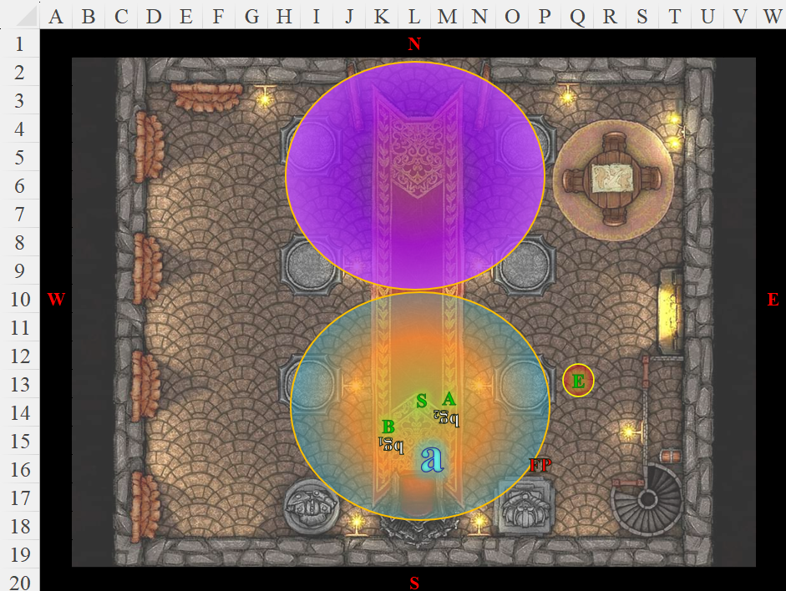

Round 5

The ape clawed at both bodyguards one at a time.

|  |  |  |  |  |  |  |  |  |
| --- | --- | --- | --- | --- | --- | --- | --- | --- |
| **Character** | **Attack Type** | **Damage** | **BAB** | **Str Mod+** | **Other+** | **Total Score** | **Roll** | **Total** |
| Ape | Claw 1 | 1d6+5 | 2 | 5 | 2 flank | 9 | 8 | 17 |
| Ape | Claw 2 | 1d6+5 | 2 | 5 | 2 flank | 9 | 13 | 22 |

*Hit, hit.*

*Dmg to Bodyguard 1: 5 + 5 = 10.*

*Dmg to Bodyguard 2: 6 + 5 = 12.*

Both bodyguards were pummeled to death by the ape, who now turned to Pompeii.

The diabolist leader was left alone in the room with the heroes. He certainly had a few spells left, and could have tried to run past them, but the ape would surely get him. If apprehended, he would surely be tried, and with enough evidence, hanged, his soul being summarily delivered to the devil with whom he made a pact for the power he now held on to. His next decision would determine the course of history.

Father Pompeii Vesuvius’s forked tongue flicked over dry lips as he weighed his choices. The bodyguards’ broken bodies sprawled across the blood-slick floor. His axiomatic storm sputtered out, leaving only the lantern’s dull glow casting jagged shadows across the stone.

His heart—a withered, scorched thing—thudded painfully beneath his breast. Loviatar’s lash had made him strong, but the Goddess of Pain made no promises of victory—only suffering. To surrender was to invite torment. To flee would mean eternal damnation, cast back into Asmodeus’s grasp as a failed servant. He could fight on, hurling hexes and blights, but the emerald shimmer of Eldrin’s dimensional anchor still clung to his flesh like a chain.

“Clever little bookworm,” he rasped. His cloven nails traced the cracked, ivory flail tucked into his belt—the Maiden’s symbol. His legacy—tarnished. His cult—unmasked.

His voice carried into the silence. “What mercy would you offer Loviatar’s disciple?”

Banshee’s kukri twirled in her fingers. “None.”

Sebenzi glanced toward Eldrin, her brow furrowed. “Oghma’s wisdom teaches that even the most wretched souls may turn from darkness... but this one has worn his chains willingly.”

Pompeii’s slitted pupils fixed on the gnome. He felt the weight of those ancient eyes—piercing, patient. Archivists were the worst kind of clerics—no zeal to burn, no passion to break. Only cold, methodical judgment.

The ape snarled behind him.

If there was one thing Pompeii feared more than death... it was irrelevance. To die as another name scratched in the Font of Knowledge’s ledgers—his life’s work reduced to parchment.

“I could serve your cause,” he purred. “Secrets beyond mortal ken... Oghma would appreciate such offerings, would he not?”

Artemis and Sebenzi emerged from the axiomatic storm unharmed, anticipating the

Round 6, end of rounds

Banshee did as well.

Eldrin’s voice was steady. “Every book has an end, Vesuvius.”

Pompeii’s smile flickered. Would he yield? Or would he cast one final spell and meet his goddess in agony, as every true disciple must?

The ape charge-attacked Pompeii, but stopped short of its mark. Eldrin held it, stating, “You have but one chance to save yourself in this life, Pompeii Vesuvius. Kneel and surrender, or die where you stand.”

Father Pompeii's forked tongue flicked out once more, tasting the stagnant air as if it might reveal some hidden path to escape. His amber eyes flitted toward the room’s only exit—the ape’s shadow stretched long across the threshold. There would be no flight. The archivist’s words hung in the damp silence, binding him more tightly than the dimensional anchor ever could.

*Kneel and surrender... or die where you stand.*

The tiefling’s lips curled into something that might have been a smile—if not for the tremor in it. His mind, so sharp in ritual and cruelty, found itself trapped on the edge of decision. He had sworn his soul to two masters—one of torment, the other of tyranny—and both would claim him if he fell.

There was only one mercy left.

The *unholy storm* had just expired, and now the *axiomatic storm* did as well.

The diabolist’s knees creaked as they bent—slowly, painfully—until he knelt upon the cold, bloodstained floor. His claws uncurled from the flail at his belt, letting it clatter against the stone.

His voice, raw with spite, whispered through gritted teeth.

“I... surrender.”

*Shield of faith* spells expired all around as Sebenzi let out a breath she hadn’t realized she was holding, clutching her staff to her chest.

Banshee’s blade lingered in the air, lips pressed thin. “Burn him now or bind him better. He’ll find a way to wriggle loose.”

Eldrin stepped forward, his steel-shod boots echoing across the chamber. The gnome’s face remained cold, eyes locked on the kneeling tiefling as if already transcribing the scene into memory.

“The Oghmanyte creed does not permit the slaying of those who yield,” he intoned, voice steady but not without bitterness.

The ape loomed behind them—each wet breath stirring Pompeii’s dark hair. The fiend-blooded priest dared not look back.

“I would offer you death, Father Vesuvius,” Eldrin continued, “for it is the only mercy you deserve. But Oghma would have the truth—every name, every rite, every devil’s deal you have brokered.”

He knelt so they were eye to eye. “And you will speak them all.”

The tiefling’s slitted pupils flared wide—a flicker of panic in the face of something worse than death: confession.

“Bind him,” Eldrin ordered as the ape expired and dematerialized.

Sebenzi stepped forward, pulling silk cords from her satchel.

Artemis and Banshee flanked Pompeii as the cleric worked, winding the binding prayer of Oghma into each knot. The tiefling did not resist—but his golden eyes burned with the promise of suffering yet to come.

“You are a vessel of knowledge now,” Eldrin murmured. “No longer a servant of the Lash. You will live long enough to see your works dismantled and your goddess forgotten. And furthermore, you will be known throughout your former circles as a traitor, and a collaborator with Oghmanytes.”

Banshee added for good measure, “There won’t be a corner of Toril or the Planes where your deeds won’t be known of. Bards will compose cautionary tales for children to grow up on. Father Vesuvius, the weak.”

For the first time, Father Pompeii Vesuvius's smile faded completely. The diabolist snarled at the woman, “Now that I am bound you slur me!” He inhaled with resolve, “I shall see you on the field in one life or the next,” he cryptically foretold.

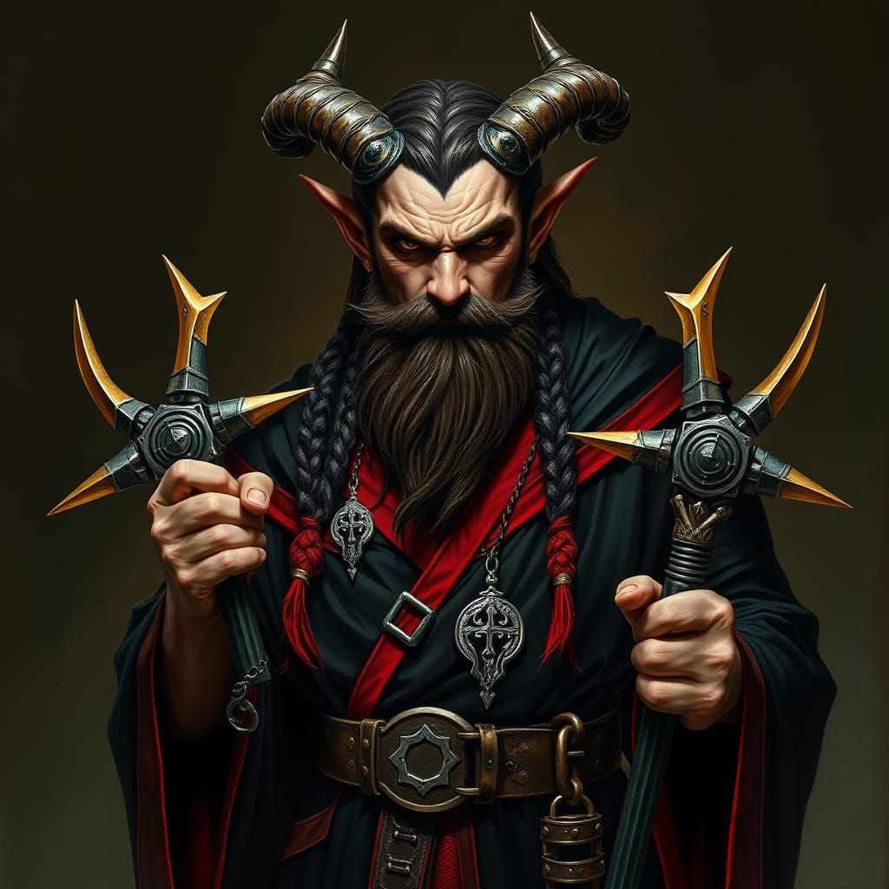

And so it came to pass that the Waterdeep cell of the diabolist cult became undone, and as they headed back to the Font of Knowledge, they began to discuss the next steps in their investigation, in subdued language such that the devil-man didn’t understand.