**Oghma’s Faithful**

**by Alexis Álvarez and Microsoft Copilot**

**Chapter 6: The Match**

Afternoon, 15 Marpenoth, 1372 DR

Eldrin had taken some of his friends’ advice on physical training as of late, and had gotten rid of his love handles and other flab over the last tenday or so in preparation for a tournament to test his mettle. He was an archivist, and intended to be casting spells and what not, but he’d wanted to be in the best shape to withstand damage in case his opponent were to deal any.

He was signed up for a single tournament in what was called the Fifth Circle, a fight in an arena accommodating champions whose powers rank at the 5th level of proficiency. As a 5th-level archivist, he was expecting to confront a comparably apt individual in the arena within the hour. He engaged in a little physical warmup to get his muscles ready and reduce the risk of injury and considered the use of terrain. He was told this arena had columns located throughout, behind which the stealthy gnome could hide between castings of spells.

~*~

Eldrin had been let into the corridor that led out into the eastern end of the 120’ x 100’ oval arena, and now the gates opened for him as he emerged onto the sandy stage before a crowd of hundreds, seated all around him. Opposite him was a fellow he’d met a few times named Korik the Quick.

Round 1

The announcer announced the announcement that the battle had begun.

|  |  |  |  |  |  |
| --- | --- | --- | --- | --- | --- |
| **Character** | **Group** | **Initiative** | **Roll** | **Modified Roll** | **Speed** |
| Korik | 2 | 1 | 18 | 19 | 30’ |
| Eldrin | 1 | 2 | 13 | 15 | 30’ |

Round 1

Korik had been preparing himself mentally and physically for this moment. The moment the announcer declared the battle had begun, he drew his shortbow and sprang into action. He had the advantage of first move, and now dashed towards the nearest column for cover *[L15]*, moving swiftly and silently.

*Korik gained 20% concealment at his position partly behind the column as he aimed.*

His keen eyes locked on Eldrin, assessing his opponent’s position. Drawing his MW Composite Shortbow, he nocked an arrow and prepared to take a shot at Eldrin, aiming to catch him off guard.

|  |  |  |  |  |  |  |  |  |  |  |
| --- | --- | --- | --- | --- | --- | --- | --- | --- | --- | --- |
| **Ranged Weapon** | **Dmg.** | **D+** | **TH+** | **Critical** | **Rng.** | **Wt.** | **Atk** | **Roll** | **Check** | **Notes** |
| MW Composite Shortbow, Str +2 | 1d6 | +2 | 1 | x3 | 70’ | 2.0 | +6 | 8 | 14 | 1d6 Skirmish |

*Miss.*

Eldrin could not conduct a Dark Knowledge check on dwarves, seeing as they were humanoid. Eldrin actually knew Korik cursorily, and assumed he was not evil, so he didn’t bother casting *protection from evil* on himself. Instead, he went with *sanctuary*, which would allow him to cast further innocuous spells with a lesser chance of being bothered by the dwarven archer.

*Eldrin’s sanctuary spell subjected Korik to a Will save in order to deal damage to Eldrin.*

Eldrin then moved to fully behind the closest southern column *[AD16 on the map you have]*, and did not peek around it like Korik would have to in order to shoot.

Round 2

Korik saw his arrow miss its mark, but he didn’t let it phase him. He noted Eldrin casting a spell—sanctuary. The dwarf ranger knew this would make it difficult to target his opponent directly, and he needed to adapt quickly. He assessed his options and decided to move forward strategically. He wanted to close the distance between himself and Eldrin, making it harder for the gnome to avoid his attacks. He moved from his position at L15 towards Q14, using the columns for cover as he advanced. As he moved, Korik sheathed his bow and drew his MW Silvered Rapier, readying himself for close combat. He knew he needed to break through Eldrin’s *sanctuary* to land a strike.

|  |  |  |  |  |  |  |
| --- | --- | --- | --- | --- | --- | --- |
| **Opposed Skill Check** | **Rank** | **Ability**  **& Mod.** | **Misc.**  **Mods.** | **Total** | **Roll** | **Check** |
| **Korik, Move Silently** | 5 | **Dex (+2)** | 0 | 7 | 12 | 19 |
| **Eldrin, Listen** | 4 | **Wis (+2)** | 2 | 8 | 6 | 14 |

*See below.*

Eldrin did not hear the dwarf creeping up on him from the west as he cast *shield of faith* upon himself, then drew his masterwork dagger.

*Eldrin gained a +2 Deflection bonus to AC.*

Round 3

Korik took advantage of the cover provided by the columns and the fact that Eldrin hadn’t noticed him. With his MW Silvered Rapier in hand, he moved closer, trying to position himself within striking distance of Eldrin. Korik moved from W14, staying alert and ready to engage in melee combat. He prepared to strike. The dwarf ranger-scout-wilderness rogue steeled himself, anticipating the magical resistance he would need to break through.

|  |  |  |  |  |  |  |
| --- | --- | --- | --- | --- | --- | --- |
| **Opposed Skill Check** | **Rank** | **Ability**  **& Mod.** | **Misc.**  **Mods.** | **Total** | **Roll** | **Check** |
| **Korik, Move Silently** | 5 | **Dex (+2)** | 0 | 7 | 6 | 13 |
| **Eldrin, Listen** | 4 | **Wis (+2)** | 2 | 8 | 7 | 15 |

*See below.*

Eldrin heard the dwarf coming in from his northwest, though the stone column still provided hard cover. He cast *spiritual weapon [expired on Round 8]* and manifested Oghma’s spiritual longsword just around the pillar *[AB14]*, and sent it charge-attacking against Korik.

|  |  |  |  |  |  |  |  |  |  |
| --- | --- | --- | --- | --- | --- | --- | --- | --- | --- |
| **Melee Weapon** | **Dmg** | **D+** | **TH+** | **Critical** | **Type** | **Wt.** | **Atk** | **Roll** | **Check** |
| Spiritual Longsword | 1d8 | 1 + 2  charge | 2 charge | 19-20, x2 | Slashing | 0.0 | +7 | 11 | 18 |

*Hit. Dmg: 6 + 1 + 2 charge = 9 [20/29 hit points].*

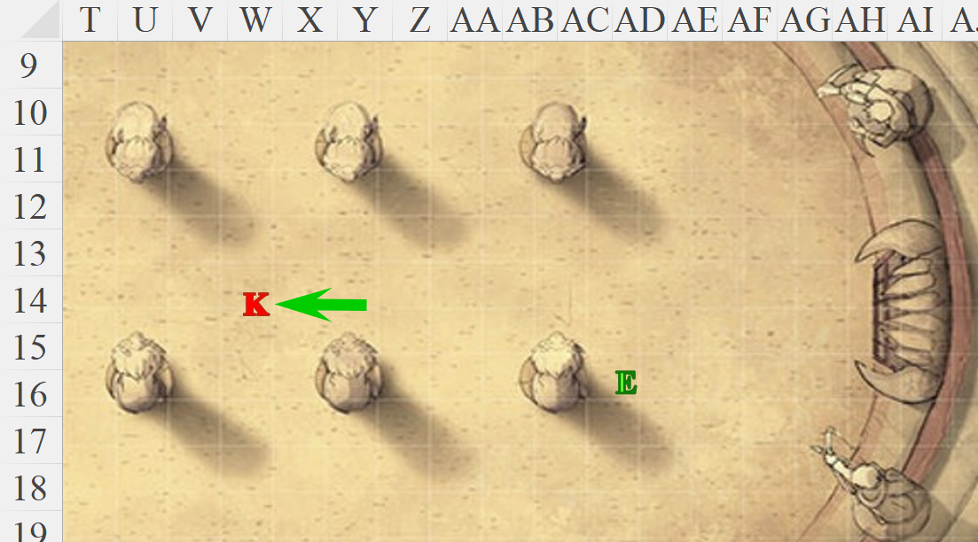

Round 4

Korik gritted his teeth as the spiritual longsword of Oghma struck him, feeling the sting of its ethereal blade. He moved swiftly from W14 to AD15, closing the distance to engage Eldrin directly in melee combat. He raised his MW Silvered Rapier, attempting to strike Eldrin and disrupt his concentration. Before he could strike, he had to overcome Eldrin’s **Sanctuary** spell. Korik steeled himself, focusing his will to break through the magical barrier.

|  |  |  |
| --- | --- | --- |
| **Prayer** | **Level** | **DC** |
| Sanctuary | 1 | 16 |

*See saving throw below.*

|  |  |  |  |  |  |  |
| --- | --- | --- | --- | --- | --- | --- |
| **Save vs.**  *sanctuary* | **Rank** | **Ability & Mod.** | **Misc. Mods.** | **Total** | **Roll** | **Check** |
| **Korik, Will** | **1** | **Wis (+1)** | 1 | 3 | 11 | 14 |

*Fail vs. DC 16.*

His attack bounced off of a barely visible, reddish cylinder around Eldrin’s form. As he had moved towards Eldrin, the longsword had both attacked [opportunity] and pursued him.

|  |  |  |  |  |  |  |  |  |  |
| --- | --- | --- | --- | --- | --- | --- | --- | --- | --- |
| **Melee Weapon** | **Dmg** | **D+** | **TH+** | **Critical** | **Type** | **Wt.** | **Atk** | **Roll** | **Check** |
| Spiritual Longsword | 1d8 | 1 | 0 | 19-20, x2 | Slashing | 0.0 | +5 | 3 | 8 |

*Miss.*

Eldrin now cast *divine favor [expired on Round 14]* upon himself, urging his dagger to be more puncturing.

*Eldrin gained +1 to weapon damage.*

He moved westward and slightly back northward to W16, incurring an attack of opportunity from the dwarf.

|  |  |  |  |  |  |  |  |  |  |
| --- | --- | --- | --- | --- | --- | --- | --- | --- | --- |
| **Melee Weapon** | **Dmg** | **D+** | **TH+** | **Critical** | **Type** | **Wt.** | **Atk** | **Roll** | **Check** |
| MW Silvered Rapier | 1d6 | 1 | 1 | 18-20, x2 | Slashing | 2.0 | +6 | 14 | 20 |

*Hit. 4 + 1 = 5 [33/38 hit points remaining].*

Blocked once again by pillars from Korik’s line of sight, the gnome hid from view as he considered his next actions.

OOC: Please let me roll the dice, and use smart quotes, not straight quotes. I added the longsword’s attack of opportunity below.

IC: Round 5

Korik felt a surge of determination. Though Eldrin’s sanctuary spell had thwarted his initial attack, he wouldn’t be deterred. The spiritual longsword was an annoyance, but his focus remained on closing the distance to Eldrin and breaking through his defenses. The wilderness rogue moved westward from AD15 to X15, flanking Eldrin.

The spiritual longsword took an attack of opportunity.

|  |  |  |  |  |  |  |  |  |  |
| --- | --- | --- | --- | --- | --- | --- | --- | --- | --- |
| **Melee Weapon** | **Dmg** | **D+** | **TH+** | **Critical** | **Type** | **Wt.** | **Atk** | **Roll** | **Check** |
| Spiritual Longsword | 1d8 | 1 + 2  charge | 2 charge | 19-20, x2 | Slashing | 0.0 | +7 | 6 | 13 |

*Miss.*

Korik was close enough to swing, and so he did.

|  |  |  |  |  |  |  |
| --- | --- | --- | --- | --- | --- | --- |
| **Save vs.**  *sanctuary* | **Rank** | **Ability & Mod.** | **Misc. Mods.** | **Total** | **Roll** | **Check** |
| **Korik, Will** | **1** | **Wis (+1)** | 1 | 3 | 16 | 19 |

*Success. Sanctuary bypassed. This is not allowed by canon, but I’m allowing it to keep this a fair fight.*

|  |  |  |  |  |  |  |  |  |  |
| --- | --- | --- | --- | --- | --- | --- | --- | --- | --- |
| **Melee Weapon** | **Dmg** | **D+** | **TH+** | **Critical** | **Type** | **Wt.** | **Atk** | **Roll** | **Check** |
| MW Silvered Rapier | 1d6 | 1 | 1 | 18-20, x2 | Slashing | 2.0 | +6 | 1 | 7 |

*Miss.*

Eldrin took a gamble by casting *summon nature’s ally III [expired on Round 10]*, knowing that if the dwarf hit with his blade, Eldrin might lose his concentration on the spell. It would take an entire 6 seconds to cast it, during which he began to conjure up the image of an animal to manifest.

Round 6

Korik’s blade had missed its mark, but he was undeterred. He saw Eldrin starting to cast a spell and recognized the opportunity to strike again. Knowing that the gnome’s concentration was crucial for the spell, Korik prepared to disrupt it. He made another swift attack with his MW Silvered Rapier, aiming to break Eldrin’s focus and prevent the summoning spell from completing.

|  |  |  |  |  |  |  |  |  |  |
| --- | --- | --- | --- | --- | --- | --- | --- | --- | --- |
| **Melee Weapon** | **Dmg** | **D+** | **TH+** | **Critical** | **Type** | **Wt.** | **Atk** | **Roll** | **Check** |
| MW Silvered Rapier | 1d6 | 1 | 1 | 18-20, x2 | Slashing | 2.0 | +6 | 3 | 9 |

*Miss.*

His attack once again bounced off the magical barrier of Eldrin’s sanctuary, protecting the gnome as he finished up his summoning spell.

Consequently, an ape materialized before Korik, and immediately pummeled him with its fists.

|  |  |  |  |  |  |  |  |  |  |
| --- | --- | --- | --- | --- | --- | --- | --- | --- | --- |
| **Character** | **Attack Type** | **Damage** | **BAB** | **Str Mod+** | **Total Score** | **Roll** | **Total** | **Crit** | **Threat** |
| Ape | Claw 1 | 1d6+5 | 2 | 5 | 7 | **20** | 27 | 20 | þ |
| Ape | Claw 2 | 1d6+5 | 2 | 5 | 7 | 8 | 15 | 20 | ý |

*Threat, miss. Natural attack, not subject to critical hit.*

*Dmg: 5 + 5 = 10 [10/29 hps].*

Eldrin sighed with relief at the successful conjuring, and cast *hold person* on Korik, forcing him to yield if successful.

|  |  |  |  |  |  |  |
| --- | --- | --- | --- | --- | --- | --- |
| **Save vs.**  *hold person* | **Rank** | **Ability**  **& Mod.** | **Misc.**  **Mods.** | **Total** | **Roll** | **Check** |
| **Korik, Will** | **1** | **Wis (+1)** | 1 | 3 | 20 | 23 |

*Success. Spell effect negated.*

The spell did not work, and the dwarf was able to fend off the longsword.

|  |  |  |  |  |  |  |  |  |  |
| --- | --- | --- | --- | --- | --- | --- | --- | --- | --- |
| **Melee Weapon** | **Dmg** | **D+** | **TH+** | **Critical** | **Type** | **Wt.** | **Atk** | **Roll** | **Check** |
| Spiritual Longsword | 1d8 | 1 | 0 | 19-20, x2 | Slashing | 0.0 | +5 | 4 | 9 |

*Miss.*

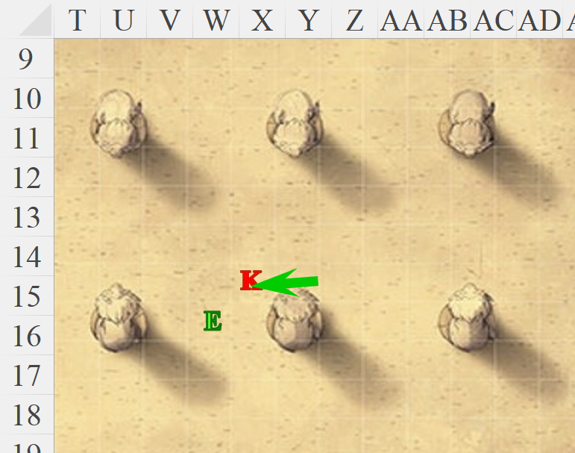

Round 7

Korik felt the intense pain from the ape’s strike, but his determination and resilience kept him going. He decided to focus on the immediate threat—the ape. He launched a precise attack with his MW Silvered Rapier, aiming to bring down the summoned creature quickly.

|  |  |  |  |  |  |  |  |  |  |
| --- | --- | --- | --- | --- | --- | --- | --- | --- | --- |
| **Melee Weapon** | **Dmg** | **D+** | **TH+** | **Critical** | **Type** | **Wt.** | **Atk** | **Roll** | **Check** |
| MW Silvered Rapier | 1d6 | 1 | 1 | 18-20, x2 | Slashing | 2.0 | +6 | 16 | 22 |

*Hit. Dmg: 5 + 1 = 6 [23/29 hps].*

The ape attacked Korik.

|  |  |  |  |  |  |  |  |  |
| --- | --- | --- | --- | --- | --- | --- | --- | --- |
| **Character** | **Attack Type** | **Damage** | **BAB** | **Str Mod+** | **Other+** | **Total Score** | **Roll** | **Total** |
| Ape | Claw 1 | 1d6+5 | 2 | 5 | 2 flank | 9 | 7 | 16 |
| Ape | Claw 2 | 1d6+5 | 2 | 5 | 2 flank | 9 | 19 | 28 |

*Miss, hit. Dmg: 4 + 5 = 9 [1/29 hps].*

The longsword attacked Korik.

|  |  |  |  |  |  |  |  |  |  |
| --- | --- | --- | --- | --- | --- | --- | --- | --- | --- |
| **Melee Weapon** | **Dmg** | **D+** | **TH+** | **Critical** | **Type** | **Wt.** | **Atk** | **Roll** | **Check** |
| Spiritual Longsword | 1d8 | 1 | 2 flank | 19-20, x2 | Slashing | 0.0 | +7 | 6 | 13 |

*Miss.*

Eldrin was prepared to cast *searing light*, and could see that Korik was about to collapse with 1 hit point left. “Do you yield?” the lawful good archivist asked his neutral good adversary.

Korik felt the intense pain from the ape’s strike, but his determination and resilience kept him going. Though he was on the brink of collapse, he *had* the resolve to see the fight through to the end. Hearing Eldrin’s offer to yield, Korik considered the honorable gesture. Recognizing the worthiness of his opponent and understanding the value of preserving his strength for future battles, he made his decision. Korik lowered his Silvered Rapier, showing a sign of respect to Eldrin and the audience. “I yield,” he announced, his voice clear and resolute. He knew that living to fight another day was the wiser choice.

Round 8

Cheers from the crowd immersed both combatants, and Eldrin immediately dismissed the longsword and ape, casting *cure moderate wounds* on him.

*Korik gained 8 + 5 = 13 hps [14/29 hps].*

By this time, a designated healer came out from the east entrance and applied the rest of the magical healing that Korik needed.

*Korik gained 15 hps [29/29 hps].*

Eldrin took note of the spells that he had and had not cast.

|  |  |  |  |
| --- | --- | --- | --- |
| **Prayer** | **Level** | **DC** | **Cast?** |
| Detect Magic | 0 | 15 | q |
| Cure Minor Wounds | 0 | 15 | q |
| Light | 0 | 15 | q |
| Resistance | 0 | 15 | q |
| Cure Light Wounds | 1 | 16 | q |
| Divine Favor | 1 | 16 | þ |
| Protection from Evil | 1 | 16 | q |
| Shield of Faith | 1 | 16 | þ |
| Sanctuary | 1 | 16 | þ |
| Cure Moderate Wounds | 2 | 17 | þ |
| Hold Person | 2 | 17 | þ |
| Silence | 2 | 17 | q |
| Spiritual Weapon | 2 | 17 | þ |
| Searing Light | 3 | 18 | q |
| Dispel Magic | 3 | 18 | q |
| Summon Nature’s Ally III | 3 | 18 | þ |

It had been a solid spell selection, and he’d been fortunate to be able to carry the summoning spell through to completion; those took so long to manifest!

Korik felt the relief as Eldrin’s healing magic flowed through him, mending his wounds. He stood tall, showing respect to his opponent and the audience. “Well fought,” he said to Eldrin, acknowledging the gnome’s prowess and strategy. The designated healer’s additional magic fully restored Korik’s strength, and he felt ready to face future challenges with newfound respect for his opponent. The crowd’s cheers and applause were a testament to the honorable battle both combatants had displayed. Eldrin’s spellcasting had been meticulous and effective, while Korik’s resilience and adaptability had been commendable.

After the match, they were ushered back into and through the corridors that led them back out where many from the crowd had gathered to throw flowers upon both participants of the tournament. “Great match!” many of them said, and things the like.

They had both fought well, and a few dwarven ladies were now blinking interestedly at Korik, hoping the honorable warrior of the woods would come over and mingle a bit. Eldrin excused himself to go speak with his friend Mira, and Korik was left to explore the moment.

Korik basked in the crowd’s admiration, feeling a sense of pride and accomplishment. The cheers and applause were a testament to the hard-fought battle, and he took a moment to appreciate the support of the spectators. Noticing the interested glances from the dwarven ladies, Korik smiled warmly and made his way over to them. “Greetings,” he said with a nod, “I hope you enjoyed the match.” He engaged in conversation, sharing tales of his adventures in the wilderness and the challenges he had faced.

They returned pleasantries and invited Korik to a nearby table where the best ale in Secomber was reputed to be served. The atmosphere was filled with celebration and camaraderie, and Korik relished the opportunity to connect with others and share in the joy of the moment. He knew that this experience would strengthen his reputation and bonds with those around him. Eldrin was nowhere in sight, and probably headed home, and Korik considered the ales and the company.

Korik felt a warm sense of camaraderie as he joined the dwarven ladies at the nearby table. The ale was indeed the finest he had tasted in Secomber, and he savored every sip. The company was lively, and the conversation flowed easily, filled with laughter and stories of past adventures. Korik shared tales of his time in the wilderness, the creatures he had encountered, and the challenges he had overcome. The dwarven ladies were enthralled by his stories, and their admiration for his bravery and skills grew with each tale.

As the evening went on, Korik found himself enjoying the company and the celebration. He knew that this night would be a memorable one, strengthening the bonds of friendship and camaraderie within the community. With a sense of contentment, Korik raised his mug of ale and toasted to new friendships and future adventures. He felt grateful for the opportunity to connect with others and share in the joy of the moment.