Oghma’s Faithful
by Alexis Álvarez and Microsoft Copilot

Chapter 9: Secomber to Deluvium
____________________________________________________________________________________________________________

Abstract: At dawn on the 5th of Nightal, the heroes of Oghma—Artemis, Banshee, Eldrin, and Sebenzi—awoke in the Temple of Oghma, ready to begin their important journey. With Eldrin and Banshee riding their loyal wolfhounds, and Artemis and Sebenzi mounted on light riding horses, they set out on the road paralleling the River Delimbyr. Their journey took them to the Flowering Hills, where they enjoyed a peaceful picnic with a family of friendly sprites.
As they continued their journey, they encountered various challenges, including a rockslide at mile 40 that damaged the rear wagon of a caravan they had joined, and an injured horse that Sebenzi quickly healed. They traveled through the Rolling Meadows and reached the stunning Sunset Cliffs at mile 124, taking a moment to appreciate the breathtaking view.
Their peace was abruptly interrupted by a swarm of giant fire beetles, which attacked the group. Despite the beetles managing to harm one horse, one dog, and two humanoids, the heroes successfully killed or drove off the beetles. After tending to their injuries, the heroes of Oghma continued their journey with renewed determination, ready to face whatever challenges lay ahead.
As the heroes of Oghma journeyed along the road parallel to the River Delimbyr, they faced various challenges and enjoyed peaceful moments, including a picnic with friendly sprites and an encounter with a rockslide that damaged a caravan. When they arrived in a small hamlet, they were welcomed by a pair of siblings who directed them to their contact, Father Rhilos, a druid. Rhilos informed them of the cult’s activities and the corruption in a nearby village, emphasizing the need to prevent the cult leader, Professor Farleigh, from teleporting away. The heroes prepared to meet with two druids who would guide them and help them infiltrate the village unnoticed.
Artemis, who had started a journal, was contemplating names for their group, including “The Oghma Vanguard” and “The Secomber Sentinels.” As they awaited their next steps, the heroes discussed their strategies and spells, ensuring they were ready to confront the cult’s threats. Rhilos provided valuable intelligence and introduced the heroes to their guides, Nevra and Moab, who would help them navigate the village and avoid detection. With their mounts rested and their plan in place, the heroes set out with renewed determination to thwart the cult’s sinister plans.
____________________________________________________________________________________________________________

Dawn, 5 Nightal

It had been a nippy night, and the Temple of Oghma had no heating infrastructure, so they’d curled up with their dogs or body pillows and packed on a lot of blankets in their respective beds, and with the cackling of roosters outside, they prepared for the day’s ride.

The whisper gnomes—Eldrin and Banshee—would ride their wolfhounds while the humans—Artemis and Sebenzi—would be provided with light riding horses. None of them were very experienced riders, certainly not fit for mounted combat, but their trip would be far less arduous with mounts.

They forecast an 11-day trip on their mounts, with scenic spots such as the Flowering Hills and the Sunset Cliffs conveniently located on or near the roadside. Eldrin kept a travelogue, and Sebenzi kept a journal.

As the exited the Temple into the courtyard where the two horses were waiting, dawn broke over the horizon, casting a golden glow across the Temple of Oghma. The rooster’s crow signaled the start of their journey. Eldrin and Banshee prepared the barding on their loyal wolfhounds, Colonel Curna and Deneir, while Artemis and Sebenzi readied their light riding horses, which had already been outfitted with leather barding. The animals seemed to sense the importance of the mission, their eyes bright with anticipation.

With the sun rising, they set out along the southwestern road that paralleled the River Delimbyr. The path was flanked by picturesque landscapes, with the river glistening in the morning light. Eldrin kept a meticulous travelogue, noting every landmark and detail, while Sebenzi documented their journey in her journal.

For two days, they traveled steadily, covering 32 miles. The scenic route offered moments of beauty and peace, a stark contrast to the dangers they anticipated. On the second day, they reached the Flowering Hills, a verdant expanse adorned with blooming wildflowers and gentle rolling terrain.

As they traversed the hills, they spotted a family of sprites fluttering among the flowers. The tiny, ethereal creatures shimmered in the sunlight, their laughter like the tinkling of bells. Curious and friendly, the sprites approached the travelers.

“Welcome to the Flowering Hills!” one of the sprites chirped, her wings glistening like dew-kissed petals. “We rarely see visitors here.”

The heroes exchanged smiles, charmed by the sprites’ presence. Eldrin, ever the diplomat, introduced their party. “Thank you for the warm welcome. We’re on a journey to bring justice to those who need it. May we share your company for a while?”

The sprites agreed, and the heroes dismounted, settling down for a picnic amidst the vibrant flowers. They shared stories and food, enjoying a rare moment of peace. The sprites regaled them with tales of the hills and the creatures that called it home.

As they ate, Sebenzi sketched the scene in her journal, capturing the beauty of the moment. Eldrin noted the sprites’ lore in his travelogue, ensuring their wisdom wouldn’t be forgotten.

The picnic provided a much-needed respite, and the heroes felt their spirits lifted by the sprites’ joyous company. As the sun began to set, they thanked the sprites for their hospitality and prepared to continue their journey. They mounted their wolfhounds and horses, waving goodbye to the sprites. The Flowering Hills faded into the distance, but the memory of the magical encounter stayed with them.

The journey had been mostly uneventful until they reached mile 40, according to the sign they’d just passed. They had joined up with a caravan, and were now leading it along a muddy path. The eroded terrain and recent rains had turned the path into a muddy pass, and the caravan proceeded with caution. The heroes of Oghma kept a watchful eye on their surroundings, aware of the potential dangers.

As they navigated the treacherous path, the ground began to rumble. Eldrin, riding at the front, looked back just in time to see the hillside give way. A rockslide cascaded down the slope, sending debris tumbling towards the horses.

“Rockslide! Hurry, move forward!” Eldrin shouted, urging everyone to speed up.

The caravan sped up, the wagons bouncing along the muddy pass. The rear wagon took the brunt of the damage as several rocks struck it, but the quick response of the drivers ensured that the main caravan remained unscathed.

Banshee, riding Deneir, looked back at the debris with wide eyes. “That was too close! Is everyone okay?”

Artemis and Sebenzi, guiding their horses with skill, glanced at each other and then back at the caravan. “We’re good,” Artemis called out, “Let’s keep moving before the path becomes any more dangerous.”

Sebenzi, always the healer, urged her horse to the rear wagon to assess any damage. “We need to make sure the supplies are intact. If there are any injuries, I’ll tend to them.”

The group agreed and continued on, keeping their spirits high despite the near-miss. The scenic beauty of the journey was tempered by the reminder of the dangers they faced, but the heroes of Oghma remained resolute. They knew their mission was crucial, and they would face whatever challenges lay ahead with determination and courage.

The rest of the day was uneventful as the road meandered towards drier and firmer ground, and by the end of the day, they were ready to camp in a discreet patch of overgrown foliage in an unmarked area.

~*~

By day 4, the heroes of Oghma arrived at the outskirts of the Crystal Stream, a sparkling tributary that provided a refreshing break for the travelers. The water was so clear that they could see fish swimming and the stones at the bottom glittering like crystals. The tranquility of the stream was a welcome respite from the treacherous path they had navigated earlier.

As they approached the stream, they dismounted their horses and wolfhounds, allowing the animals to drink and rest. Eldrin took a moment to fill his canteen with the cool, refreshing water, while Sebenzi began to set up a small campfire for a quick meal.

The group was enjoying the peaceful surroundings when a movement caught Banshee’s eye. She glanced towards the dense foliage on the opposite bank and saw a majestic creature stepping out from the underbrush. A large, muscular cougar with sleek, tawny fur and piercing green eyes emerged, its gaze fixed on the travelers.

The cougar, a formidable predator, moved gracefully, its powerful muscles rippling under its fur. It approached the water’s edge, clearly interested in quenching its thirst. The heroes of Oghma tensed, ready to defend themselves if necessary, but they quickly realized that the cougar was not displaying any signs of aggression.

Eldrin whispered to the group, “Let’s stay calm and avoid any sudden movements. It looks like the cougar just wants to drink.”

Sebenzi nodded, her hand resting on the hilt of her weapon just in case. “We should give it space and respect its presence. We’re in its territory.”

Artemis, ever the pragmatist, kept her eyes on the cougar while slowly reaching for her bow, ready to act if needed. “Let’s just keep an eye on it and let it be.”

Banshee, observing the cougar’s behavior, added, “If we stay calm and avoid provoking it, we should be fine.”

The heroes of Oghma continued to watch the cougar, ensuring they made no sudden movements. The cougar, sensing no immediate threat, lowered its head to the water and began to drink. The travelers maintained their distance, respecting the wild animal’s need for space. After a few minutes, the cougar finished drinking and raised its head, regarding the group one last time before turning and disappearing back into the dense foliage. The encounter had been tense, but the heroes had managed to avoid any confrontation.

As the cougar vanished into the forest, Eldrin let out a breath he hadn’t realized he was holding. “That was close. Good job, everyone.”

Sebenzi smiled, feeling a sense of relief. “We handled that well. Let’s take this as a reminder to always be aware of our surroundings.”

Artemis nodded in agreement. “Let’s finish our meal and get back on the road.”

~*~

They had traveled 72 miles according to the most recent marker, and now had to suddenly stop as Artemis’ horse injured its hoof and foot. Falling to the ground, the herbivore dropped Artemis, who was also badly hurt, such that she fractured her femur under the weight of the horse.

Sebenzi—the party’s cleric was more than prepared for such a situation, and with a few castings of cure light wounds the moment was repaired, and they were off as if nothing had transpired.

“Wow, my leg actually feels better than before,” commented the favored soul.

“That’s because the healing treated the soreness from sitting on the saddle all day,” explained her healer.

It must have been day 6 or 7—they had lost track and needed to turn to their journals to remember by now—when they happened upon the Rolling Meadows, a vast ocean of fields crisscrossed by brooks and groves. They checked their logs, and were indeed on the sixth day of their trip, and a bit ahead of schedule, so they rested their legs and their mounts, setting up camp earlier than normal, and spending the majority of the afternoon in a desolate spot a mile or so south of the road, overlooking the river.

~*~

As they journeyed further along the road, the heroes of Oghma found themselves approaching the 124-mile mark. The sun was beginning to dip towards the horizon, casting a warm, golden light over the landscape. The air was filled with the soft rustling of leaves and the distant chirping of birds as they made their way through the serene countryside.

The path led them to a breathtaking sight: the Sunset Cliffs. The cliffs rose majestically above the river, their edges bathed in the vibrant hues of the setting sun. The jagged rock formations, weathered by time and the elements, created a dramatic contrast against the tranquil waters below. The scene was a perfect blend of nature’s raw power and serene beauty.

Eldrin, leading the group, signaled for them to stop. “We’ve made it to the Sunset Cliffs,” he announced, his voice filled with awe. “Let’s take a moment to appreciate this view.”

The heroes dismounted their horses and wolfhounds, allowing the animals to rest. They stood at the edge of the cliffs, taking in the panoramic view of the river winding its way through the valley below. The sun’s rays painted the sky with shades of orange, pink, and purple, creating a mesmerizing tapestry.

Sebenzi took a deep breath, feeling the cool breeze against her face. “This is incredible,” she said softly. “A reminder of the beauty we’re fighting to protect.”

Artemis, ever the pragmatist, couldn’t help but smile at the sight. “It’s beautiful.”

Banshee, with her keen eyes, scanned the horizon, ensuring there were no immediate threats. “Let’s take a moment to rest and enjoy this before we continue,” she suggested.

The heroes of Oghma spent a few precious moments standing at the edge of the Sunset Cliffs, their hearts and minds rejuvenated by the stunning scenery. They knew their journey was far from over, but for now, they allowed themselves to be enveloped by the beauty of the world they were striving to protect.

As the heroes of Oghma stood at the edge of the Sunset Cliffs, taking in the breathtaking view, the peaceful moment was abruptly interrupted by a loud buzzing noise. The sound grew louder, and the group quickly realized it was coming from a swarm of giant fire beetles.

The beetles, each about the size of a small dog, had been drawn by the scent of the travelers and their mounts. Their iridescent shells glinted in the fading sunlight as they approached, their mandibles clacking hungrily.

Eldrin was the first to react, drawing his weapon and shouting a warning to his companions. “Giant fire beetles incoming! Get ready to defend yourselves!”

The heroes sprang into action, but the beetles were already upon them. One of the beetles lunged at Artemis’ horse, sinking its mandibles into the animal’s leg. The horse reared up in pain, nearly throwing Artemis off in the process.

Banshee’s wolfhound, Deneir, leapt to defend his master but was quickly swarmed by several beetles. The brave dog yelped as the beetles bit into his flank, causing him to stagger.

Sebenzi, seeing her companions and their animals in distress, cast Bless to bolster their defenses. “Stay strong, everyone!” she called out, her voice filled with determination.

Despite the magical aid, the beetles were relentless. One of them managed to bite Eldrin’s arm, causing him to wince in pain. Another beetle latched onto Banshee’s leg, its mandibles drawing blood.

Artemis, gritting her teeth against the pain, swung her longsword with precision, slicing through one of the beetles. “We need to drive them off! Keep fighting!”

With renewed determination, the heroes of Oghma fought back against the swarm. Sebenzi used her staff to knock away beetles, while Eldrin called upon his divine power to strike down the insects. Banshee fired arrows with deadly accuracy, taking down beetles from a distance.

The beetles, sensing the tide turning against them, began to scatter. One by one, they were either slain or driven off, their buzzing receding into the distance. The battle was over, but not without cost.

Artemis dismounted, checking on her injured horse. The wound was painful but not life-threatening, and Sebenzi quickly tended to it with healing magic. Deneir, though injured, wagged his tail gratefully as Banshee knelt to check on him.

Eldrin and Banshee also received healing for their injuries, ensuring everyone was back on their feet. “That was a close call,” Eldrin said, catching his breath. “But we made it through.”

Sebenzi nodded, her expression resolute. “Let’s make sure everyone is fully healed and ready to continue. We can’t afford any more delays.”

The heroes of Oghma took a few moments to regroup and heal, their resolve strengthened by the encounter. They knew their mission was crucial, and they were prepared to face whatever challenges lay ahead with courage and determination. With the Sunset Cliffs behind them, they continued their journey, ever vigilant and ready for whatever the road might bring.

~*~

Morning, 16 Nightal

Eldrin put down his travelogue after inking a few more lines and sketches in it, reflecting the last few bits of his trip, adding a space for the hamlet Deluvium, and another further down the page for the Ardeep-Daggerford Turnpike.

- Mile 0: Secomber
- Mile 32: The Flowering Hills: An area where wildflowers bloom in a vibrant display of colors.
  - Mile 40: Rockslide: The party is nearly killed as they speed up along the muddy pass.
- Mile 56: The Crystal Stream: A clear, sparkling stream that provides a refreshing break for the travelers. The water is so clear that you can see fish swimming and the stones at the bottom glitter like crystals.
  - Mile 72: Injured Horse: One of the horses in the caravan steps on a sharp rock and injures its hoof.
- Mile 91: The Rolling Meadows: Expansive meadows with gently rolling hills covered in lush green grass. The open landscape provides a sense of freedom and peace for the travelers.
- Mile 124: The Sunset Cliffs: A series of cliffs that offer a stunning view of the sunset over the River Delimbyr.
  - Mile 140: Giant Fire Beetles: A pack of six giant fire beetles crosses the path. They can be used for their bioluminescent glands.
- Mile 136: Hamlet Deluvium turnout.
- Mile 150: Ardeep-Daggerford Turnpike (End)

The marker for mile 136 was now a few hundred feet away, and as they came upon it, confirmed the number on it, and turned right as Artemis said to, she divulged a bit more.

Artemis had in the meantime started her own journal, using a blank notebook that Eldrin had imparted upon her, and had started to come up with names for their band of fearless heroes:

- The Oghma Vanguard
- The Whispering Blades
- The Enlightened Pathfinders
- The Guardians of Lore
- The Celestial Crusaders

In reality, they were not fearless, but rather courageous, meaning that they pretended to be fearless during moments when they were scared quite out of their wits. It was a way of life.

In any case, they all had their notebooks put away as the horses could smell water in troughs waiting for them. The mounts walked along the road that within minutes had them in the midst of a tiny hamlet that couldn’t have housed more than a dozen families.

One young man and woman were milking a cow, and now spotted Artemis on horseback and waved. She nodded and led her horse there, with her companions following close behind. “He around?”

The two who must have been siblings smiled, and the teenage boy nodded.

“Follow me, brother and sisters,” the favored soul of Oghma murmured to her friends as they trod through a town not accustomed to strangers. They were not a fruit stand roadside village, and kept to themselves, as was evident by their demeanor.

The heroes took their mounts around behind the property, where a gazebo overlooked a pond that had taken someone half a lifetime to build and rebuild to their whims. They led the horses and wolfhounds to drink at the crystalline waters of the pond, and dismounted, following Artemis to the gazebo where they were to wait for their contact.

For a few minutes, they rested and discussed contingencies moving forward, letting their mounts enjoy the pond and unfenced backyard that gave way to the idyllic wilderness beyond.

“Well,” a voice familiar to Artemis said. “If it isn’t the Secomber Sentinels.”

Artemis instantly thought, “Hm! Secomber Sentinels: I like it!”

“Rhilos!” Artemis was glad to see the druid who might have snuck up on them just to get an eavesdrop on their conversation.

“I got the news you were on your way a tenday ago. I remember a time when they would have dispatched you by teleport, but now... ahh... budget cuts,” he rolled his eyes, “pension plan fleecers... don’t get me started on city vice.”

“We won’t,” the human of 23 years told the half-elf of 123 years. “So, we don’t want to impose, and it’s already late morning. What do you have for us?”

“First and foremost,” the man introduced himself, “Oghma be with you,” he bowed his head. “I am Father Rhilos, venerator of Oghma’s knowledge, and keeper of Selonor Thelandiira’s wilderness.” He gestured to the land around them, referencing the deity central to their team, and an elven deity less known to them.

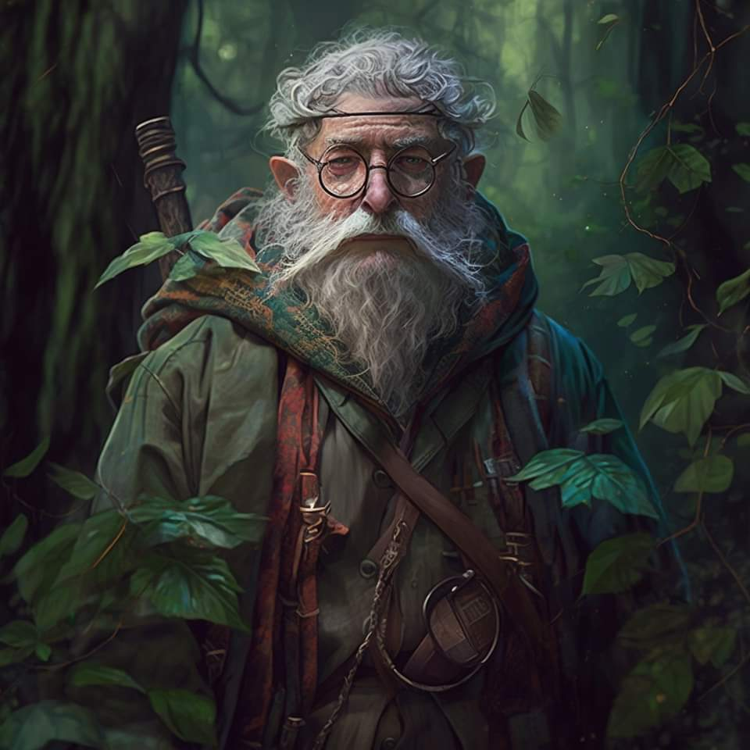

“As for what I have, it’s not all good news,” the bearded elf replied before getting down to business, “but you’ll have some help along the way. The intel is spotty, but the Turnpike is that little village—you remember—at the Y-intersection that’ll veer towards Waterdeep one way, and then the other way to Daggerford, and then, of course, back that way to Secomber.”

“Right,” Banshee was following along with the others.

“Like our humble hamlet, their larger village has no formal temple, and the Cyricists have been leveraging that to their advantage, paying the few guards there—volunteers, really—a few coins to look the other way,” the man explained. “The corruption is rife, which means that coin could sway the loyalties of any of their hired hands, but the diabolists are able to manipulate the minds of commoners and peasants like putty, and the suspect you confronted—the so-called Professor Farleigh—is reputed to be back in business, with a makeshift base of operations in a grotto a few miles from the Y-shaped roads that comprise the village.”

“So he means to stay there?” asked Sebenzi.

“Based on the progress he’s making in automating the supply chain at the Turnpike, and on how much the cult’s leadership has moved around in the last year, I estimate the Professor will be there another tenday or two before he teleports to another site. Now this is the crucial part: as you all learned a tenday ago, the Professor tries to teleport away as soon as he realizes that he is about to be apprehended, so he should be confronted with spells like dimensional anchor and hold person so he can be prevented from escaping, as he isn’t a very skilled rider, and doesn’t really have a second means of escape.”

“We had this intel about the teleport already, but we appreciate the confirmation,” Eldrin spoke tactically. “Sebenzi has the most comprehensive spell selection among the four of us, with mine being the second most versatile.”

Artemis added, “You’re already familiar with my god’s favors,” she referred to her truncated list of spells, “and Banshee here is more of a monogamous spellcaster.”

The urban ranger explained, “I’m a one-spell-per-day kind of gal.”

Eldrin took comfort in that.

“And you, Rhilos, if I may ask, you seem like a spellcaster, do you partake in the craft?” asked Eldrin.

“Ah, yes,” Rhilos answered. “I’m semi-retired, but I’ve been a druid most of my adult life.”

“So Rhilos,” Artemis was awkward in her non sequitur. “You mentioned that we’d have help along the way.”

“Oh, right. Two druids, speaking of...” Rhilos recalled now, his memory not being what it had been decades earlier. “Nevra and Moab,” he said their names as if that were enough information, then added, “They’re good people... a bit woodsy even for my taste, but noble hearts.”

“We meet up with them there?” Sebensi asked.

The druid replied, “No, they’re a few houses down from me. We’ll go see them in a moment. They’ve agreed to be your guides, and because they’re known quantities to the toll guards, they’ll vouch for you and avoid any trouble. You’ll want to look like total civilians, though, so every weapon you have should be stowed in that there haversack, and you’ll want to dress like you have just enough wealth to make it out on the road.”

“Other than Banshee, we don’t do too well with intrigue and pretense,” Eldrin recalled. “We couldn’t bluff a child out of a copper piece.”

“Then let Banshee do the talking,” Rhilos smiled, looking at Artemis, whose mouth often got her into misunderstandings.

“Now that the horses are done drinking,” he motioned to the animals, “Let’s go see Nevra and that husband of hers.”

“You mean your son-in-law?” Artemis confirmed.

“Y-yes, that one,” Rhilos humphed. He turned to the others, explaining, “Nevra’s my stepdaughter. It’s complicated. Her mother’s... complicated.”

